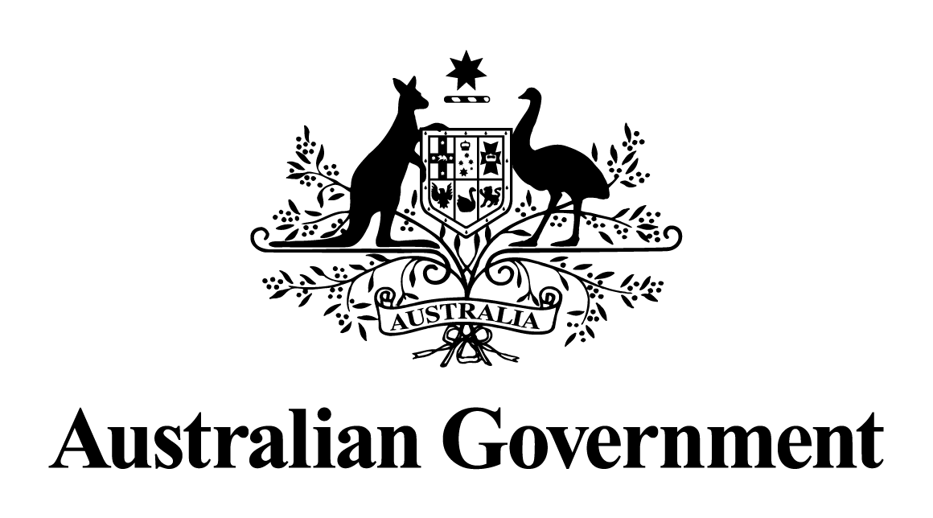

# Australian Government response to the Parliamentary Joint Committee on Human Rights report:

# ParentsNext: examination of Social Security (Parenting payment participation requirements – class of persons) Instrument 2021

The Government notes all recommendations made by the Committee and additional recommendations made by the Australian Labor Party and the Australian Greens Senators.

Given the passage of time, a substantive Government response is no longer appropriate.