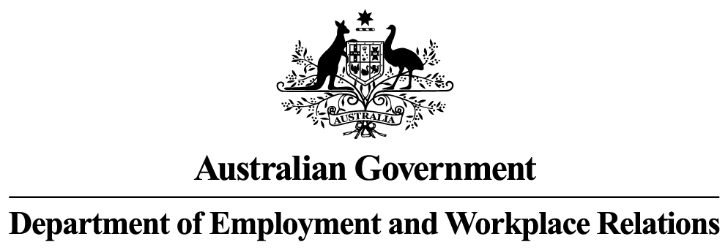

**Monthly Leading indicator of employment**

***August 2024***

Following a downward revision for July 2024, the Monthly Leading Indicator of Employment (the Indicator) has now fallen for two consecutive months (July 2024 and August 2024). Contrary to the July 2024 Indicator results, this means that a turning point in the Indicator in January 2024 is no longer confirmed. The main contributor to the revision was a larger negative contribution from China’s Purchasing Managers Index for Manufacturing Output.

The Indicator’s last confirmed peak was in March 2022, followed by 17 consecutive monthly declines to August 2023. This peak implied that the annual trend rate of employment growth would continue to fall to below its long-term trend rate of 2.9 per cent after an average lag of 12‑18 months. The annual trend rate of employment growth was 2.8 per cent in June 2024 (the most recent data), below the recent high of 4.6 per cent over the year to September 2022.

LEVELS OF THE LEADING INDICATOR OF EMPLOYMENT AND CYCLICAL EMPLOYMENT

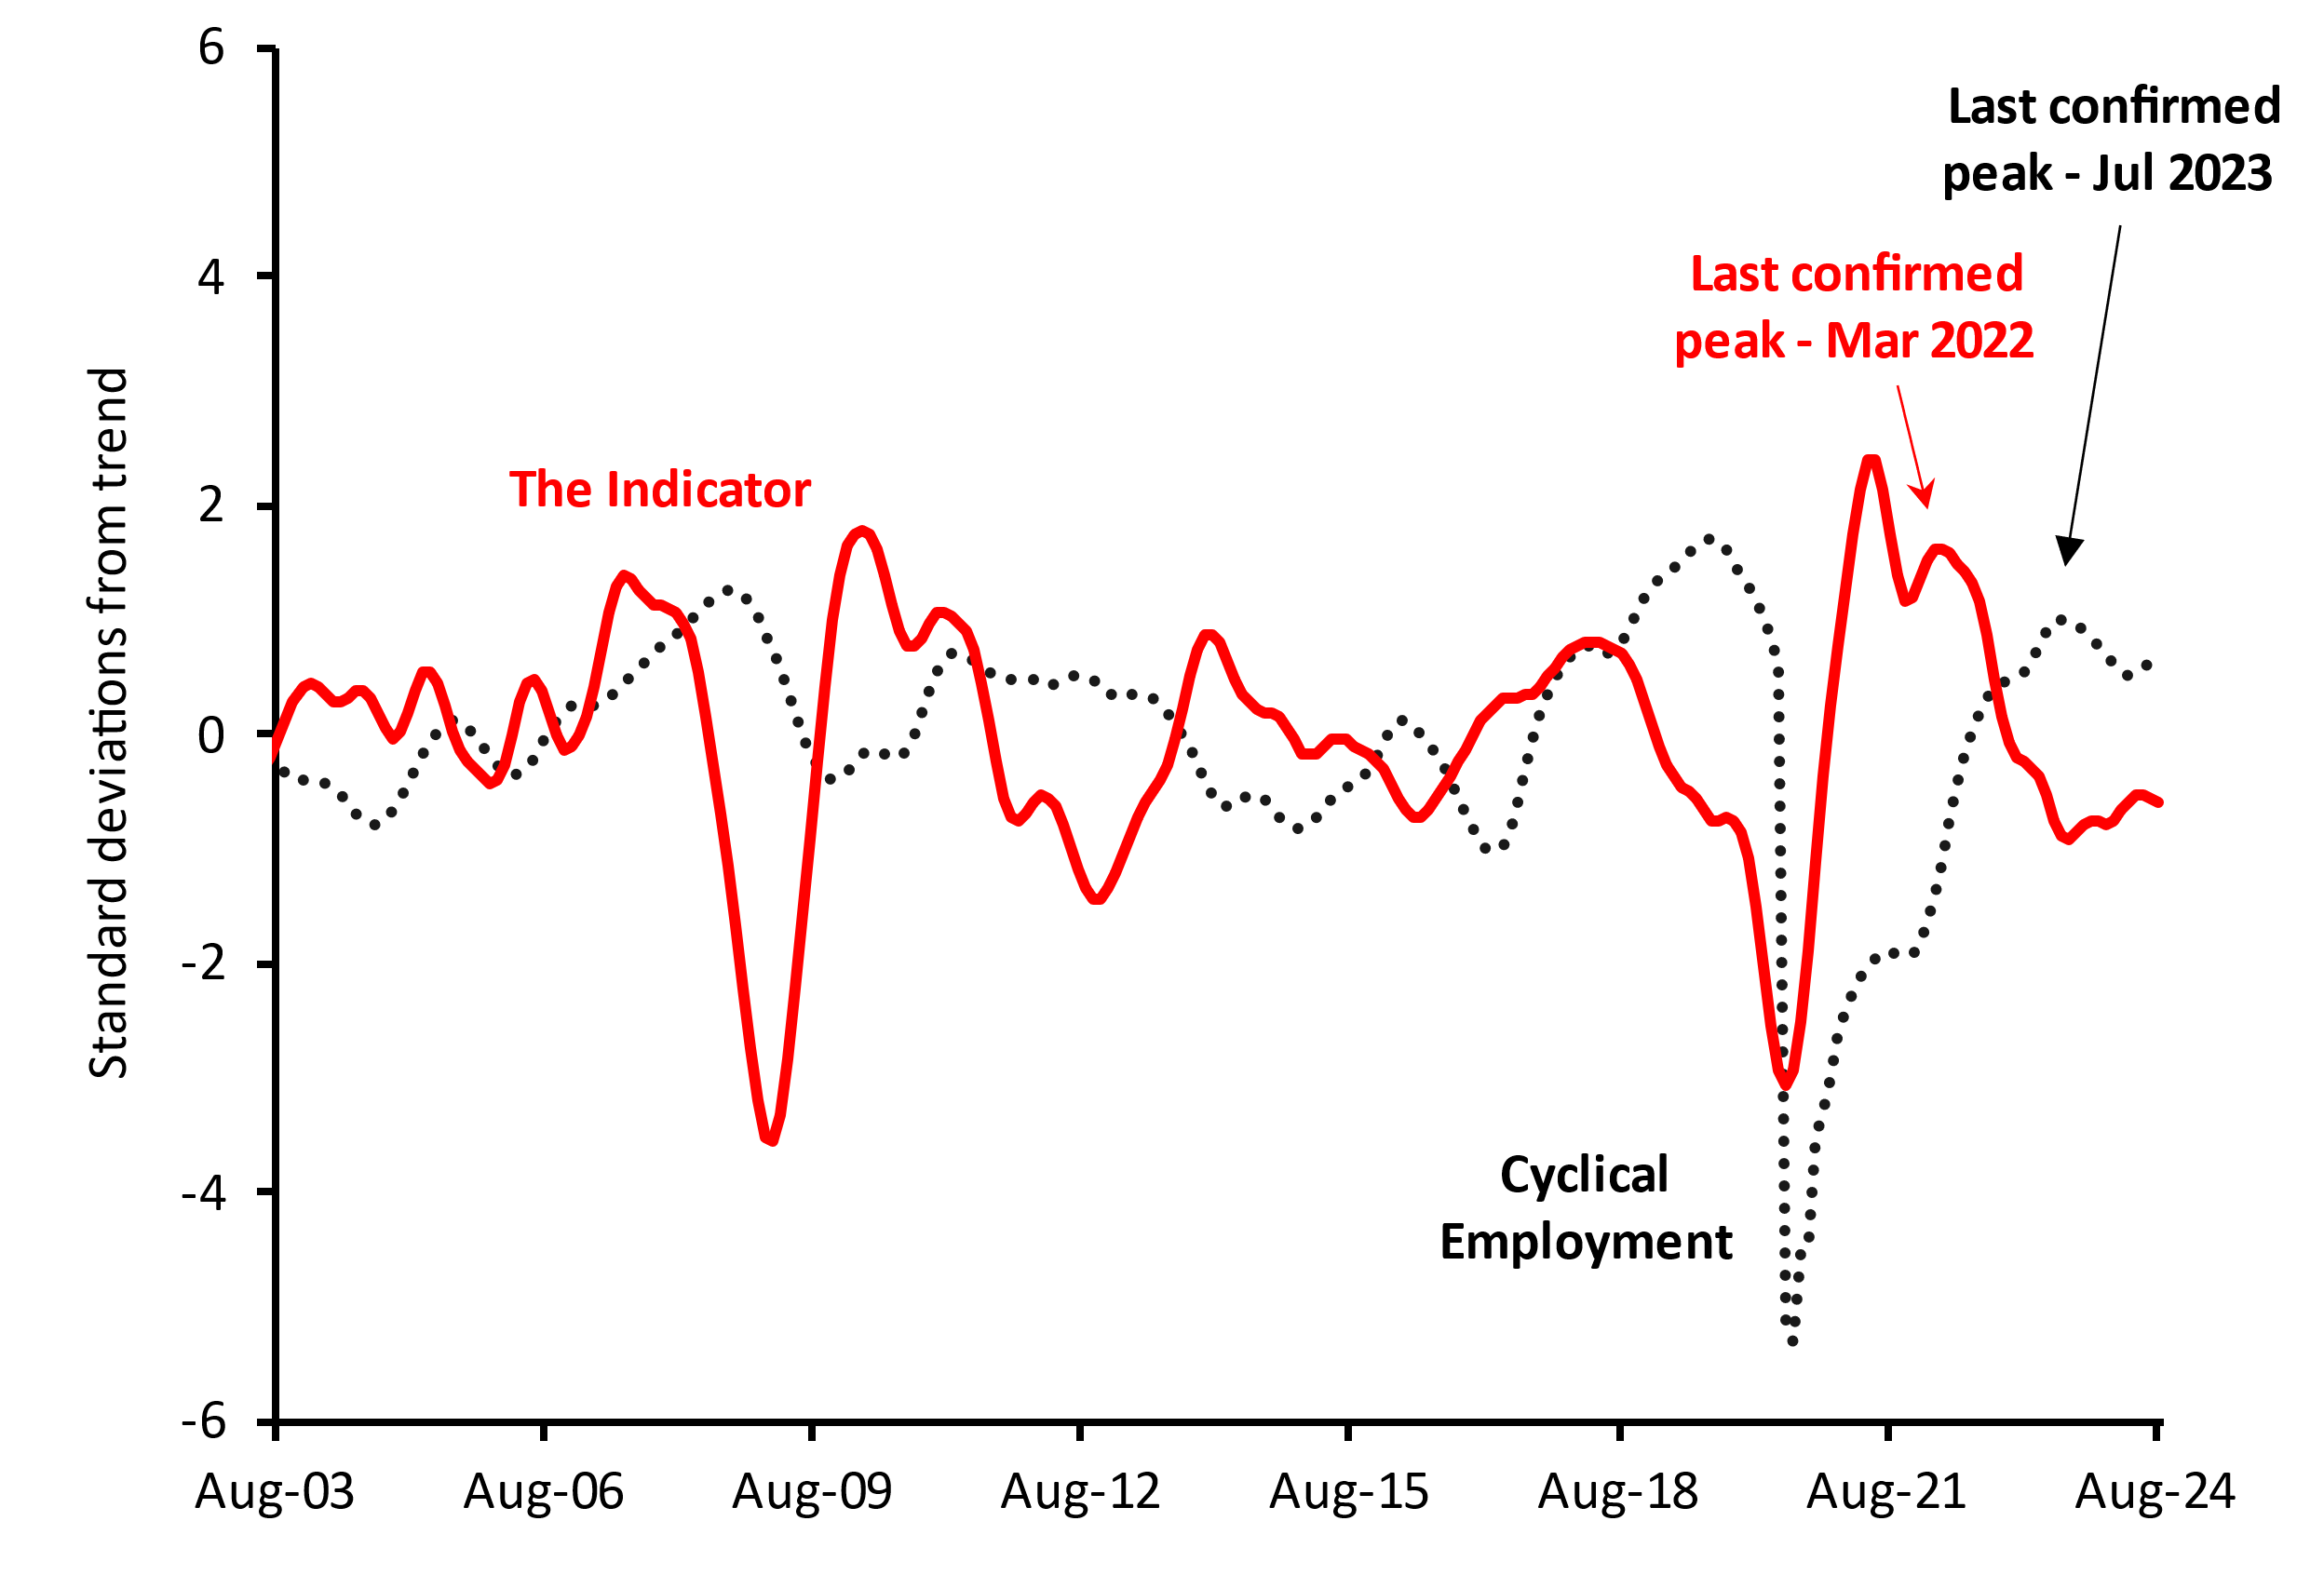

Note: Levels expressed as standard deviations from trend.

# Monthly CHANGES IN Value of Leading Indicator

|  |  |  |  |  |  |  |
| --- | --- | --- | --- | --- | --- | --- |
|  | **Mar-24** | **Apr-24** | **May-24** | **Jun-24** | **Jul-24** | **Aug-24** |
| **Change in Leading Indicator** | 0.074 | 0.087 | 0.055 | 0.006 | -0.022 | -0.045 |
| Note: Monthly changes in standard deviations from the cyclical trend. | | | | | | |

# Components of the Leading Indicator

|  |  |  |  |
| --- | --- | --- | --- |
| **Series** | **Contribution to change in Leading Indicator** | | |
| **Jun-24** | **Jul-24** | **Aug-24** |
| **China’s Purchasing Managers Index for Manufacturing Output** (July 2024 data) | -0.013 | -0.027 | -0.038 |
| **US Yield Difference (10-year vs. 3-month interest rates)** (July 2024 data) | 0.026 | 0.012 | 0.000 |
| **NAB Forward Orders Index** (June 2024 data) | -0.019 | -0.019 | -0.022 |
| **Westpac-Melbourne Institute Leading Index of Economic Activity** (June 2024 data) | -0.001 | 0.000 | 0.003 |
| **Westpac-Melbourne Institute Consumer Sentiment Index**  (July 2024 data) | 0.014 | 0.012 | 0.013 |
| ***Change in Leading Indicator:*** | ***0.006*** | ***-0.022*** | ***-0.045*** |

**Note:** The cyclical components of each series contribute to the monthly movements in the Indicator. Each series in the Indicator has the same weight of 20 per cent. The units of measurement for the contributions to change in the Indicator are monthly changes in the standard deviation from the long-term trend.

### Technical Notes

The Indicator is designed to provide advance warning of turning points in ‘cyclical employment’ (i.e. the deviation of the centred one-year trend in employment from the centred six-year trend). The average lead time of the Indicator over the series (i.e. the time between a peak or trough in the Indicator and the corresponding peak or trough in cyclical employment) is over a year.

A ‘turning point’ in the Indicator is confirmed when there are six consecutive monthly movements in the same direction after a turning point. A fall (or rise) in the Indicator does not necessarily mean that the level of employment will immediately fall (or rise). Rather, it implies that after a lag, the growth rate of employment may fall below (or rise above) its centred six-year trend rate.

The Indicator is the average of the normalised and standardised cyclical elements of the five series in the table above, which have been shown to lead cyclical employment consistently over a long period. The individual components and the composite Indicator for previous months are subject to revision when new monthly data become available.

#### RELEASE DETAILS

The Indicator is available on the Department of Employment and Workplace Relations website ([Monthly Leading Indicator of Employment Latest Release - Department of Employment and Workplace Relations, Australian Government (dewr.gov.au)](https://www.dewr.gov.au/employment-research/announcements/monthly-leading-indicator-employment-latest-release)). The September issue is scheduled for release on Wednesday 18 September 2024.

Contact OfficerS

Dr Thai Nguyen / Mr Lachlan Kerwood-McCall

Economic Analysis Section, Department of Employment and Workplace Relations

Email: [leading.indicator@dewr.gov.au](mailto:leading.indicator@dewr.gov.au)