Main idea:

The article is presenting the challenge to understand how a cell lineage is evolving due to genetic impact or disease influencing the changes on a human body cell.

Experimental methods such as following cell over time using imaging techniques can harm sampling, thus, only giving a snapshot of the cell in a specific time stamp.

The writers suggest a deep learning process to generate samples from a single cell imaging that will provide a series of time-based cell lineage imaging without the risk to disrupt samples.

Background:

There are large numbers of works that has been reconstructing cell lineage from a single cell image. The flaws of these methods are: they tend to make strong assumptions on the biological process and do not use the time point information in their process.

All of these methods use PCA, ICE, TSNE to reduce the sample dimensionality, then use the embeddings to measure similarity to another cell. The use of similarity is under the assumption that cells change keeps some linearity between them. As measures are in high dimensional space the previous assumption is unrealistic.

Method:

* Data: using two data sets of pairs of each cell in a different time point,
* Task: the task is to point whether a pair is coming from the same cell or not. This task is similar to a face verification task.
* Approach: constructing a pipeline to reconstruct cell lineage images by encoder-decoder architecture, applying loss function that measure the dist between images and adding a L regularization to improve the learning phase.

Results: this method improve the PCA method by more than 20%

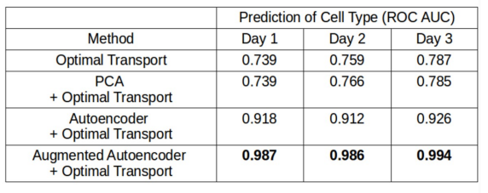

Conclusion:

The presented approach and method can greatly improve disease examination (cancer cells and other), alert on cell situation, help to decide on proper medical treatments.