High Flow

Richard Blackwell

## Headlines

| **Metric** | **Aug-24** | **Q1** | **Q2** | **Q3** | **Q4** | **YTD** |
| --- | --- | --- | --- | --- | --- | --- |
| New Clients Supported in Period | 0 | 0 | 1 | 1 |  | 2 |
| Clients Supported in Period | 1 | 0 | 1 | 2 |  | 2 |
| Previous 12 Month ED Attendances for Clients Supported in Period | 0 | 0 | 0 | 0 |  | 0 |
| Previous 12 Month Emergency Admissions for Clients Supported in Period | 0 | 0 | 0 | 0 |  | 0 |
| Previous 12 Month Ambulance Conveyances for Clients Supported in Period | 0 | 0 | 0 | 0 |  | 0 |
| Previous 3 Month ED Attendances for Clients Supported in Period | 0 | 0 | 0 | 0 |  | 0 |
| Previous 3 Month Emergency Admissions for Clients Supported in Period | 0 | 0 | 0 | 0 |  | 0 |
| Previous 3 Month Ambulance Conveyances for Clients Supported in Period | 0 | 0 | 0 | 0 |  | 0 |

## Changes in Activity

| **Metric** | **Aug-24** | **Q1** | **Q2** | **Q3** | **Q4** | **YTD** |
| --- | --- | --- | --- | --- | --- | --- |
| New Clients Supported in Period | 0 | 0 | 1 | 1 |  | 2 |
| Reduction in ED attendances starting 3 months from intervention beginning (NHSE Target 40%) |  |  |  |  |  |  |
| Reduction in non elective admissions 3 months from intervention beginning (NHSE Target 40%) |  |  |  |  |  |  |
| Reduction in ambulance conveyances 3 months from intervention beginning (No NHSE Target) |  |  |  |  |  |  |
| Reduction in ED attendances 12 month prior to 12 months post (OND Target 40%) |  |  |  |  |  |  |
| Reduction in Non elective admissions 12 months prior to 12 months post. (OND Target 40%) |  |  |  |  |  |  |
| Reduction in ambulance conveyances 12 months from intervention beginning (No NHSE Target) |  |  |  |  |  |  |
| Reduction in people experiencing loneliness at the end of support (NHSE Target 66%) |  |  |  |  |  |  |
| Clients Ending Support | 0 | 0 | 0 | 0 |  | 0 |
| Clients ending Support and Experiencing Improved Wellbeing | 0 | 0 | 0 | 0 |  | 0 |
| People report a positive experience from our support (NHSE Target 80%) |  |  |  |  |  |  |
| People progress at least one goal (OND Target 90%) | 0 | 0 | 0 | 0 |  | 0 |

## Process KPIs

| **Metric** | **Aug-24** | **Q1** | **Q2** | **Q3** | **Q4** | **YTD** |
| --- | --- | --- | --- | --- | --- | --- |
| 80% of new clients has a wemwebs baseline score | NaN% (0/0) | NaN% (0/0) | 0.0% (0/1) | 100.0% (1/1) | NaN% (0/0) | 50.0% (1/2) |
| 80% exited client has a wemwbs exit score | NaN% (0/0) | NaN% (0/0) | NaN% (0/0) | NaN% (0/0) | NaN% (0/0) | NaN% (0/0) |
| 80% of clients have a Y/N loneliness question | NaN% (0/0) | NaN% (0/0) | 0.0% (0/1) | 0.0% (0/1) | NaN% (0/0) | 0.0% (0/2) |
| 80% client has a loneliness exit score | NA% (NA/0) | NA% (NA/0) | NA% (NA/0) | NA% (NA/0) | NA% (NA/0) | NA% (NA/0) |

## Data Points

| **Metric** | **Aug-24** | **Q1** | **Q2** | **Q3** | **Q4** | **YTD** |
| --- | --- | --- | --- | --- | --- | --- |
| Number of wider beneficiaries | 0 | 0 | 0 | 0 | 0 | 0 |
| Clients who declined | 0 | 15 | 0 | 0 | 0 | 15 |
| Case concluded successfully | 0 | 2 | 0 | 0 | 0 | 2 |
| Closed cases due to disengagement | 0 | 0 | 1 | 0 | 0 | 1 |
| Closed cases due to death | 0 | 0 | 0 | 0 | 0 | 0 |
| Closed cases (other reasons, ie moving out of area) | 0 | 0 | 1 | 0 | 0 | 1 |
| Number of contacts/interventions with clients | 0 | 175 | 159 | 0 | 0 | 334 |
| Current caseload | 1 | 0 | 1 | 2 |  | 2 |

## Support Provided

| **Metric** | **Aug-24** | **Q1** | **Q2** | **Q3** | **Q4** | **YTD** |
| --- | --- | --- | --- | --- | --- | --- |
| Team Around the Person meeting conducted | 0 | 0 | 0 | 0 | 0 | 0 |
| Flow meeting with FC & Lead Professional | 0 | 0 | 0 | 0 | 0 | 0 |
| One-to-one work with clients (per client) number of individual one to one interactions with client | 0 | 48 | 103 | 0 | 0 | 151 |
| Continued ongoing contacts with professionals (total number of seperate contacts) | 0 | 5 | 10 | 0 | 0 | 15 |
| Caseworker research undertaken to find solutions for clients | 0 | 8 | 5 | 0 | 0 | 13 |
| Caseworker support to access Personal Health Budget | 0 | 0 | 0 | 0 | 0 | 0 |
| Caseworker support with Form filling | 0 | 3 | 1 | 0 | 0 | 4 |
| Caseworker support with IT incl. virtual meetings, emails etc | 0 | 0 | 0 | 0 | 0 | 0 |
| Caseworker support to meet aspirations | 0 | 1 | 2 | 0 | 0 | 3 |
| Client involved in coproduction work (total number of seperate contacts) | 0 | 0 | 0 | 0 | 0 | 0 |

## Outputs: Sections - Previous 3 months

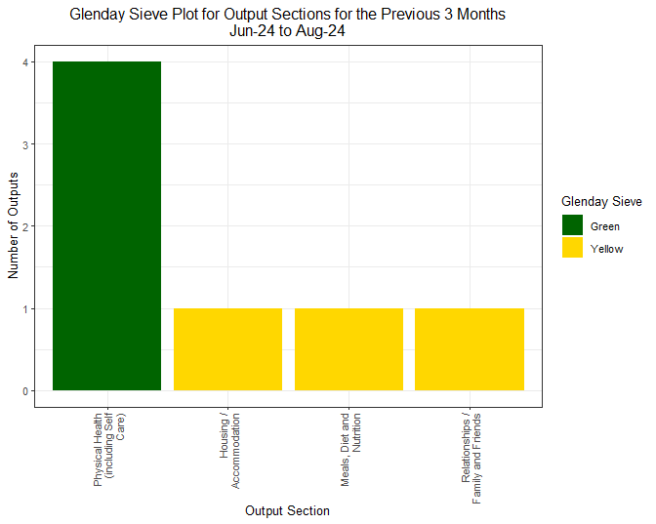

## Outputs: Sections - Year to Date

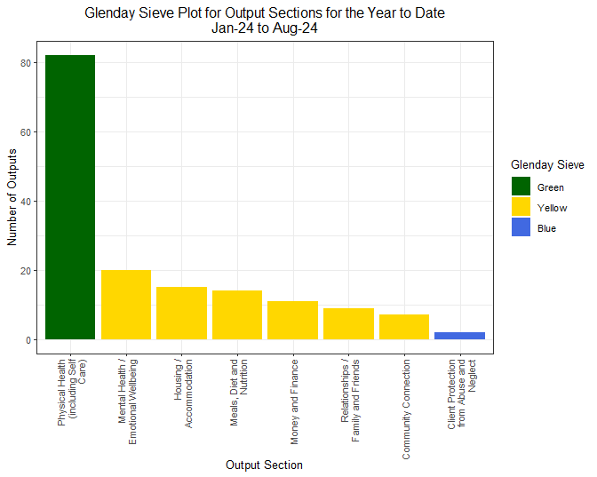

## Outputs: Sections and Outputs - Previous 3 months

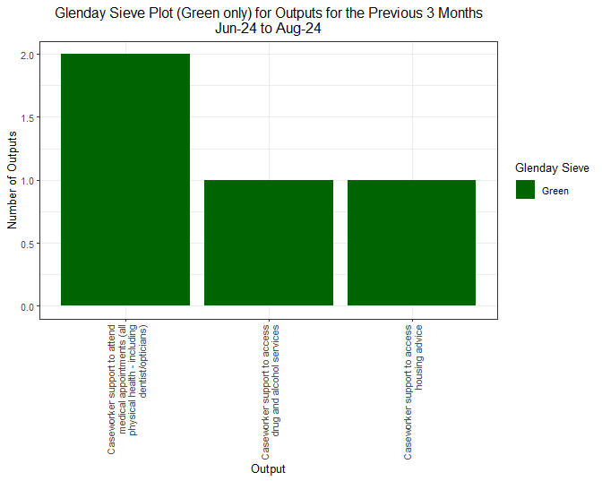

## Outputs: Sections and Outputs - Year to Date

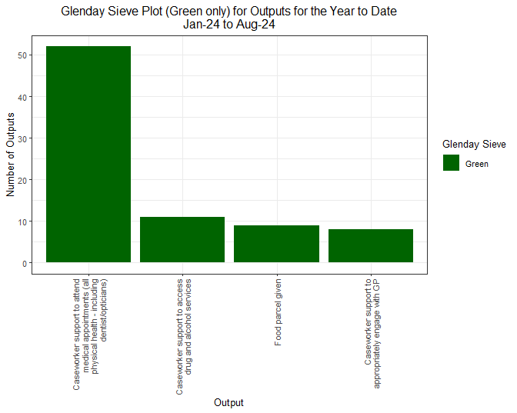

## Outcomes: Sections - Previous 3 months

## Warning: No shared levels found between `names(values)` of the manual scale and the  
## data's fill values.

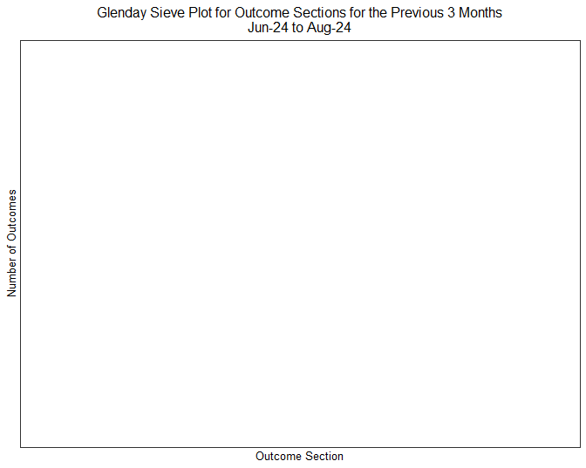

## Outcomes: Sections - Year to Date

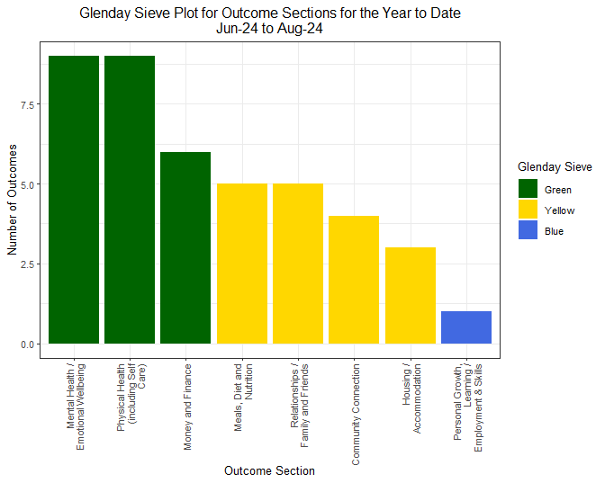

## Outcomes: Sections and Outcomes - Previous 3 months

## Warning: No shared levels found between `names(values)` of the manual scale and the  
## data's fill values.

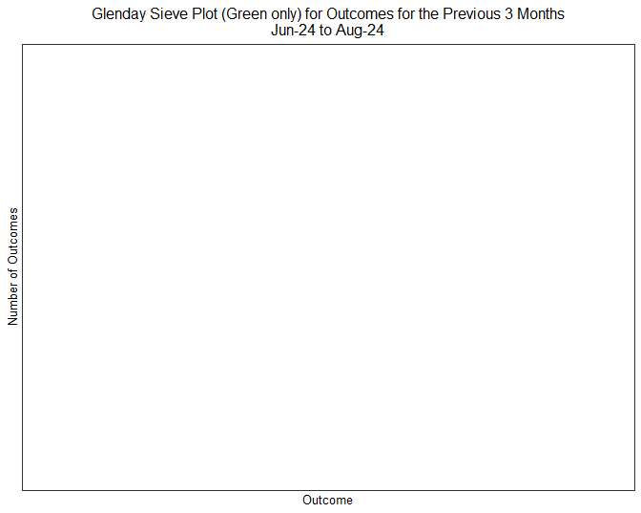

## Outcomes: Sections and Outcomes - Year to Date

