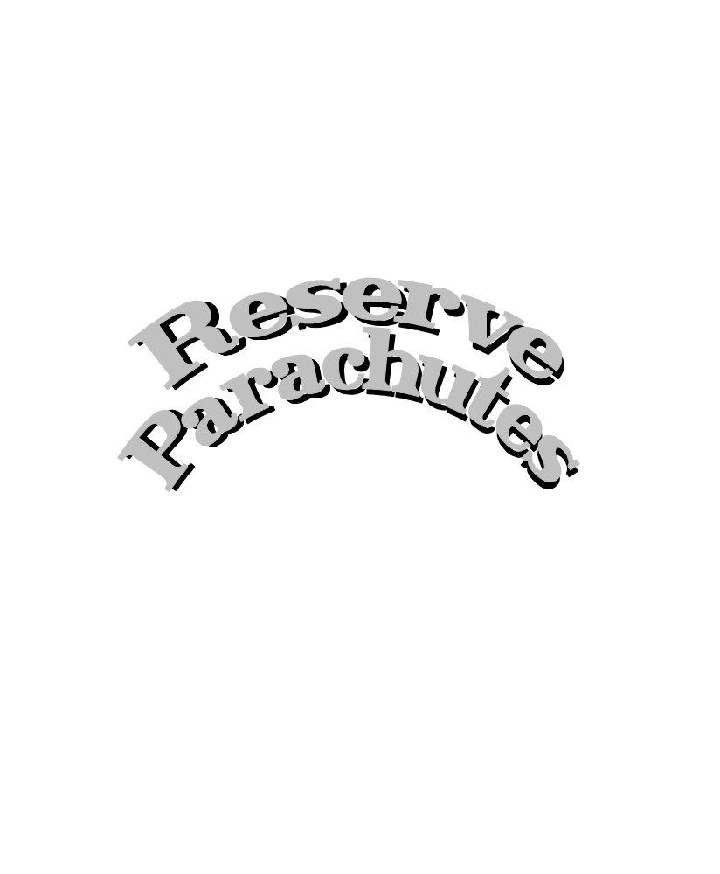

BASIC PARACHUTE USE....A PRACTICAL PERSPECTIVE FOR PARAGLIDER PILOTS

The sport of paragliding enjoys the unique opportunity to draw from both hang gliding and skydiving perspectives and thus avoid many of the fatal mistakes made in the evolution of both sports. Putting politics and ego's aside, this article is an attempt to couple that knowledge with the current paragliding experience in the area of emergency reserve parachute use in order to offer paraglider pilots important reserve information.

PARAGLIDER RESERVE PARACHUTE NEEDS COMPARED TO HANG GLIDING AND SKYDIVING
Although paraglider pilots can learn much from hang gliding and skydiving there are some important differences in the reserve parachute needs of paraglider pilots.

The most notable difference between a paraglider and a hang glider is the obvious lack of ridged structure. In an emergency deployment situation the paraglider pilot does not have the air frame to help absorb some of the landing impact or add extra drag to slow the rate of descent. In addition most hang gliding harnesses keep the pilot prone while paragliding harnesses force the pilot into a seated position. Hang glider pilots do not have the masses of lines threatening entanglement nor the opportunity for reinflation if the hang glider is broken.

Differences between a paraglider and a traditional ram-air parachute are a bit more subtle for the untrained eye. For our purposes it will suffice to say that the main function of a ram-air parachute is to bring the sky diver to the ground as safely as possible. The paraglider is designed to keep the pilot in the air. In an emergency situation the skydiving harness will force the jumper into an upright position. Unlike paragliding, often malfunctions occur at a high rate of speed with plenty of altitude and a landing field within easy reach. Skydiving main parachutes are cut-a-way prior to reserve deployment. This gives the skydiver clean air above them without risk of entanglement.

Reserve parachute considerations unique to paragliding

Because paragliders are often flown relatively close to the ground, paraglider pilots need a reserve parachute that can open within a very short distance, and bring the pilot down softly as possible. Since turbulence is a primary contributor to malfunctions, the reserve parachute should be extremely stable and reliable even in adverse conditions. Paraglider harnesses must allow the pilot to descend under reserve parachute in a head up foot down position. A pilot impacting seated requires a rate of descent of no more than 14 feet per second to avoid serious spinal cord injuries.

The paraglider pilot should be intimately familiar with controlling their paraglider in less than optimum conditions. Since emergency situations can quickly change control inputs correcting one situation can aggravate other situations. Paraglider pilots using a reserve parachute are put in the unique position of having to deal with two decellerators, (“parachutes”) one “ram-air” the other “round”, at the same time. This requires the pilot to make decisions throughout the whole emergency. Once the reserve parachute is inflated it does not mean the pilot is out of danger.

HOW TO AVOID PROBLEMS BEFORE THEY BEGIN
Often problems can be avoided by taking a little extra care while inspecting your equipment. If something looks strange to you, don’t be afraid to speak up. It could save your life.
Although accidental deployments are not as common as they once were it remains the pilots responsibility to check their equipment before every flight. Most accidental deployments could have been prevented if the pilot had performed a thorough preflight and maintained awareness of their parachute system. Checking the safety pin prior to launch, taking care not to snag the handle while launching or grab the wrong strap when trying to adjust the harness helps prevent accidental deployments.
Be aware that some emergency parachute systems require very little input to deploy. This is especially true of a freshly packed parachute that has not yet conformed to your body/harness shape.

Check your harness/parachute rigging
Be sure your reserve parachute is mounted securely to your harness in such a way that it will not interfere with any control movements including your speed bar.

Make sure your parachute riser is attached to your harness.

Make sure your hook knife is easy to see and reach.

Inspect riser
Double check the routing of your riser to insure no twists will occur with your paraglider risers as your reserve parachute deploys. Some pilots have been known to attach their reserve to one or both of the carabiners used to connect the paraglider to the harness. This attachment point is not considered an adequate location due to the problems you may encounter with entanglement or the ability to prepare yourself for a parachute landing fall (PLF).

Make sure your riser is routed in such a way as not to want to wrap around your neck or body during an uneventful deployment.

Check the riser for signs of damage that may have been caused by dirt, abrasion, or friction. Pay special attention to the harness connection loop and the point of riser entry into the parachute container.

If you notice extra slack caused by the riser slipping out of the parachute container, be sure to tuck it all the way back into the container.

Repack often.
Repack according to manufacturers instructions and every time your parachute has been exposed to excessive moisture or heat. Remember a wet parachute is prone to sticking together and deploying slowly. Opening forces are higher due to the decreased fabric permeability due to water content. After each repack your parachute will seem larger. Be sure to squeeze excessive air out of the parachute before you fly.

If there is any question about whether your parachute is properly packed in the deployment bag, hook the handle on a solid object and pull on the riser. Continue to pull until the entire system is streched out and free from the deployment bag. The riser, lines then canopy should snake out of the deployment bag in a smooth orderly sequence.

DO NOT ATTEMPT TO REPACK YOUR OWN PARACHUTE WITHOUT APPROPRIATE GUIDANCE OR TRAINING.

Note: When you have your ballistically deployed parachute repacked ask the packer to disconnect the rocket and pull the lanyard to simulate the rocket pulling the parachute out of the container. It should pull out smoothly.

Inspect your deployment bag/diaper
Inspect rubber bands
If your deployment bag uses rubber bands, replace them every repack or more often if needed. If your parachute has been left out in the sun, the gromets can heat up and melt the rubberbands. Do not double stow (wrap them around the lines more than once). Use only the appropriate size rubber bands as recommended by the manufacturer.

Check grommets
Brass grommets have a chemical reaction with rubber bands that quickly deteriorates the rubber. If your deployment bag has brass grommets, consider updating your deployment bag or at the very least changing to nickel plated grommets.

Inspect deployment bag handle
Be sure it is securely mounted to the deployment bag, has reinforcement at the attachment points, and has a curved pin(s) properly attached to the handle.

Inspect safety pins
They should be curved and smooth with the end rounded. They may be made from solid wire or die cut. If they have any burrs file them smooth and lubricate. If they are made from clevis pins or cable, replace with proper curved pins. If they are rusty, clean and lubricate them or replace.

Inspect safety pin holders
Be sure the safety pin holder (usually a cord, rubber fitting or bungee) is tight enough to hold the safety pin without slipping. The safety pin holder should be secured around the safety pin shaft only. If the holder slips above the shaft to the safety pin attachment on the handle, it will not deploy. If your safety pin holder is not holding the pin securely tighten it up.

Triple check your harness handle/safety pin release system***
Be sure the safety pin releases before tension is placed on the deployment bag. If the parachute handle pulls on the parachute before the safety pin is released your parachute will not deploy. Each time you replace your parachute in your harness sit in a simulator and practice pulling the handle to make sure your safety pin is releasing properly. This cannot be over emphasized!

RESERVE PARACHUTES DO NOT ALWAYS WORK*** ...protect yourself by flying within your experience level and the parameters of your paraglider.
Some pilots think they can do anything because the reserve parachute will save them if they get in trouble. This is not true. Sometimes, even if parachutes are properly designed, packed, rigged and maintained, they just do not work.
Before Every Flight
Preflight your parachute:
- Check your safety pins
- Be sure your handle loop is accessible.
- Look at your riser routing making sure “extra riser” has not slipped out of your parachute container.
- Double check your parachute container. Be sure it is properly closed.
- Be sure you have easy access to your hook knife.

If you have a ballistically deployed system:
- Check to make sure your safety is off and your handle is available
- On landing do not forget to secure your safety.

DECIDING WHEN TO DEPLOY
One of the most difficult decisions is determining when it is time to deploy your reserve parachute. Obviously the closer you are to the ground the less time you have to make that decision. Given enough altitude some situations will correct themselves while others can quickly worsen.

Situations in which you may want to consider deploying your parachute include mid air collisions, major line entanglement, structural failures, increasingly violent surges, unrecoverable major canopy collapses, and any time you have lost control of the paraglider close to the ground. Much of the decision whether or not to deploy will depend on your familiarity with your paraglider’s specific flight/recovery characteristics, the weather conditions, the terrain in which you are flying and most importantly, your proximity to the ground.

Many paraglider pilots use a critical altitude below which they will no longer attempt to correct the situation and automatically go for their reserve parachute. A critical altitude of 500’ seems to be common especially for newer pilots. When determining your critical altitude it is important to note how much altitude you can expect to lose before your particular reserve parachute will be fully inflated. Since opening distance is a function of fill volume, the larger your parachute the more air is required to fill up the canopy for full inflation. Likewise the longer your parachute riser and lines, the more altitude it will take to reach full riser-line-canopy extension and the higher your critical altitude becomes.

The most important factor in determining how much altitude you can lose during a deployment has to do with how and where you throw your reserve. Obviously the worse possible case is dropping your parachute directly below you. In that situation your weight has to race below the falling parachute and wait for full riser-line-canopy extension before you have a chance of coming down under an open parachute.

DEPLOYING YOUR PARACHUTE
No matter what...memorize these steps:
1. Look for the deployment bag handle. Paraglider harnesses have a number of adjustment straps that can easily be confused with the parachute deployment handle in an emergency situation. Be sure to look for the correct handle so you do not waste precious time tugging on the wrong strap.
2. Reach and grab the handle securely.
3. Pull the handle down and away from you. Your deployment system may require a downward yank or, if it is a Velcro closure, a peeling action, to dislodge the curved pin(s) and Velcro. Be sure to practice this step in a simulator each time you repack, switch harnesses or change parachute containers. Be familiar with your equipment.
4. Look for clear air. Avoid any lines or paraglider sail that might tangle with your reserve parachute.
5. Throw the deployment bag towards the clear air. Throw the bag hard, as if your life depended on it, because it very well could. Your riser should come to full extension followed by your lines and canopy. If you get a good throw away from you your system will take less time and altitude to open. If you drop your reserve parachute below you, you risk entanglement. You also will require to fall a greater distance before your body weight will load your parachute so it can open.
6. Yank vigorously on the riser. This will help to spread the suspension lines and open the air channel if your canopy has not yet inflated.
7. If necessary pull your parachute back in with yanking movements and repeat steps #5 & #6.
8. If at low altitude, immediately prepare for impact.
If you have time evaluate your situation and decide the safest course of action before impact.

WHAT TO DO AFTER YOUR RESERVE PARACHUTE OPENS
If you are close to the ground immediately prepare for impact. The most common impact approach is to do a PLF . To do a PLF it takes proper training and practice. The military spends about 2 weeks teaching the PLF techneque.

PLF
To do a PLF position your body feet down, legs together and knees slightly bent, toes slightly pointed, arms in, elbows in and eyes on the horizon.. Allow your muscles enough tension to protect your bones on impact. Basically you are preparing to use your legs and body as shock absorbers on impact. As you reach the ground try to hit in a rolling motion with your feet-calf-thigh-butt-side of torso-shoulder impacting in the direction you are drifting. Your arms and elbows should be tucked in as not to impact the ground. Be careful to keep your head tucked in order to avoid snapping your neck.

PLF Altenative
An easier method for impacting requires that you keep your knees together and slightly bent with your arms tucked into your body. Try to stand on impact. If you have any vertical speed you will probably end up impacting in a rolling motion regardless A PLF is not appropriate for certain landing areas. If it looks like you are going to impact on a steep slope, among boulders or other obstacles consider this alternative approach.
Pros: Alternative approach is easier to pull off than an proper PLF. It requires little practice. It is safer than some improper PLF’s.
Cons: A proper PLF is usually the best option. You can break your legs trying to stand up.

Key Concepts
There are several schools of thought as to the proper procedure to use after your reserve parachute has opened and you still have altitude. We will attempt to discuss the pro’s and con’s of each approach. Before we start it is important that you understand some key concepts
.
1. The slower your rate of descent under parachute, the less likely your paraglider will want to continue “flying”.
2. Smaller reserve parachutes will generally bring you down faster than the larger size of the same model.
3. Some reserve paragliding parachutes and harnesses are not constructed to withstand freefall deployments.
4. Your reserve parachute (assuming it is round) will always be down wind of the suspended weight. If the pilot represents the suspended weight and is falling straight down towards the ground the parachute will be straight overhead. If the pilot is drifting downwind the parachute will always be downwind of the pilot
5. Both the paraglider and the parachute need to have a suspended weight loading the canopy to operate properly.
6. If your parachute is descending fast your paraglider may want to fly in front and below you (down plane).
7. A round parachute will always follow the suspended weight while a paraglider will always want to fly the suspended weight. They each struggle to be the dominate canopy.
8. Paragliders are very sensitive to symmetry. If one side of the paraglider is inflated or controlled differently than the other side you will probably experience a turn or spin.
9. Emergency situations are often extremely violent.
10. Indecision can be dangerous. Be decisive in your plan and commit yourself to it.
11. Be prepared to panic.

Keep in mind that much of your ability to react to the situation will depend on your experience and knowing the capabilities and limitations of your equipment. Your options might be severely limited by the size and performance of your parachute, your mode of failure and flight characteristics of your paraglider. Always have a clear strategy with a back-up plan in mind.

THINGS YOU CAN DO IF YOU ARE COMING DOWN UNDER PARACHUTE WITH TIME TO SPARE

If your paraglider and parachute are in a state of equilibrium...do nothing. If it ain’t broke don’t fix it
If you find yourself coming down at an acceptable rate of descent under both your paraglider and your reserve parachute don’t do anything. Your paraglider and parachute are in a state of equilibrium. Ride it down with the understanding that conditions can change at any moment. Even slight pilot control movements, body movements or turbulence can disrupt that equilibrium. Watch the action of your paraglider and parachute. Look at your probable impact area and be prepared to deal with those elements.
Pros: Easy to remember and reasonable approach
Cons: The equilibrium can be easily disrupted and the situation can deteriorate rapidly.

If your paraglider is totally or partially functional, come down under both your paraglider and your parachute
If you are able to guide your paraglider above your head but away from your parachute as you descend, do so. Be careful not to fly your paraglider too close to your parachute and cause entanglement.
Pros: You have a known rate of descent in preparation for impact and you may have some directional control. Since the parachute is carrying much of the load, you may have less pressure in the paraglider and thus experience less control pressure.
Cons: If the pilot has their attention directed upward he may easily lose sight of how close the ground is.

Disable your paraglider no matter what so your reserve alone can bring you down
The idea of disabling the paraglider has been promoted in an attempt to address problems that can be encountered by having two “parachutes” fighting over control of the suspended load. For a parachute to behave properly it has to have a weight loading the canopy. A paraglider needs weight loading as well. Without that weight the canopy will behave erratically at best. If both the paraglider and the parachute are fighting for the suspended weight the situation can easily worsen.
Pros: Disabling the paraglider allows the reserve parachute to function properly.
Cons: The process of disabling the paraglider can cause multiple problems such as total loss of control, entanglement of the parachute with the paraglider, lines of the reserve parachute being cut by the paraglider lines, reinflation of part or all of the paraglider, uncontrollable spinning, lines or sail wrapping around the pilot and tightening its grip as it twists. Changing problems can set up a chain of events where by the pilot is required to quickly correct one situation while causing a host of other problems.

WORD OF CAUTION:...When ever you pull in the paraglider be careful not to wrap lines around your hand or fingers. If the paraglider reinflates while you are bringing it in it can tie you up. Just because you think your paraglider is disabled doesn’t mean it will stay disabled.

The following approaches have been suggested to disable your paraglider:

Perform a B-line stall and maintain the stall
Pros: Properly performed a B-line stall will disrupt the flight characteristics and allow the paraglider to act like a giant air brake.
Cons: Since a paraglider is very sensitive to symmetry, if a B-line stall is not executed perfectly you risk yawing pitch oscillations which may bump the paraglider into the parachute or lines (depending on where your paraglider is relative to your parachute). This maneuver requires the pilots total attention to keep from tangling.

Pull in the paraglider from one brake line and pull in one end only of the paraglider.
Pro: If the uncontrollable spinning wraps up the paraglider without causing damage to the pilot or parachute, it could disable the paraglider fast.
Con: It could aggravate the situation and cause the paraglider to spin violently while wrapping up. After several twists the pilot can lose all control or even become tied up in the paraglider lines or sail. As the pilot had no input the paraglider can start to unwrap itself. It could fly erratically around the parachute or pilot and cause severe damage.

Pull in the paraglider by pulling in one rear riser until fabric is in hand and continue pulling in the entire paraglider.
Pros: This could work in a down plane situation.
Cons: Any action taken asymmetrically may cause the paraglider to behave erratically. You need lots time and altitude to pull in the entire paraglider. You need the strength to pull in the entire paraglider and maintain it. It is easy to lose ground awareness.

Pull in both rear risers to pull the whole trailing edge down and tuck it in-between your legs
Pros: You will be disabling your paraglider in a symmetrical manner which allows you more control.
Cons: It may take a massive amount of strength to accomplish this task.
Once the paraglider is pulled in, tuck it between your legs
Pros: By tucking the paraglider between your legs you are in a PLF position automatically. It could give you a nice amount of padding for impact
Cons: Accomplishing this task in a reasonable amount of time will be difficult at best. The chance of re-inflation can cause even more serious problems if it impairs the pilots vision or gets loose and flies into the reserve parachute.

If your paraglider reinflates try to fly it with the reserve parachute in tow.
Pros: You may have regained directional control. The more drag you have over your head the slower you will come down.
Cons: If you fly your paraglider into your parachute you can wrap them up and end up descending with no effective parachute or paraglider.

Cut-a-way your paraglider.
If you are under canopy and your paraglider is behaving in a violent uncontrollable manner you may consider cutting one riser or disabling the paraglider by cutting lines. Before you attempt to cut away your paraglider try to determine the probability of entanglement worsening your situation..
Pros: It is a quick way to disable your paraglider.
Cons: Chances of the paraglider entangling with the reserve are likely. In trying to avoid a “hard landing” you could be putting yourself in a possible life threatening situation.

A COMMON SENSE APPROACH ONCE YOU HAVE THROWN YOUR PARACHUTE AT ALTITUDE
Once you have thrown your parachute the real issue becomes that of control. The following approach should be used as guidelines in establishing your own standad operating proceedures (SOP’s).

- Assess the failure
- Note your proximity to the ground
- Control the failure
- Prepare for impact

- As the reserve is inflating try to grasp the paraglider control lines.
- Gingerly determine how much control you have.
- If there is some control try to maintain the paraglider so as not to interfere with reserve.
- If it is uncontrollable, disable the paraglider in a symmetrical manner.
- If possible get a hold of the center of the trailing edge of the paraglider and hold it for the ride down. This is the one place you do not risk re-inflation.
- Disable paraglider anyway you can being careful not to tangle your body in the wreckage.
- Never lose sight of where the ground is!

A WORD ABOUT STEERABLE RESERVES
As in any parachute design the steerable reserve parachute concept has tradeoffs.
To steer a round parachute, vents are built into the canopy. By closing a particular vent the parachute will turn. The vents cause the parachute to have forward speed. The pilot can control the direction the parachute is pointed by turning into the desired direction.
Some of the advantages of having a steerable reserve include increased stability in the parachute design, the ability to land into the wind and to steer yourself away from danger. The disadvantages are:
You can achieve steerability only after your paraglider is disabled and the process of disabling the paraglider and maintaining a disabled paraglider while you reach for the parachute steering lines can be difficult at best.
Steerable parachutes have a forward glide. If you have no control over which direction the reserve parachute will open you risk the chance of having your reserve glide into your wreckage upon opening.
If you misread the direction the wind is blowing upon landing, or you are unable to steer the parachute because you are busy trying to deal with the paraglider, you increase your chance of a down wind hard landing.
You must remember not to flare at landing. Pulling the steering lines down on a steerable round canopy will cause a harder impact since it accelerates your rate of descent.
If you have a steerable reserve parachute with a single riser you can face a multitude of problems.

A WORD ABOUT PARASWIVELS
If you have a single riser you may want to consider installing a paraswivel in your parachute system. A paraswivel can be valuable if your parachute is descending straight while you are spinning or if you are coming down straight while your parachute is spinning. It could possibly help your situation. The only draw back would be if the paraswivel somehow got tangled in the paraglider lines.

WHAT DO YOU DO IF YOU ARE DRIFTING TOWARDS POWER LINES, WATER OR OTHER DANGEROUS SITUATIONS?
Obviously you must try everything in your power to steer clear of danger. If your reserve parachute has a double riser configuration at the shoulders of your harness that goes directly to the reserve parachute, you may be able to pull down on one riser and redirect your parachute that direction. This may require strength comparable to doing a continuous chin up to maintain that input. If you have a single suspension point, you are at the mercy of the wind.
Power Lines: If it looks like you will be descending through rows of power lines, position your body with your chin tucked on your chest, your arms wrapped straight over your head. Try to position your body as narrow as possible in an attempt to clear or bounce off the power lines. If you are stuck hanging from electrical lines do not touch the ground or allow anyone to touch you. Kevlar, spectra and nylon are all conductors. Wait for someone to turn off the electricity before you attempt rescue. If you fly into lower voltage power lines it is possible that you will short them out but don’t count on it. Some people who have gotten caught in power lines hanging above the ground have actually gotten out of their harnesses and jumped safely to the ground. Before you attempt such a feat be sure your body movements will not dislodge the parachute or paraglider and put you in a worse situation.
Water Landings: If you think you are going to descend into water disconnect your leg and chest straps in preparation for jumping free just before you impact the water. Always have your hook knife ready in your hand. Depth perception can be very deceitful over water so look for concrete clues to determine your altitude over water. Many skydivers have gotten seriously hurt or killed jumping into the water when they were too high.
If you find yourself under water with your canopy overhead try not to make any thrashing movements. Stay under water and swim away from your impact area. The lines and parachute can easily tie you up under water. Remain calm.

WHAT DO YOU DO AFTER YOU LAND?
After you land be sure to disconnect your paraglider and reserve parachute. Get out of your harness immediately. Have your hook knife ready just in case you get dragged. If you see another pilot being dragged deflate the parachute by grabbing one side of the parachute and pulling it down to the ground.

PRACTICE MAKES PERFECT
The best preparation for an emergency situation requiring the use of your parachute is practice.

In a Simulator
The best way to practice is in a simulator hanging from the ceiling. If possible have your dealer or a friend swing and twist you around violently while you try to deploy. Practice with each hand. If you wear gloves, practice with gloves. (Note how easy it could be for lines to get wrapped around your neck.)

In the Air
At least once every flight practice looking and reaching for your handle. Imagine yourself reaching for the handle with your right hand and with your left hand.

At Home and any time
Visualize yourself in your mind’s eye performing a successful emergency parachute deployment. Choose various scenario’s depicting yourself in a full frontal collapse, a violent spin, a partial collapse close to the ground, a mid air and any other emergency situations you can imagine. In each case consider your options, choose a plan of action, and take yourself step by step through the deployment process. Imagine problems with your first plan and implement plan “B”. Be sure to continue guiding yourself through your decision making processes until you are safely on the ground unhooked from your paraglider and reserve. Practicing a successful deployment in your mind’s eye increases your chances of responding precisely and accurately to any emergency situation.

CONCLUSION
The suggestions posed in this article are far from absolute. Each situation demands the pilot to make a judgment call. The better prepared you are with a mental check list of procedures the greater chance you have for an uneventful deployment. As in all growing sports we believe it is important to learn from each other’s experience. When you hear about an accident or deployment instead of chalking it up to “pilot error” imagine yourself in the same situation and figure out what steps you would take to get out of the situation safely.

Know your equipment. Know your limits. Have your SOP’s ready for any emergency situation. Do not assume that just because you have a parachute it will work. Above all else Fly Safely!

