**Adaptation of Walbro Diaphragm Carburetors for Slow and Smooth Idle and Progressive Midrange RPM**

Edited and adapted by Gerry Farell

Additional notes in red by Had Robinson

From: <http://webspace.webring.com/people/bf/flphg/idle_adaptation.html>

For the most part, a carburetor that comes out of the box, unless it was designed and built for a one-of-a-kind engine, will need some changes made to fit the needs of the engine. These changes are also needed due to the type of fuel & oil that will be used.

From there it goes on up the ladder in stages to fit various needs and levels of performance. These changes for high performance are called *Blueprinting*.

Although *stock* WG8 carbs are being used on powered paraglider and hang glider harnesses, they were not specifically designed and fabricated for the Radne Raket 120 (or many other engines, for that matter. The fact is that the balance of air to fuel ratio is not proportionate under certain circumstances, so it has to be *made* proportionate depending on the engine it is mounted on. Don't think of this so much a 'modification' or full 'blueprinting' but just an adaptation of the Walbro carb to your particular engine needs.

A lot of pilots don't really understand carburetors, but the Walbro is a very simple carb, and to get it to perform properly, it's just getting a balance and combination of needle jets, metering lever height, re-seat pressure and for full diagnostic purposes, pop-off pressure.

**In order to follow these instructions (for cleaning & tune up) it is essential to first learn the names of the carburetor's parts and if possible, their function.** I first recommend that a pilot understand the general principles on how the Walbro metering system works:

**Walbro Service Manual** (PDF 5.8MB)  
  [http://www.southwestairsports.com/PPGTechInfo/MiniPlane/HRServiceNotes/WalbroWG8/WalbroSM.pdf](%20http://www.southwestairsports.com/PPGTechInfo/MiniPlane/HRServiceNotes/WalbroWG8/WalbroSM.pdf%20)

This article is divided on two basic sections: The first is Cleaning & Tuning and the second is the Modification for Smooth and Slow Idle. Since you have to take the WG8 carb off your engine, let's start with a cleaning and calibration.

There are two different Walbro repair kits available: The **K12-WG** has almost all the parts, including needle, fuel strainer screens, etc. Note that it does not contain a Metering Spring, it is sold separately as Walbro part # 98-320-7 (OEM # 503 28 12-18). The **D12-WG** kit contains only the gaskets and diaphragms.   
Place the carb on a clean surface and remove both end caps. With the metering diaphragm removed, you can push on the lever in the center of the carburetor body to see how things work. The lever is connected to a main needle valve, and this is what meters the desired fuel pressure to the high- and low-speed jets. The rivet in the center of the diaphragm pushes down on the lever, and this, in turn, lifts the main needle valve out of its seat. Fuel fills the cavity, and the venturi effect in the carb's throat pulls fuel into the airstream.

Note where the parts go and ensure it is s squeaky clean inside. Dirt is the most common cause of carburetor problems! Using a carburetor cleaning solution, be sure to clean the Inlet Needle's (a.k.a: main needle valve, needle, metering valve, metering needle, etc.) rubber tip & seat as well as the internal wire mesh fuel filter. Compressed air is the best method to clean all orifices without leaving fibers from commonly used items such as a cotton swabs.

**Pop-Off Pressure and Inlet Valve Reseat Pressure**

The Metering System is very simple: It consists of a pivoting lever working like a seesaw with a spring on one side and an Inlet Needle (with a red rubber tip valve) on the other.

If you don't have the pressure-testing tool, don't worry, just make sure you clean the carb, blow it dry and use new diaphragms & gaskets and set the Metering Lever height; The resulting pop-off and reseat pressure will be functional as long as you don't damage or modify the Metering Spring:

1) Don't deform or cut the small Metering Spring. If in doubt, replace it with Walbro part Walbro part # 98-320-7 (OEM # 503 28 12-18; WG8 carburetor).

2) Set the Metering Lever at the correct height as explained below.

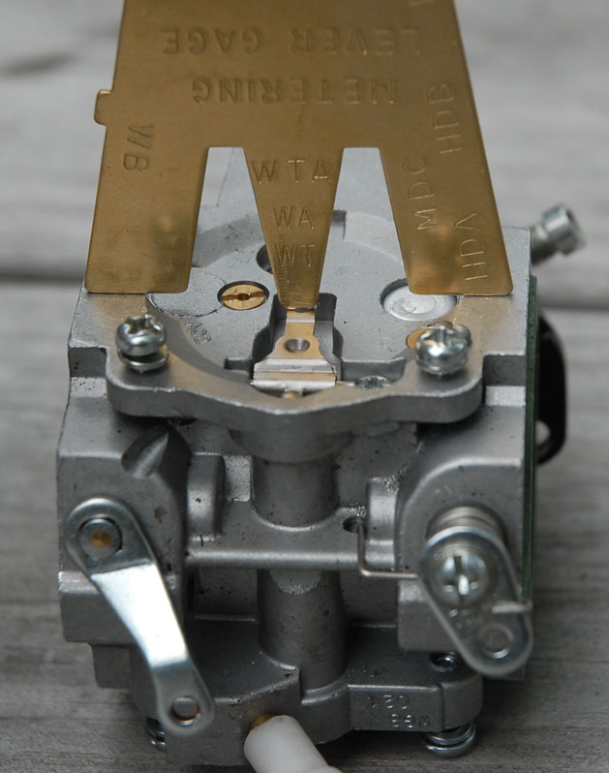  
Setting the Metering Lever height. Photo by Richard Cobb.

The height of the metering lever on any diaphragm carburetor is critical for controlling when and how far the inlet needle “pops” open thus configuring the engine's acceleration characteristics. If the metering Lever is set too high (relative to carburetor surface), it may create a rich condition, while a metering lever set too low may create a lean condition. The [distance from the outer frame of the carburetor body to the top] of the Metering Lever must be **0.75 mm or 0.067" (WG carbs) and 1.45 mm or 0.057" (WB carbs)**. Walbro sells a calibrated brass plate gage to be used as depth meter (Walbro item # 500-13-1) available through most power tool shops. I recommend you also take a look at Wind-Drifter's photos on this: <http://www.wind-drifter.com/technical/wg8walbro.php>).  
  
HR: The rebuild kits distributed by Walbro for their WG carbs have had diaphragms without a tang on the button for many years now. Also, the metering lever in these kits is preset for a height of about 1.7mm.  
  
WG-8 carburetors off new Miniplane Top 80 engines have a metering lever (ML) value of 1.7mm. However, the Top 80 service manual specifies a distance of 0.5mm – 0.7mm (from the top of the metering lever to the top edge of the carburetor body). As Gerry notes, too great a value can lean out the engine at high loads. If the 1.7mm value is used, the total travel of the ML valve is about 1.0mm from closed to full open. Testing has shown that this value is too low, especially if the throttle is opened suddenly. That is, the valve will not open enough to allow enough fuel in to power the engine when it is suddenly accelerated. As a result, the engine can stall.  
  
The huge question is: why does Miniplane deliver new engines with the ML distance set to too great a value and thus risk leaning it out? The Miniplane service manual clearly states that the distance should be 0.5mm – 0.7mm. WG-8’s set to this value on the Top 80 run and accelerates better. The diaphragm has a total independent travel of about 3.25mm which would mean that the ML would have a range of movement of about ½ that value (1.62mm) because the distance from the pivot to diaphragm button is about double from the pivot to the ML. How much does the ML valve have to be raised in order for it to deliver enough fuel to a fully loaded engine? If the ML is set to 1.7mm, the ML valve only has an operating range of about ½ mm. If the ML is set to 0.7mm, the ML valve range doubles to 1.0mm.  
  
Because of the principle of operation of a diaphragm type carburetor, if the diaphragm is subjected to a constant pressure the force exerted on the button does not change no matter where the diaphragm is within its fixed range of movement. This means that the diaphragm will exert the same force on the ML at the same pressure no matter the ML’s relative position to the range of diaphragm movement. The tech at Walbro failed to note this. As long as the diaphragm and the ML have their full range of movement, there is no danger of the fuel mixture being too rich or too lean. It is only at the extremes of diaphragm movement that mixture may be too rich or too lean.  
  
For these reasons, it best to stick with the official Miniplane ML value. New engines need to have the carburetor checked to be sure the ML value is correct. While the Top 80 will run with the 1.7mm value it will run much better if the range is opened and adjusted to the factory specification.  
  
If you get your rebuild kits from Miniplane, the diaphragm has the tang on it. Note that if the metering lever value is too low, the engine will not start because it will always flood. If too high, the engine will go lean at high loads and, possibly, burn up. It is best to error on the side of too low as it won’t hurt anything. If you have a kit with a tanged button, be sure to engage the tang in the metering lever when reassembling the carburetor.)  
  
As Gerry notes below, the pop-off pressure is one of the two most important factors that changes the air/fuel mixture ratio (the other value is the size of the main jet).  
  
If you do change the ML height, bend the short end, not the long. If you bend the long end, you may affect the lever’s smooth functioning on the pivot. Remember that the ML moves up and down at over 9,000X/minute.

**Pop-off pressure calibration:** (HR Warning: high pop-off pressures will lean out the engine and possibly burn it up.) Pop-off is the pressure at which the Inlet Valve 'pops' open on demand and allows fuel to travel toward the needle jets. It is important to understand the difference between the measured pop-off pressure during a bench test and the actual functional pop-off pressure of a running engine; In a running engine, the pop-off pressure will happen on demand and it depends on various dynamic factors not present during a simple bench test. Factors such as fuel demand and atmospheric pressure determine the actual pop-off pressure in a running engine. The one thing we must do regarding setting the pop-off pressure, is setting the correct and critical Metering Lever height. Since we are pressure-testing the carb while subjected to an abnormal (non-running) situation, the measured pop-off pressure will not be the same as in a running engine, but this test can be used for diagnostic purposes.

For example, if the pop-off pressure during the bench test happens at 30 PSI or more, it is too high, and it is indicative of sticky diaphragm flap valves or a sticky Inlet Valve seat.

If you wish to actually pressure-test a Walbro carburetor, prime it as usual and then simply remove the fuel supply line and attach the Walbro pressure tester onto its fuel inlet fitting. [Walbro’s pressure tester part # 57-11 ; $57.42 USD]. Pump air into the system and watch the gage needle drop when the Inlet Needle pops off its seat (opens). You want a pop-off pressure between **14 and 25 PSI.**

To adjust the pop-off pressure, run a depth gage across the Metering Lever, calibrate the gap to **0.75 mm (WG carbs) and 1.45 mm (WB carbs)** (HR: Please see the discussion on this above.) below the edge of the carburetor body, no gasket, but does not restrict the gage from moving across it. If you go higher in the lever, it will give a lot more fuel and it can become a little hard to start because the inlet valve will not be able to close in time.  
  
When reassembling, first place the thick Metering gasket on the carb body, followed by the thin Metering Diaphragm.

**Inlet Valve Reseat Pressure Calibration:** (HR: if you must change the value, add shims under the spring. Contact us if you have questions.) The normal position of the inlet valve is closed (the metering spring keeps it closed). The Walbro manual states that calibrating its reseat (closing) pressure is far more important than pop-off pressure! When the Inlet Valve gets unseated (pops open) under fuel demand, it must then **reseat (close) at 10-12 PSI**. You’ll know by watching the pressure drop on your pressure gage. After pop-off happens, the pressure drop should end and remain steady at 10 PSI or above. It should never drop below 10 PSI. This will ensure that fuel pump pressure does not override (push open) the Inlet Needle Valve since the fuel pump produces 5-7 PSI.

To increase the inlet valve reseat pressure, gently stretch the Metering Spring, this increases the force on the inlet needle seat (shuts tighter). To decrease the reseat pressure, carefully compress the metering spring (careful not to lose it!). **NEVER CUT IT!** If in doubt, replace the Metering Spring (Walbro part # 98-320-7, OEM # 503 28 12-18; WG8 carb

The test pressure gage should remain **steady** at about 10 - 12 PSI when the Metering needle valve (Inlet Valve) reseats. A leaky carburetor is indicated if the pressure continues to drop. According to the Walbro pressure pump manual, a continuing pressure drop can indicate:

*Flawed or dirty Inlet Valve seat.  
*Worn Inlet Valve rubber tip.  
*Internal crack of porosity in body casting or fuel pump body casting.   
*Leaking fuel pump gasket or fuel pump diaphragm .

**Important Notes on Carb Re-assembly:**

**1)** When re-assembling, you must place the gaskets and diaphragms in this precise order:  
Fuel pump side: Pump diaphragm on the carb body, followed by the gasket and then the lid.   
Metering side: Metering gasket on the carb body, followed by the metering membrane and then the lid.  
**2)** When re-assembling, make sure the Metering Lever clips into the Metering Diaphragm, or the engine just won't go. This does not apply it you are using the metering kit that does not incorporate the lever & diaphragm clip.  
**3)** WB series carbs have an internal Circuit Plate next to the metering system. The plate's gasket goes next to the carb body, followed by the membrane and last the plate.

**Modification:**   
(Acknowledgement to Scott Travers for sharing this technique that was part of Mr. Travers' engine maintenance clinic.)

Once you’ve done this basic cleaning and calibration homework, you can relax as you've done the difficult part. Here's how to make a Walbro equipped engine start *hot or cold* with a smooth and progressive midrange: Look at the throttle butterfly (a.k.a.: throttle valve, throttle plate, throttle flap) in the carb throat and you will see there a notch on the butterfly’s outer edge; some flaps have the small indentation and some do not. It should be on the adjustment needle side of the carb close to the lowest pick-up hole (idle).

Almost appears as though someone accidentally nicked the butterfly. Here's the problem. That little nick in the butterfly plate accomplishes the entire airflow for the idle circuits. This is why your idle stop screw and spring are mashed all the way in while your Low speed screw is opened a mere one turn out. Your engine is starving for air while you’ve cut its idle fuel supply to nothing.

Your High-speed needle in the WB carb series is open at 1 to 3/4 turn for top end and your Low speed needle is open 1/8 turn. That is a major expanse of territory with no midrange coverage. The Low jet is too low to cover midrange while the High jet is too high to do the same.

This is an old technique used in go-karting that can be applied to slide and butterfly carbs alike for specific tuning needs:

**Note the exact position of the throttle butterfly plate and lower jet apertures, remove the plate and use a 6mm diameter Dremel grinding stone** [**(#932)**](http://www.dremel.com/productdisplay/bit_template.asp?SKU=932&Color=009933) **or rat tail file to cut away a small half moon so that the notch is aligned with the idle pick up hole (the lowest hole in the carb throat). For testing purposes, I purchased a few throttle plates and I started out by cutting a notch of about 0.2mm deep and gradually increasing its depth up to 4mm and after several static tests I settled for a 2.0 mm deep notch for the Radne Raket 120 with either a WG or WB series carb. Alternatively, you can also grind a somewhat shallower flat straight cut instead of a curved notch.**

(HR: For the Polini 100, the maximum depth is 1.8mm and the maximum width is 4.7mm. Exceeding these values will make the idle speed too fast. I made the mods at 4,000’ MSL so the values I have given here may have to be adjusted according to your altitude above sea level.)

Throttle plates modified for correct idle air requirements of a Raket 120: Left: WB-42; Right: WG8

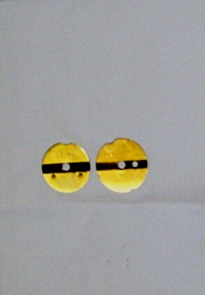

The next two pictures are of a WB-32 modified by Mr. Scott Travers for use on a Solo 210 engine. These two photos were taken from both ends of the same carb:

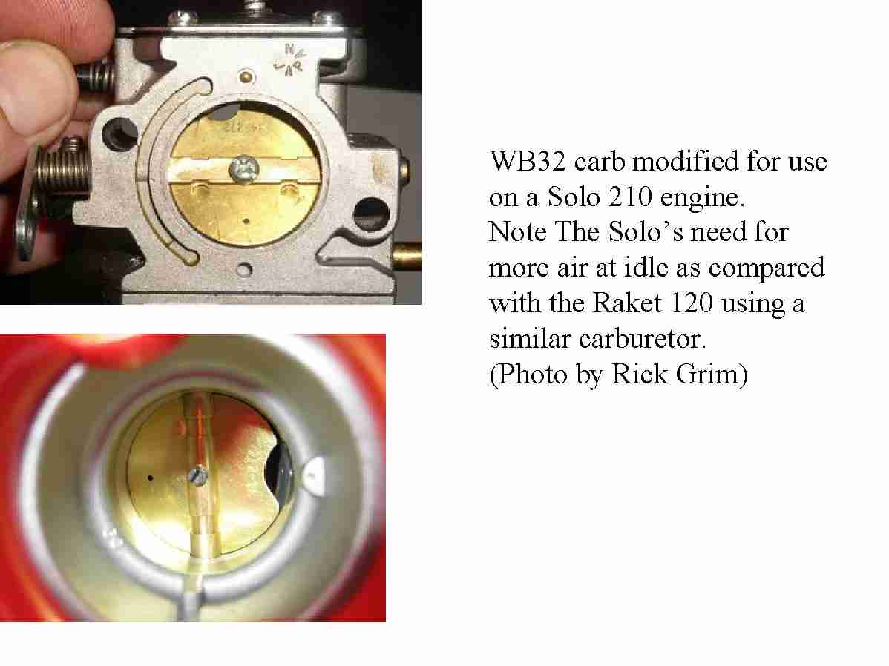

**IMPORTANT:** Wherever the idle pickup holes are in your carb throat, make the plate notch in front -or aligned- to them, and make sure you do not grind any more than 2mm. If you grind away too much, the engine will simply have a fast uncontrolled idle that cannot be adjusted with the idle stop screw or the Low speed needle (buy a $0.79 cent spare butterfly plate just in case: Throttle Valve, Walbro # 34-305); For Walbro distributors in your country or state click [HERE.](http://wem.walbro.com/distributors/service/distributors.asp)

When you place the throttle flap back, ensure it closes completely before tightening it to its shaft, and don't push too hard while tightening it or you will bend the delicate brass shaft. Add one small drop of Loctite to its central screw. Mount the carb on the engine and make sure the throttle cable permits the complete throttle assembly to open and return “all the way” against the stop! With this done you will now open the Low speed needle 1 turn (WG8); [WB series: Open the Low speed needle 1 turn and open the High speed needle 1/2 turn to start out] and back out that mashed idle stop screw to where it's supposed to be: about half way out.

Again, check that the complete throttle assembly works correctly and the throttle flap **closes completely and freely**. Also test the choke mechanism for free movement. Start your engine and allow it to warm up at low/mid RPM.

**High Speed Needle Adjustment**   
If you have a WB series carb, next make a high speed run and adjust your High speed needle at high RPM. The ideal high speed mixture is the richest setting that still permits strong acceleration up to peak RPM. With this in mind, it is always wise to start out slightly over rich and slowly lean the mixture out. If the high speed mixture is too lean, you'll experience weak or "lazy" mid range acceleration. You'll eventually find a narrow adjustment range where peak rpm operation seems unchanged. However, within this range, there should be a noticeable difference in mid to high range acceleration. Finding the setting within this range that gives the best "middle through high range acceleration" usually requires patience to train your hearing. Once you are satisfied with the settings, make a full throttle run of no more than one minute and then take a [spark plug reading.](http://tsrsoftware.com/images/read_plugs-tsr_software.jpg) Remember that a [spark plug reading is a must!](http://www.dragstuff.com/techarticles/reading-spark-plugs.html) Repeat the High-speed circuit adjustment until your top end is smooth and plug reading is light tan in color.

**Spark Plug Reading**   
(HR: This is generally not a good way as it is often inaccurate – install a [cylinder head temperature gauge](http://www.elpasoparagliding.com/PPGTechInfo/General/generalinfo.htm) instead.)

Radne switched the recommended spark plug from Nipponderoso to the NGK BPH7A with the electrode gap set at 0.6 mm. Determining proper fuel mixture by inspecting the color and condition of the spark plug can be very helpful in situations where the engine is being operated constantly at full RPM under full load. Using a NEW and calibrated spark plug is required: At the end of the full throttle running, the throttle should be chopped and the kill button pushed *simultaneously*; If the engine is run at partial throttle for even 5 seconds after the full throttle run, the plug reading will be invalid. After the full throttle running, a combination flashlight/magnifying glass must be used to view the carbon deposit at the base of the porcelain - down inside the spark plug where the porcelain insulator and outer steel spark plug casing meet. A ring of dark brown at the base of the porcelain denotes ideal fuel mixture, light brown is lean, and a ring of black is over rich. This is the only area of the spark plug that accurately indicates fuel mixture. Furthermore, this reading only indicates full throttle fuel mixture. No part of the spark plug can indicate Low Speed or mid-range fuel mixture. The upper part of the spark plug porcelain (by the electrodes) is often very light or white in color, however this coloring is mostly affected by additives in the gasoline and oil. The coloring of the end of the porcelain in no way indicates appropriate fuel mixtures of any throttle range.

**Low Speed Needle Adjustment**   
(The initial setting for the WG-8 should be about 1.5 turns. – HR) With the engine completely warmed up, apply about 35% throttle or as fast as 4500 - 5000 RPM. Turn the low speed mixture screw in or out in 1/8 turn increments. As you get closer to the ideal setting, the engine RPM will increase.

At the ideal mixture setting, turn in a richer or leaner direction will cause a rough idle and cause the engine to die. To confirm your perfect low speed mixture setting, touch the kill button during idling and then restart the engine about ten seconds later. The engine should restart instantly and idle steadily without touching the throttle. Avoid running an over rich Low Speed mixture screw setting in an effort to cure a mid range hesitation = lean condition.

**Idle Adjustment**  
Once the engine is operating at normal temperature, you can now adjust the idle stop screw till you achieve a smooth idle.

**What did all this achieve?**   
You now allowed enough airflow for the engine to run properly at idle. You allowed for a smooth controlled idle since the Low speed mixture is finally balanced.

By increasing Low Speed mixture volume you also decrease the midrange carry-over lag because the Low Speed jet progressively transfers control of the mixing action over to the Mid and High speed mixture circuit. Your Raket 120 never had it so good so it will allow you to power down to idle and taste the thermal you just found, and even lock the propeller without the inconvenience of stalling the engine and suffering a tough restart.

A point to consider is that if you can get your engine running at an iffy idle at about 2000-2100 RPM, then it will be at *Nirvana* idling at 2500-2600 RPM without engaging the centrifugal clutch.

**How does notching the butterfly (allowing more air to pass) differ functionally from limiting the butterfly's closure with the idle stop screw?**

Balance of air to fuel ratio is not proportionate within the mid-range or even at idle on most Walbro carbs. It has to be *made* proportionate depending on the engine it is mounted on.

You increase airflow across the butterfly and increase Low jet flow at idle, thus you achieve a smoother mid-range and lower idle speeds. You cannot compensate for this with merely opening the butterfly. Your objective is to increase Low speed jet action along with more air; In other words, the flow through the notch (when the butterfly is closed) is directly across the jet holes rather than around the entire periphery of an almost-closed butterfly.

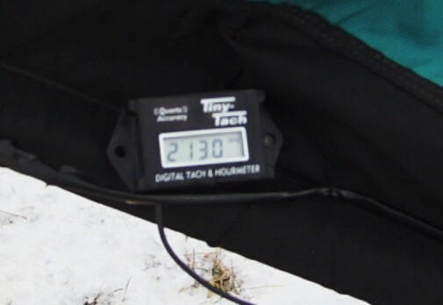

________________________________________

Edited and adapted by Gerry Farell; Full credit and appreciation to Scott Travers for sharing this technique that was part of Mr. Travers' engine maintenance clinic.

**For carburetor tuning details, it helps to learn the names of the carburetor's parts and their function.** I highly recommend to start by understanding how the Walbro metering system works:

**Walbro Service Manual** (PDF 5.8MB) <http://www.wind-drifter.com/technical/WalbroServiceManual.pdf>

**Walbro Carburetors Troubleshooting Chart** <http://www.wind-drifter.com/technical/walbro_chart.jpg>

*Alex Varv's articles <http://www.aerocorsair.com/id29.htm>are clear and very useful, but never cut the metering spring.