**Walbro WG-8 Carb Disassembly**

From: <http://www.wind-drifter.com/technical/wg8walbro.php> by Richard Cobb  
  
Additional notes by Had Robinson

This shows the disassembly of Walbro WG-8 carb that was supplied with the Radne Aero 120 on a Mosquito NRG.  Apparently some units are now shipping with the WG-10 carb.  A comparison of specifications ( see <http://wem.walbro.com/walbro/group2.asp?FamilyName=WG> ) shows that they are nearly identical.  The only differences I could find were:

* The WG8 lists a Nozzle Jet part 112-3051, the WG10 has this blank
* Metering cover screws(4) - The WG8 uses 96-589 and the WG10 uses 96-603  
    
    
    
    
    
    
    
    
    
    
    
    
    
    
  (INTENTIONALLY LEFT BLANK)

So presumably the information on this page will apply to the WG-10 in most respects. 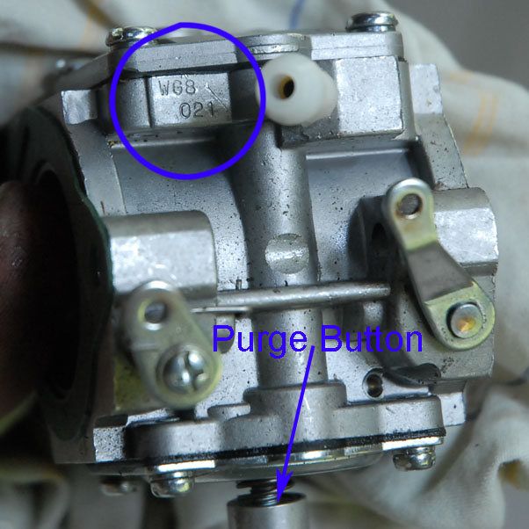

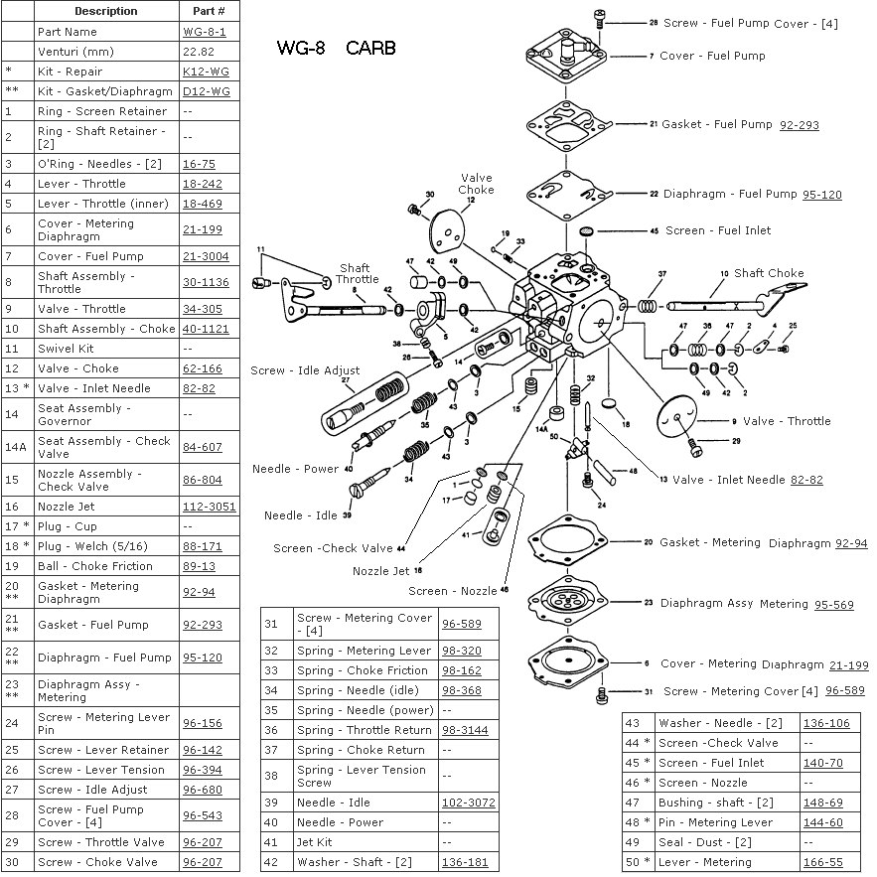  
  
There are two repair kits available.  The K12-WG has almost all the parts, including needle, fuel strainer screens, etc.  Note that it does **not** have a metering spring.  The D12-WG has just the gaskets and diaphragms (metering and pump).

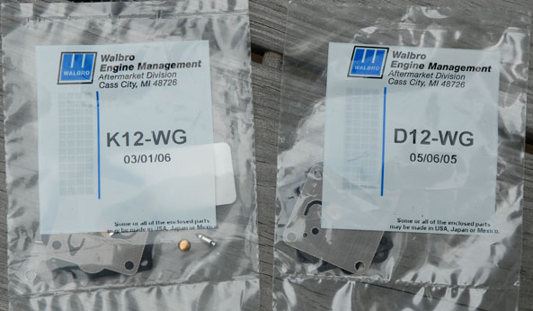

The reprint on the next page shows the operation of the fuel pump and the fuel pump diaphragm on the WG-8. Air impulse pressure on one side of the diaphragm serves to pump the fuel on the other side.  The blue arrow points to the final fuel filter screen (which has collected some debris in the photo).

|  |  |
| --- | --- |
| Fuel Pump Operation |  |

The photos below describe the fuel metering system and show 2 stages of dis-assembly. Note the debris in the fuel intake filter screen.

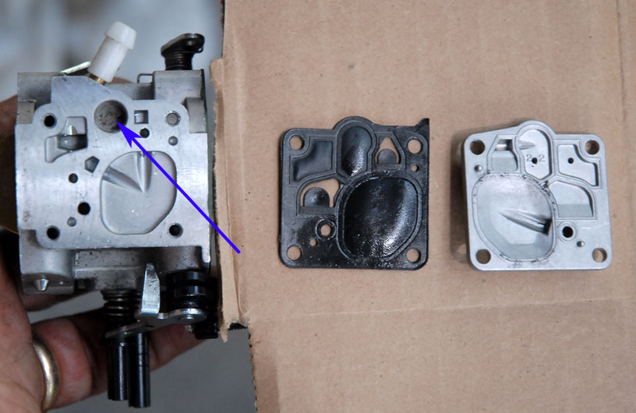

|  |  |
| --- | --- |
| Fuel Metering Description | Metering lever and spring |

Walbro has a gage for setting metering lever height, as shown below.

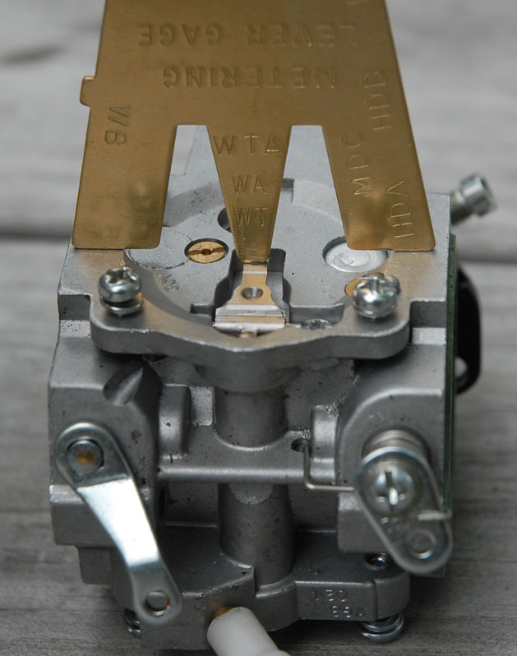

You can buy the gage from Walbro, or you can make your own.  If you download [WalbroGage.pdf](http://www.wind-drifter.com/technical/WalbroGage.pdf)  you can print out an exact scale image of the gage (be sure to turn off page scaling when you print it).  If it does not print correctly, there is a ruler in the picture you can use to scale it.  The dimensions are also included.  
  
The photos on the next page show the installation of the metering diaphragm and cover.  Note that the gasket goes on first, then the diaphragm.  (this is the opposite of the pump side).

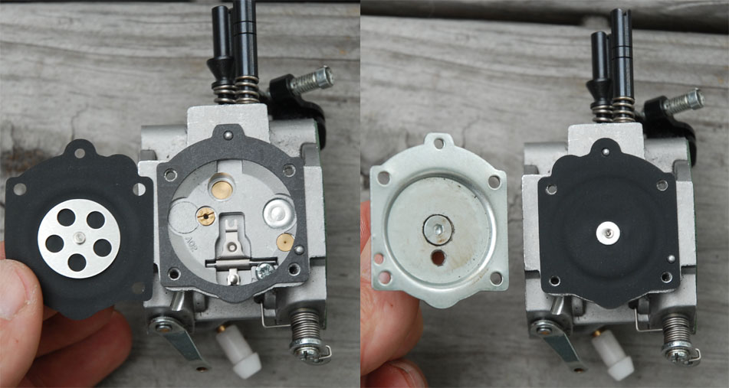

Note by Had Robinson: The metering lever in kits supplied by Walbro is preformed to be 1.7 mm below the body surface. According to the Italian version of the Top 80 service manual, the correct height is 0.5mm – 0.7mm. Do not install the metering lever without correcting it for the proper height. What is odd is that I measured the metering lever heights on (2) new Top 80’s and the height was 1.7 mm. This restricts the range of movement of the diaphragm to respond to high load conditions. My tests demonstrated that the engine would hesitate under a sudden full throttle when the height was 1.7mm but not when it was set to 0.7mm. A high metering lever height can lean out the engine at high loads. This is because the diaphragm cannot move down far enough to raise the needle valve enough to provide a greater amount of fuel.

This photo on the next page further clarifies the travel limiting effect of the metal plate on the carb body.   
  
Note by Had Robinson: Even though the plate limits the movement of the diaphragm against the metering lever, it is still possible to bend the lever by pushing on the diaphragm with a foreign object. It is safest and best to purchase or make a tool that limits the movement of the diaphragm to no more than 4mm. Most new carburetors from Miniplane have a special priming lever on the carburetor.

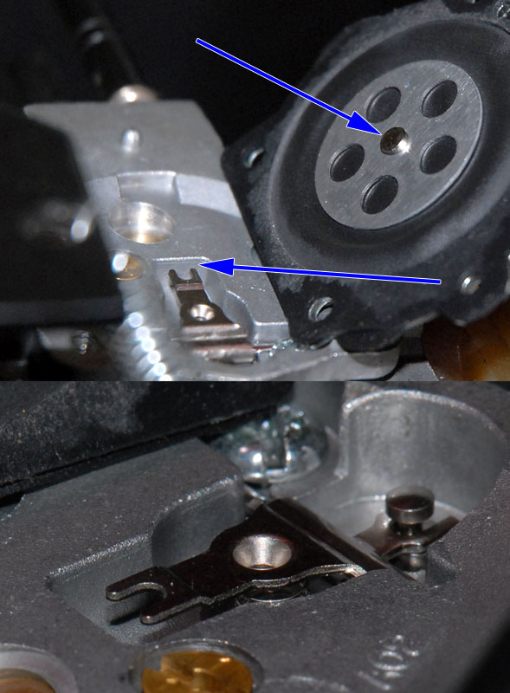

In the photos on the next page, you can see that, on the pump side, the installation order between diaphragm and gasket is reversed - that is, the pump diaphragm portion goes on first, then the gasket.  Note that the material for the pump diaphragm has changed.  The original (black) one is at the left, the newer version is translucent with an embedded mesh visible (ethanol resistant). Kits also come with the original black rubber diaphragm.

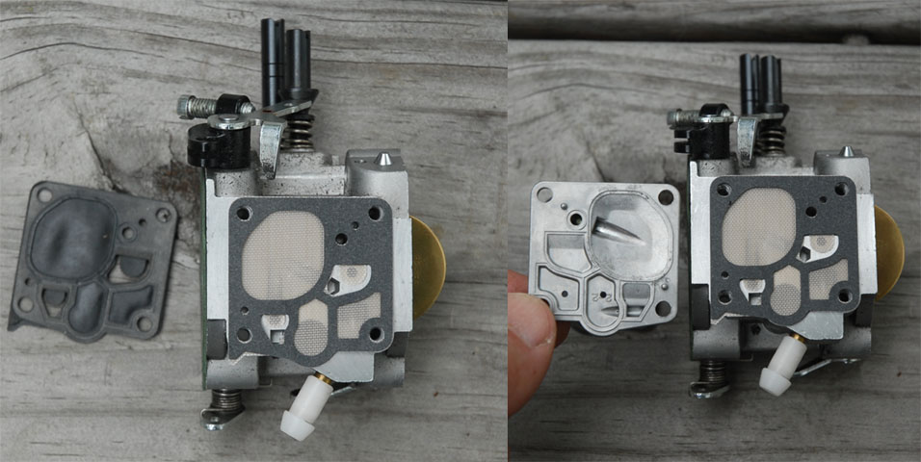

The figure on the next page shows the throttle plate modification to improve idle and mid-range operation.  This is discussed in detail by Gerry Farell: <http://webspace.webring.com/people/bf/flphg/idle_adaptation.html>   The blue arrows show the notch before and after enlarging.

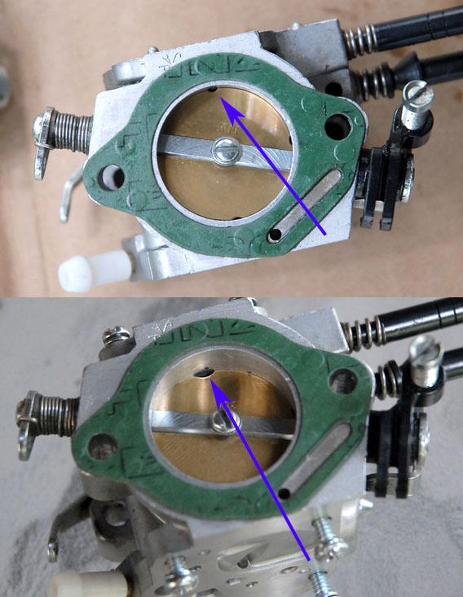

(See photos next page)

The fuel line on many units has a 1/4" line, which can allow bubbles to collect, especially in hot weather (fuel percolating).  Even at full throttle the fuel flow is not sufficient to move the bubbles from a high spot in the line, where they eventually collect and slow fuel flow enough to cause performance to decrease.  A solution with which many have reported success is to use a smaller 1/8" (~3mm) line, which also involves removing the white plastic barb on the carb fuel inlet.  Before (top) and after(bottom) are shown below:

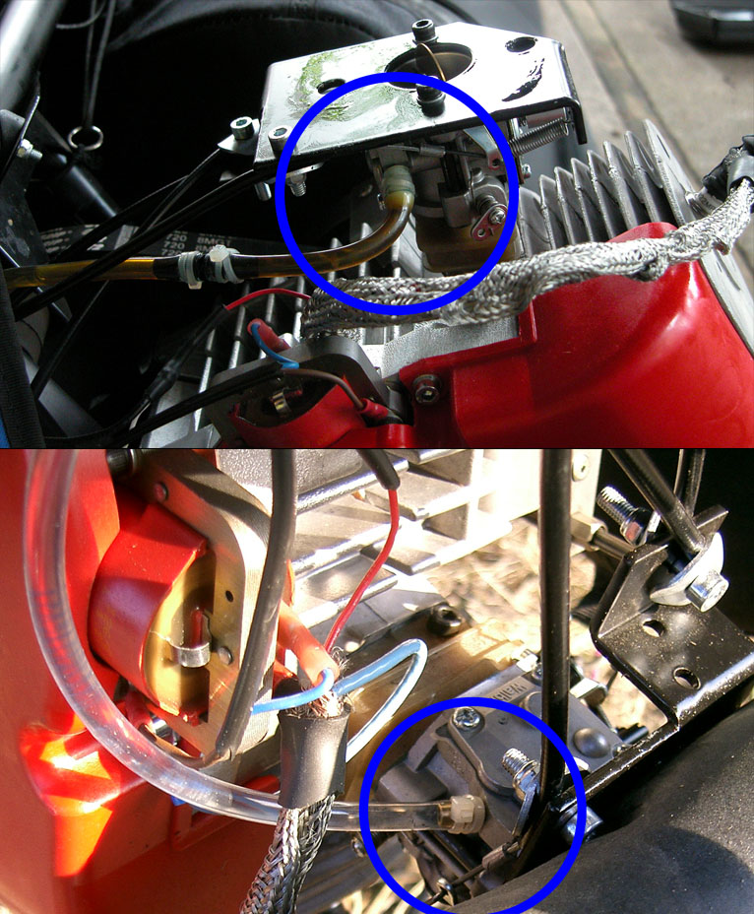

(The silver braid is/was a failed attempt to suppress radio noise from the ignition - resistor spark plugs are a much better solution).  
  
I have discovered that the nylon TyWraps work well for securing the fuel line, however, be sure to take two wraps around the hose, as a single wrap will not apply uniform pressure all the way around.

