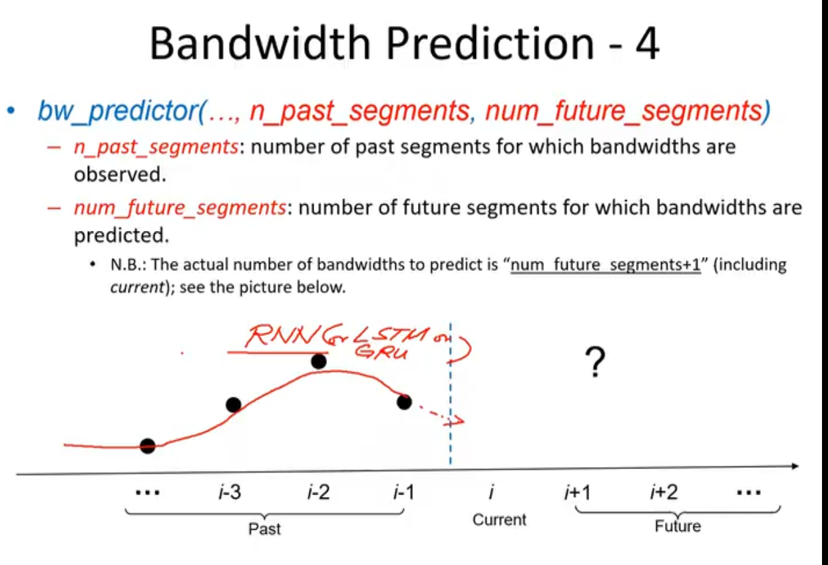

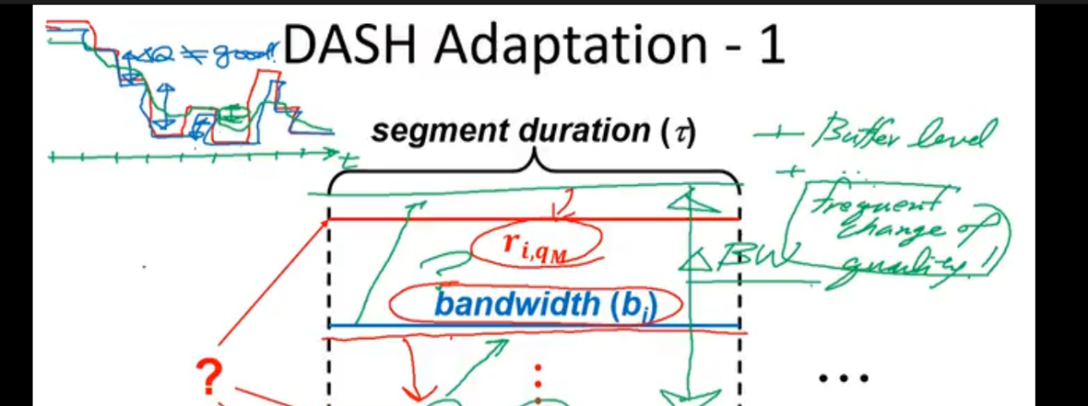

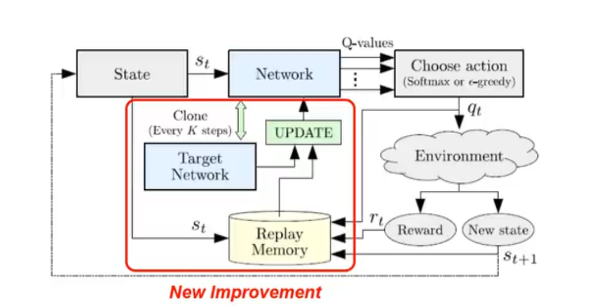

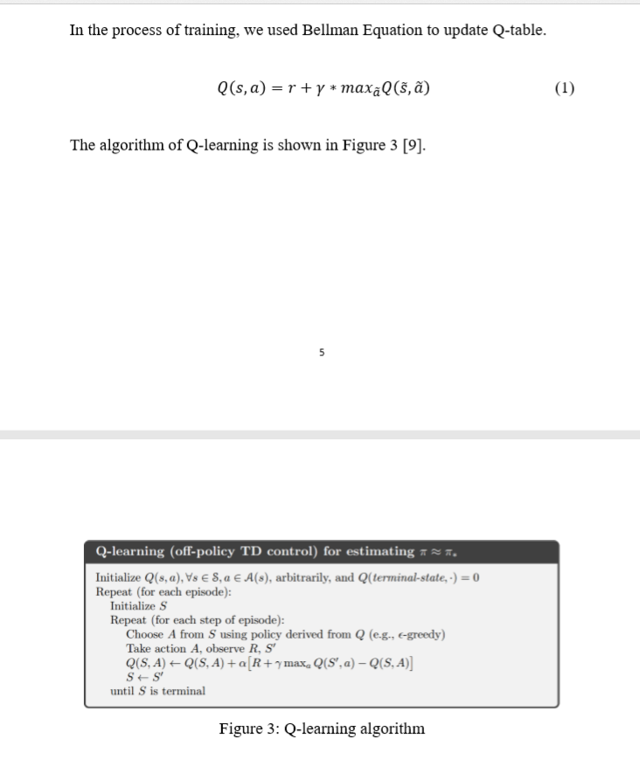

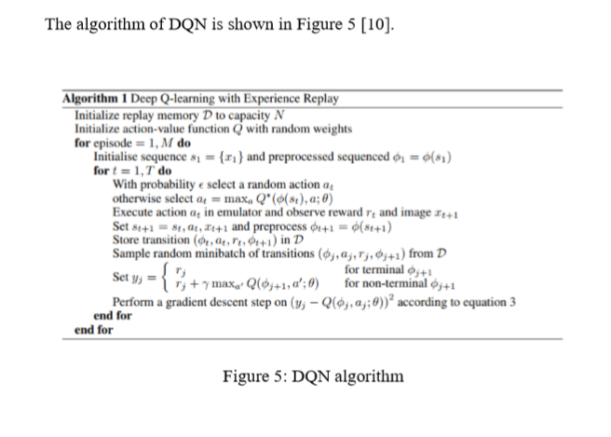

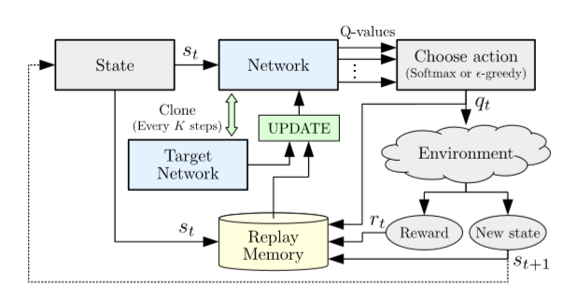

未来的带宽信息可以有效防止请求过高的quality导致bitrate过高而引起starvation，也就是buffer溢出，引起等待

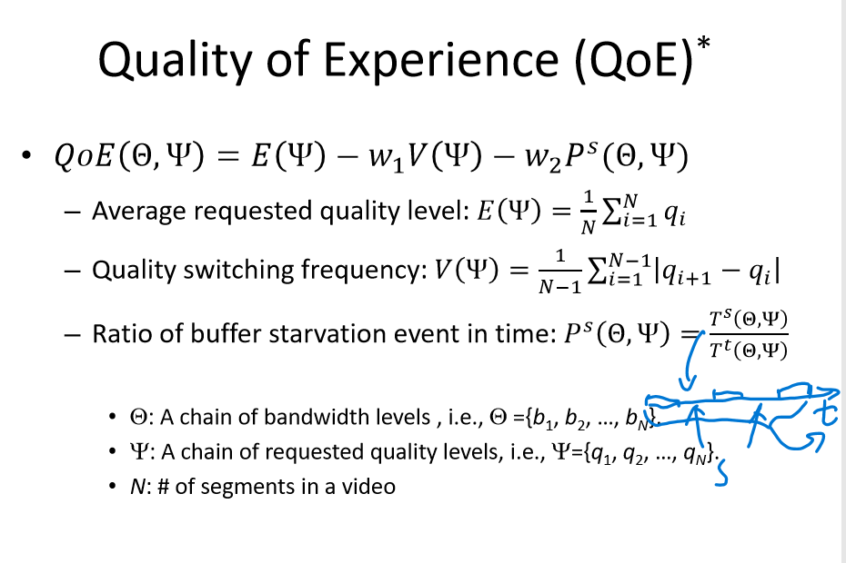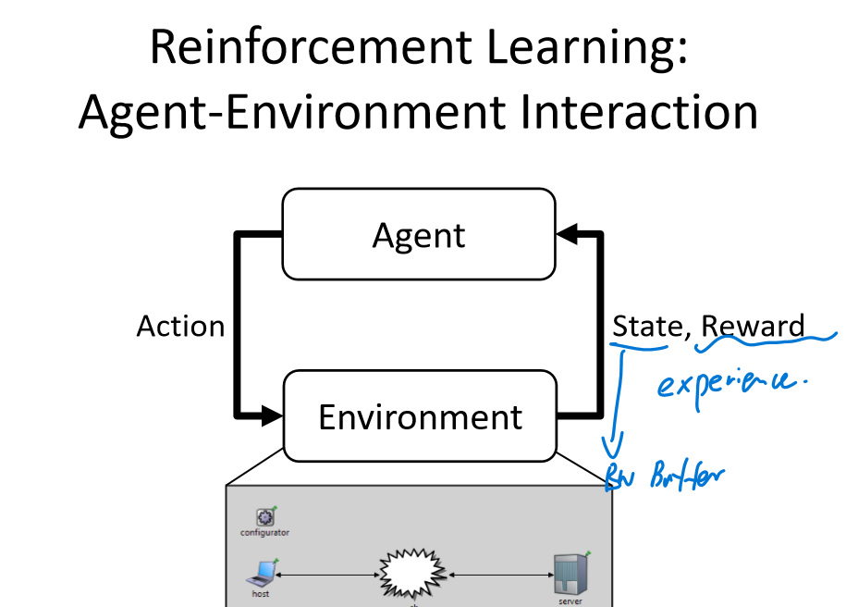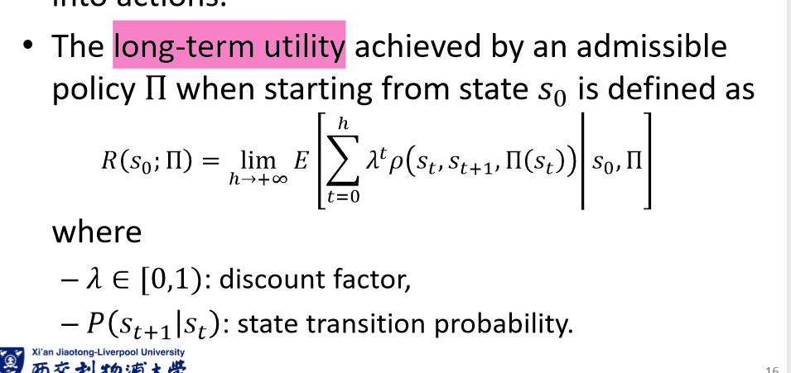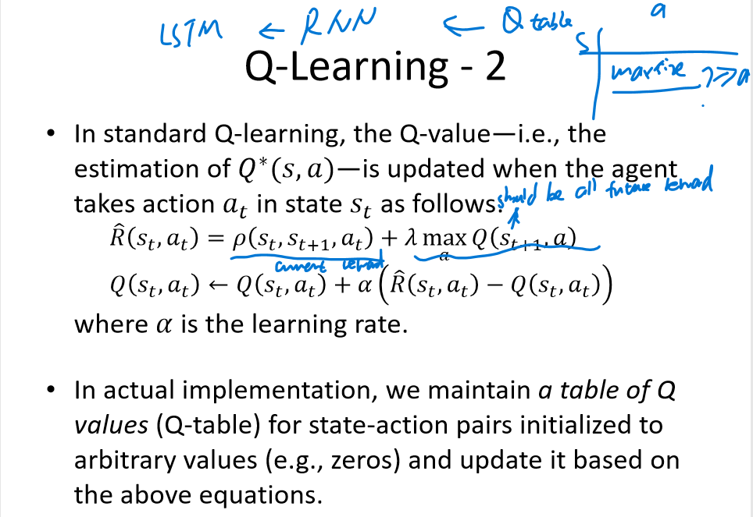

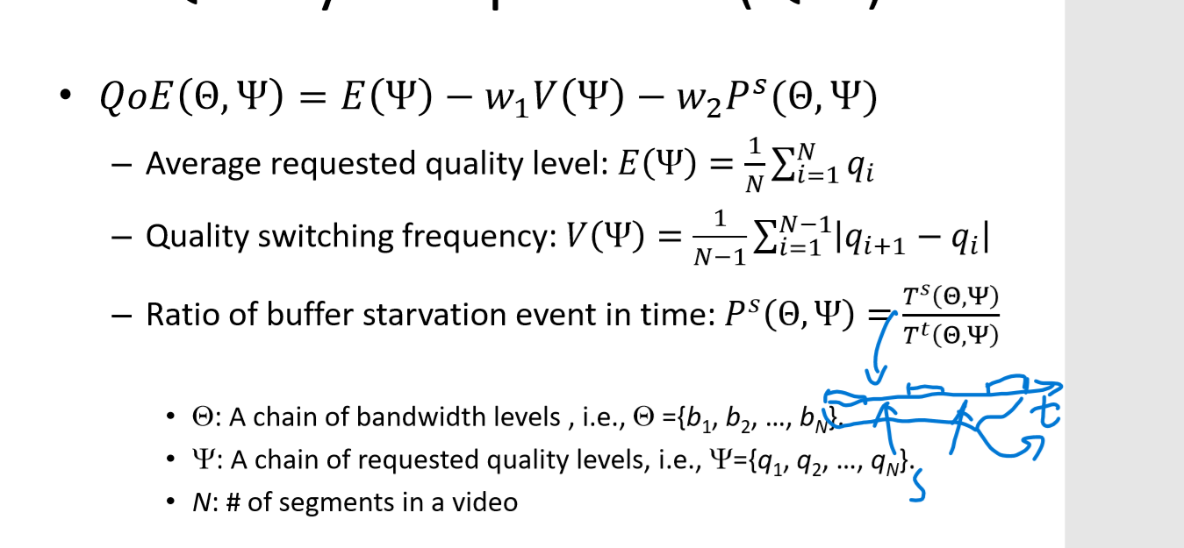

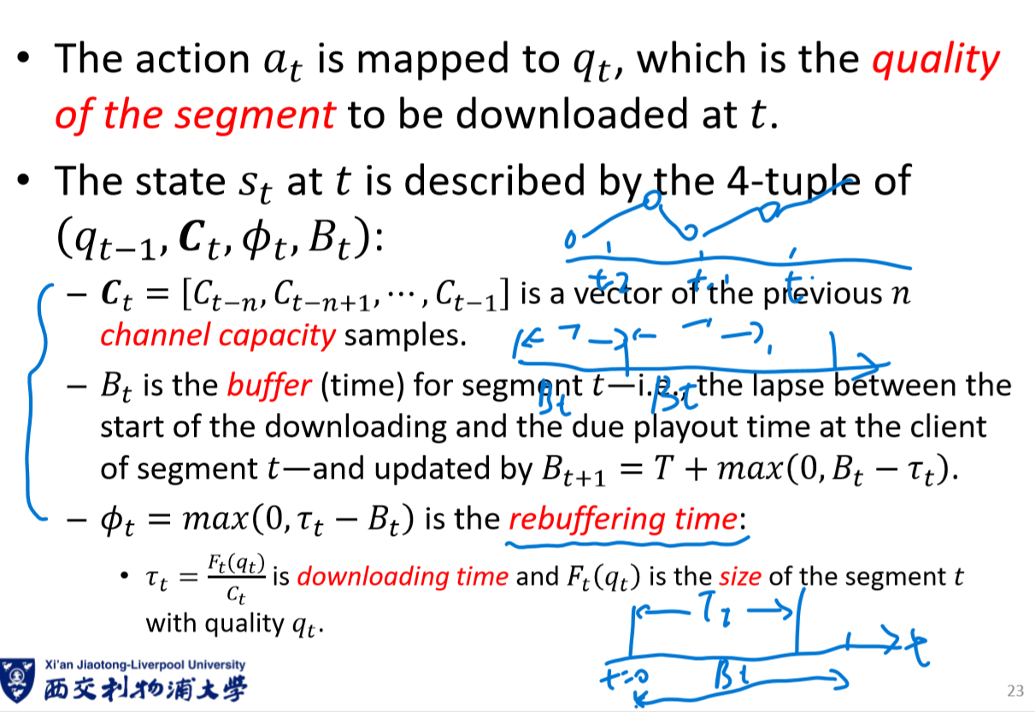

for input, target in dataset:

optimizer.zero_grad()

output = model(input)

loss = loss_fn(output, target)

loss.backward()

optimizer.step()

for param in policy_net.parameters():  
 param.grad.data.clamp_(-1, 1)  
optimizer.step()

防止梯度消失或者梯度爆炸？

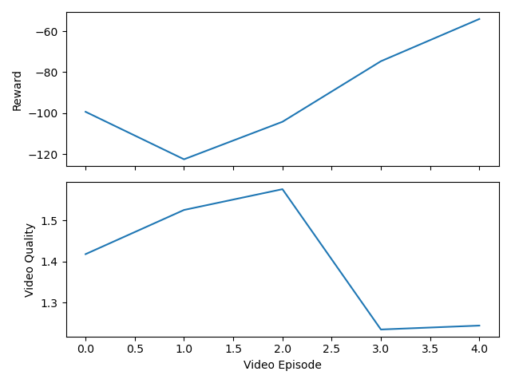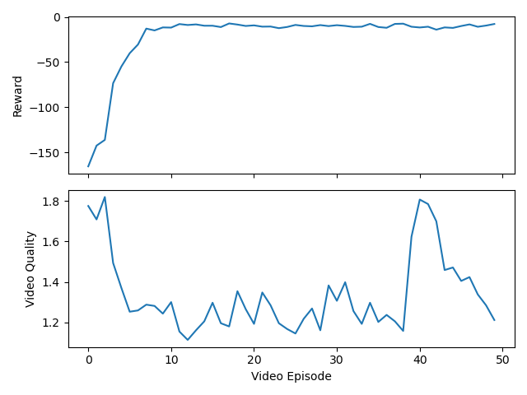

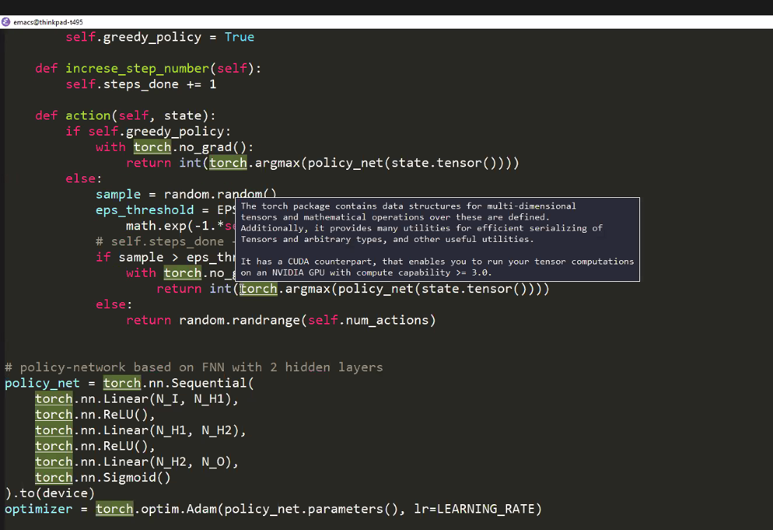



class State:  
 *"""  
 $s_t = (q_{t-1}, F_{t-1}(q_{t-1}), B_t, \bm{C}_t)$, which is a modified  
 version of the state defined in [1].  
 """* sg_quality: int  
 sg_size: float  
 buffer: float  
 ch_history: np.ndarray

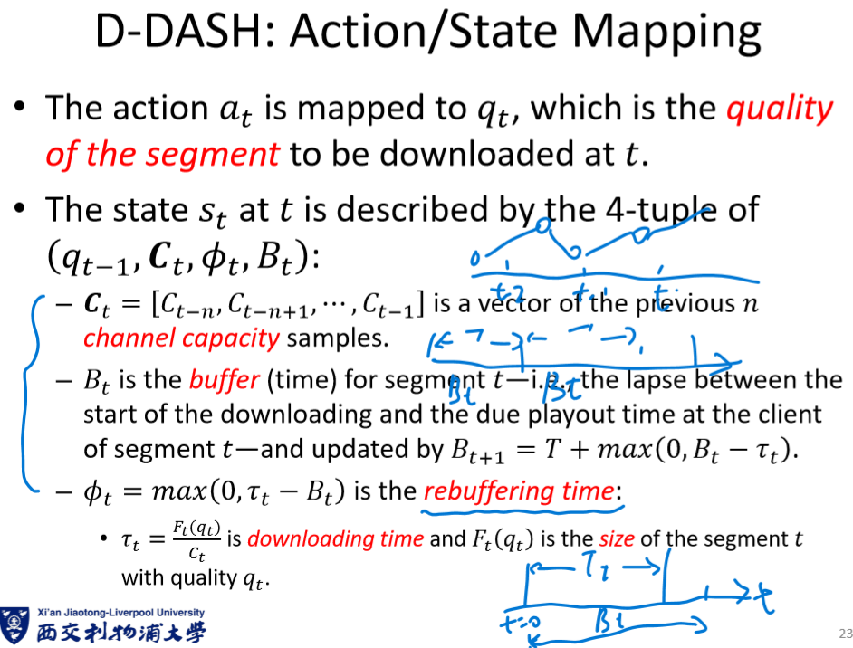

class Experience:  
 *"""$e_t = (s_t, q_t, r_t, s_{t+1})$ in [1]"""* state: State  
 action: int  
 reward: float  
 next_state: State

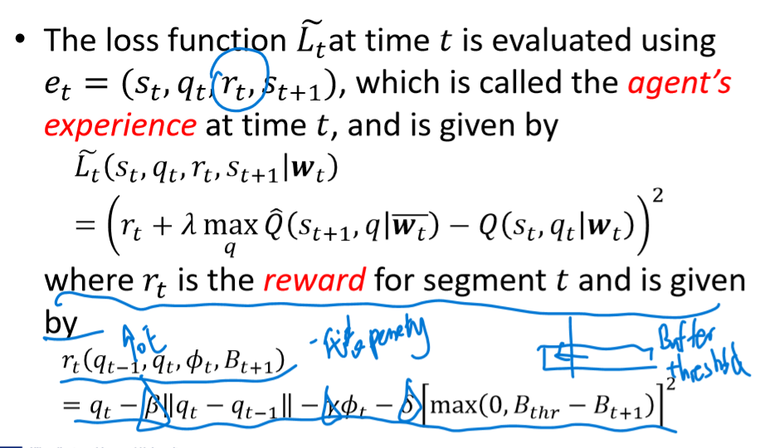

BATCH_SIZE

和memory

50 1000怎么回事

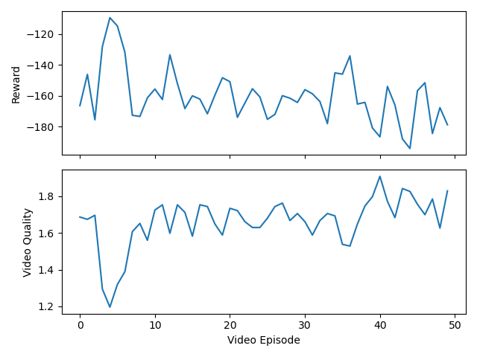、

experiences.state torch.Size([5])

state_batch torch.Size([1000, 5])

state_action_values torch.Size([1000, 1])

tag_space = self.hidden2tag(lstm_out.view(len(sentence), -1))

tag_scores = F.log_softmax(tag_space, dim=1)

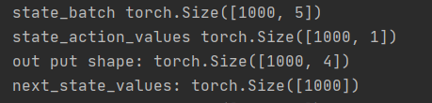

<https://zhuanlan.zhihu.com/p/105638031?utm_source=wechat_session&utm_medium=social&utm_oi=629977854172205056>

<https://zhuanlan.zhihu.com/p/104475016?utm_source=wechat_session&utm_medium=social&utm_oi=629977854172205056>

<https://zhuanlan.zhihu.com/p/29665107?utm_source=wechat_session&utm_medium=social&utm_oi=618131782479122432>

<https://zhuanlan.zhihu.com/p/29665107?utm_source=wechat_session&utm_medium=social&utm_oi=618131782479122432>

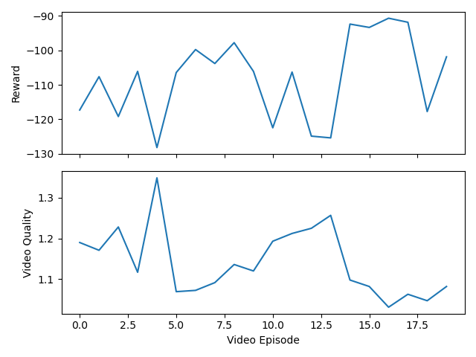

to compare the different performance of different conditions ,tiantian does many steps comparison

