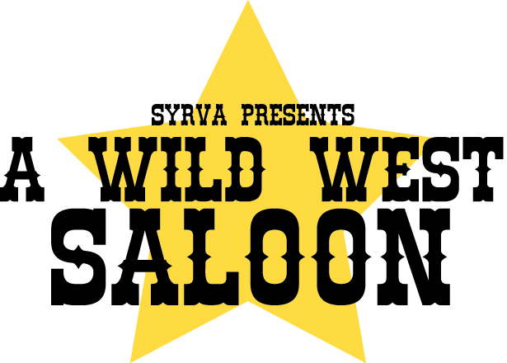

March 23, 2016

Dear Friend,

On April 30, 2016, the South Yuba Recreation Volunteer Association (SYRVA) will host its 4th annual Wild West Saloon fundraiser. Although SYRVA has years of experience organizing community-oriented fundraising events, this unique evening features bingo, card games, music, prizes, and a live auction. The ambiance is one that encourages interaction, fun, and meeting new folks. We anticipate a crowd over 100 adults. Net proceeds generated from the event are dispersed among local participating programs. Groups partnering this year are FFA, Recreational Basketball, Wheatland High Sober Grad Night, Wheatland Little League, Wheatland Senior Center, and Rainbow Girls.

Although SYRVA is a small, volunteer, community-oriented nonprofit, it has provided a steady support network for youth and their families over the years. Its mission is to promote programs in South Yuba County that engage youth in recreational activities and encourage healthy, community-building options for our citizens of all ages. Examples of how we fulfill this mission are: providing program scholarships to youth whose families are experiencing financial constraints; orchestrating a hot lunch program for over 100 families over winter break; and donating school supplies to local children. Our Partnering organizations work year round, to enhance the lives of local children and adults through healthy activities, sports, agriculture, community service, and social interaction. We estimate that over 300 children and adults benefit from our services.

We would love to include YOU as a sponsor for this event. Please consider donating merchandise and handicraft, to be used as prizes or in the auction. Monetary donations are also welcome. Or, consider attending the event by purchasing tickets at our link: http://www.payit2.com/collect-page/80614.

We thank you in advance for your time and support.

Sincerely,

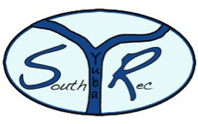

**South Yuba Recreation**

**Volunteer Association P.O. Box 1252**

**Wheatland, CA 95692**

Amelia B. Oliver (530-633-4461)

Fundraising Committee

southyubarec@yahoo.com

Tax ID #94- 3310411