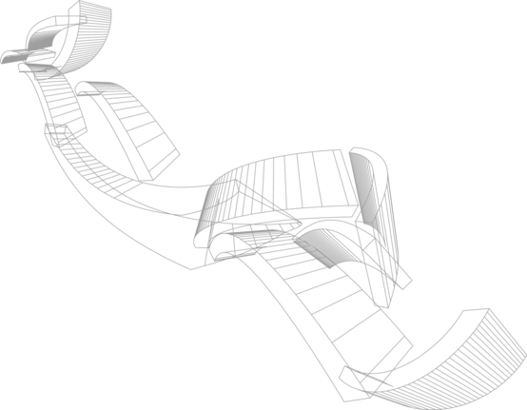Automated report template

Chamber measurement

Date of measurement: bmkDate

**Table of Contents**

# Measurement parameters

* Frequency range: bmkSweepSpec
* Pattern resolution: bmkStepSize

# Horizontal Measurement

## Gain curve

HorizontalSweepGain

## Pattern

HorizontalPattern

# Vertical Measurement

## Gain curve

VerticalSweepGain

## Pattern

VerticalPattern