Hello world

using System; // System is name space

namespace CsharpConsoleApp

{

class Program

{

static void Main(string[] args)

{

Console.WriteLine("Hello World");

}

}

}

Data Types

class Program

{

static void Main(string[] args)

{

string message = "Hello World";

int intVar = 10;

float floatVar = 10.2f;

char charVar = 'E';

bool boolVar = false;

Console.WriteLine(message);

Console.WriteLine(intVar);

Console.WriteLine(floatVar);

Console.WriteLine(charVar);

Console.WriteLine(boolVar);

Console.ReadKey();

}

}

Value vs Reference Type

Example: class, objects, array, Strings, Interface etc..

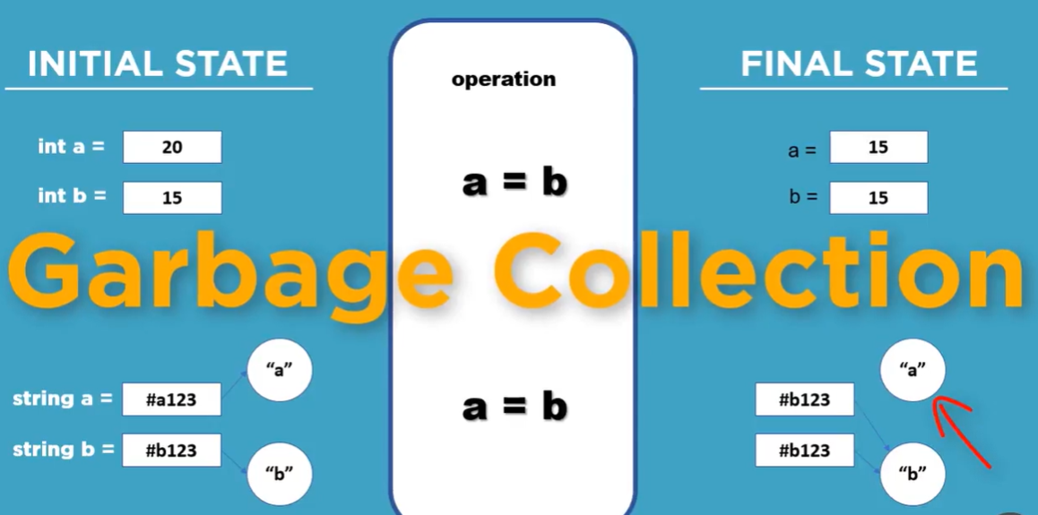

Type conversion

1-Implicit = from smaller to larger data type

2-Explicit = Larger to small data type