ROS Bag Motion Metrics Report

Processing Notes
- Metrics are computed only inside the evaluation windows from Vicon Cutoff+5s until Landing.
- Horizontal velocity is cleaned before peak/RMS calculation using x/y component bounds of -8 to +8 m/s, then computed from cleaned x/y components.
- X and Y velocity component plots use cleaned x/y values directly.
- Horizontal acceleration is cleaned before peak/RMS calculation using x/y component bounds of -8 to +8 m/s^2, then computed from cleaned x/y components.
- Savitzky-Golay smoothing is disabled for cleaned velocity and acceleration so peak metrics are not smoothed down.
- Angular rate magnitude uses raw x/y/z components.
- Roll and pitch are converted from ROS quaternion fields x/y/z/w to degrees.

Formulas
- Horizontal velocity magnitude: sqrt(vx^2 + vy^2)
- Peak horizontal velocity: max(sqrt(vx^2 + vy^2))
- RMS horizontal velocity: sqrt(mean(vx^2 + vy^2))
- Peak absolute X velocity: max(abs(vx))
- Peak absolute Y velocity: max(abs(vy))
- Horizontal acceleration magnitude: sqrt(ax^2 + ay^2)
- Peak acceleration magnitude: max(sqrt(ax^2 + ay^2))
- RMS acceleration magnitude: sqrt(mean(ax^2 + ay^2))
- Angular rate magnitude: sqrt(wx^2 + wy^2 + wz^2)
- Peak angular rate magnitude: max(sqrt(wx^2 + wy^2 + wz^2))
- RMS angular rate magnitude: sqrt(mean(wx^2 + wy^2 + wz^2))
- Peak absolute roll angle: max(abs(roll))
- Peak absolute pitch angle: max(abs(pitch))

Highlighted New Plots
- RMS horizontal velocity
- Peak absolute roll angle
- Peak absolute pitch angle

UN
- Flights processed: 8

Metric 1: Peak horizontal velocity
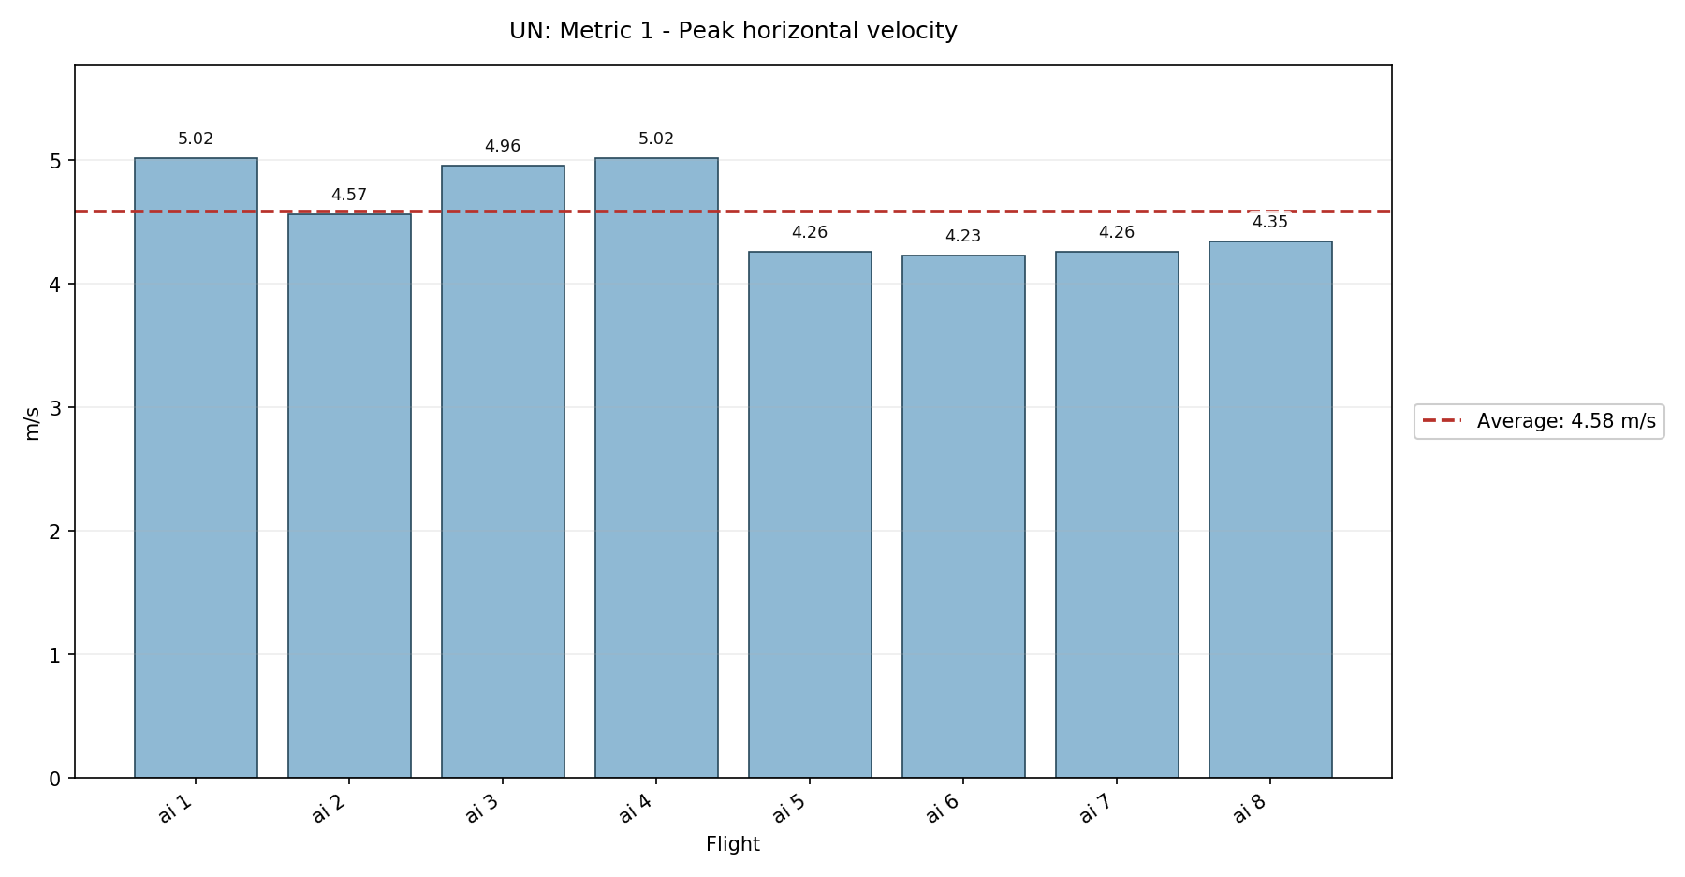

Metric 2: RMS horizontal velocity - NEW
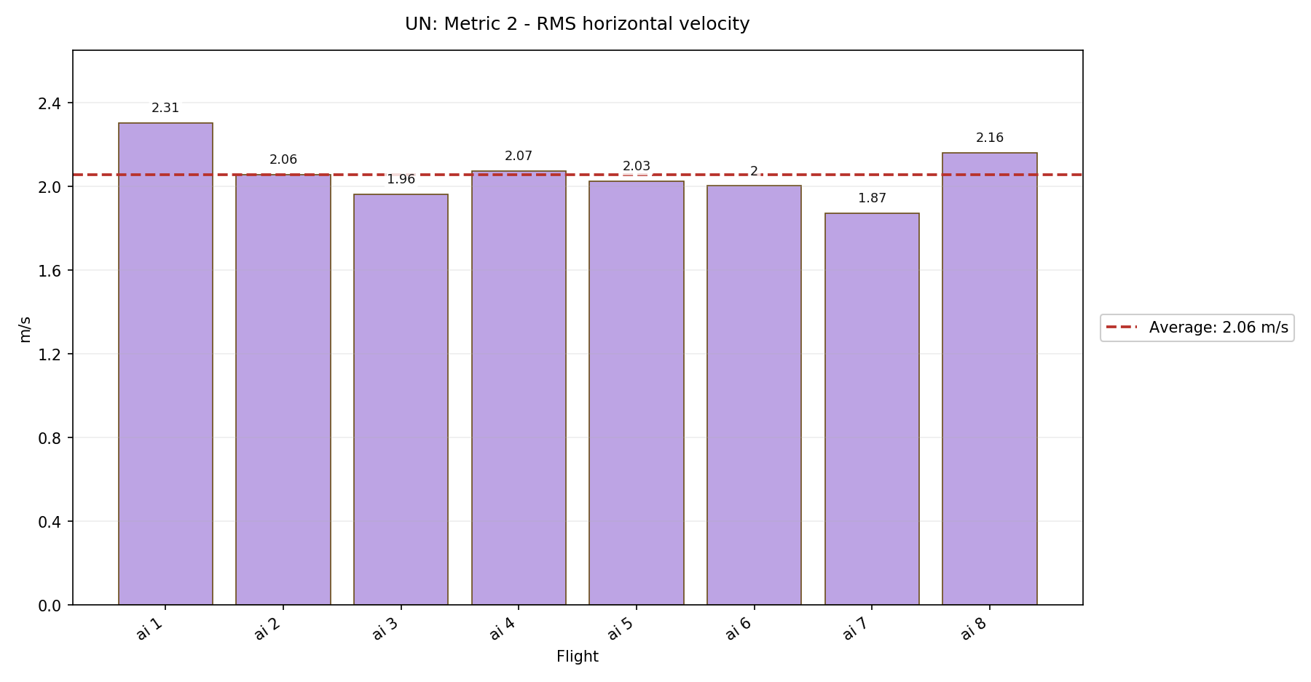

Metric 3: Peak absolute X velocity
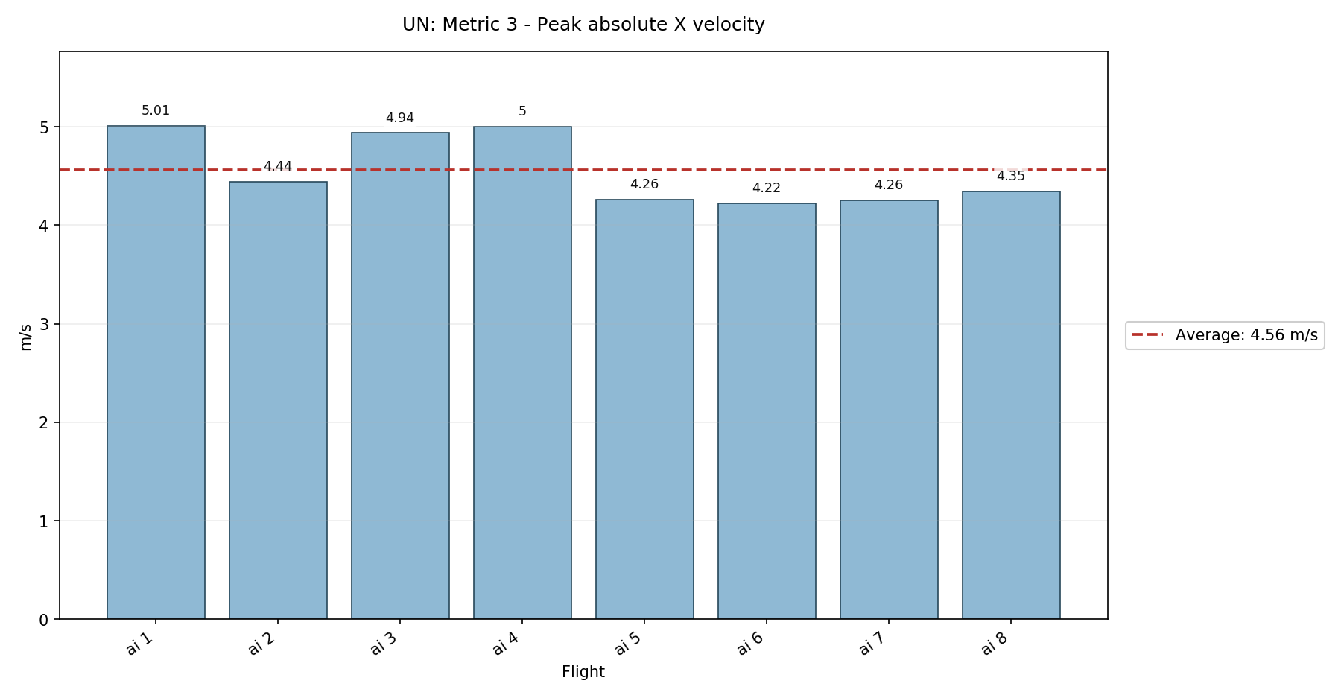

Metric 4: Peak absolute Y velocity
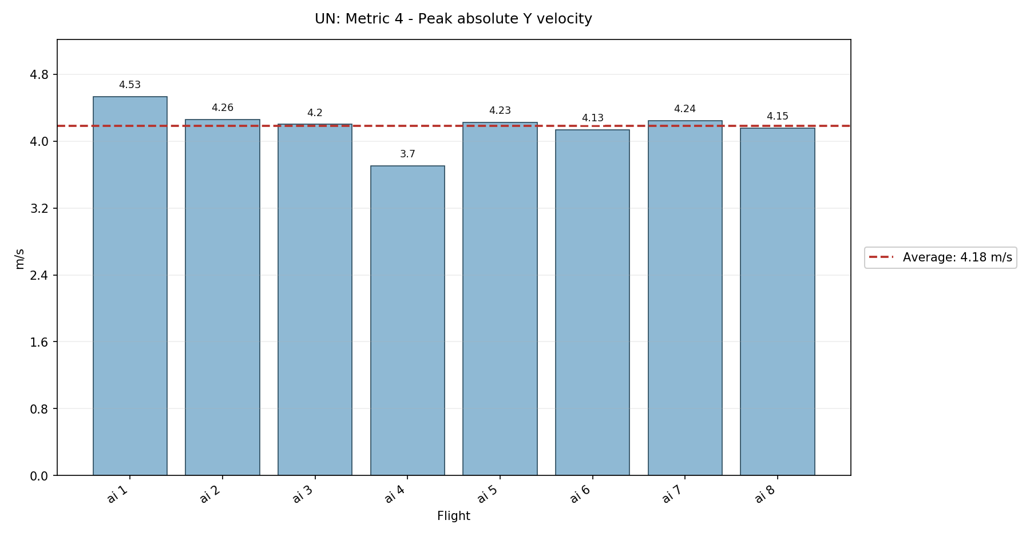

Metric 5: Peak acceleration magnitude
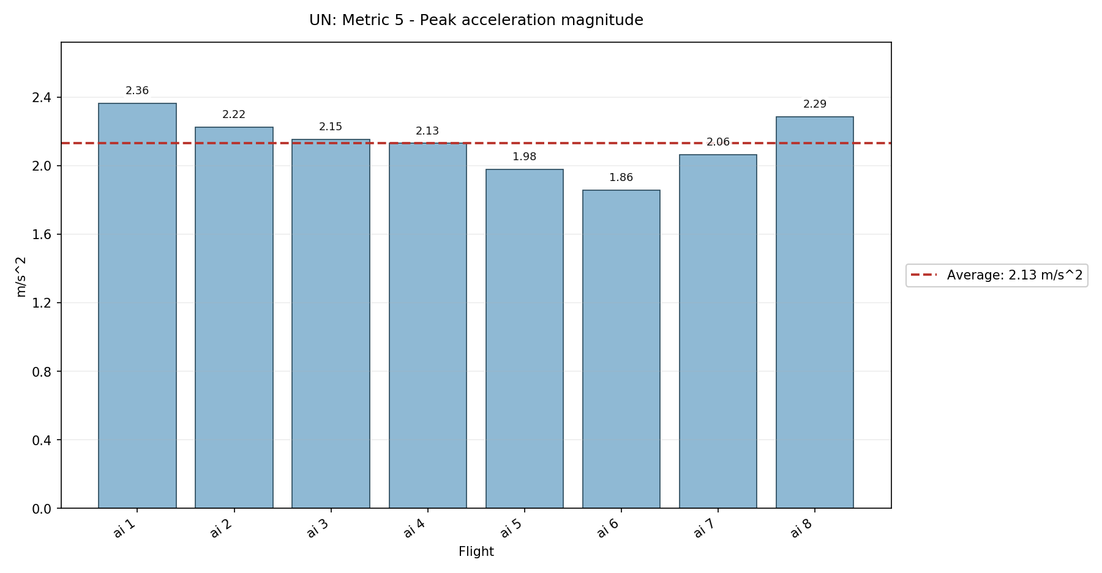

Metric 6: RMS acceleration magnitude
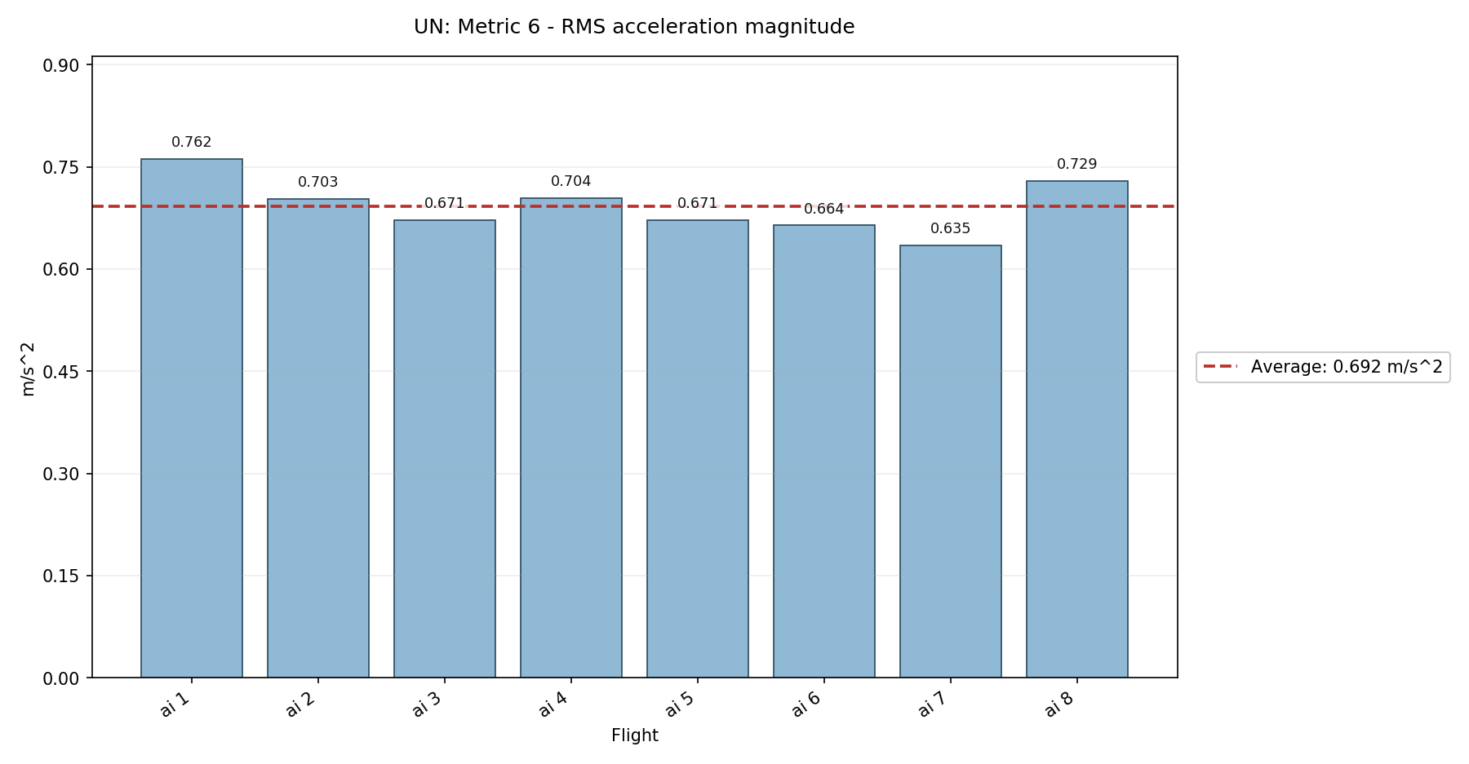

Metric 7: Peak angular rate magnitude
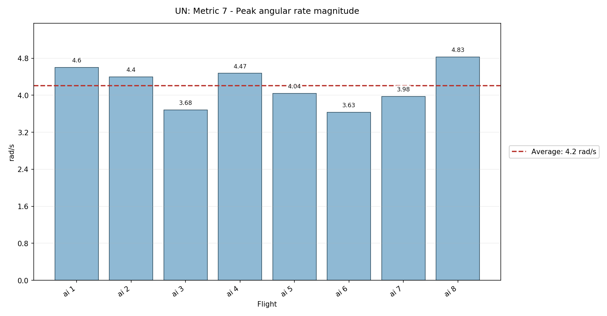

Metric 8: RMS angular rate magnitude
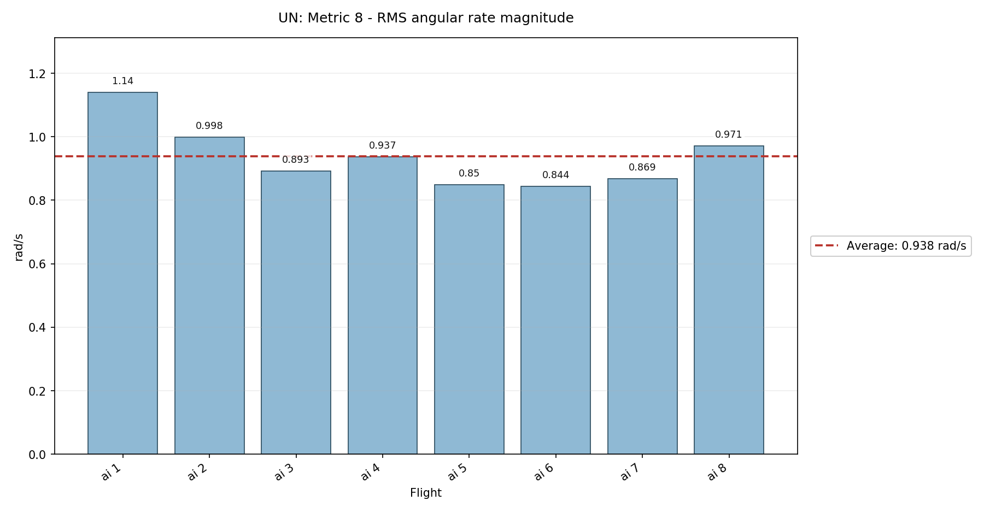

Metric 9: Minimum roll angle
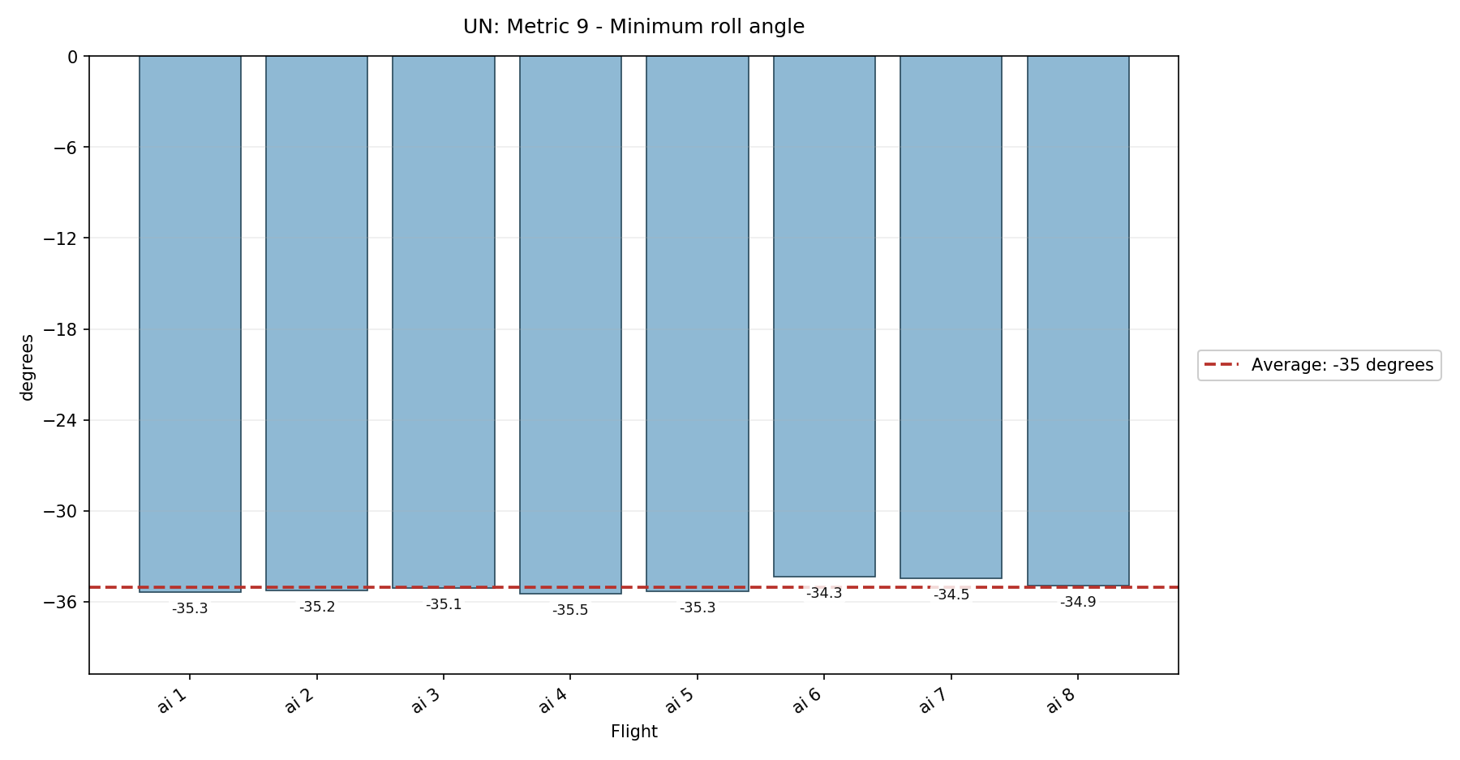

Metric 10: Maximum roll angle
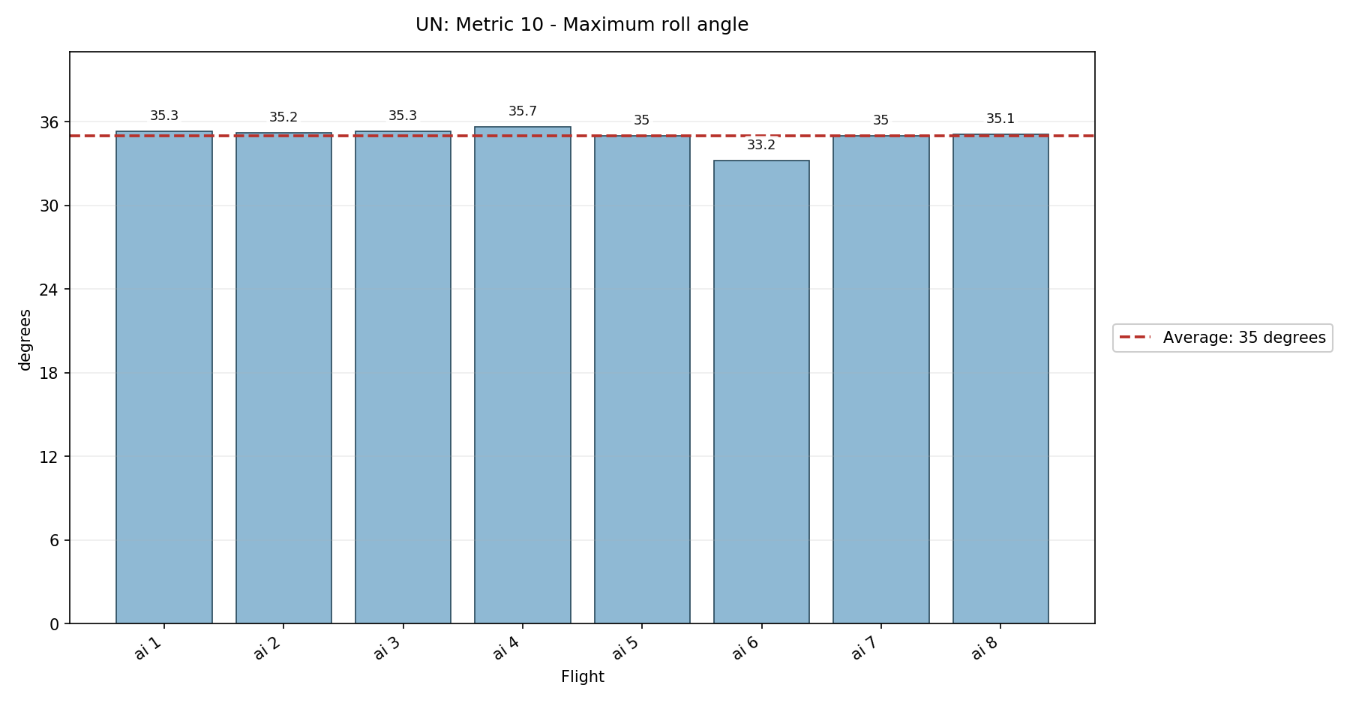

Metric 11: Peak absolute roll angle - NEW
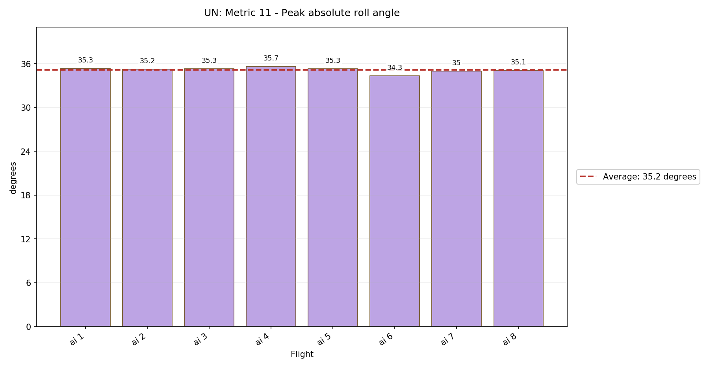

Metric 12: Minimum pitch angle
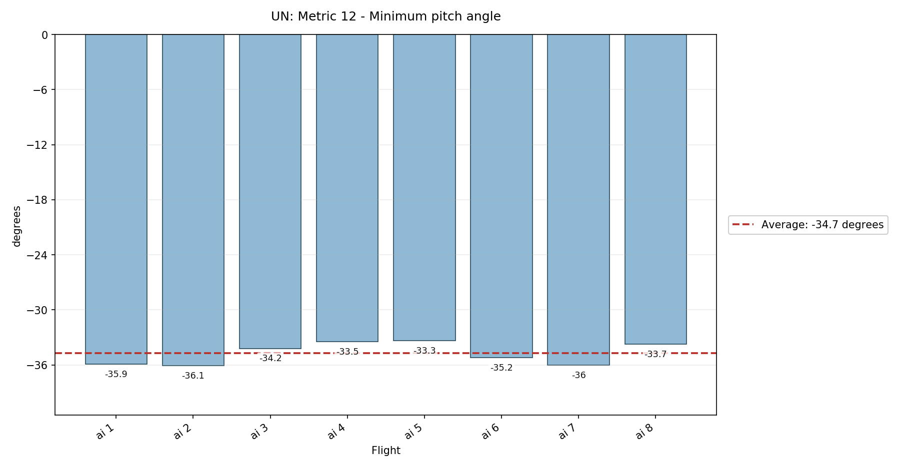

Metric 13: Maximum pitch angle
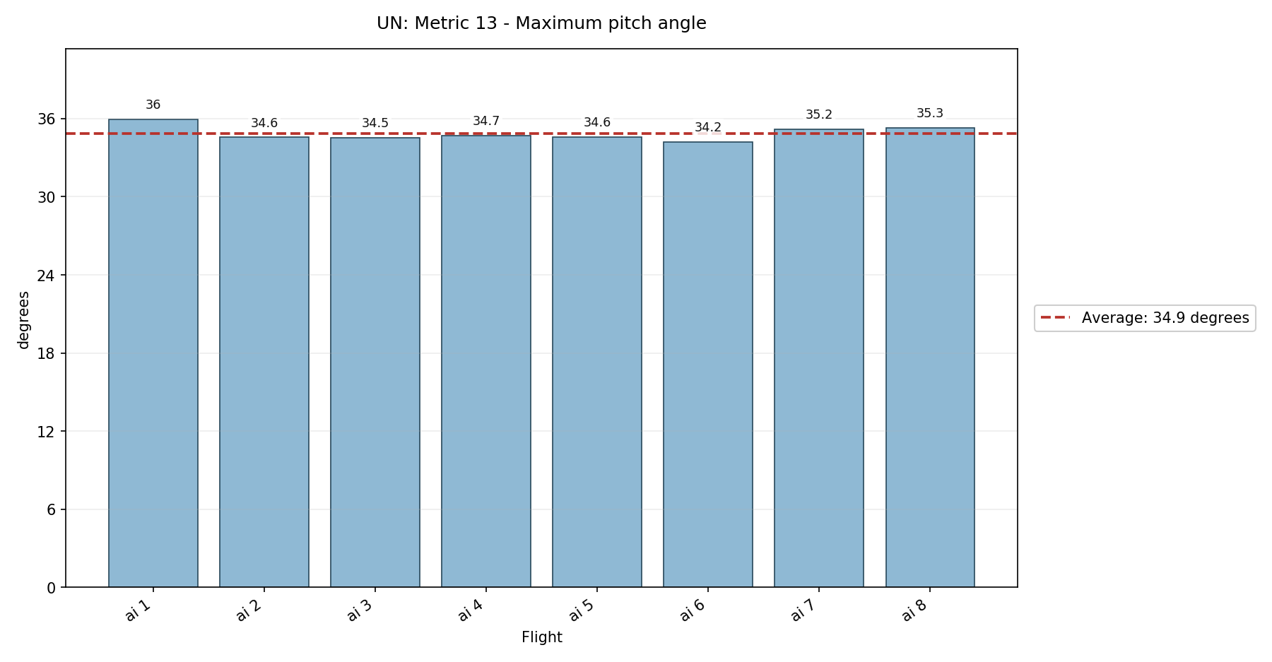

Metric 14: Peak absolute pitch angle - NEW
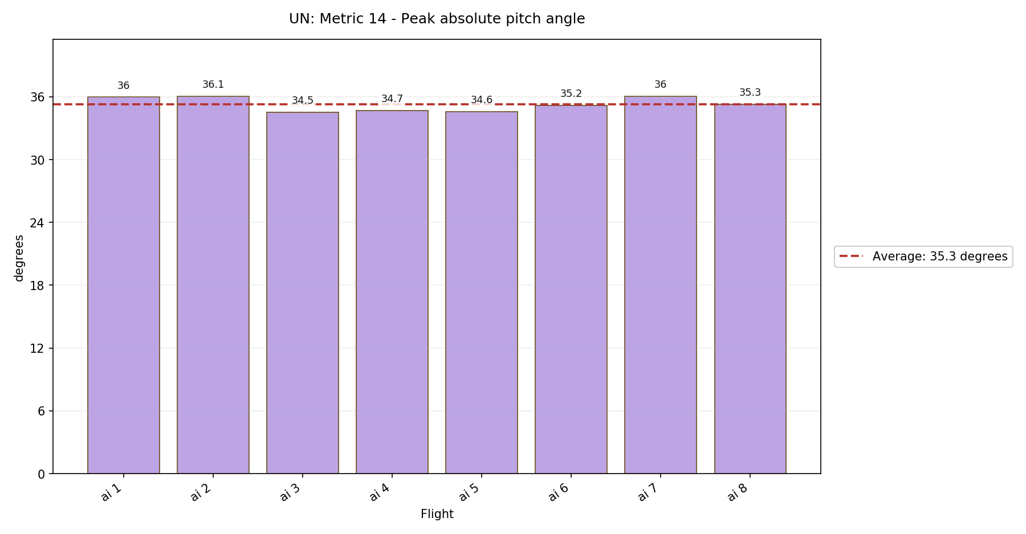

RAW
- Flights processed: 10

Metric 1: Peak horizontal velocity
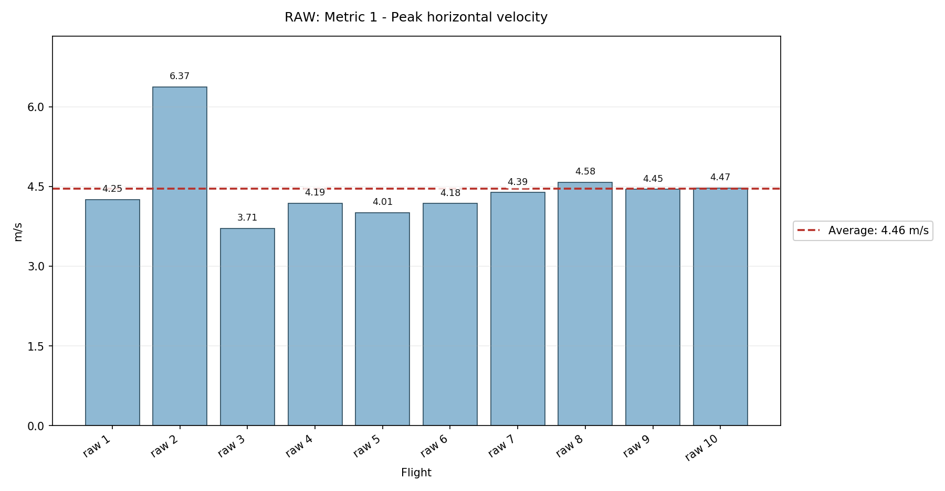

Metric 2: RMS horizontal velocity - NEW
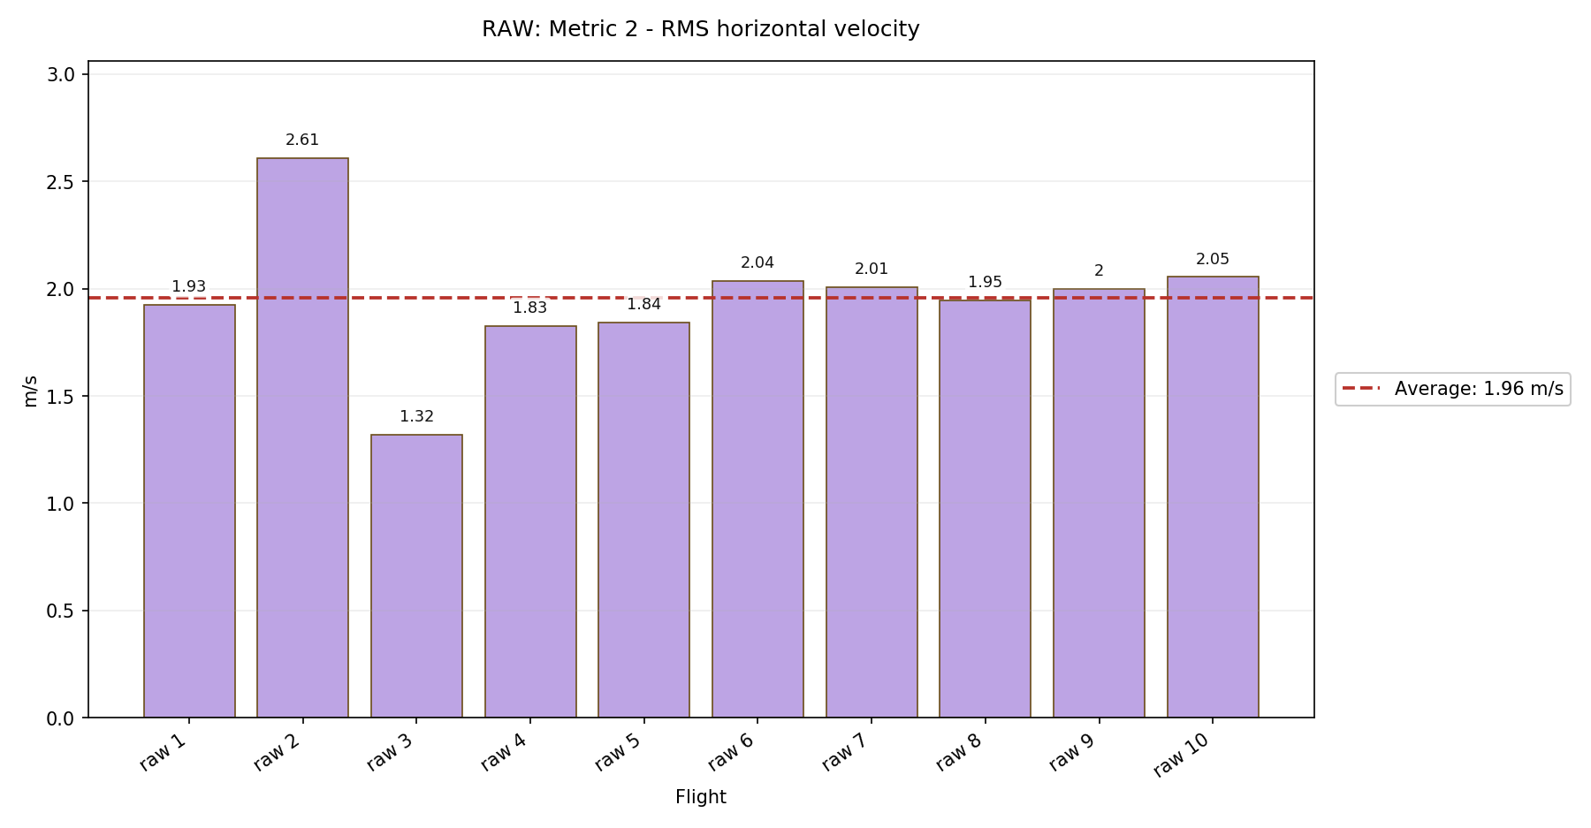

Metric 3: Peak absolute X velocity
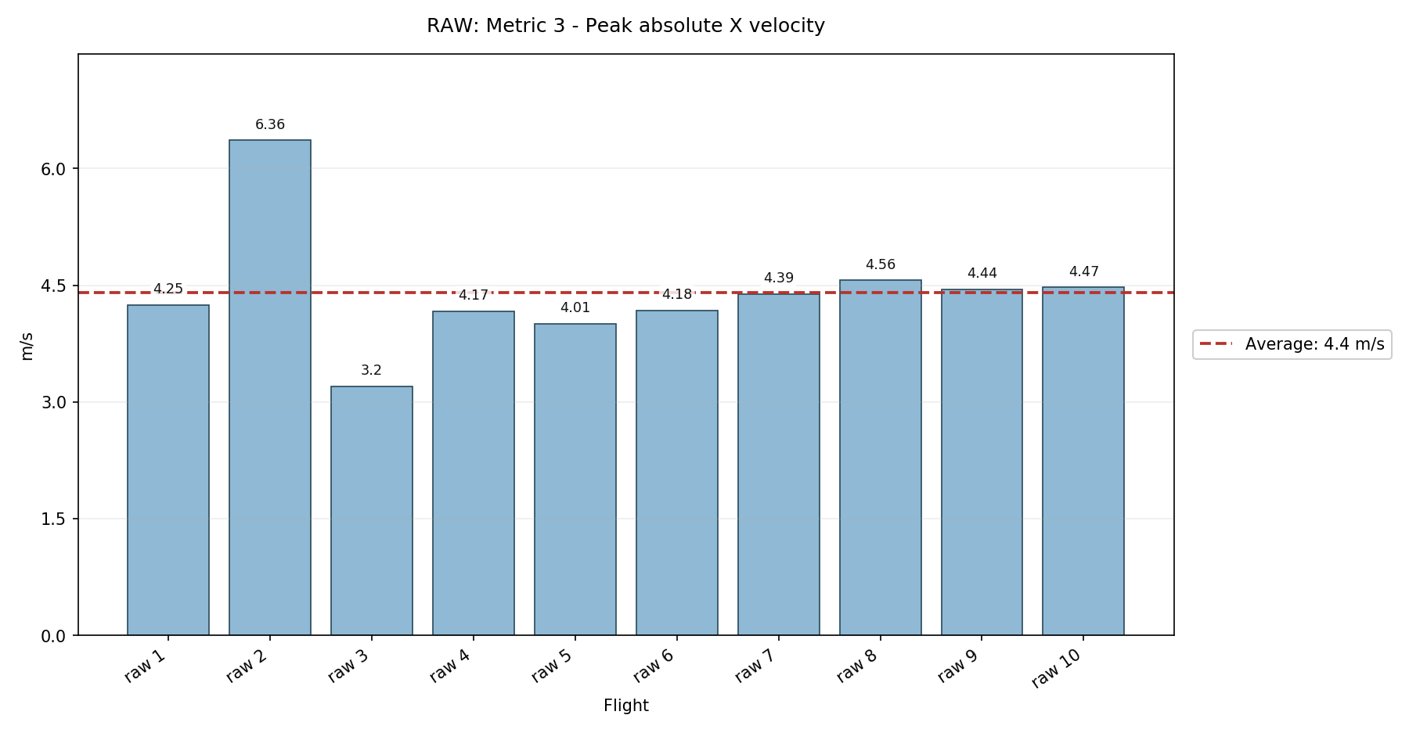

Metric 4: Peak absolute Y velocity
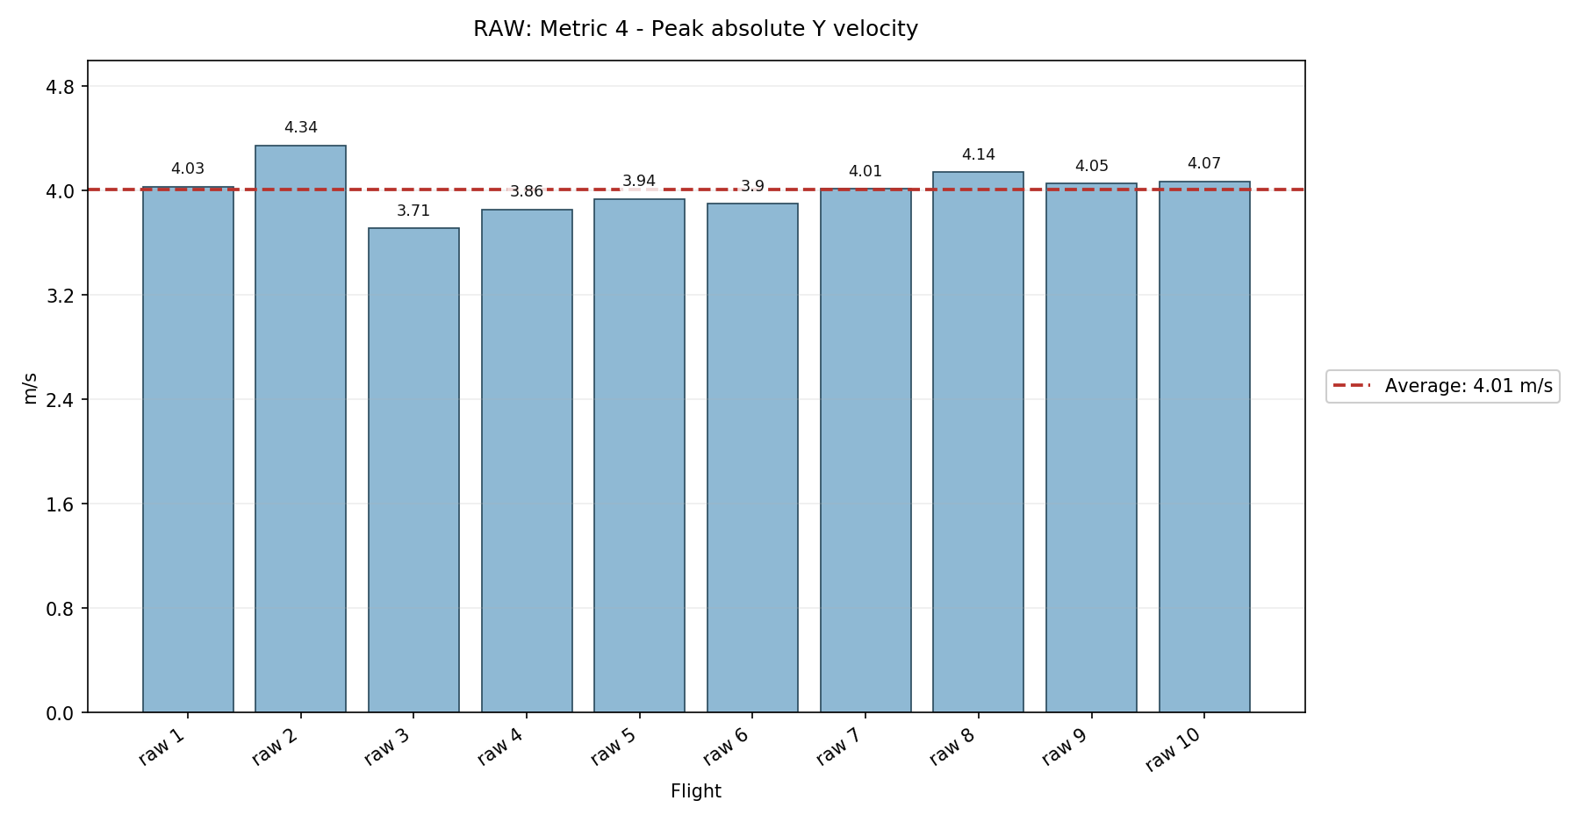

Metric 5: Peak acceleration magnitude
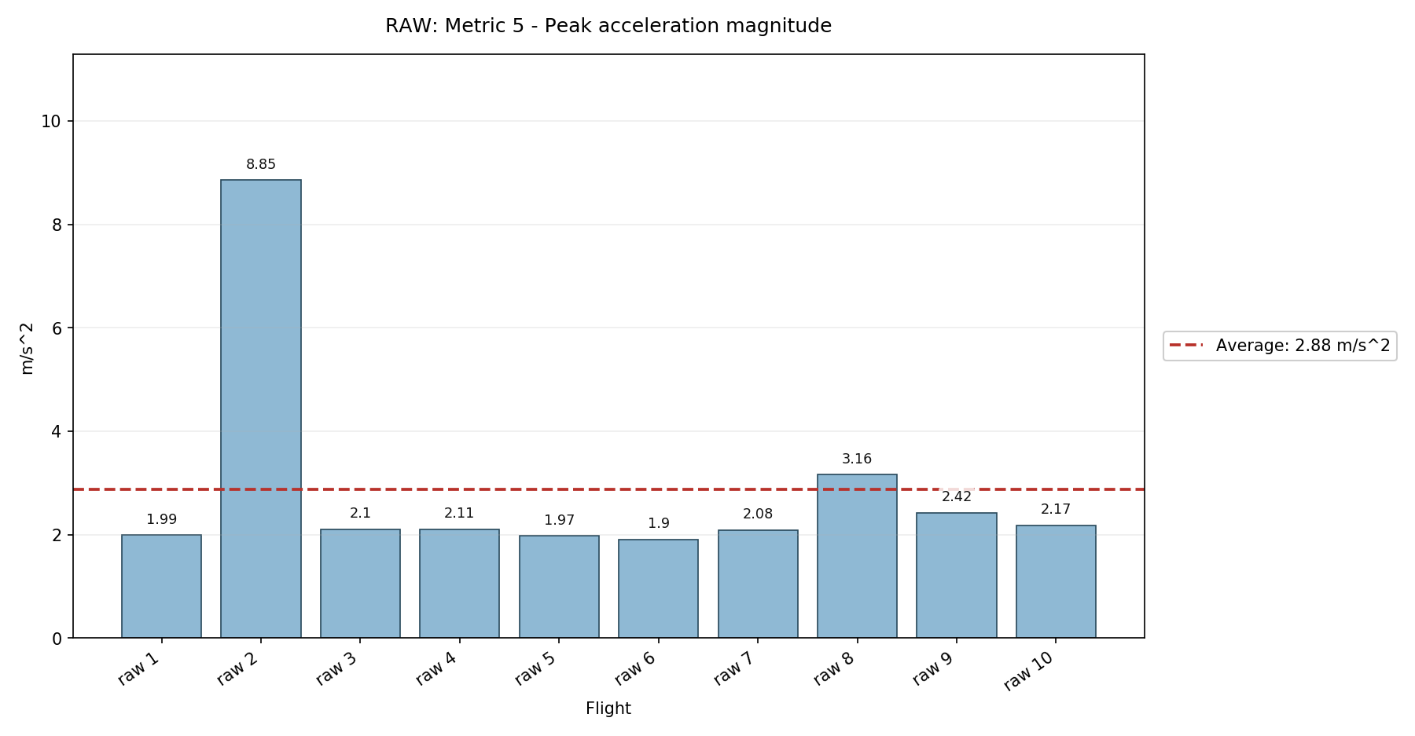

Metric 6: RMS acceleration magnitude
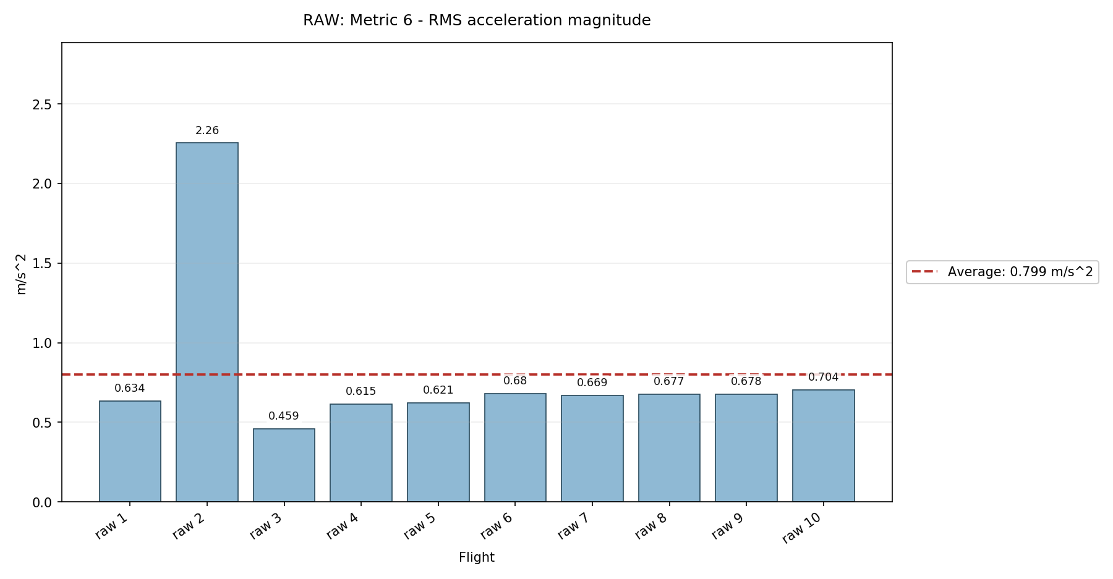

Metric 7: Peak angular rate magnitude
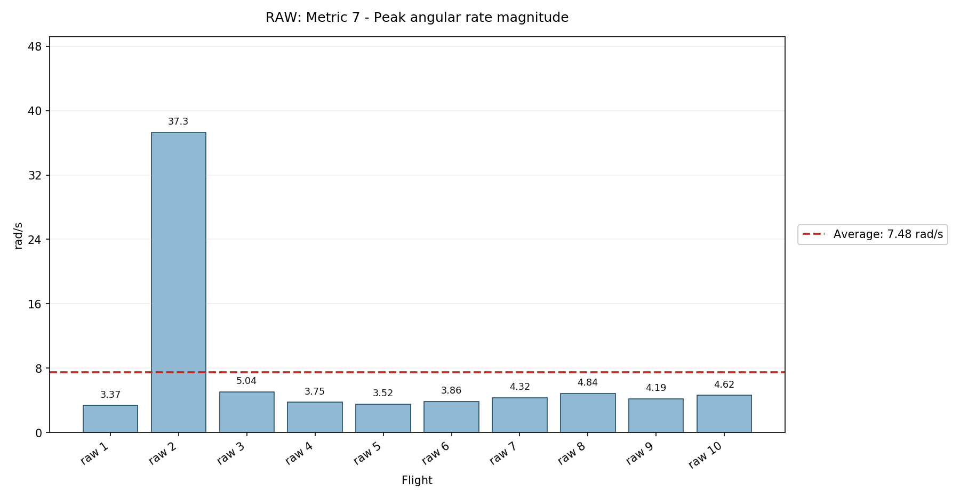

Metric 8: RMS angular rate magnitude
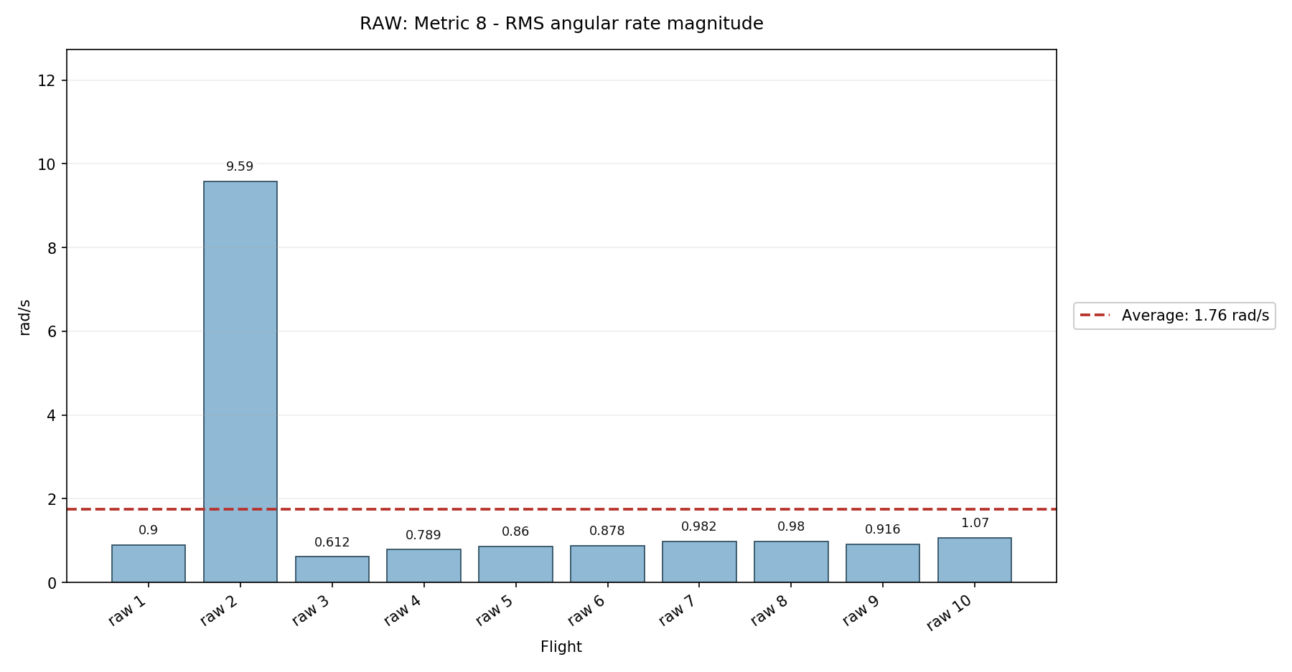

Metric 9: Minimum roll angle
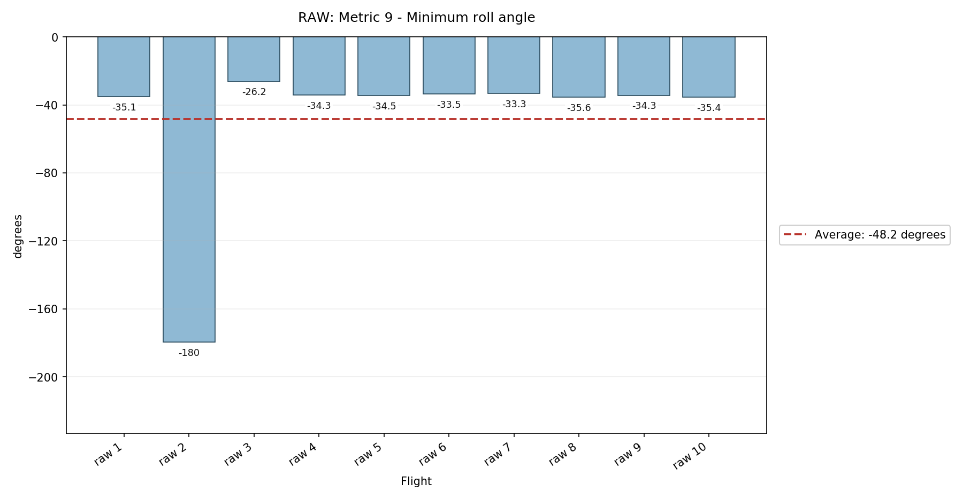

Metric 10: Maximum roll angle
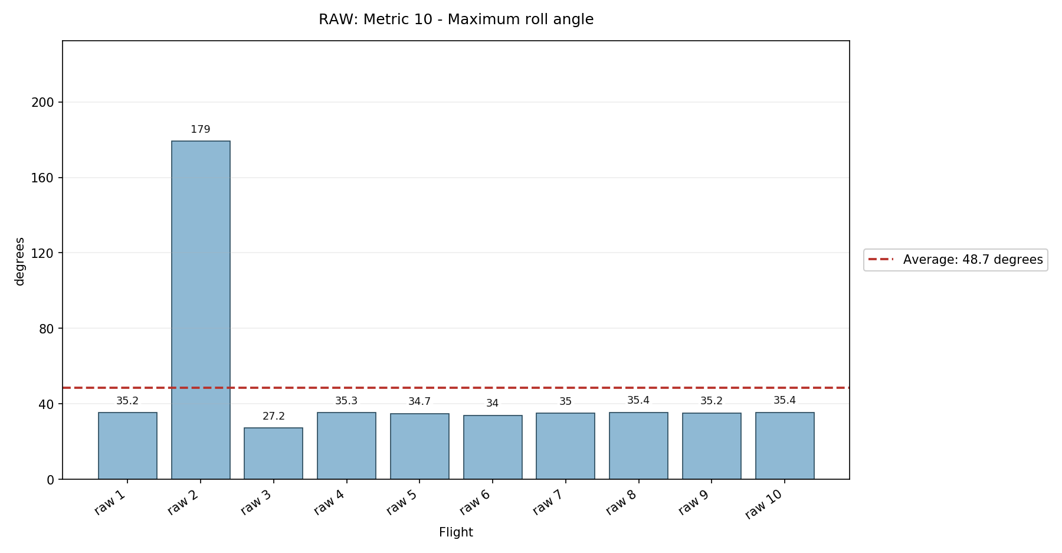

Metric 11: Peak absolute roll angle - NEW
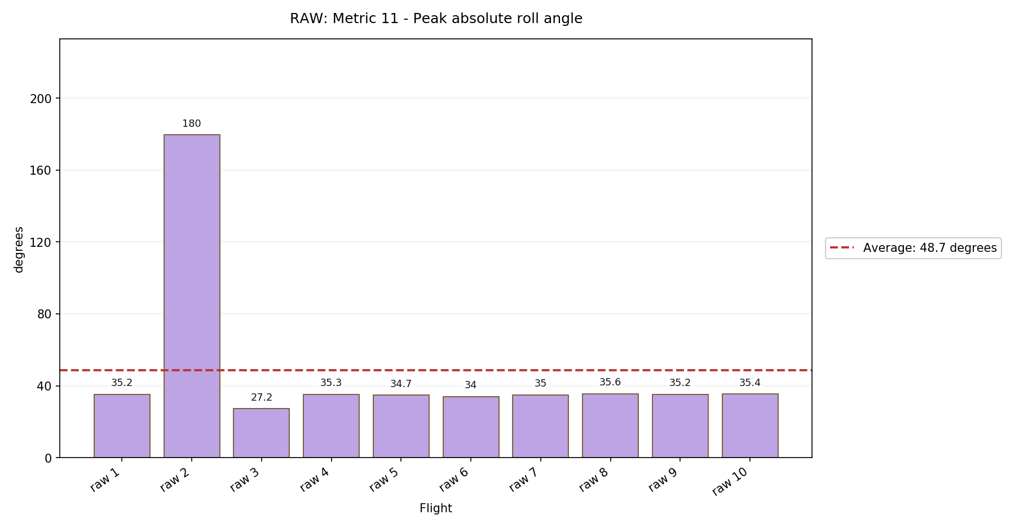

Metric 12: Minimum pitch angle
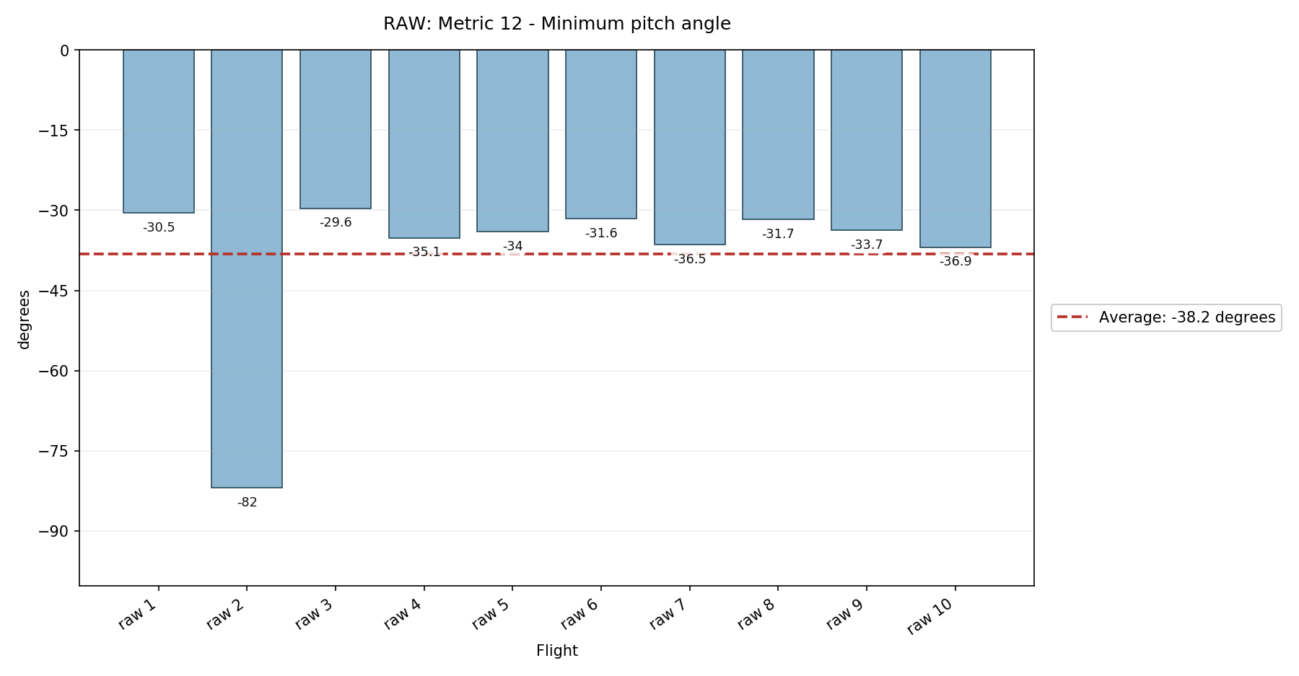

Metric 13: Maximum pitch angle
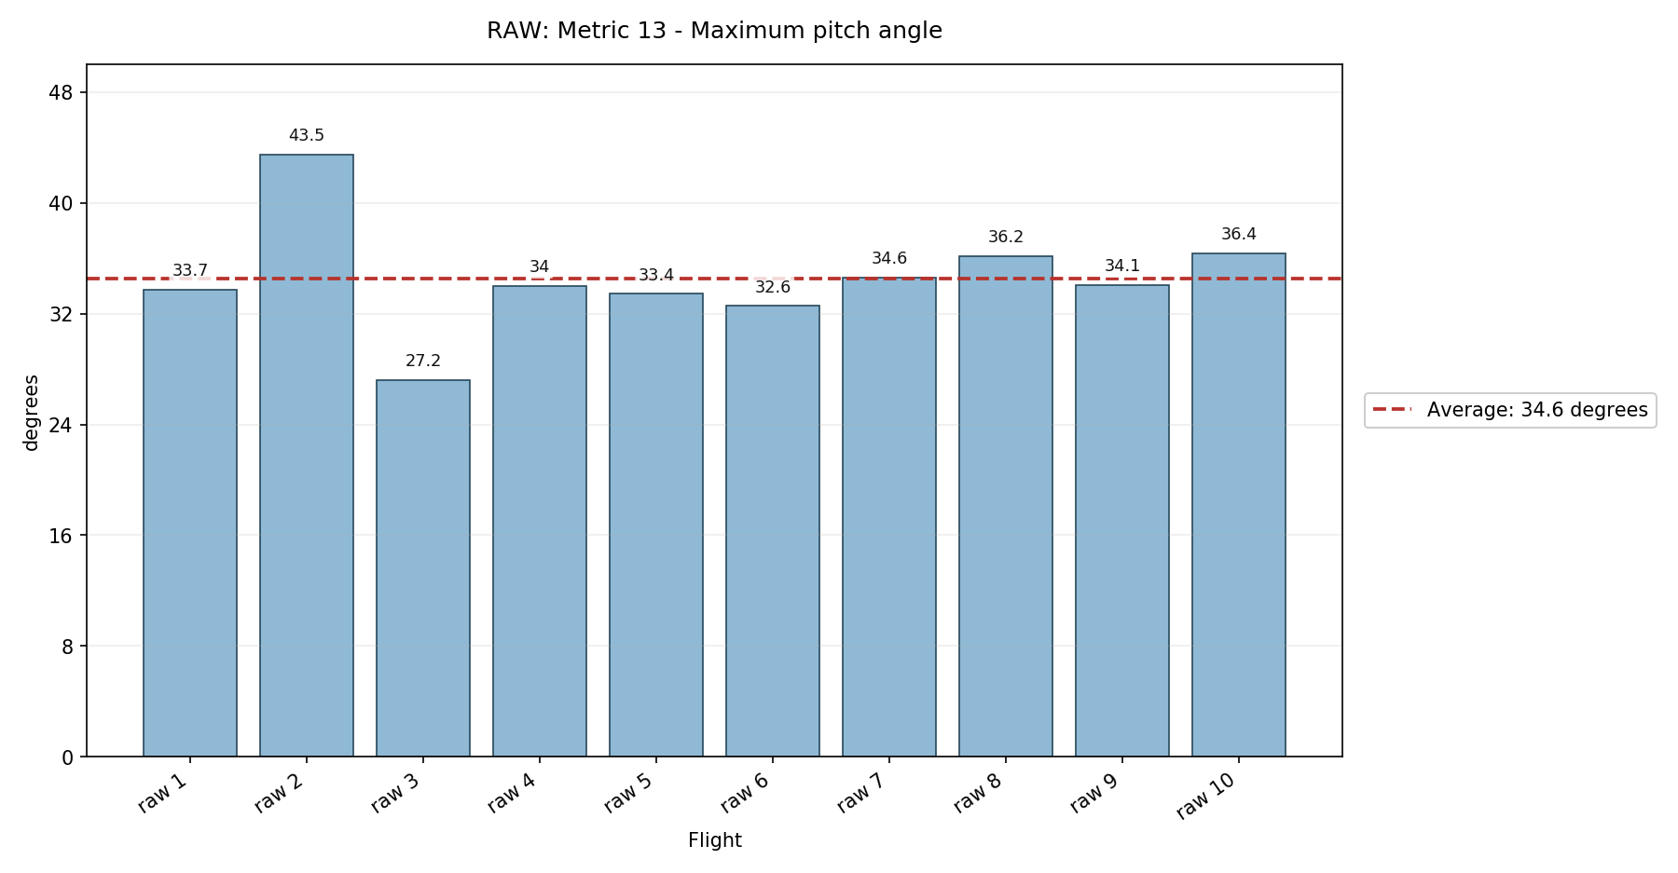

Metric 14: Peak absolute pitch angle - NEW
