Table of Contents

Java Project : Automatic Birthday Wisher 2

CONTENTS: 2

INTRODUCTION 2

Project Title: Automatic Birthday Wisher 2

Synopsis: 3

Key Features: 3

Technical Details: 4

User Interface: 4

Benefits: 4

# Java Project : Automatic Birthday Wisher

**By ,**

**23MCAB03 SOUVIK BHATTACHARYA**

**23MCAB37 VIJAY KUMAR**

# CONTENTS:

INTRODUCTION :

OVERVIEW :

REQUIREMENTS :

SNAPSHOTS :

CONCLUSION :

# INTRODUCTION

The automated birthday wisher is developed by java using the eclipse application.

The concept runs on the form of calendar events of upcoming birthdays the entered database ,

The applications runs everyday and checks for if any birthdays are coming up and wish them by sending a mail or notification.

## Project Title: Automatic Birthday Wisher

## Synopsis:

The "Automatic Birthday Wisher" is a Java-based project designed to simplify and enhance the process of sending birthday wishes to friends, family, and colleagues. In today's busy world, remembering and personally wishing everyone on their birthdays can be a challenging task. This project aims to automate this process and make it more convenient and heartfelt.

## Key Features:

User-friendly Interface: The project will have a user-friendly interface where users can input and manage their contact list with birthdays and customize their birthday wishes.

Contact Management:

Users can add, edit, and delete contacts, including their names and birthdates. The system will store this information for future reference.

## Automated Wishing:

The core functionality of the project is to automatically send birthday wishes to contacts on their respective birthdays. The system will generate personalized birthday messages based on predefined templates and the contact's name.

Template Customization: Users can create and customize birthday wish templates to add a personal touch to their messages. They can include variables like the contact's name and other details in these templates.

Notification System:

The system will send notifications or reminders to users on the day before a contact's birthday, allowing them to review and make any last-minute changes to their birthday wishes.

Multi-platform Support:

The project can be designed to work on various platforms, including desktop and mobile, making it accessible to a wide range of users.

Data Security:

The project will implement security measures to protect the contact list and user data, ensuring privacy and confidentiality.

## Technical Details:

Programming Language: Java will be used as the primary programming language due to its platform independence and extensive libraries.

Database: A database system, such as MySQL or SQLite, will be used to store contact information securely.

User Interface: JavaFX or Swing can be used to create a user-friendly graphical user interface (GUI).

Automated Messaging: Integration with email or messaging APIs (e.g., JavaMail API) will be necessary to send automated birthday wishes.

Notification Service: Implementing a notification system may require libraries or APIs like Java's TimerTask or external services like Firebase Cloud Messaging (FCM).

## Benefits:

Saves time and effort in manually sending birthday wishes.

Ensures that no birthdays are forgotten or overlooked.

Allows for personalized and heartfelt messages.

Enhances user organization and contact management.

The "Automatic Birthday Wisher" Java project aims to simplify the process of celebrating birthdays, making it easier to maintain personal connections and strengthen relationships through thoughtful birthday greetings.

SNAPSHOTS

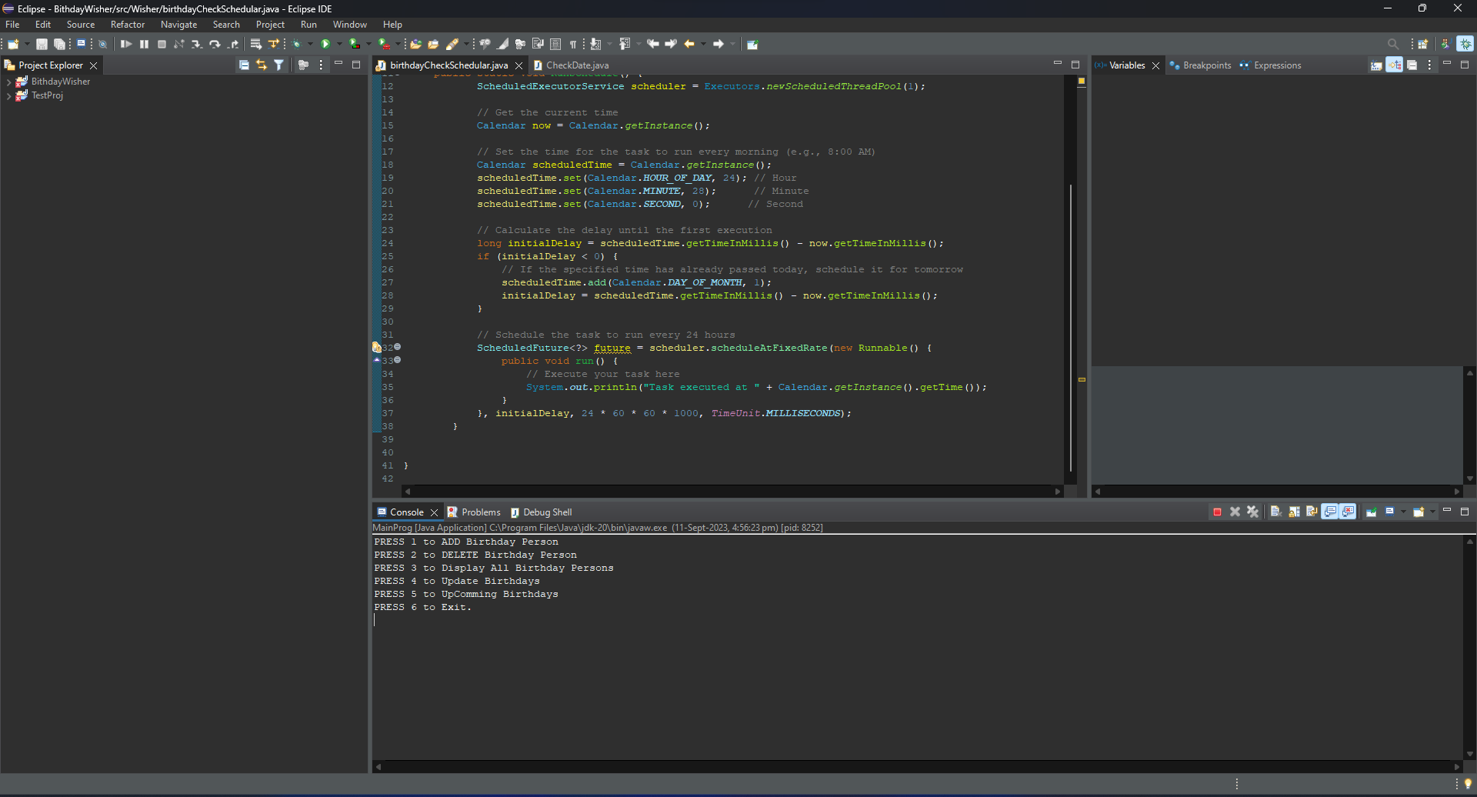

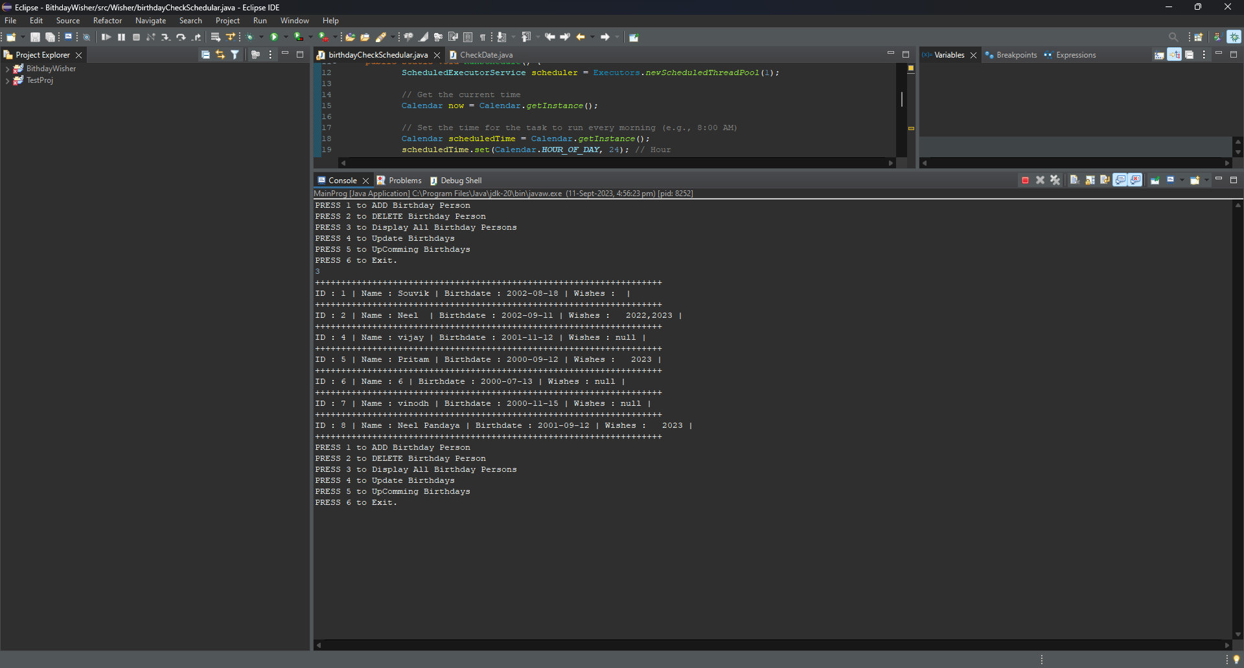

CONCLUSION

In conclusion, the Automatic Birthday Wisher is a Java-based application that offers a convenient and personalized solution for managing and celebrating birthdays. Its user-friendly interface, contact management capabilities, and automated reminder system make it a valuable tool for individuals looking to stay connected with their friends and family. The application's customization options, multiple notification methods, and scheduling features provide users with flexibility in how they send birthday wishes.

Moreover, the emphasis on security and data management ensures that user information is kept safe and accessible when needed. The ability to back up and restore the contact database adds an extra layer of reliability to the application.