Combinatorial Game Theory
Combinatorial game theory (CGT) is a branch of mathematics and theoretical computer science that typically studies sequential games with perfect information. Study has been largely confined to two-player games that have a position in which the players take turns changing in defined ways or moves to achieve a defined winning condition. CGT has not traditionally studied games of chance or those that use imperfect or incomplete information, favoring games that offer perfect information in which the state of the game and the set of available moves is always known by both players.Combinatorial games ( CG ) have following propertys:
- There are two players.
- There is a finite set of positions available in the game (only on rare occasions will we mention games with infinite sets of positions).
- Rules specify which game positions each player can move to.
- Players alternate moving.
- The game ends when a player can’t make a move.
- The game eventually ends (it’s not infinite).
Chess, Game of Nim, Tic-Tac-Toe all comes under the category of CGT.
We can divide these CG into two categories as shown below:
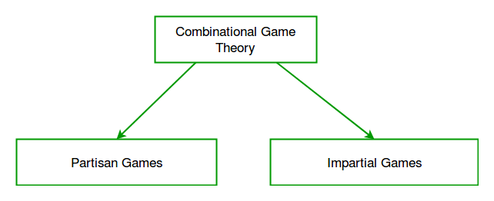
The difference between them is that in Impartial Games ( IG ) all the possible moves from any position of game are the same for the players, whereas in Partisan Games ( PG ) the moves for all the players are not the same.
Game of Nim,Sprouts are example of IG and Chess,GO are example of PG.

Impartial Games
In this type of game, the set of allowable moves depends only on the position of the game and not on which of the two players is moving. We will take Game of Nim as an example of IG.

The Game of Nim
We first look at the simple game of Nim as IG.There are many versions of this game, but we will look at one of the most common and to solve it different ways.

How to Play
For simplicity let there is three piles or nim-heaps, of stones.Players 1 and 2 alternate taking off any number of stones from a pile until there are no stones left.There are two possible versions of this game and two corresponding winning strategies that we will see.

Normal Play:
The player to take the last stone (or in general to make the last move in a game) wins. This is called normal play since most impartial games are played this way, although Nim usually is not.

Misere Play:
The player that is forced to take the last stone loses.
An example normal play game is shown below:
Sizes of heaps Moves
A B C
3 4 5 I take 2 from A
1 4 5 You take 3 from C
1 4 2 I take 1 from B
1 3 2 You take 1 from B
1 2 2 I take entire A heap leaving two 2’s.
0 2 2 You take 1 from B
0 1 2 I take 1 from C leaving two 1’s.
0 1 1 You take 1 from B
0 0 1 I take entire C heap and win.

