Sample Project
Step 1 – Create a github repository - https://github.com/souvik925saha/spring-boot-hello-world
Step 2 – Launched an instance. Set the inbound rules in the security group and set custom TCP to 8080 because Jenkins server runs in 8080 port.
Step 3 – setup the Jenkins server
- sudo apt update
- sudo apt install fontconfig openjdk-21-jdk -y
- sudo wget -O /etc/apt/keyrings/jenkins-keyring.asc https://pkg.jenkins.io/debian-stable/jenkins.io-2026.key
- echo "deb [signed-by=/etc/apt/keyrings/jenkins-keyring.asc] https://pkg.jenkins.io/debian-stable binary/" | sudo tee /etc/apt/sources.list.d/jenkins.list > /dev/null
- sudo apt update
- sudo apt install jenkins -y
- sudo systemctl start jenkins
- sudo systemctl enable jenkins
- sudo systemctl status Jenkins
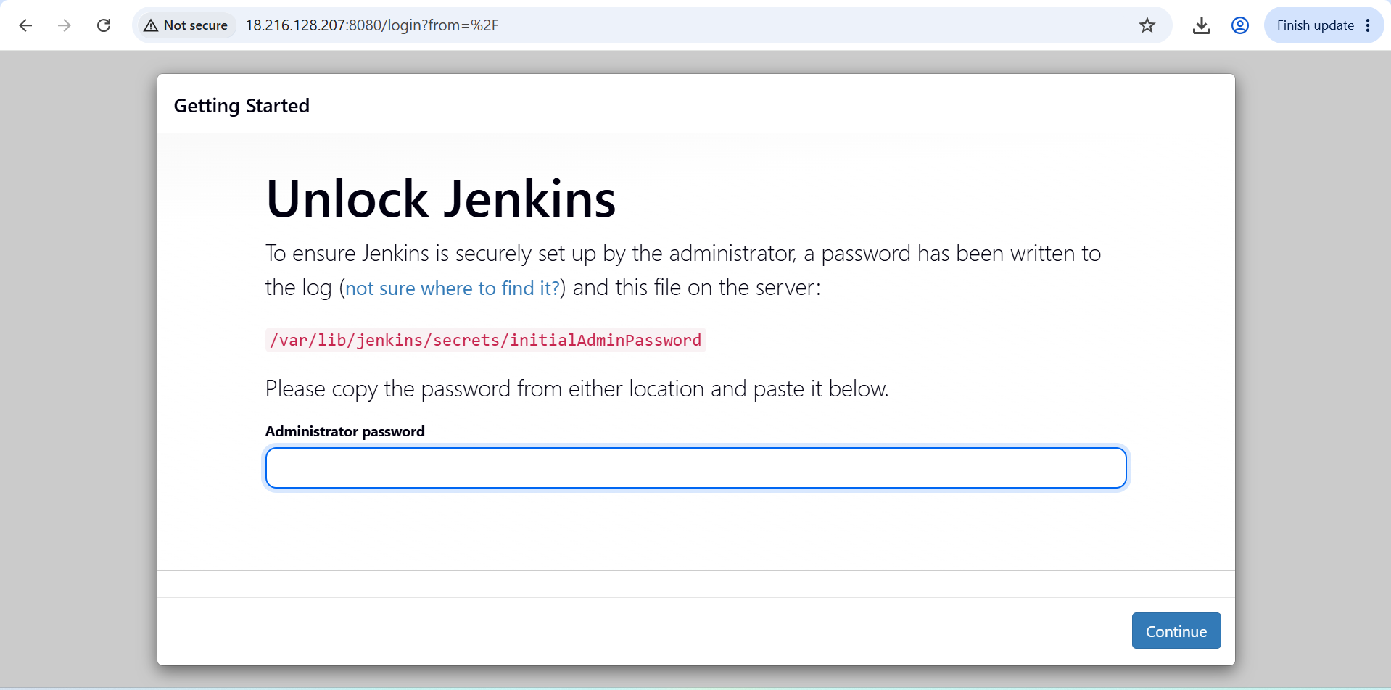
Jenkins url - http://18.216.128.207:8080/
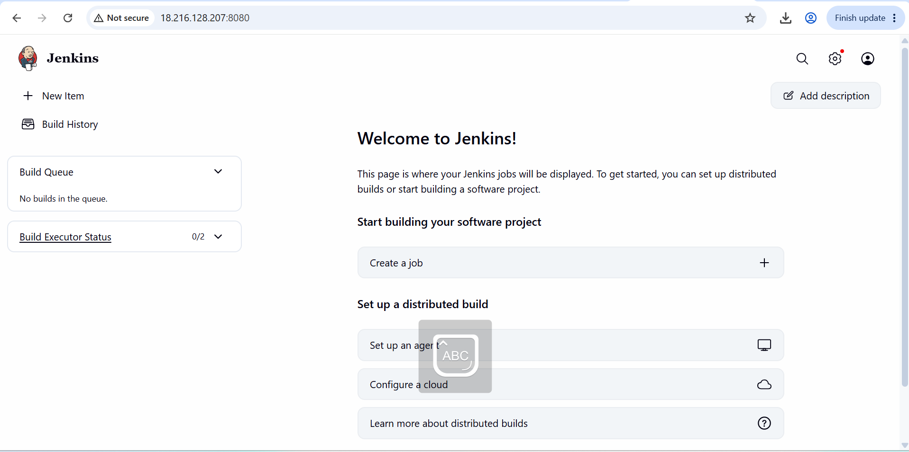
Step 4 – Build the hello world application in Jenkins. For this we need maven integration to be instated in Jenkins.
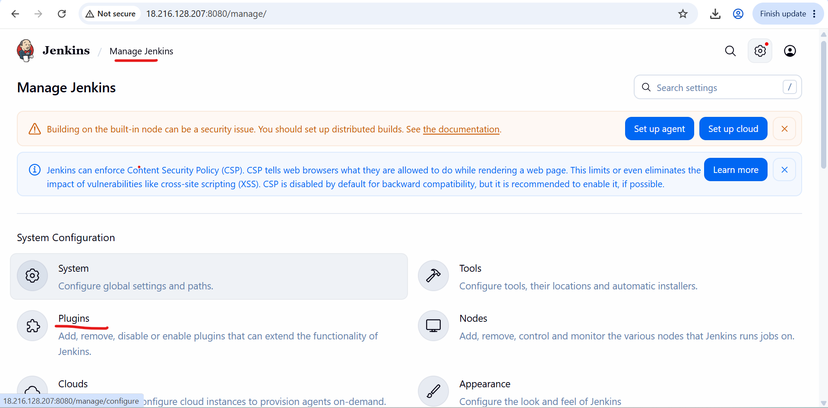
In side plugins section, we need to go available plugin, then we need to search maven integration 3.27.
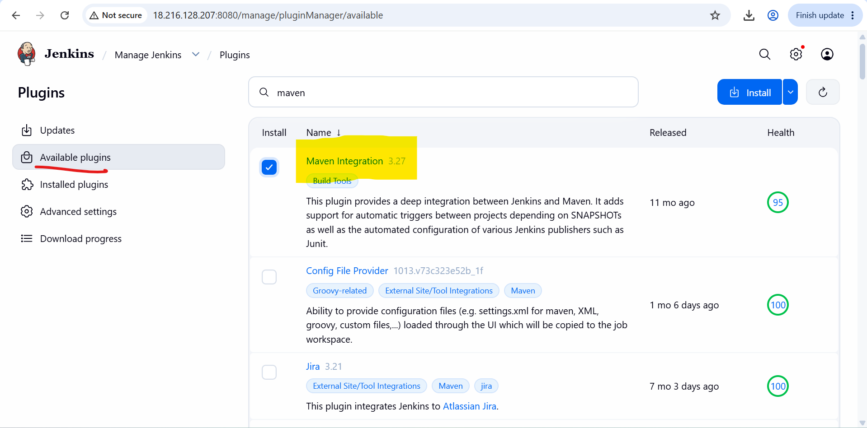
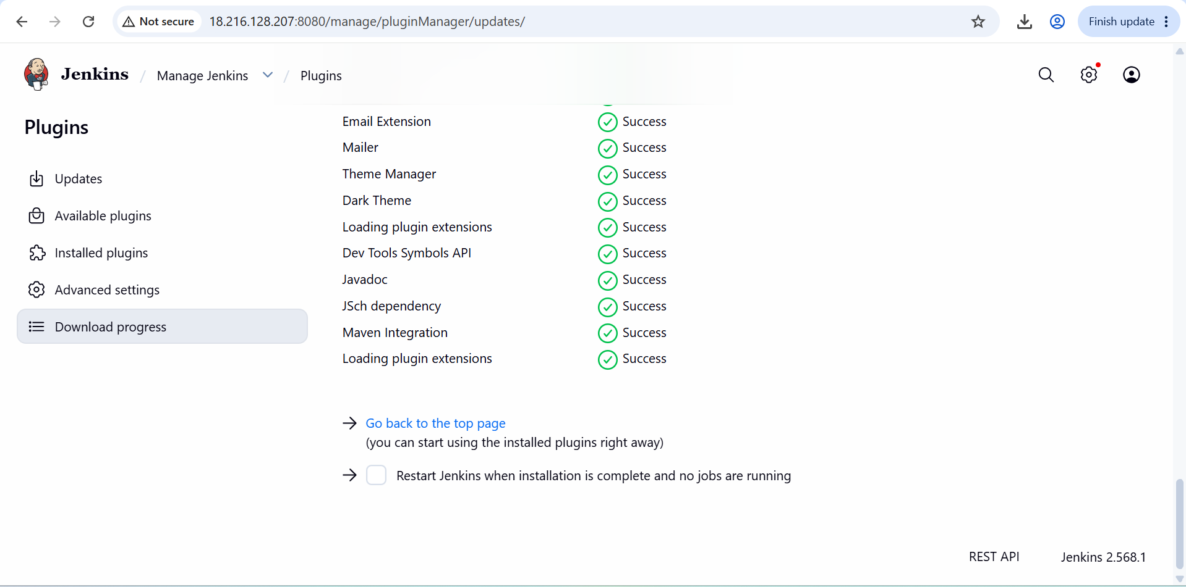
Maven integration is downloaded. Now we need to install it. For this we need to go to tools section under manage Jenkins. Then click on Apply and Save.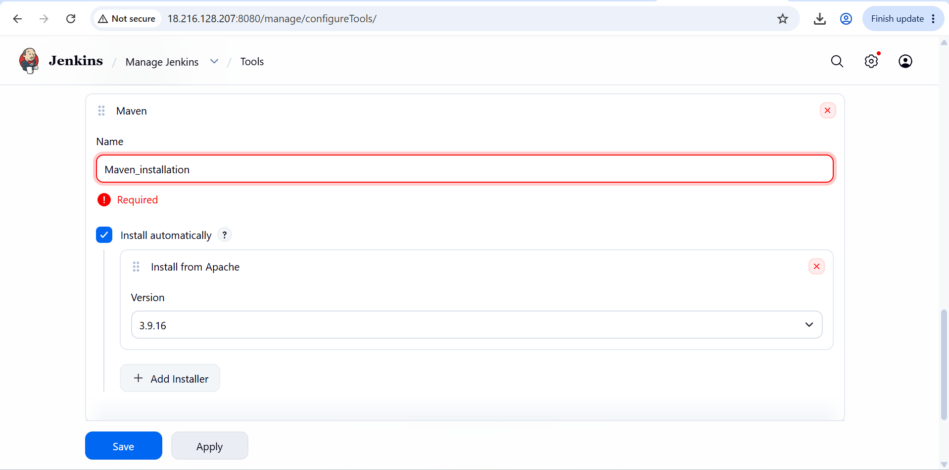
Now click on new item to build the hello world application. Give the name of the application and select ‘Maven project’. Then click on ‘OK’.
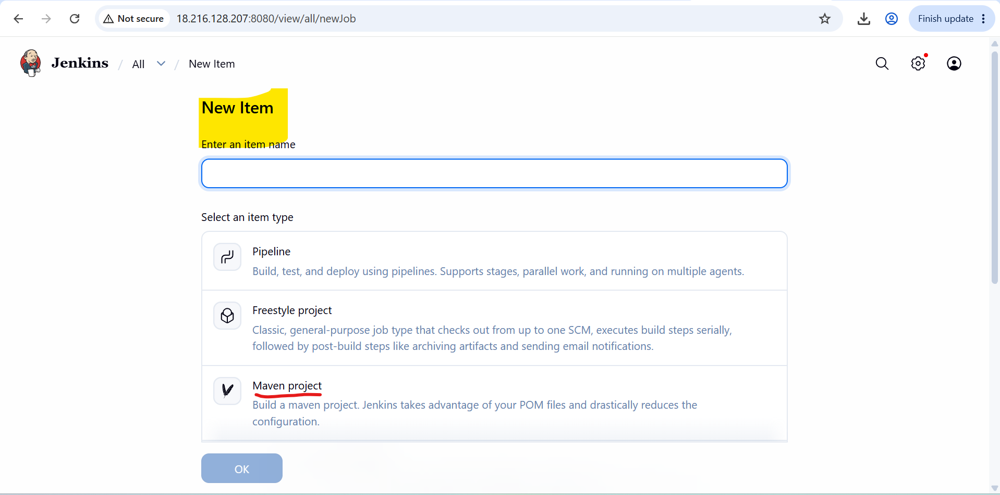
In the next page select ‘Github project’ under general. Give the project url without ‘.git’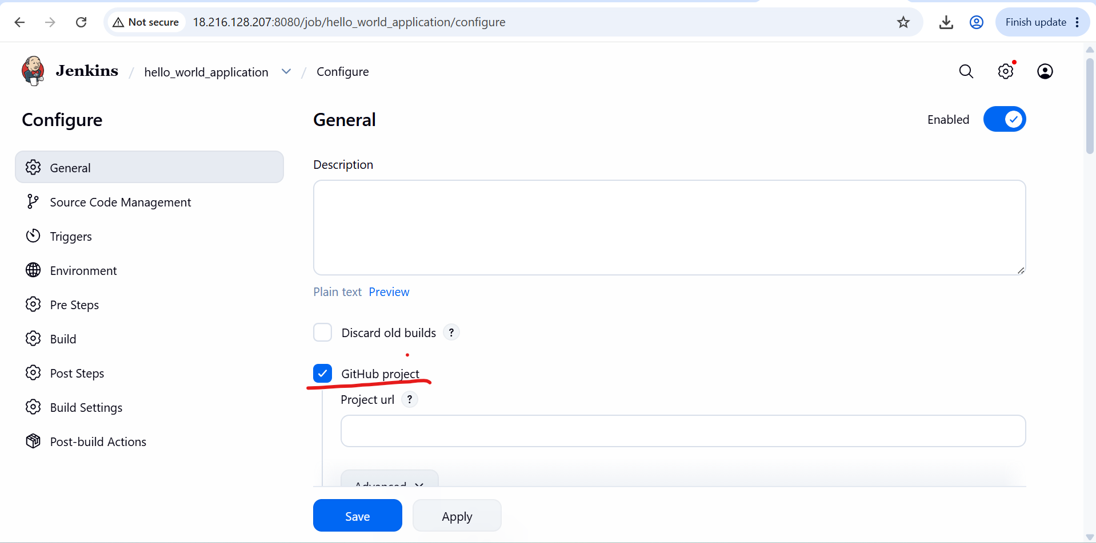
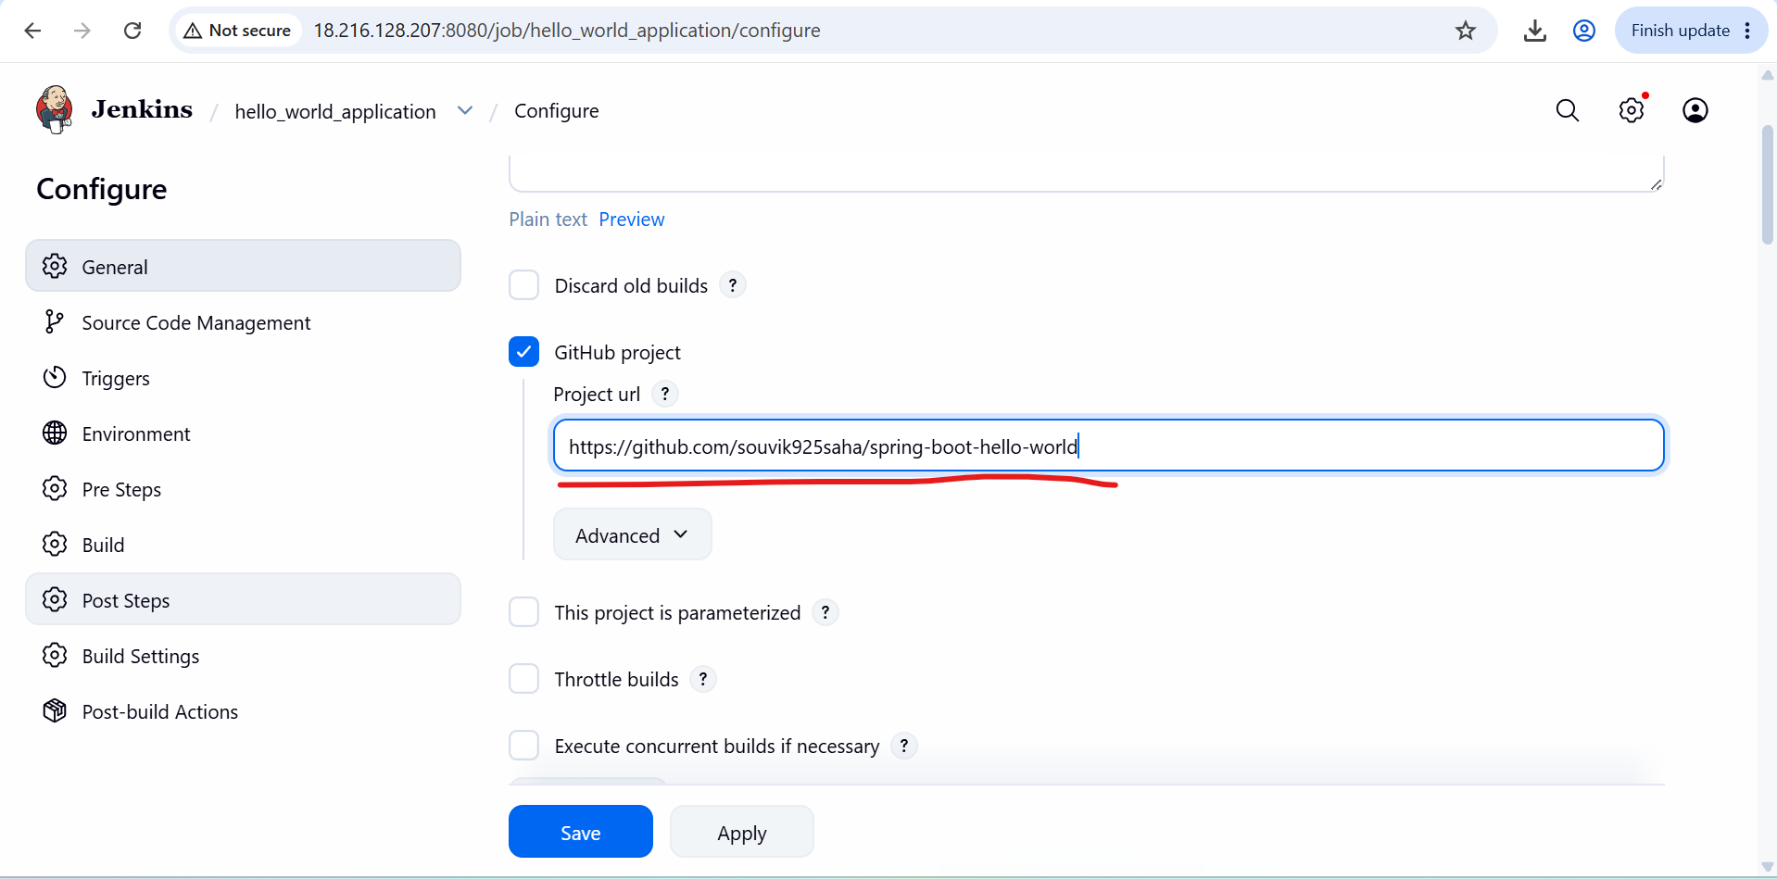
Then select ‘git’ under source code management. Then give the github url ‘https://github.com/souvik925saha/spring-boot-hello-world.git’
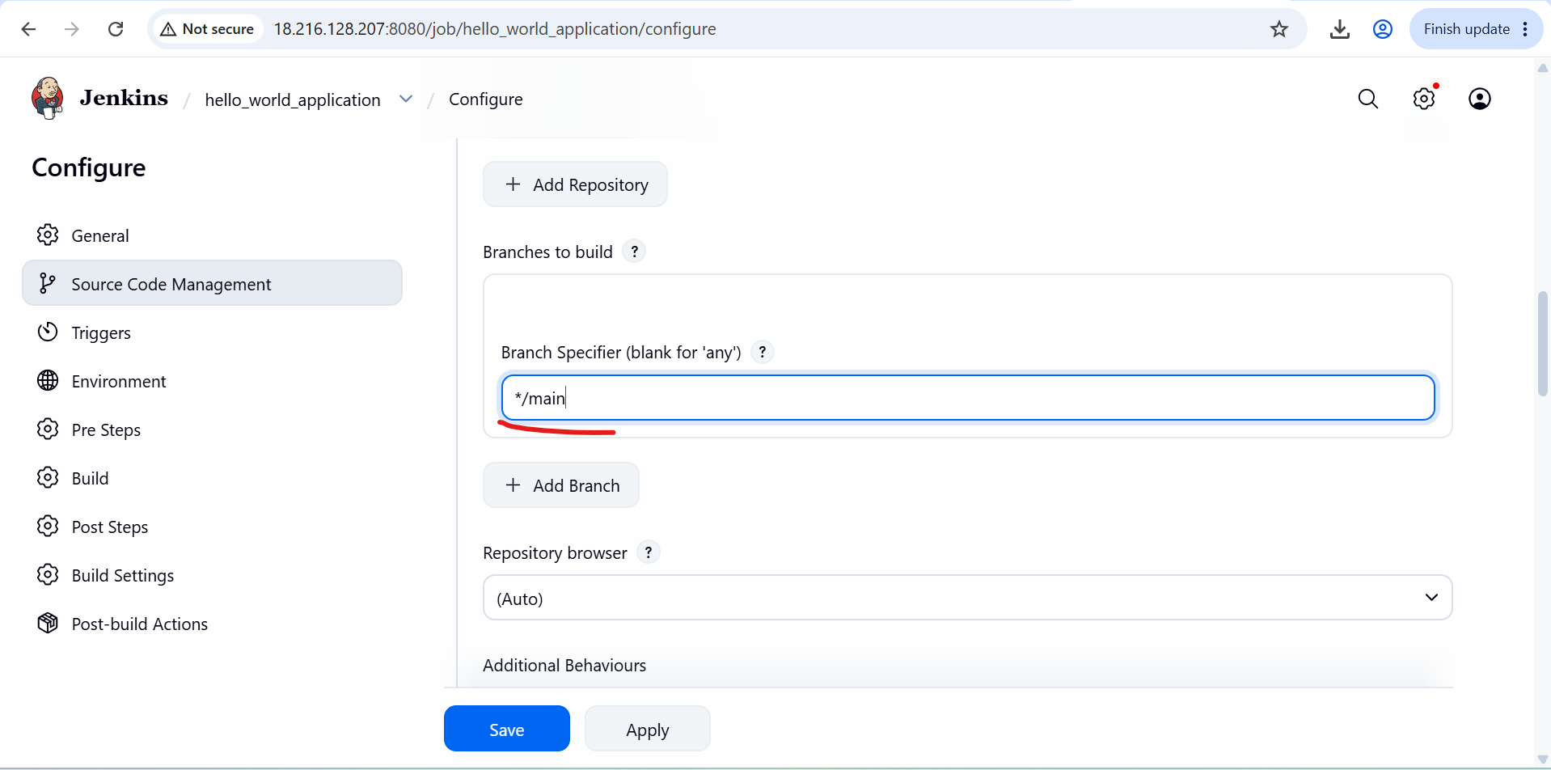
Then click on apply and save.
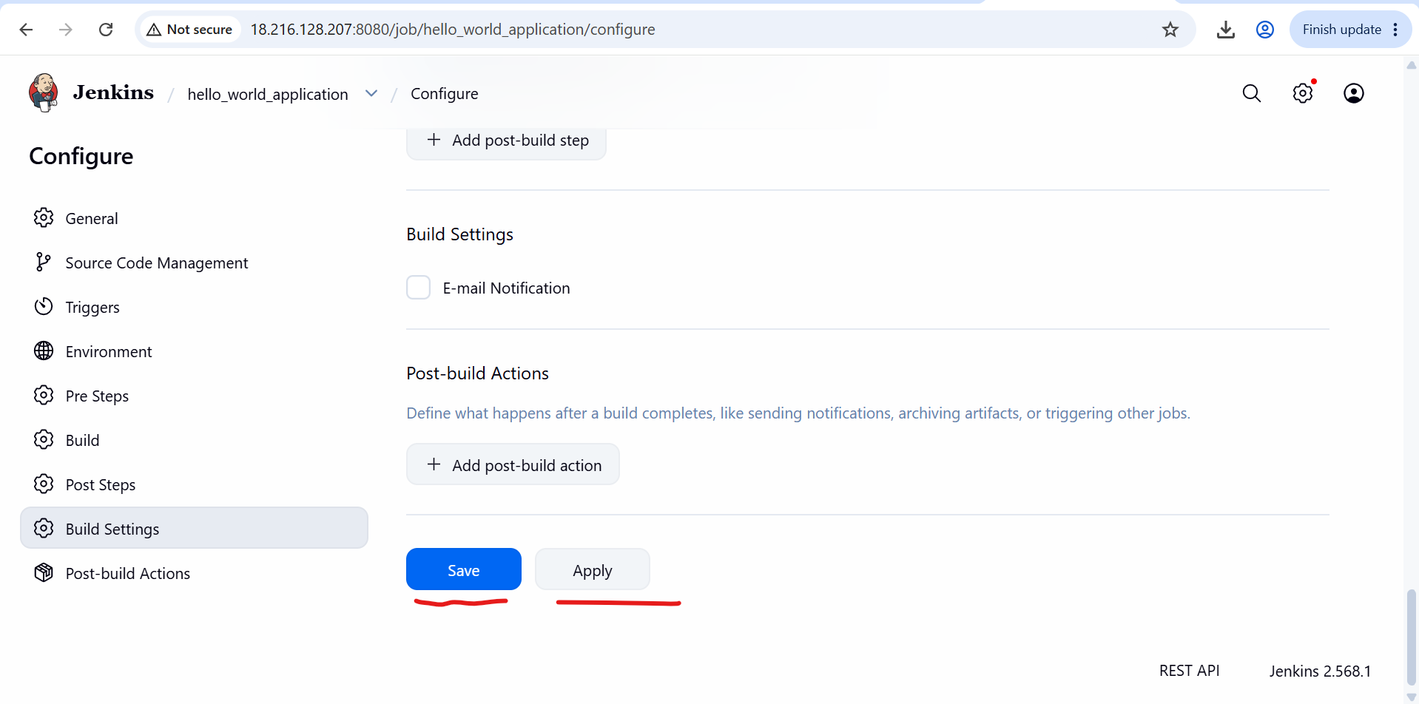
Then click on Build Now. We can see the build in build section as first build.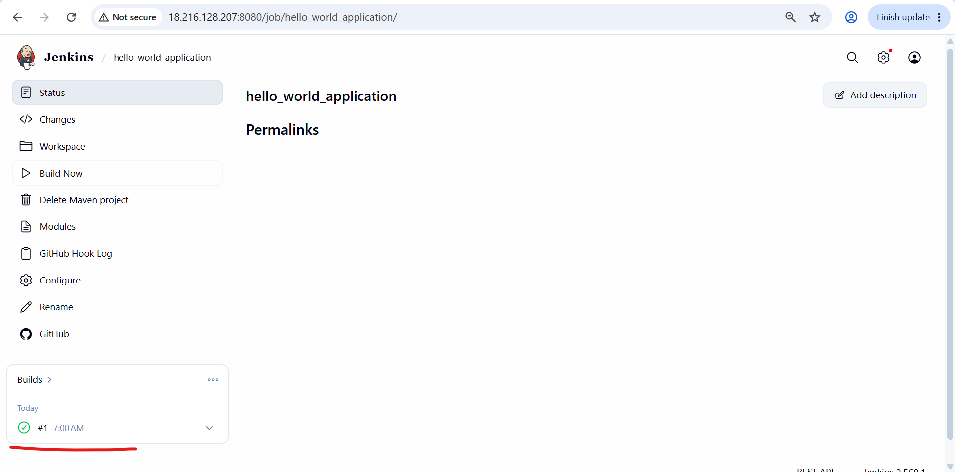
5. We can confirm that the hello-world application is build in Jenkins properly. A ‘target’ folder is created.
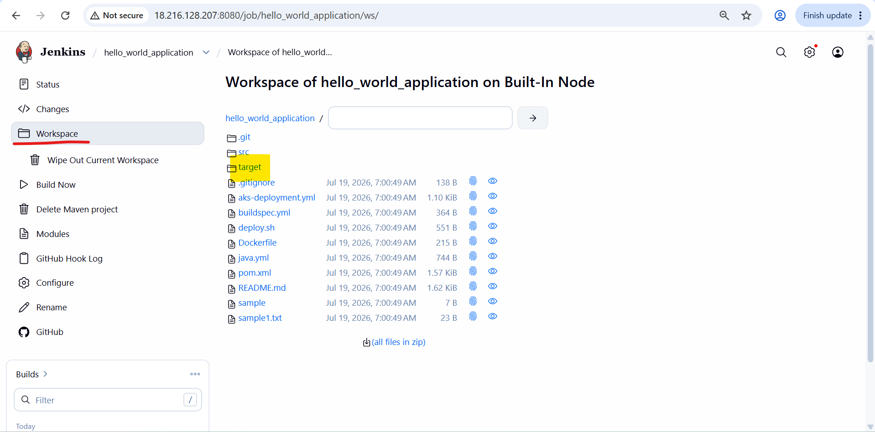

Step 5 – Now we will create a custom image in docker which is docker.hub.com
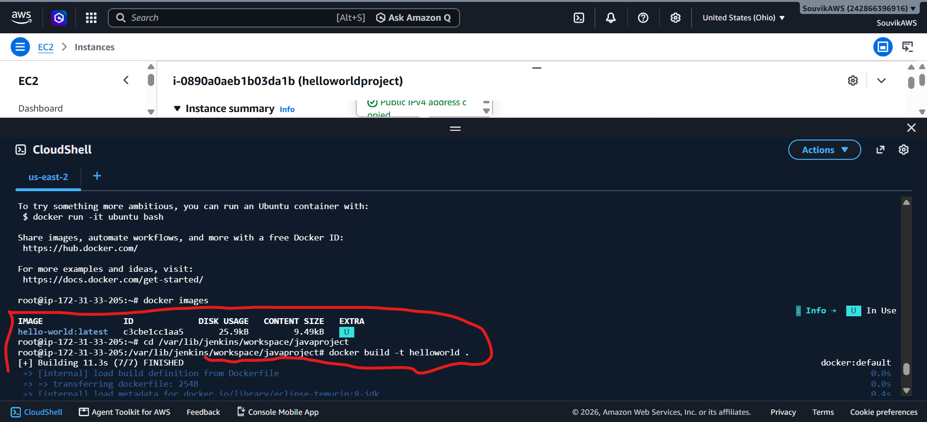
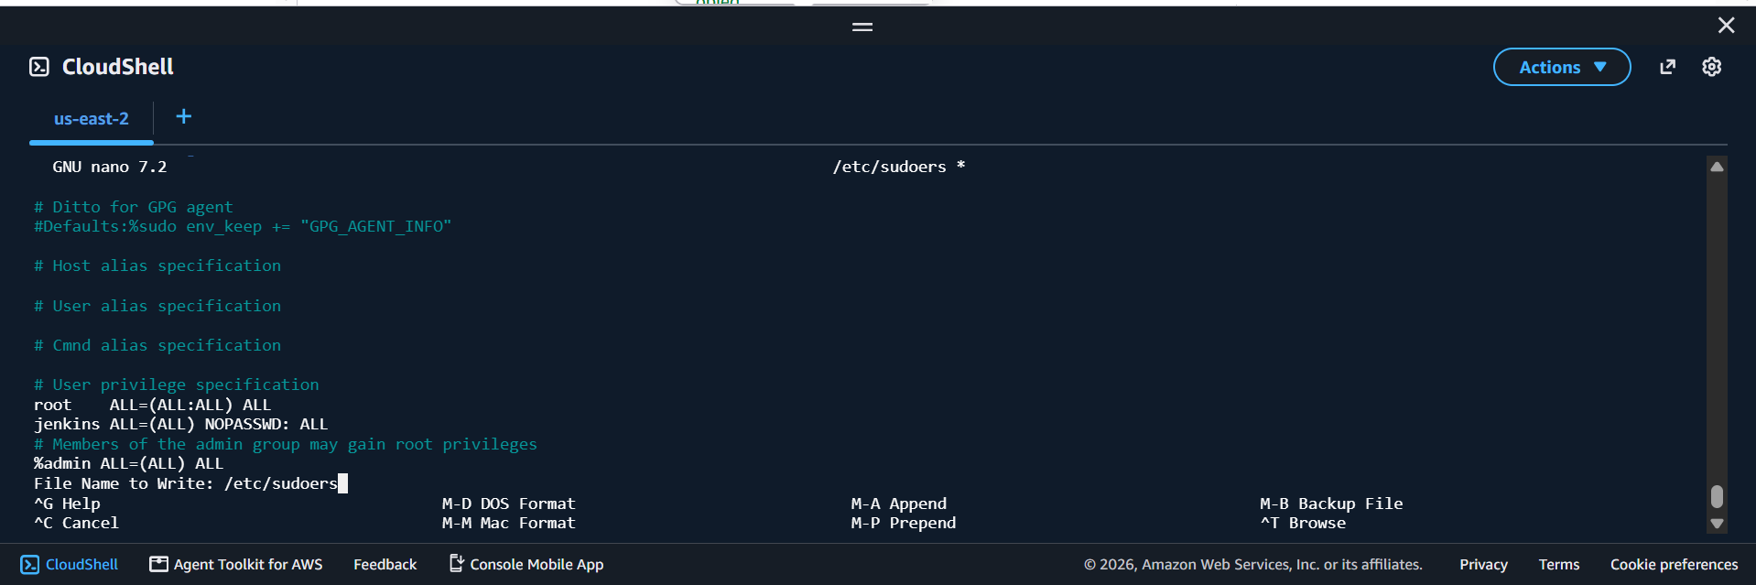
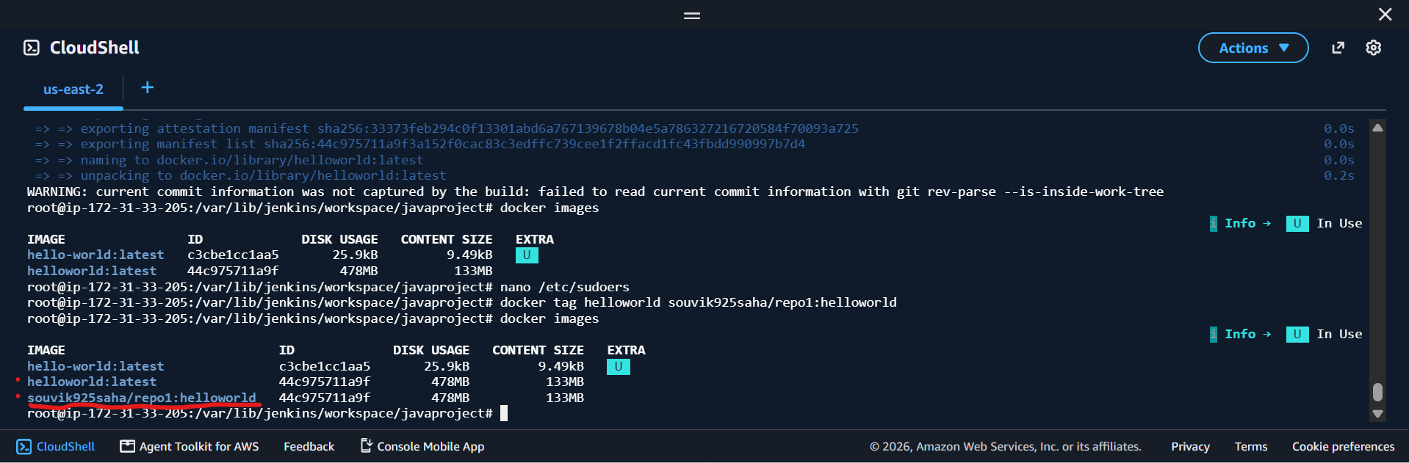
Step 5.1 We need to login into docker to push the custom image.
docker push souvik925saha/repo1:helloworld
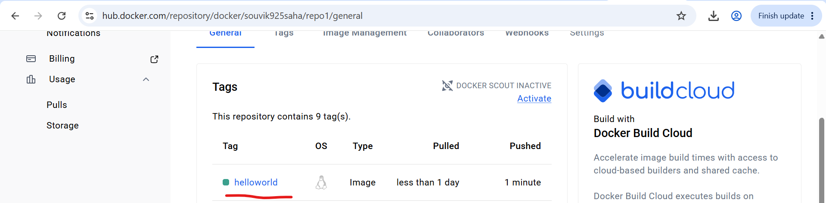
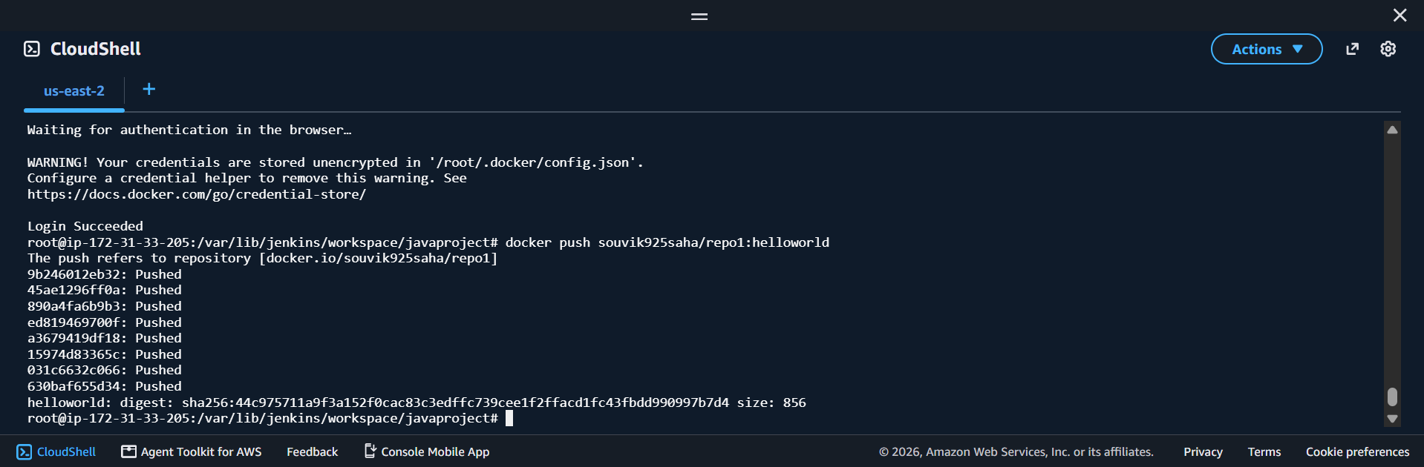

Step 6 – Now we need to run the custom image in the Kubernetes. First, we need to install minikube and then we need to run the custom image in Kubernetes environment.
