Version Control Exercises
q1)Git Setup https://confluence.atlassian.
Commands used
sudo apt install git
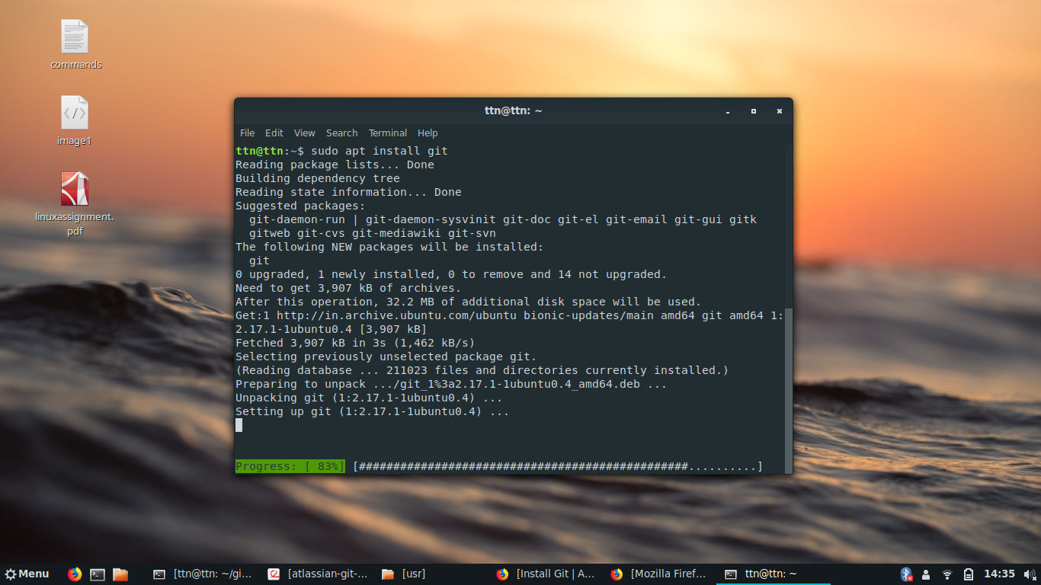

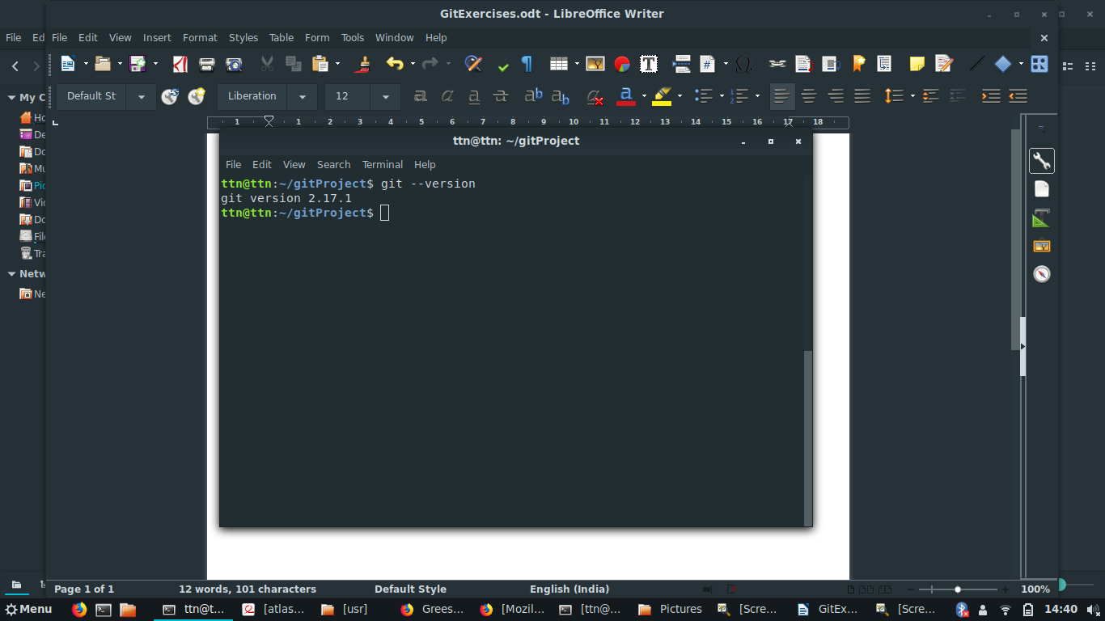

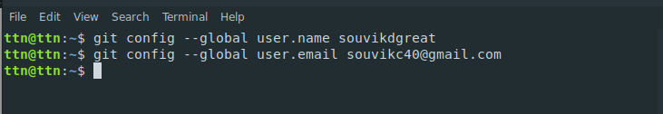

q2)Initialize a Git Repository
command used
git init
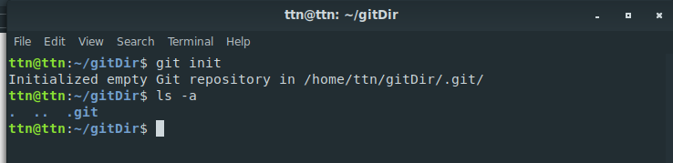

q3)Add files to the repository
commands used
//adding remote to link local repository with the remote repository
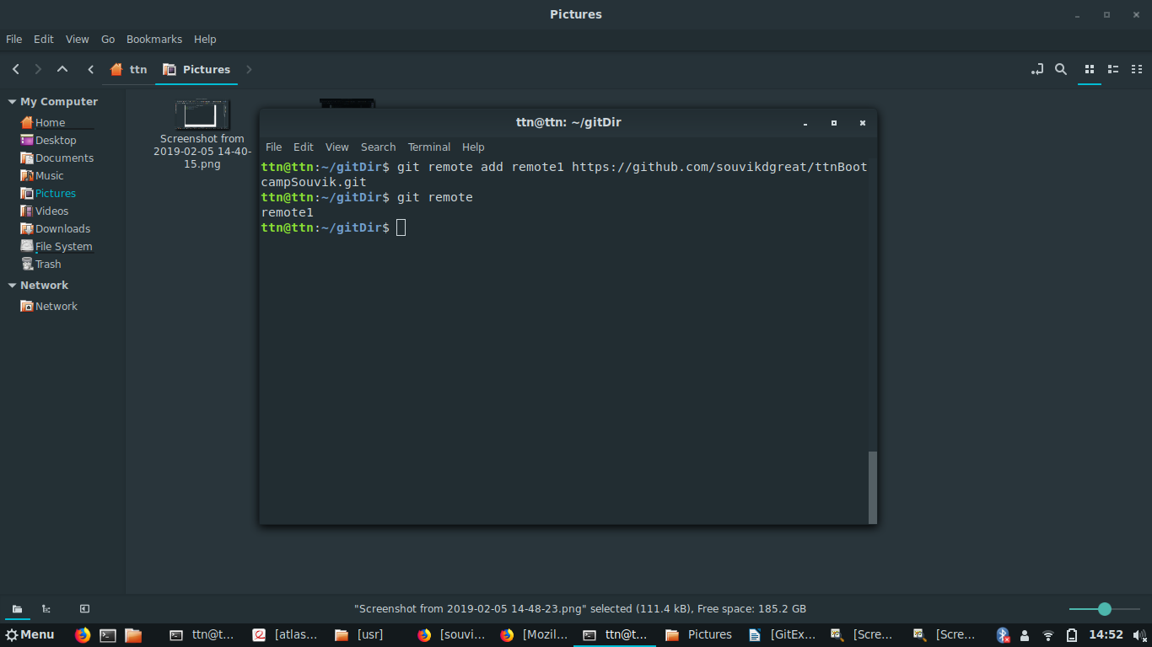

//adding files to the remote repository
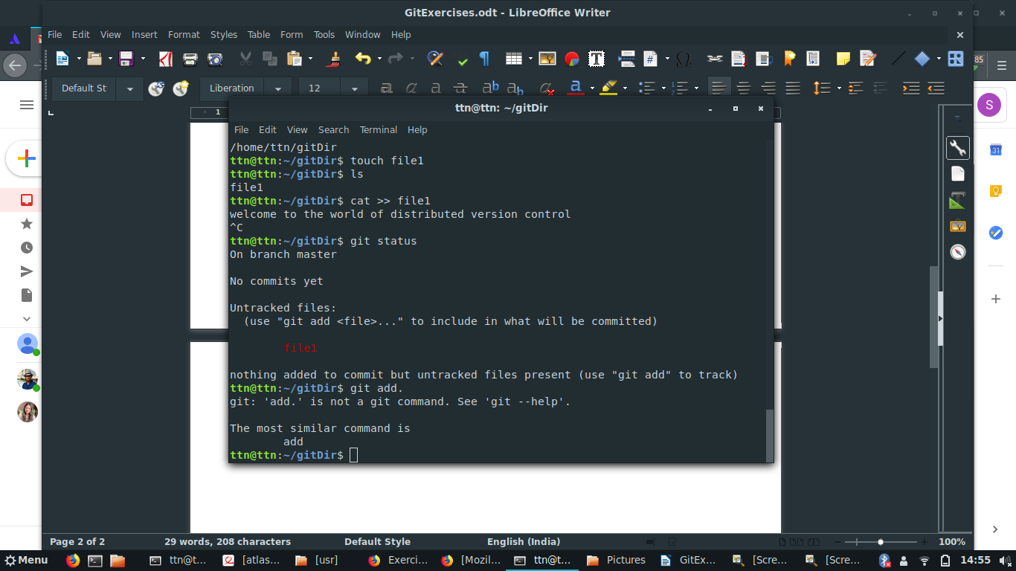

//adding files to the staging area
git add .
git status
git commit
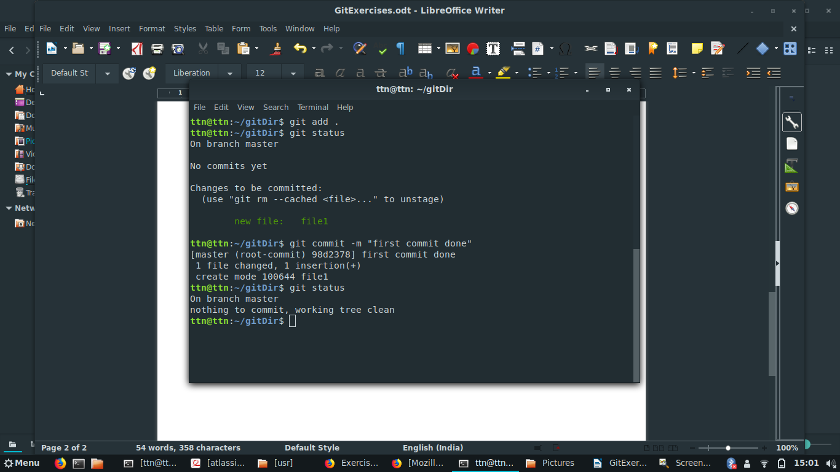

q4)Unstage 1 file
//edit the file in the repository and then stage the file and check status

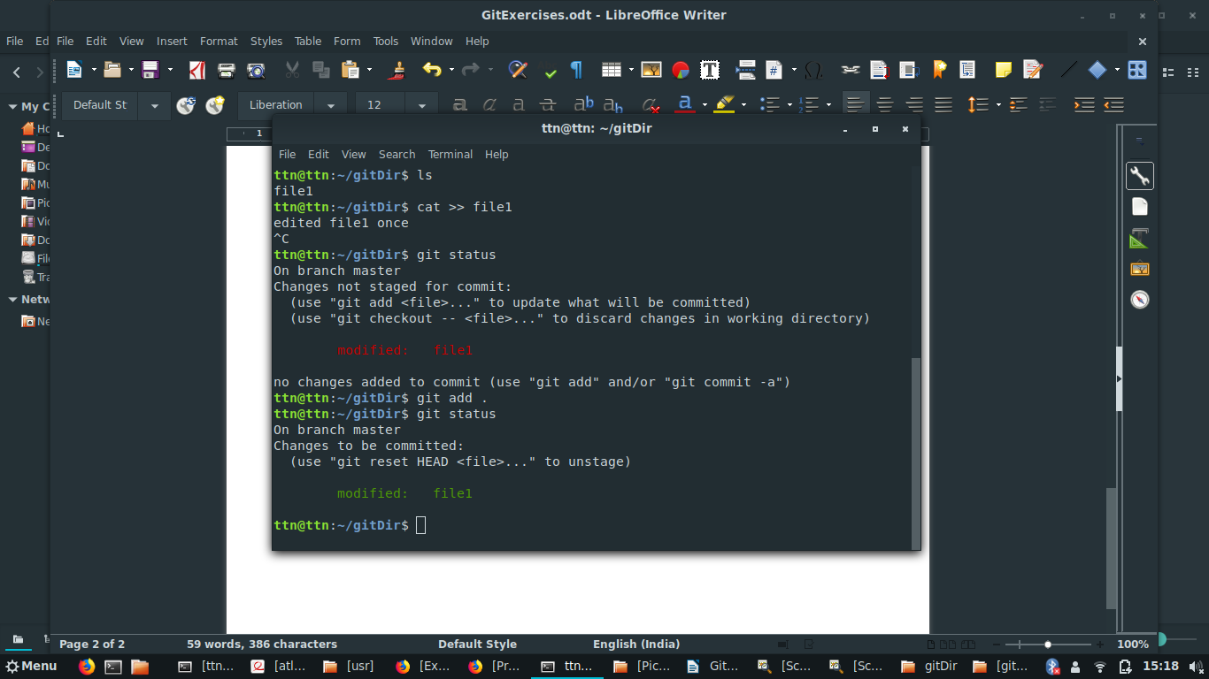

//unstage the file using git reset file name command
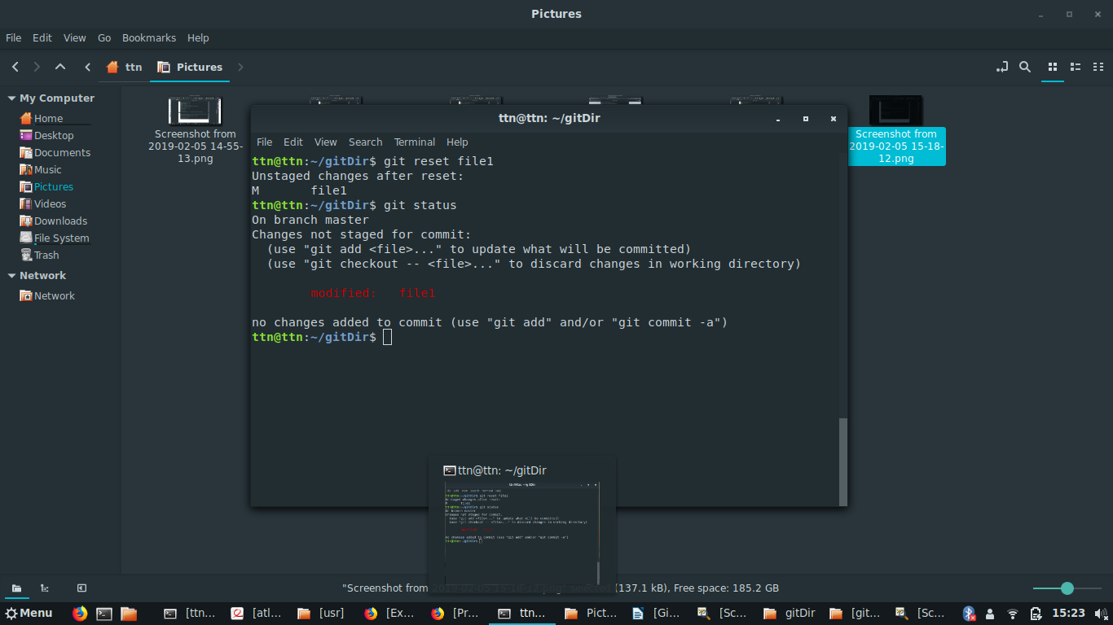

q5)Commit the file
git add .
git commit -m “2nd commit done”
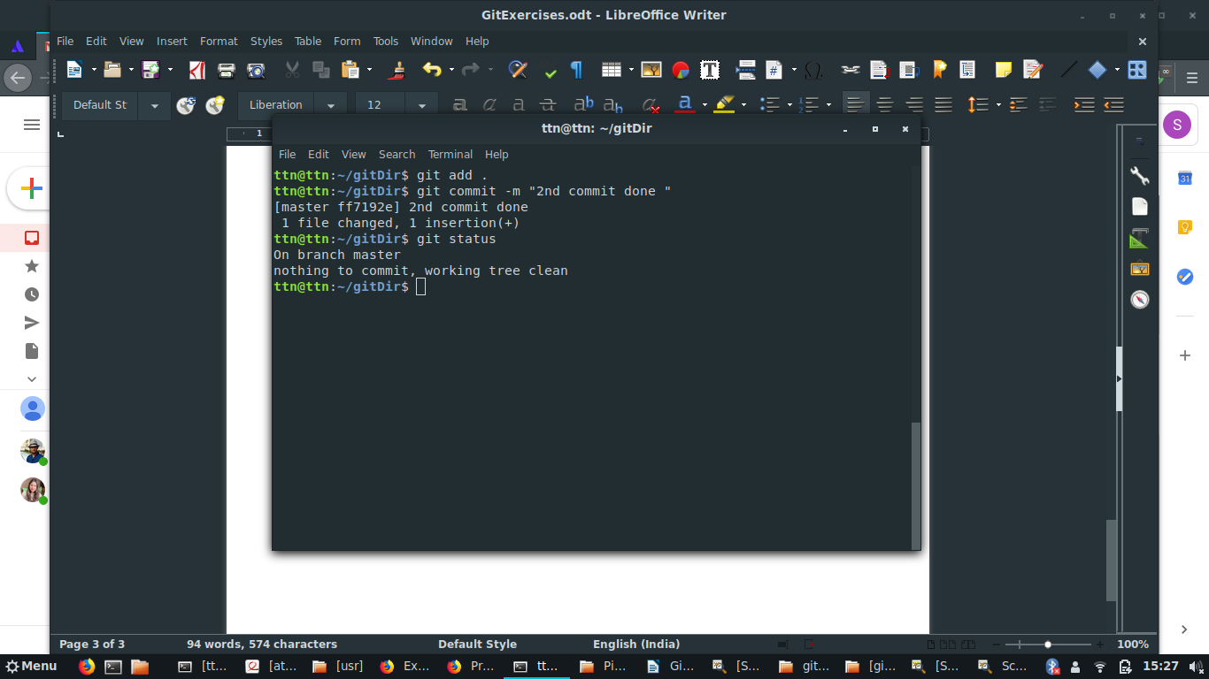

q6)Add a remote
//adding remote
git remote add remote1 <url of the repository>

//editing remote
command used : git remote set-url remote <ssh url>
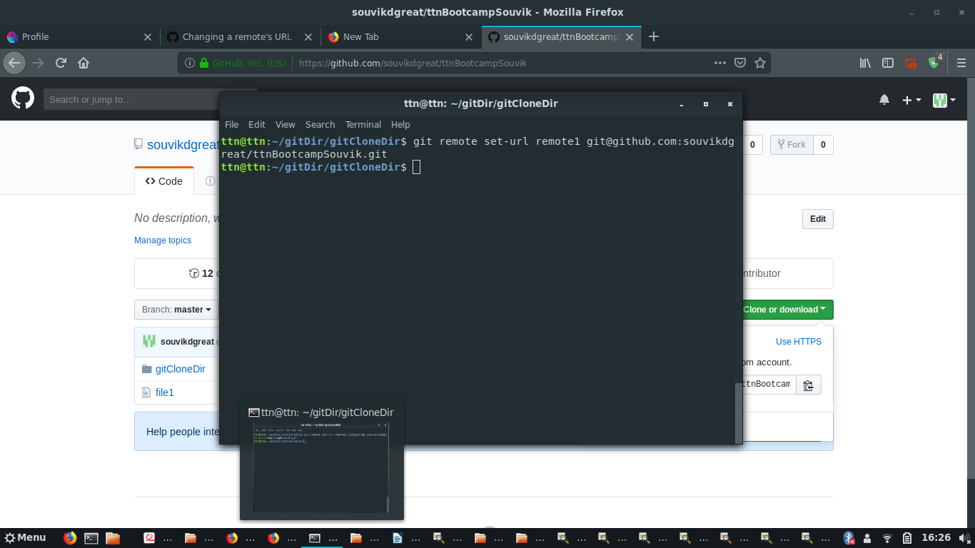

q7)Undo changes to a particular file
//git log to display the latest commit
//and then reverting the commit using git revert
//and then pushing it again to the remote directory
//commands used
git log
git revert commit_id
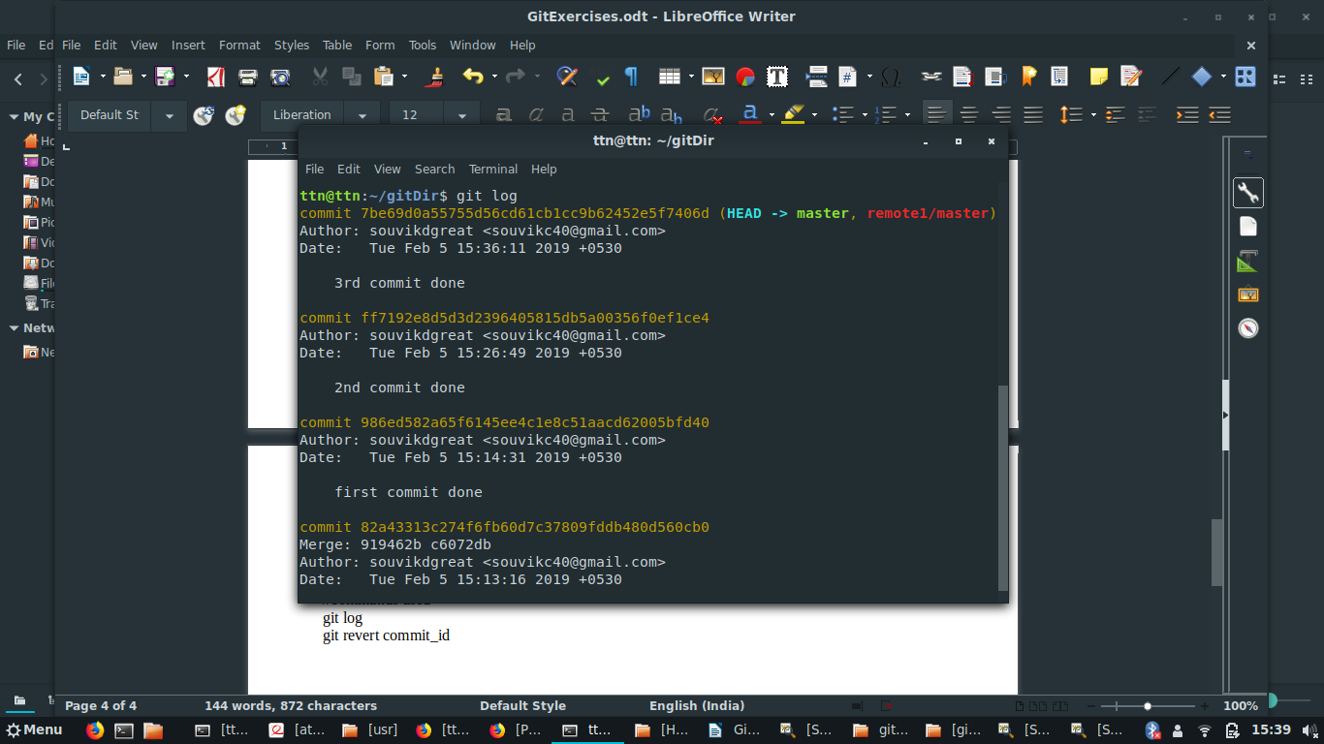

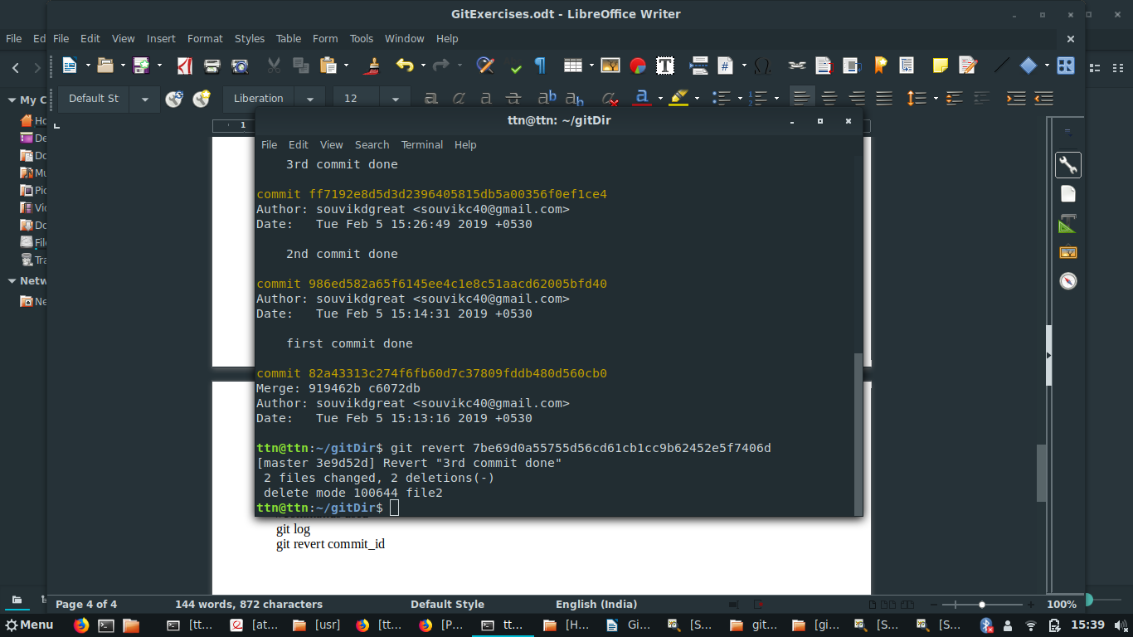

q8)Push changes to Github

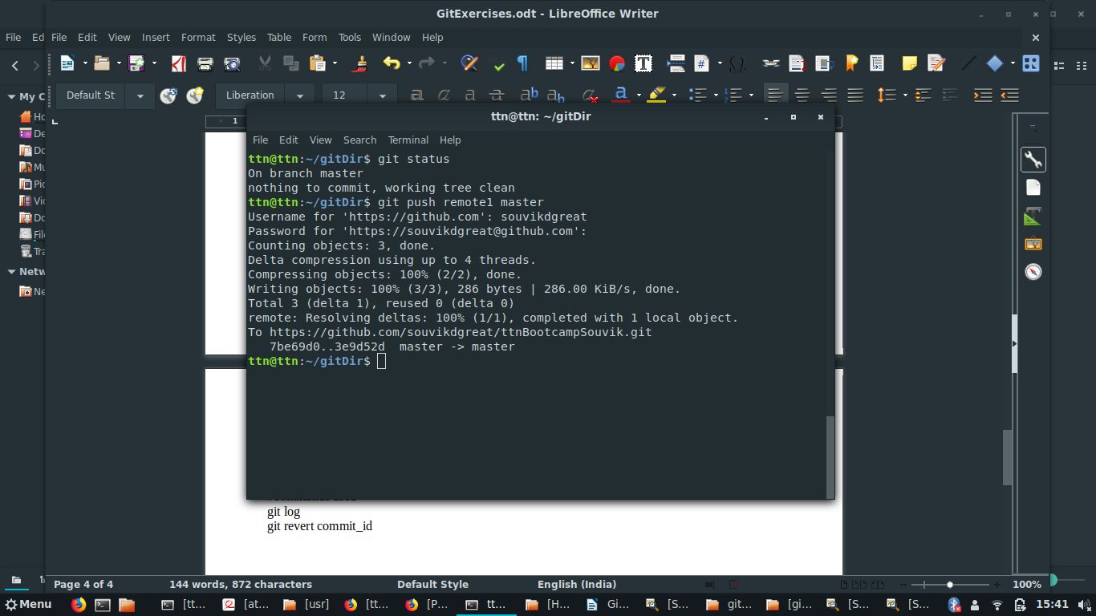

q9)Clone the repository
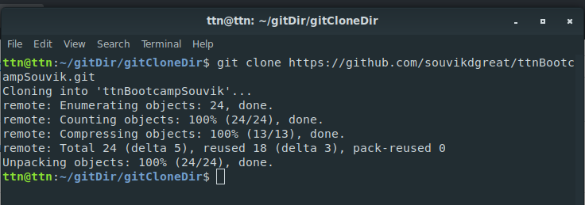

q10)Add changes to one of the copies and pull the changes in the other.

//editing the files and then pushing the files to the remote server and then pulling the changes to the cloned version

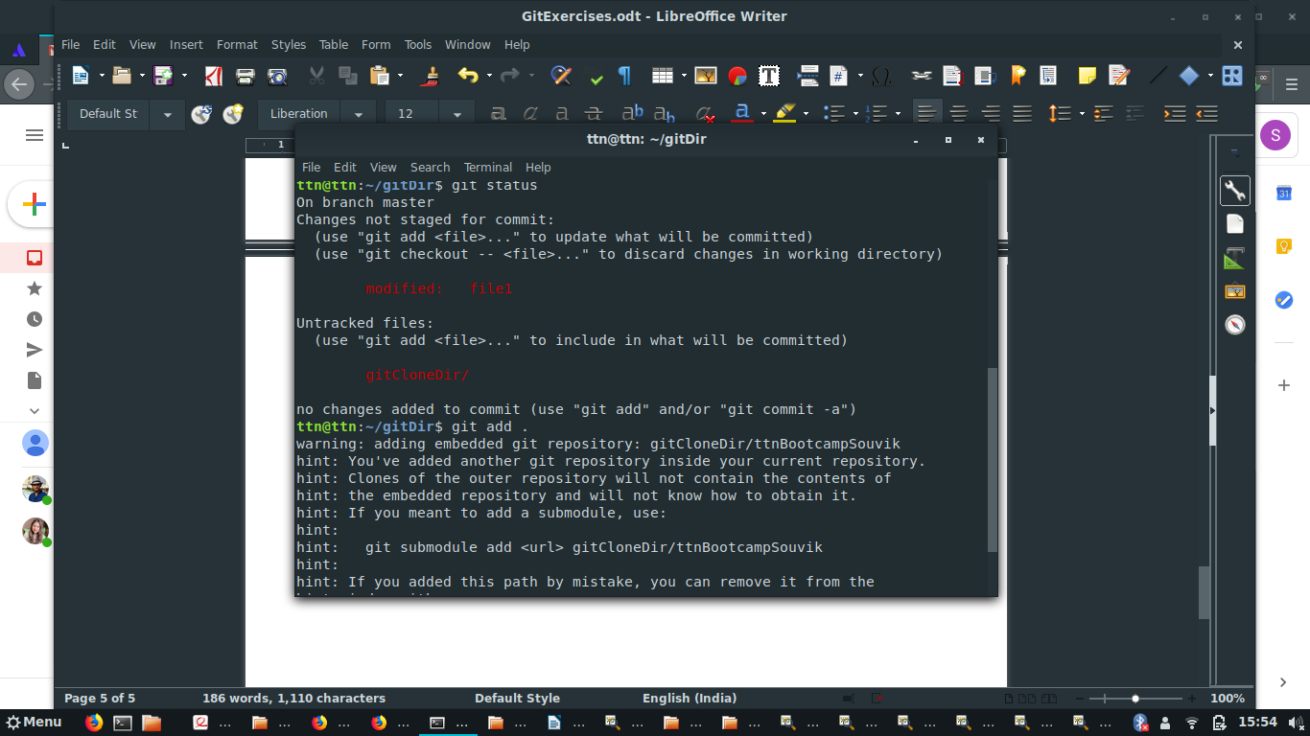

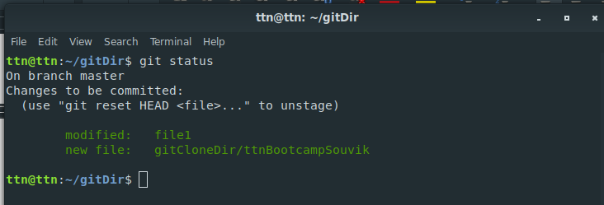

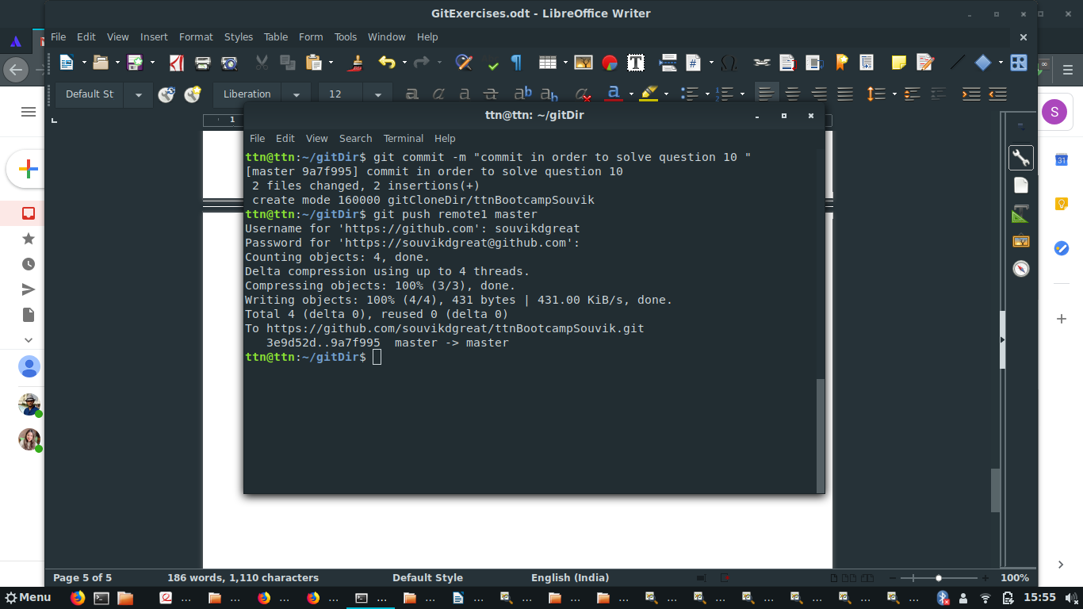

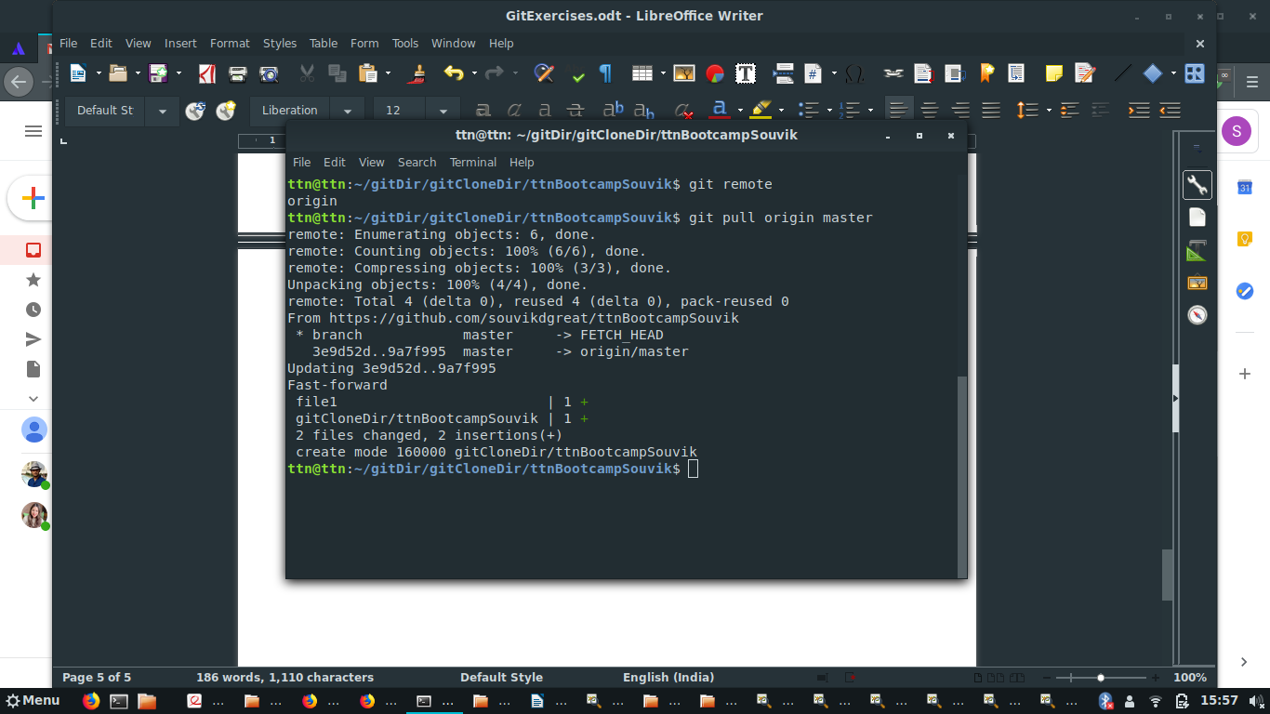
q11)Check differences between a file and its staged version
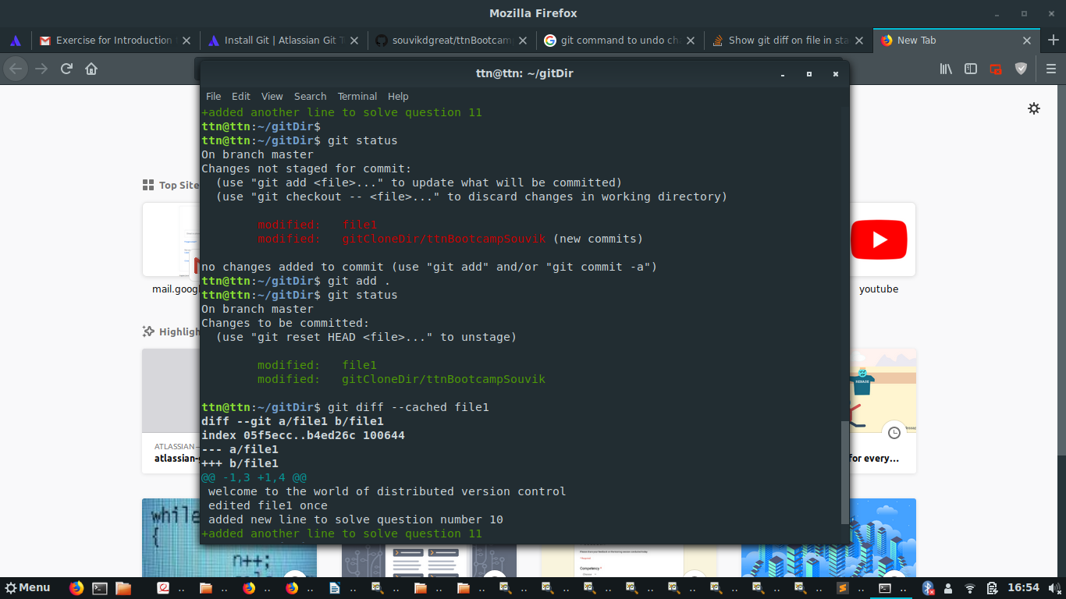

q12)Ignore a few files to be checked in
adding gitignore file to the repository
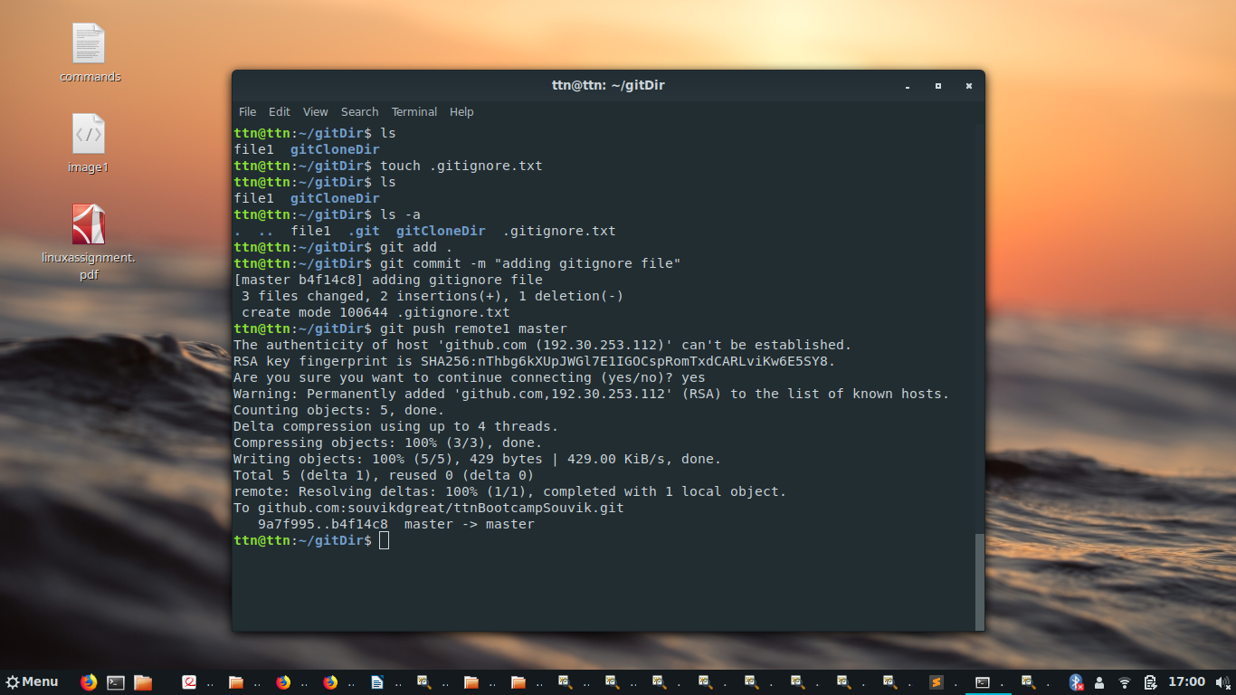

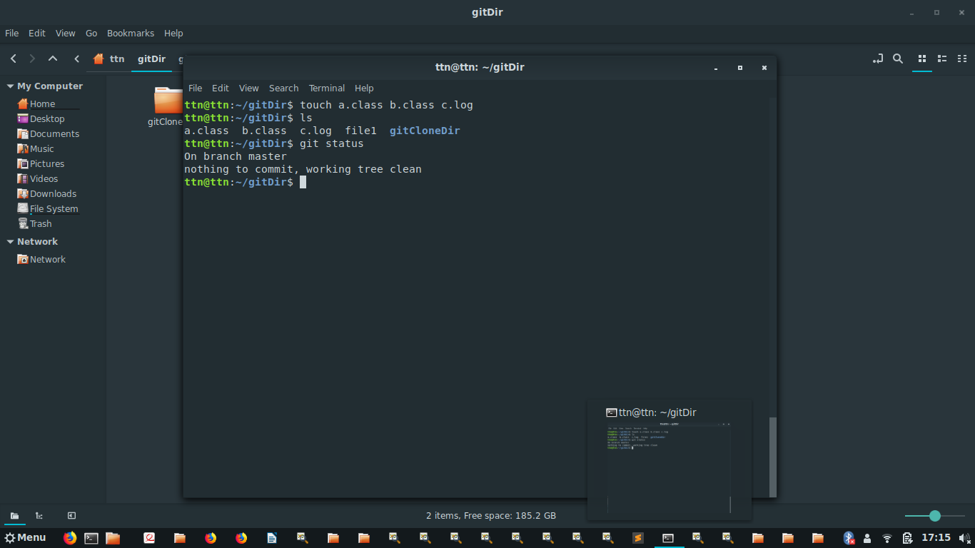

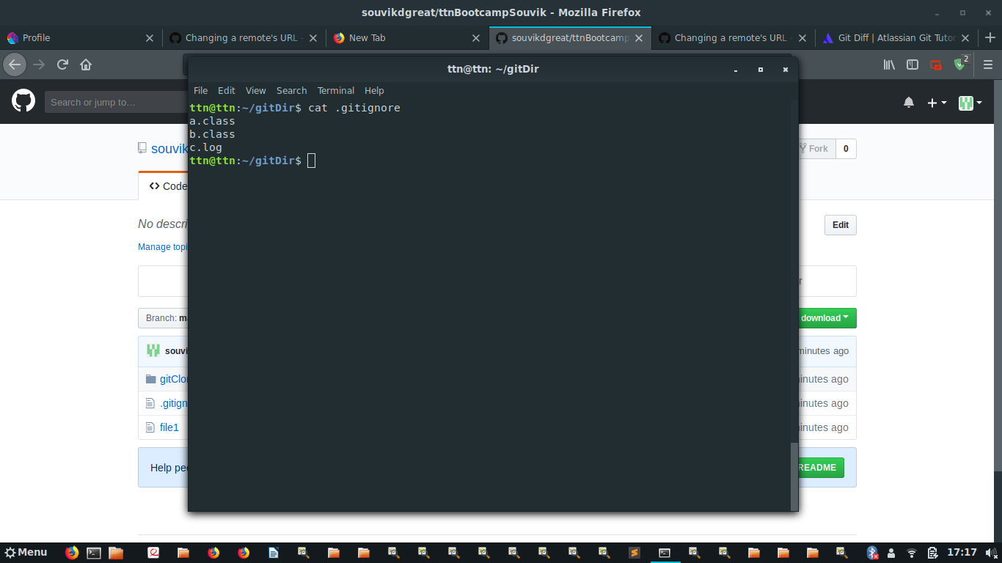

q13)Create a new branch
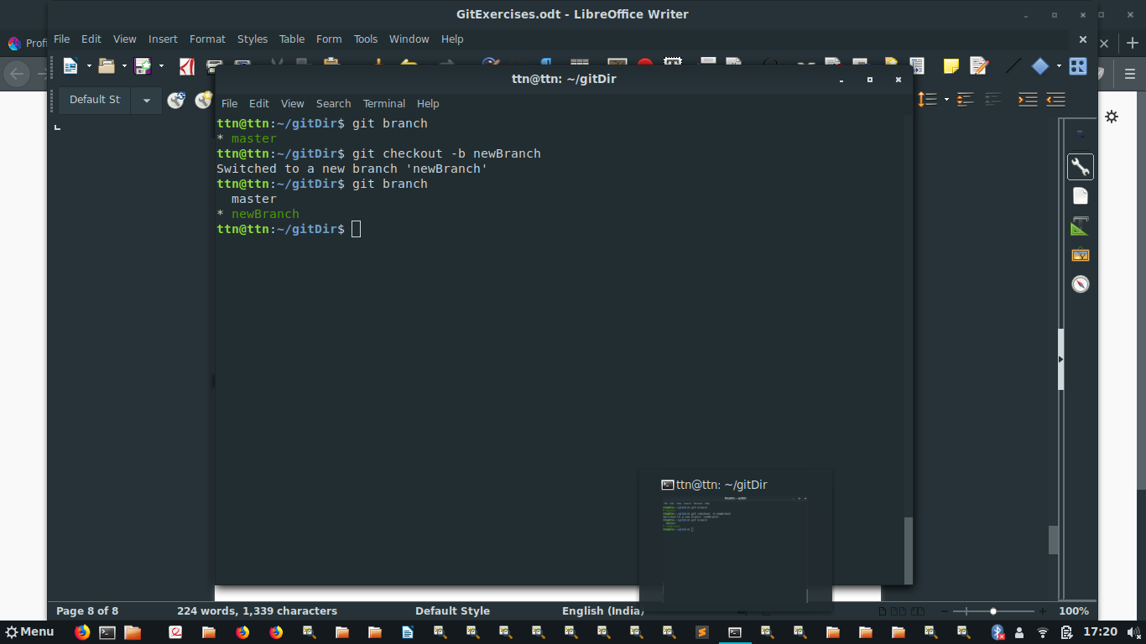

q14)Diverge them with commits
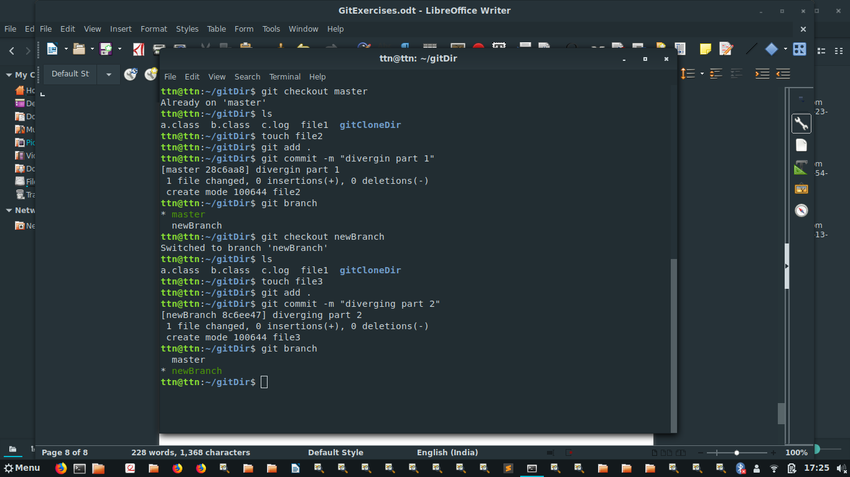

q15)Edit the same file at the same line on both branches and commit

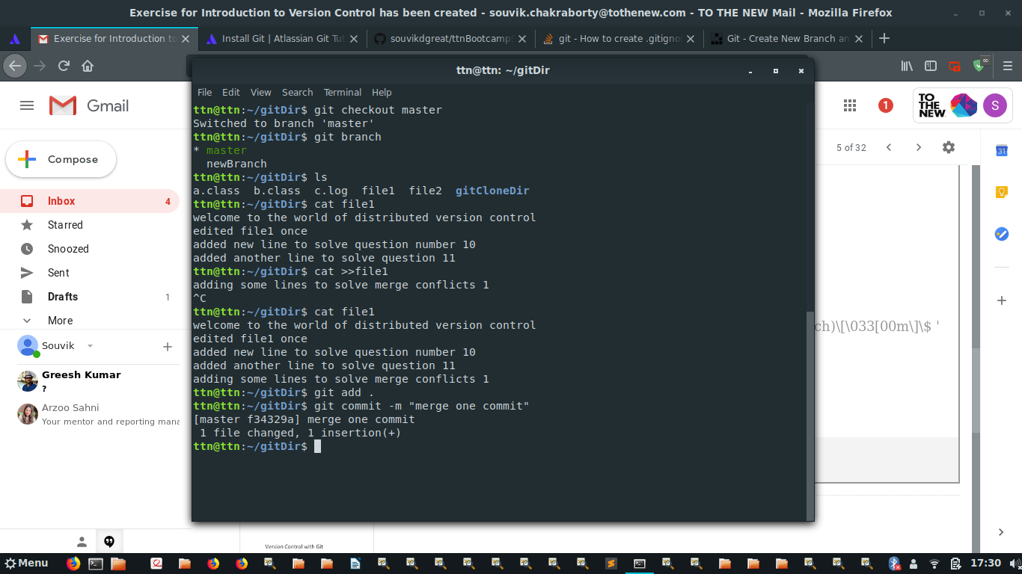

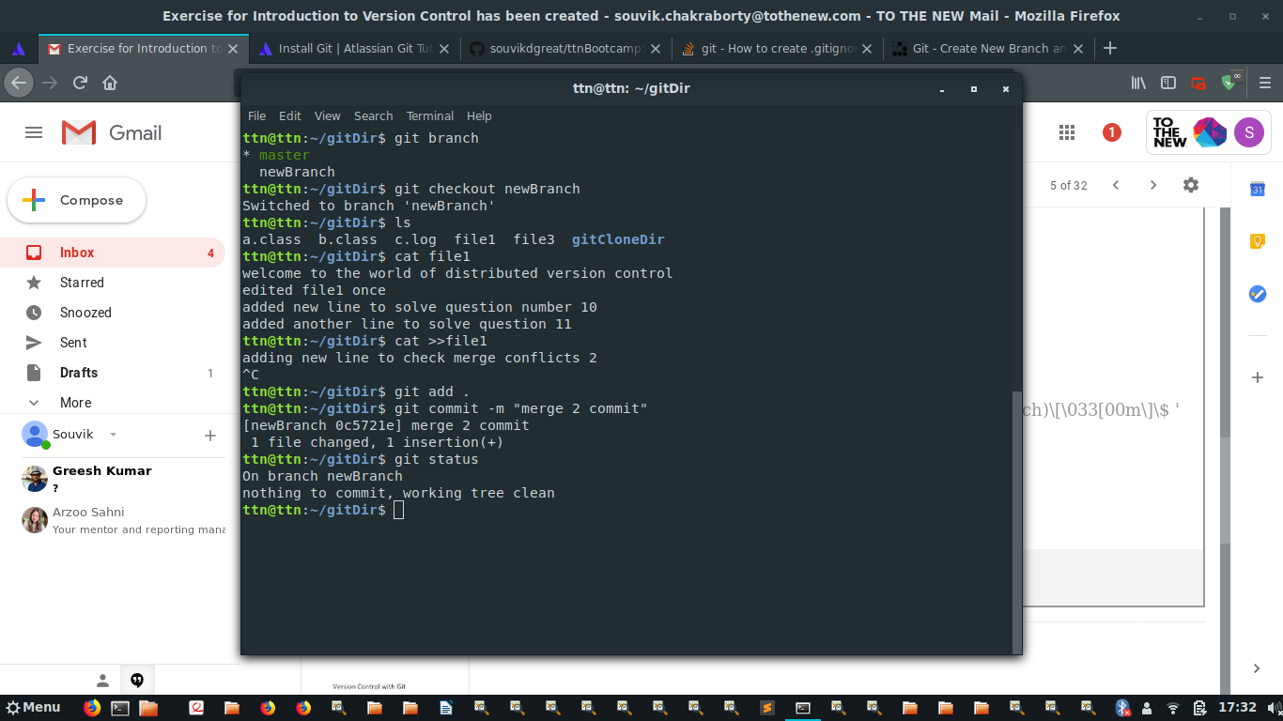
q16)Try merging and resolve merge conflicts
//merging files : merging branch in master

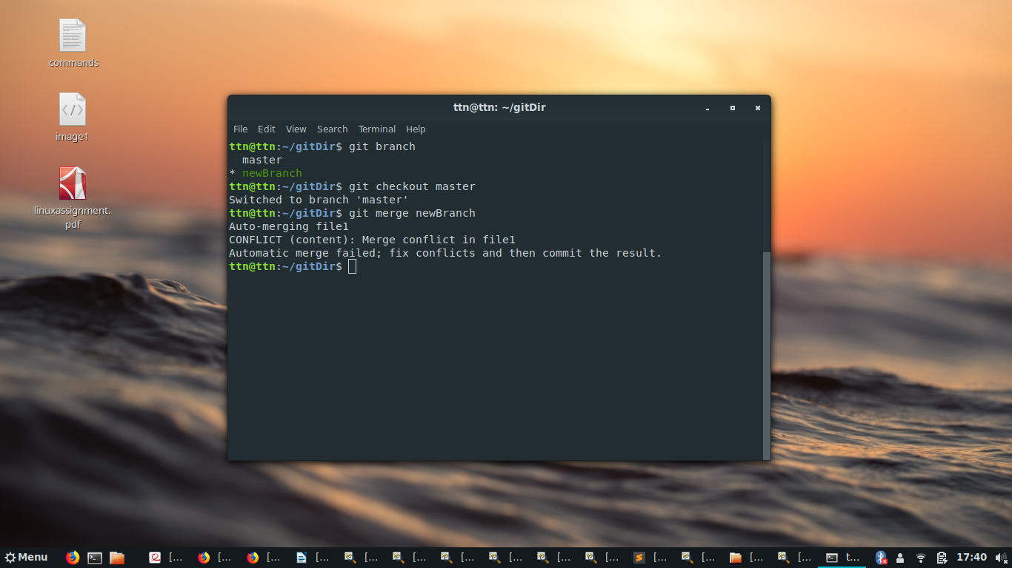

//resolving merge conflict
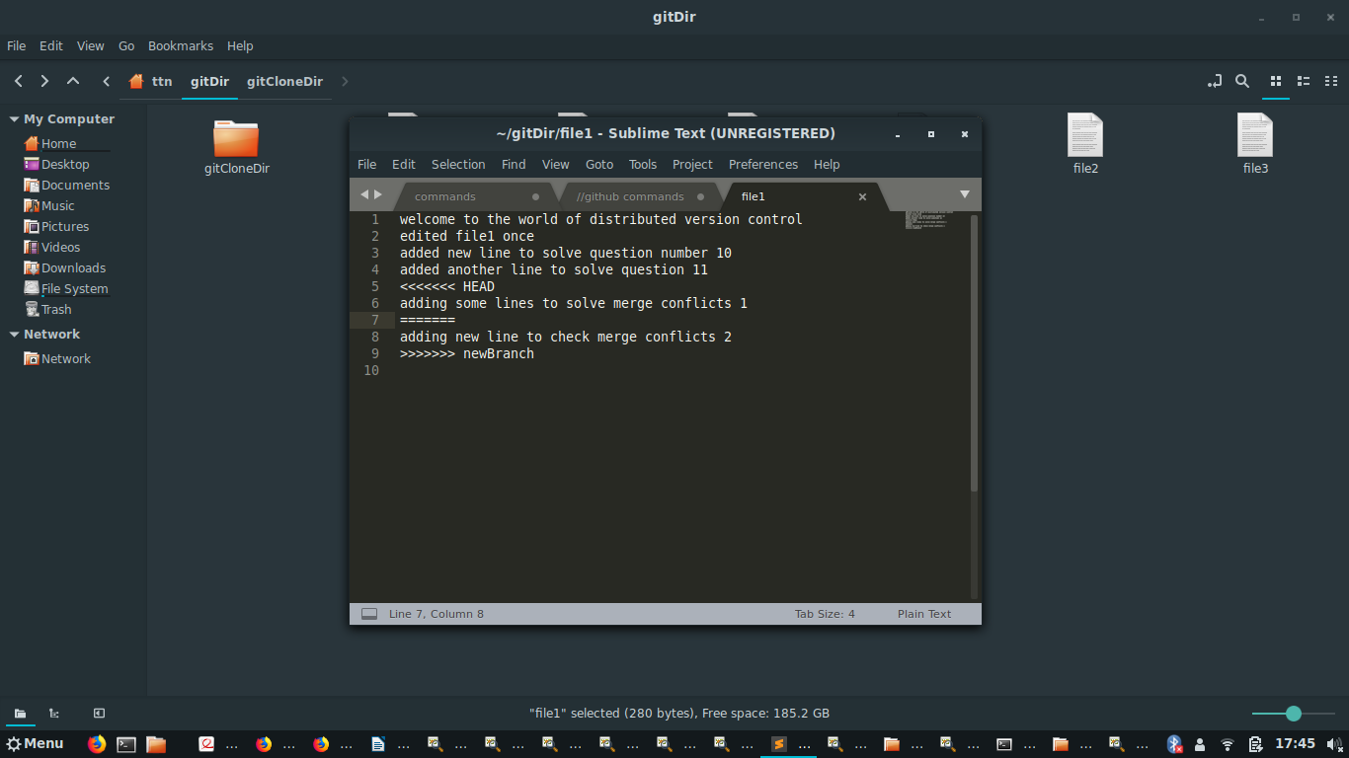

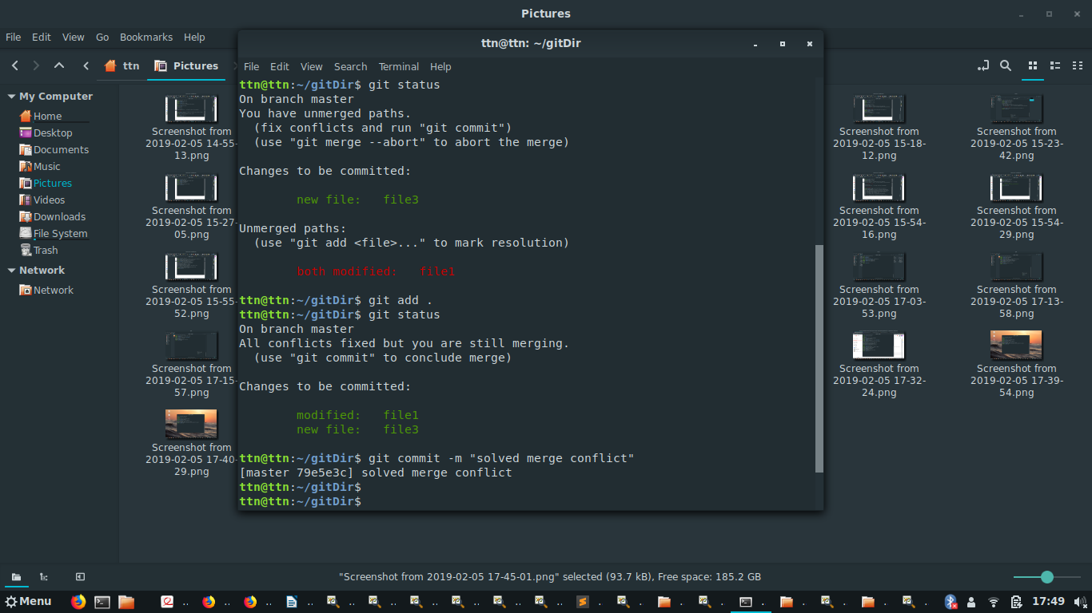
q17)Stash the changes and pop them
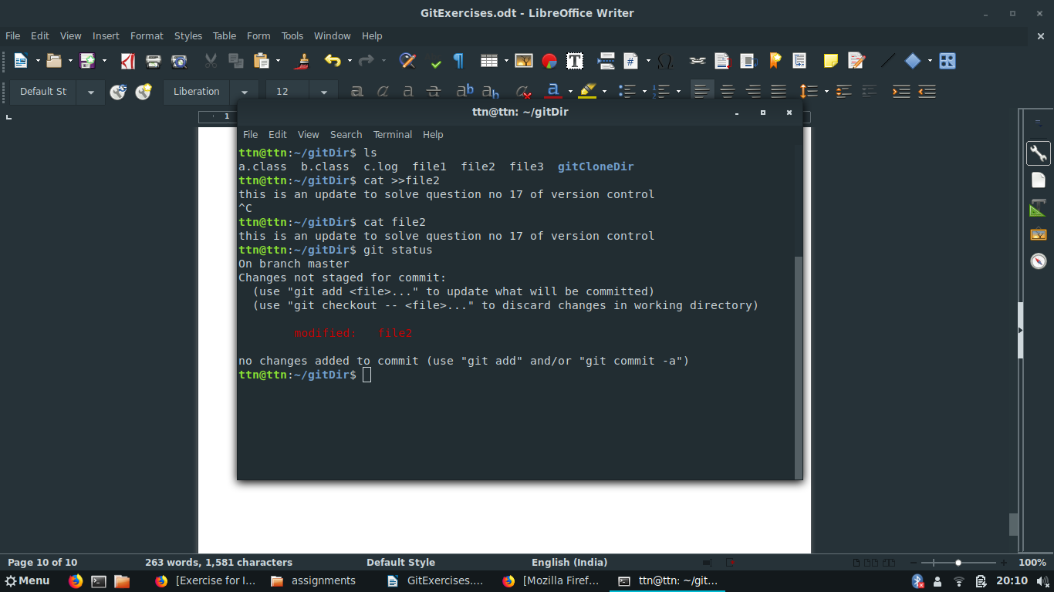

//after stashing
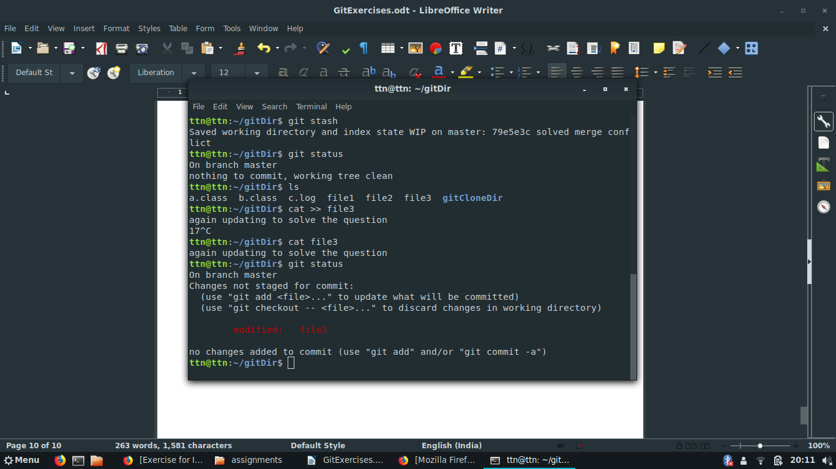

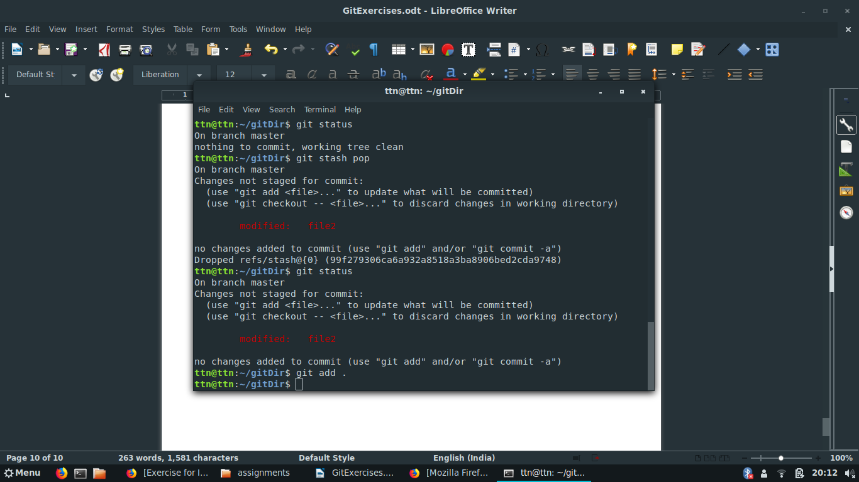
//after git stash pop
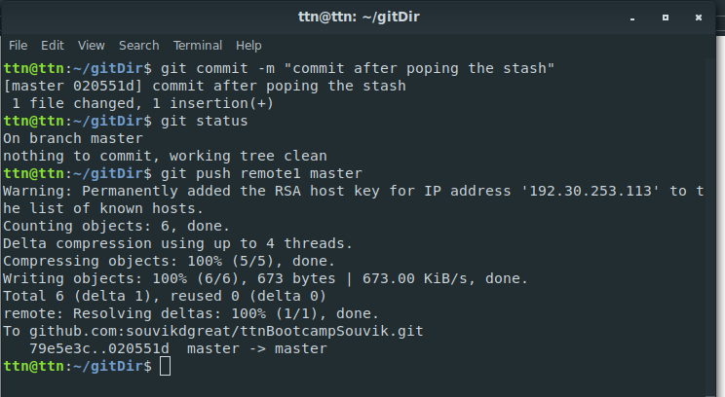

q18)Add the following code to your .bashrc file : color_prompt="yes"
parse_git_branch() {
git branch 2> /dev/null | sed -e '/^[^*]/d' -e 's/* \(.*\)/(\1)/'
}
if [ "$color_prompt" = yes ]; then
PS1='\u@\h\[\033[00m\]:\[\033[
else
PS1='\u@\h:\W $(parse_git_branch)\$ '
fi
unset color_prompt force_color_prompt

//editing the .bashrc file

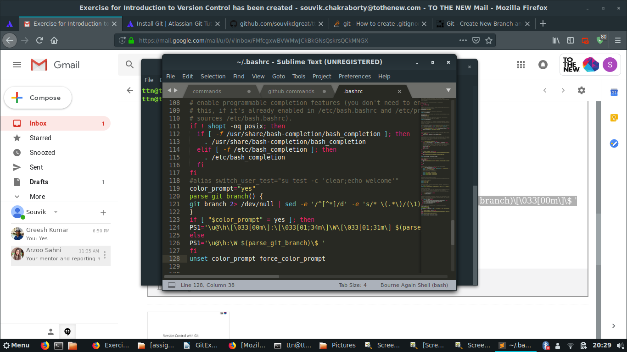

//after effect of editing is the change in color and display of the terminal


