EXPDP/IMPDP:
- Commands to check expdp jobs status?
Run the expdp comments and check the status.
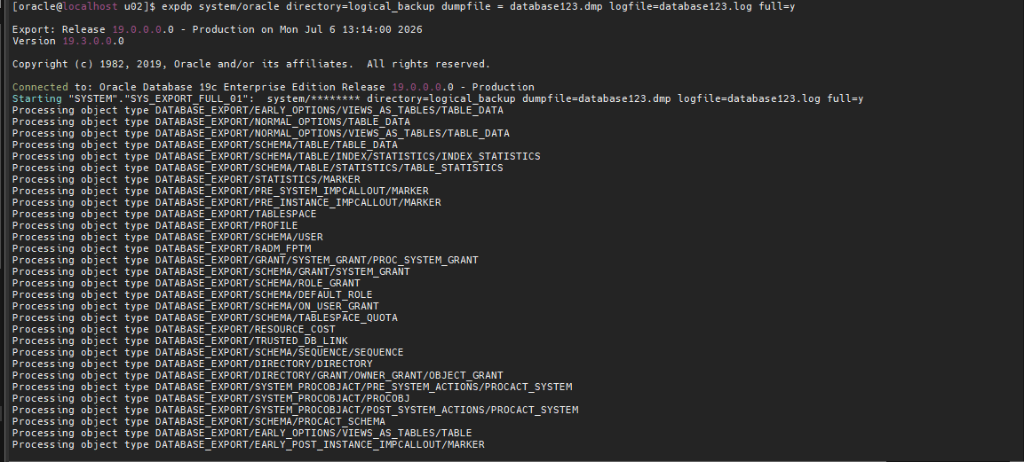
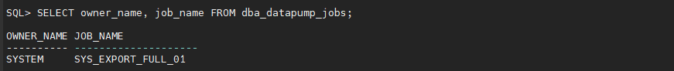
After finish the expdp backup, then check the status.
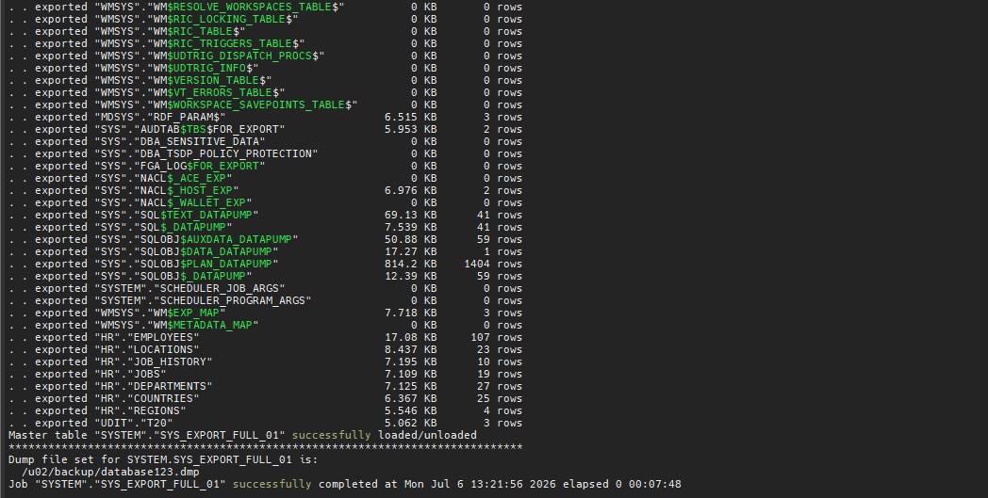
- How to start & stop expdp jobs?

STEP 1: take the logical backup.
expdp system/oracle directory=logical_backup dumpfile = database123.dmp logfile=database123.log full=y
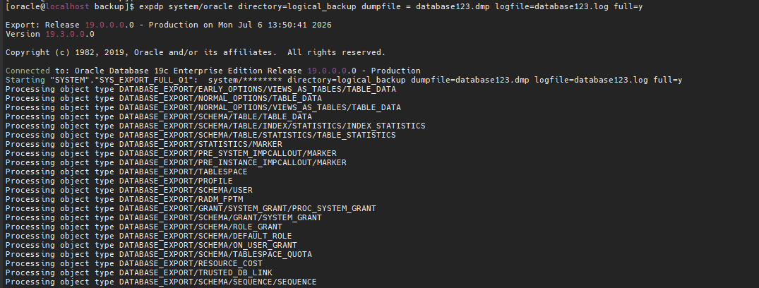
STEP 2: check the job status.
select owner_name, job_name, job_mode, operation from dba_datapump_jobs;
STEP 3: stop job
Export> stop_job = immediate
STEP 4: resume the job.
expdp system/oracle attach=SYS_EXPORT_FULL_01
Export> continue_client
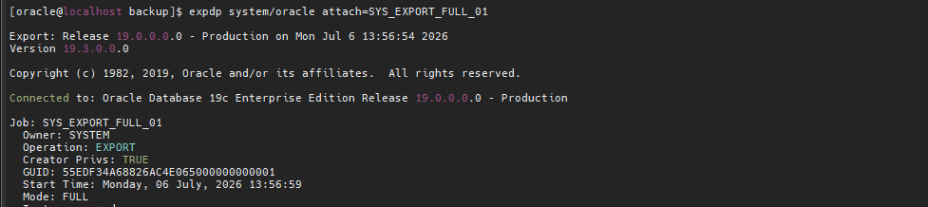
Continue_client

- How to kill expdp/impdp jobs?
STEP 1: take the logical backup.

STEP 2: check the job status.
STEP 3: kill the job.
Export> kill_job

STEP 4: check the expdp status.
- How to take expdp of schemas & tables?

SCHEMAS =>
expdp system/oracle directory=logical_backup dumpfile=hr.dmp logfile=hr.log schemas=hr
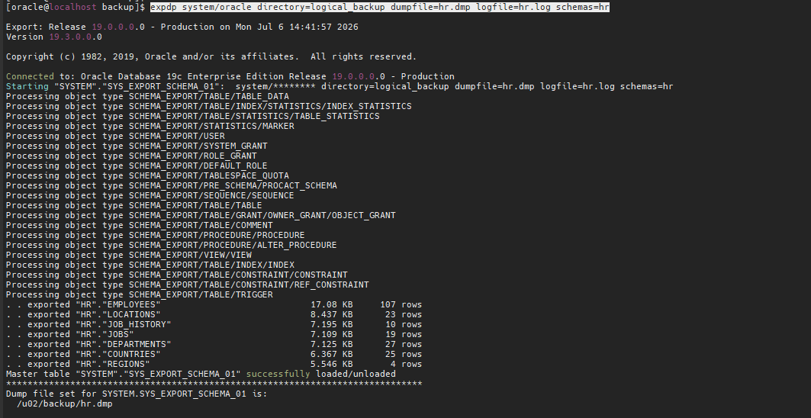
TABLES=>
Expdp system/oracle directory=logical_backup dumpfile=tab.dmp logfile=tab.log tables=hr.employees
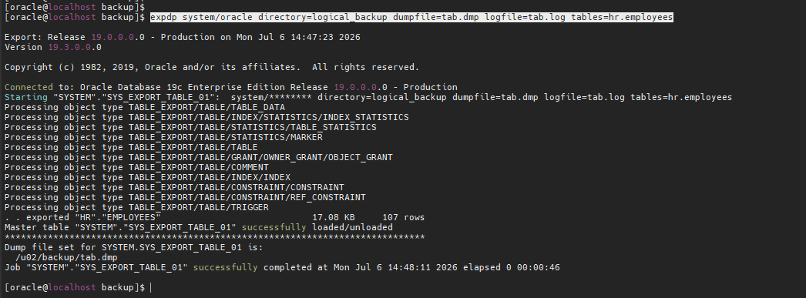
- How to take backup of data & metadata of specific table?
ONLY DATA
expdp system/oracle directory=logical_backup dumpfile=tab.dmp logfile=tab.log tables=hr.locations content=data_only
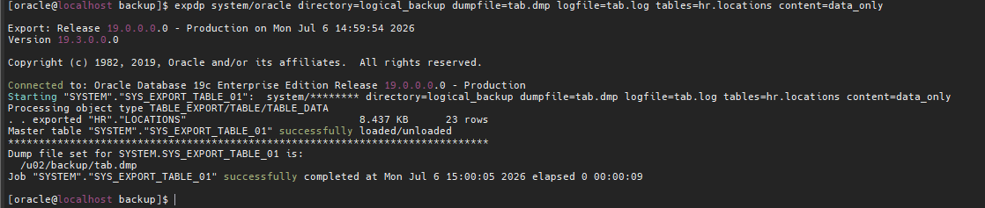
ONLY METADATA
expdp system/oracle directory=logical_backup dumpfile=tab.dmp logfile=tab.log tables=hr.locations content=metadata_only
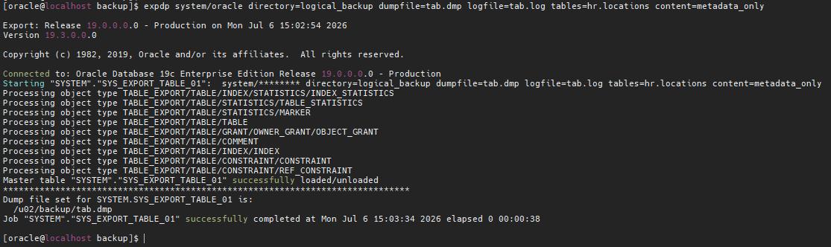
- How to take backup of data & metadata of specific schema?
ONLY METADATA
expdp system/oracle directory=logical_backup dumpfile=schema.dmp logfile=schema.log schemas=hr content=metadata_only
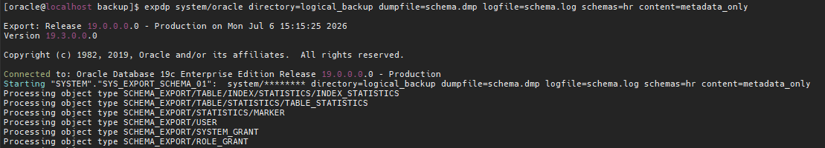

ONLY DATA
expdp system/oracle directory=logical_backup dumpfile=schema.dmp logfile=schema.log schemas=hr content=data_only
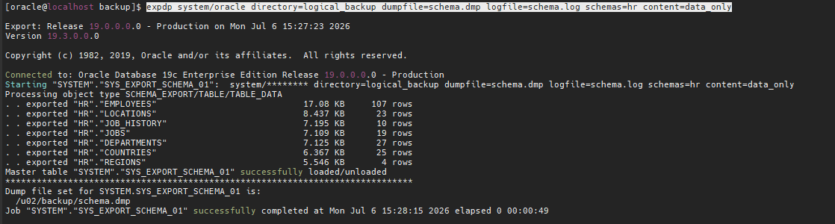
- Perform Remap schema <HR:SHA>

Step 1: backup the HR schema.

expdp system/oracle directory=logical_backup dumpfile=schema.dmp logfile=schema.log schemas=hr

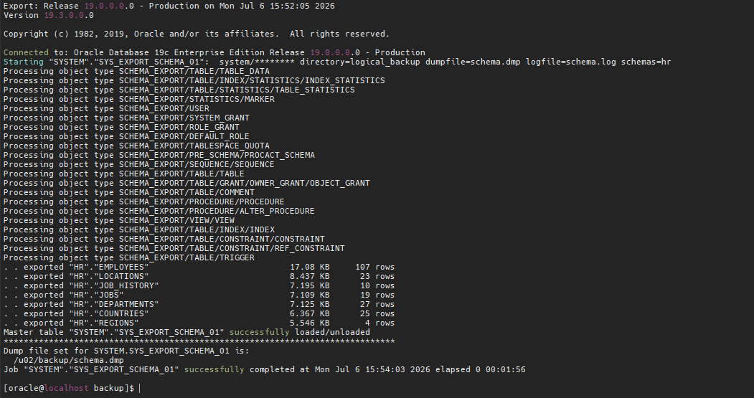

Step 2: restore the ‘HR’ schema in different schema

impdp system/oracle directory=logical_backup dumpfile=schema.dmp logfile=i.log remap_schemas=HR:UDIT

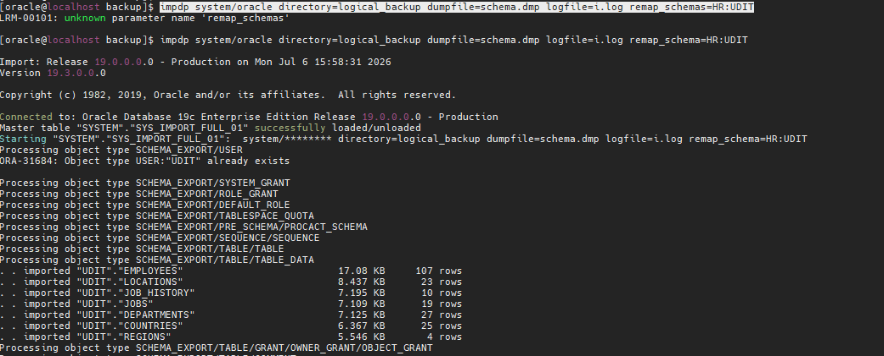

- Perform Remap TABLE <EMPLOYEE:EMPP>

expdp system/oracle directory=logical_backup dumpfile=emp.dmp logfile=emp.log tables=hr.employees

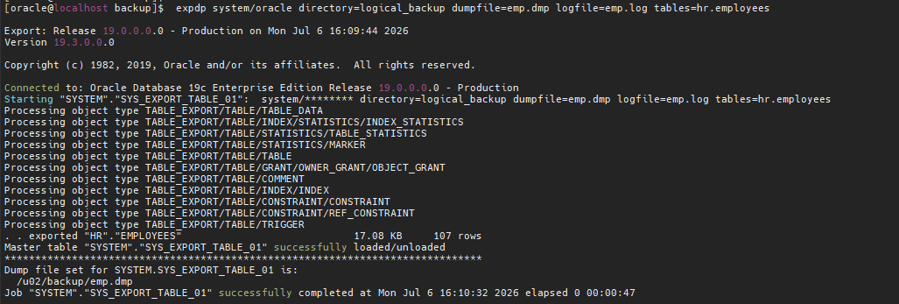

impdp system/oracle directory=LOGICAL_BACKUP dumpfile=loc.dmp logfile=loc_import.log remap_schema=hr:scott remap_tablespaces=sysaux:users
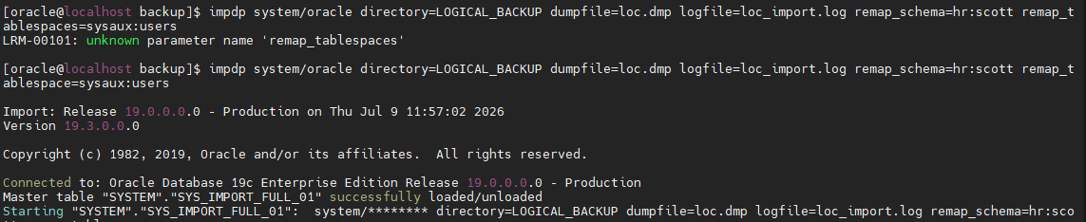

- How to run export/import backup via NOHUP?

Using nohup allows an expdp or impdp job to continue running even after you log out of the Linux server.

nohup -> Keeps the job running after logout.
file.out -> Redirects standard output to a file.
2>&1 -> Redirects errors to the same file.
& -> Runs the process in the background.

