What is the emissions per capita of Canada?

A.17.72

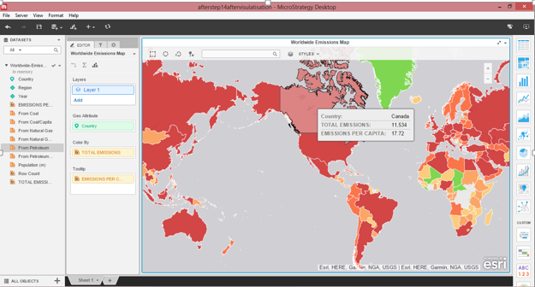

What is the overall trend in worldwide emissions?

A.The worldwide emissions have been increasing every year except for the year 2009

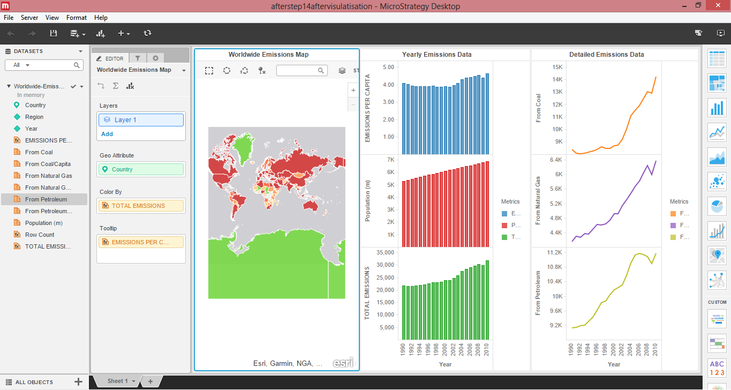

Notice that overall emissions declined in 2009, the only year in the total number of

years surveyed that indicates emissions decreases in all three emissions sources. Why

is that? What broader socio-political context might explain this single yearly

decrease?

1. The reason of emission decrease is due to the impact of the [recession](http://topics.nytimes.com/top/reference/timestopics/subjects/r/recession_and_depression/index.html?inline=nyt-classifier) on industrial production and overall energy use.

A.The statistics of Canada are provided above

The statistics of US are provided below

