PROJECT SUMMARY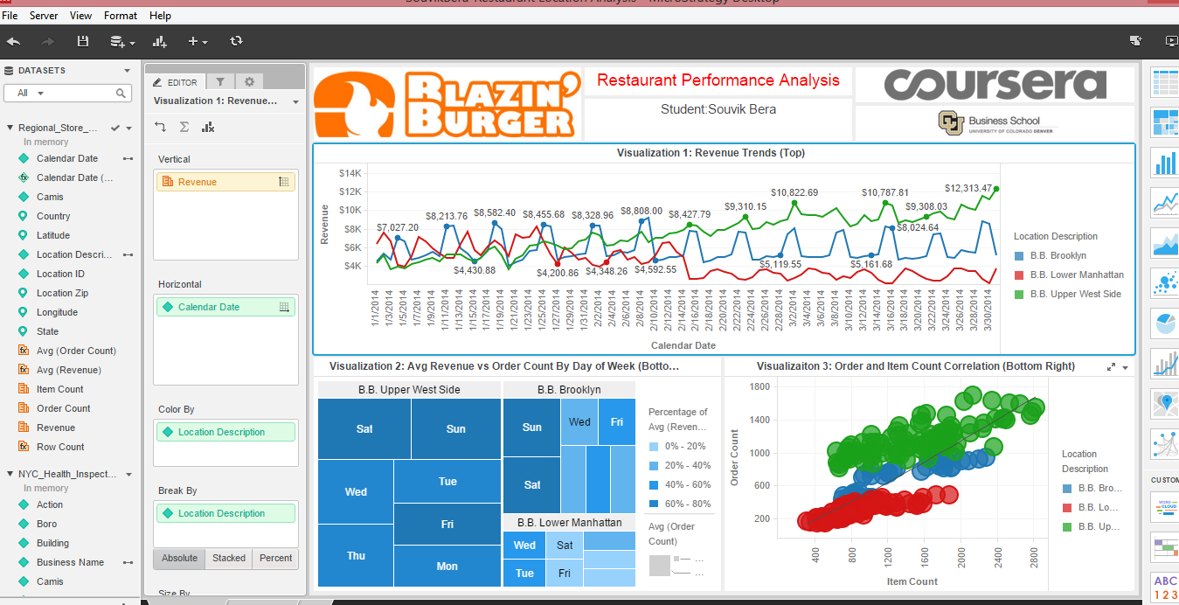

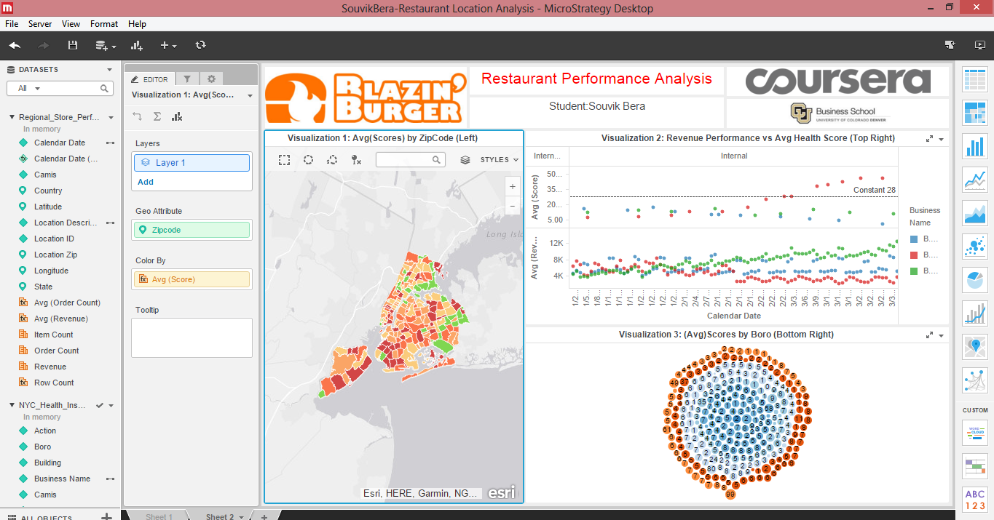

1.Analysis of all the visualizations with respect to how it is helping you find the Key Performance Indicators and the causes of various problems identified?

2.What more could you have done other than what is included in the exercise to achieve better analysis of both the datasets?

Ans 1

**Visualization 1: Revenue Trends (Top) shows us the visualization of revenue vs calender date.Here we see that the revenue lines are almost same upto mid Feb then the red line lowers indicating less revenue and the green line increases whereas the blue line remains more or less constant.**

**Visualization 2: Avg Revenue vs Order Count By Day of Week (Bottom Left) shows us the revenue alongwith area and date.We see that Upper West Side Generates maximum revenue and Lower Manhattan generates the least revenue and we can see the revenue generated from each area by day of the week.**

**Visualizaiton 3: Order and Item Count Correlation (Bottom Right) shows the correlation between order and item count.There is a trend line marked in the visualization.**

**Therefore from sheet 1 we can conclude that Restaurant at B.B.Upper West Side is performing the best whereas Restaurant at B.B.Lower Manhattan is performing the worst.**

**Visualization 1: Avg(Scores) by ZipCode (Left) shows the average score received by an area according to their zip.**

**Visualization 2: Revenue Performance vs Avg Health Score (Top Right) shows the average score and average revenue of an area according to date.There is a line drawn for average health score of 28.We see that few red points have crossed the line.**

**Visualization 3: (Avg)Scores by Boro (Bottom Right) shows average scores against boro.We can click any specific area on map and view its changed visualization.Therefore from sheet 2 we can conclude that revenue is dependent on health score.Higher health score indicates lower revenue.Thus steps should be taken to reduce the health scores to increase the revenue**. **Lot of Lower Manhattan branches received a C grade in inspection what might be a reason for the bad result.**

**Ans 2**

**We could have plot a bar graph trying to find out avg(revenue) on different week days**

**We could have examined competitor data.**