Pull image httpd

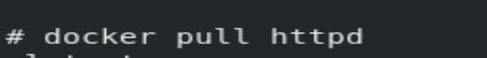

Run this image



Checking it using docker ps command



Create your own local directory(/lwweb) and add your html files here, copy index.html file inside your httpd server local html directory.

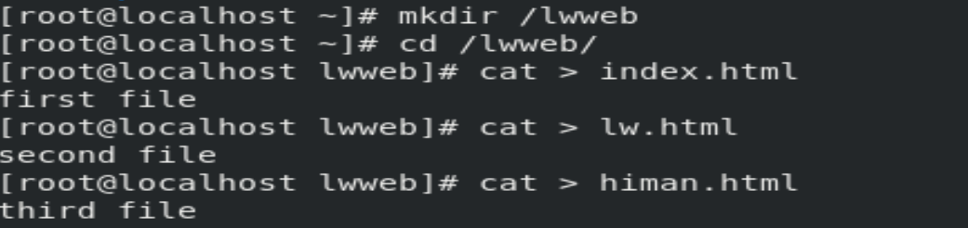

Now copy this index.html file to our server(myweb1) html directory location and check if this work.

Next we are going to link this /lwweb directory to our new webserver so that in future if we update any data in the lwweb directory this will autoupdate here.



Update testing

Now let’s create one new Repository on Git Hub with name – devops_5-05-20 and add one Index.html file.

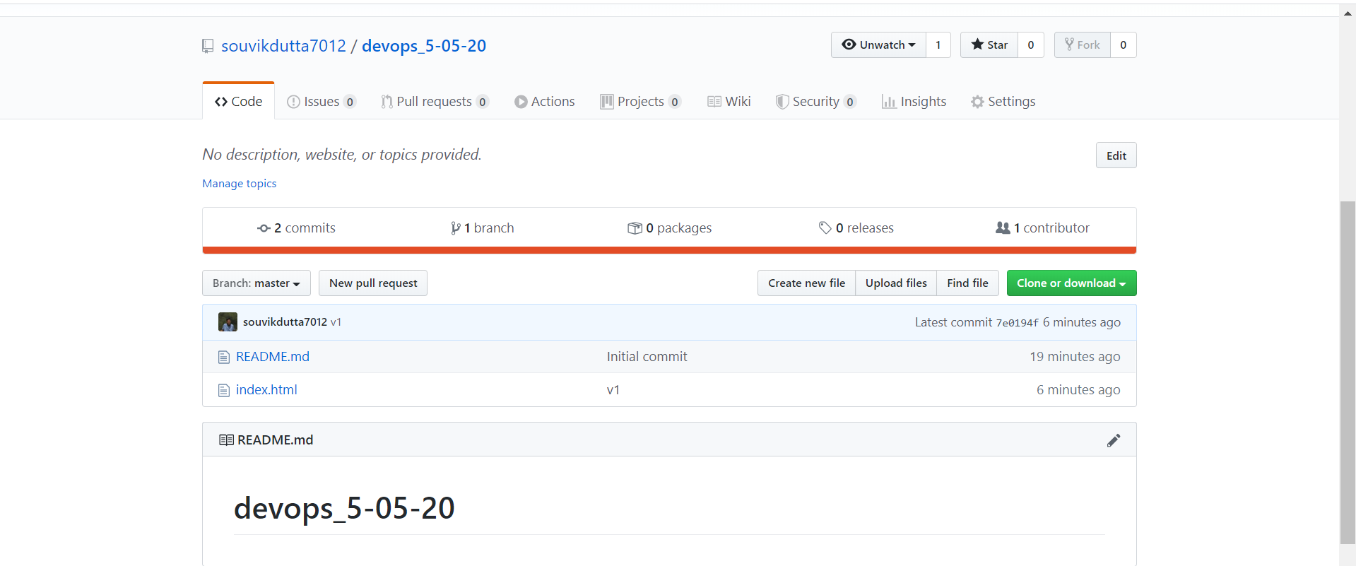

Update the local git for this repo

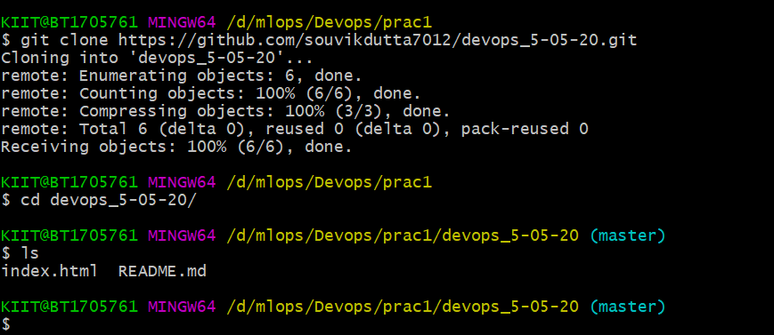

Let’s update this local repo once and see if it is working. Output says it work fine so our setup is ok

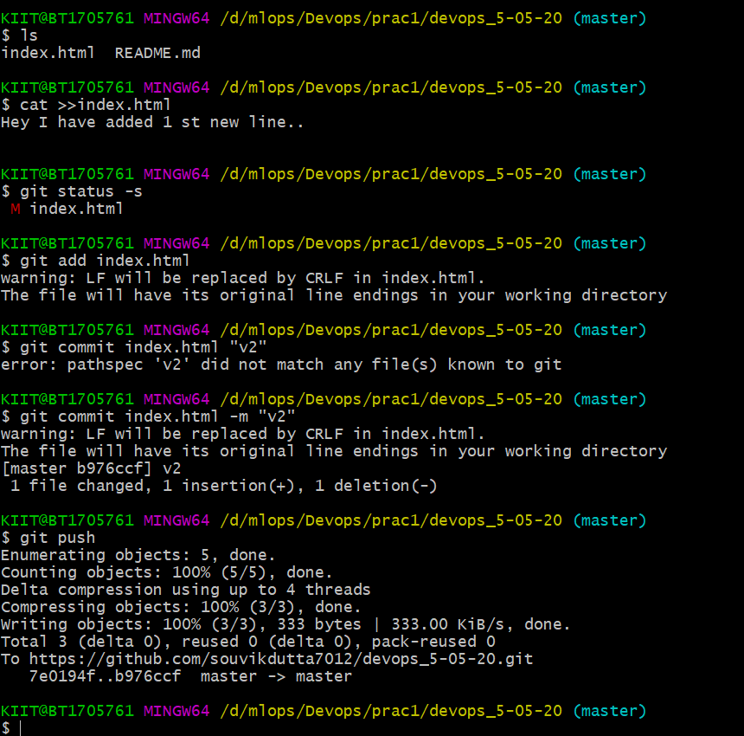

Now in order Jenkins user run all the command over RHEL web server we need to provide admin rights to Jenkins user. So we are going to change sudoers file. /etc/sudoers

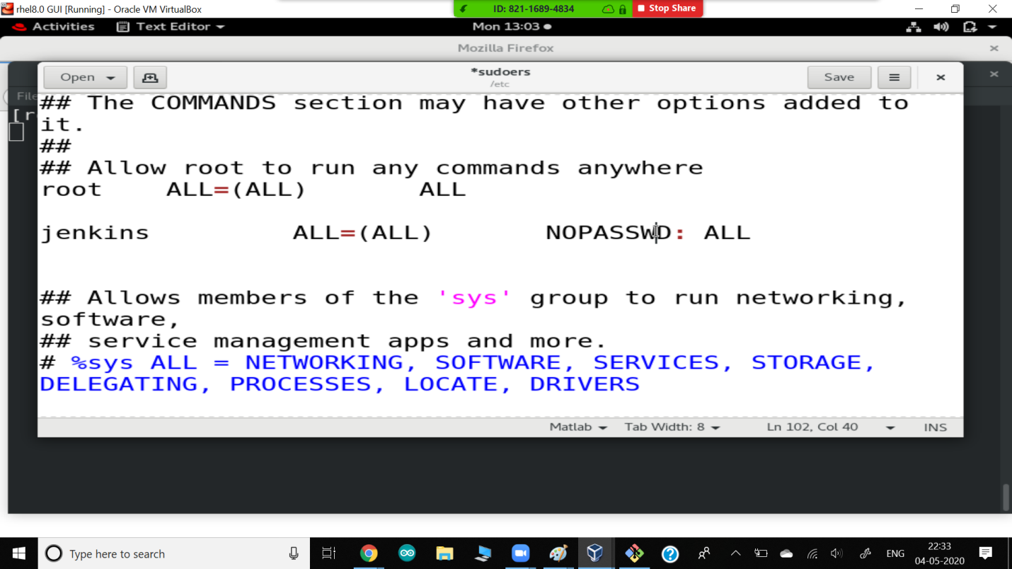

Create Your first project and connect this with GitHub Project and add cp command to copy data to lwweb directory.

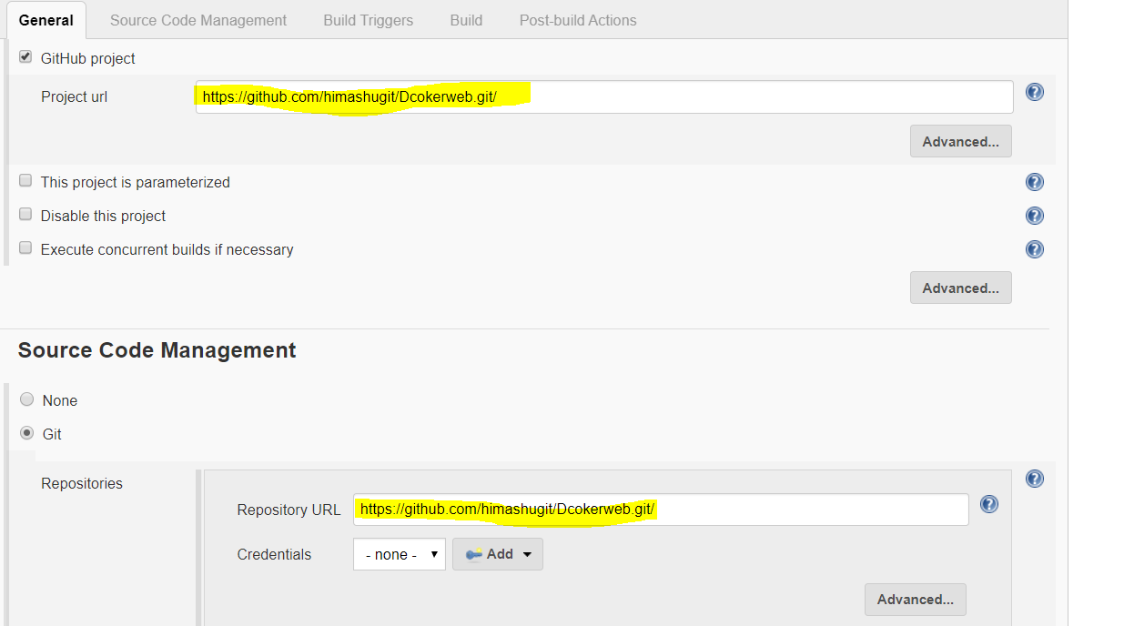

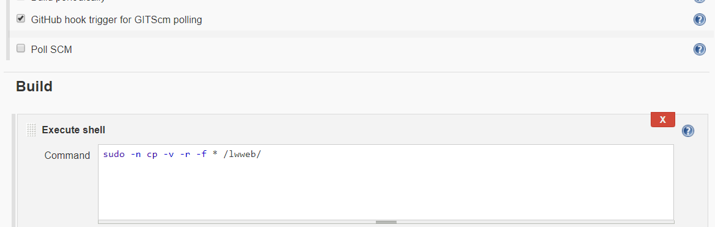

Create project-2 which will run new docker container with web server configured and display all data from lwweb directory. We are going to link this directory to new os.

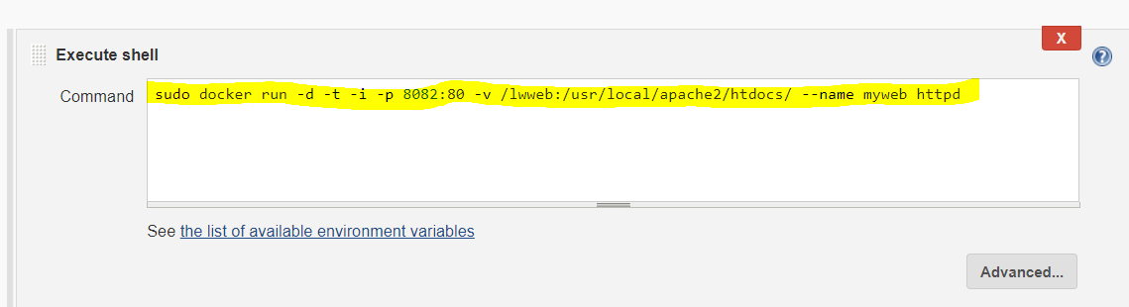

Or you can use if condition if os name is already running

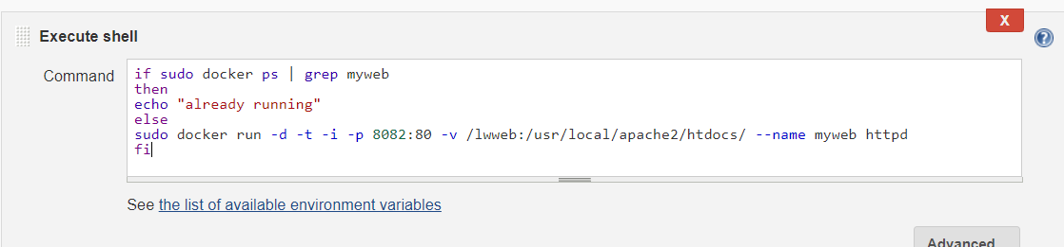

Now we are going to create a chain of these 2 jobs so they run in a order. Project1 is first and then if it working/ stable, Project-2 will run.

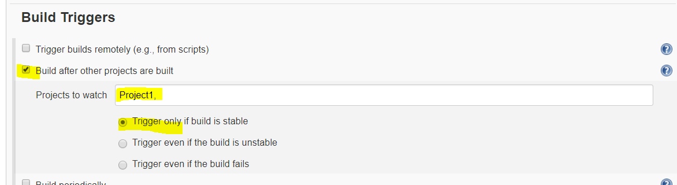

Update Poll SCM setting in Project 1. So it is continuously polling every 1 min.

