Steps to run and test the application locally:

1) JDK should be installed

2) cd {folder-path}\rock-paper-scissor\target

3) java -jar rock-paper-scissor-0.0.1.jar to start the application on port 8081

4) http://localhost:8081/game/start

To generate the token.

Sample Response:

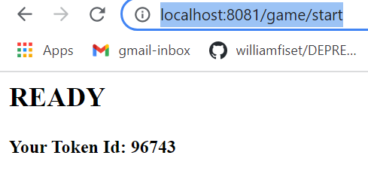

5) <http://localhost:8081/game/v1/96743/Scissors> (random server move)

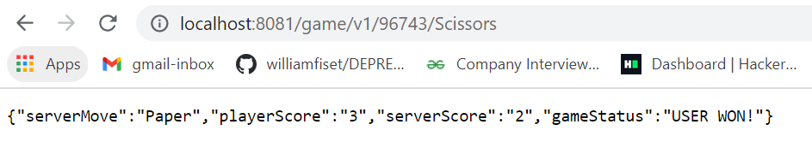

6) <http://localhost:8081/game/v2/96743/Scissors> (Server favoured)

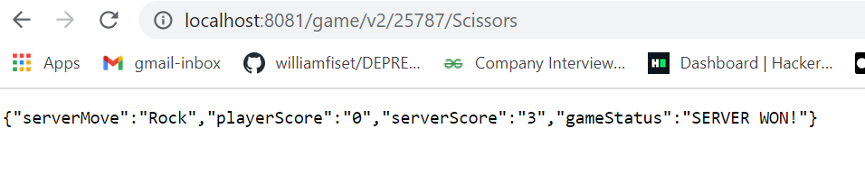

**Creating table rock_paper_scissor inside game_db (MySQL):**

CREATE DATABASE game_db;

CREATE TABLE `rock_paper_scissor` (

`game_id` int(11) DEFAULT NULL,

`server_score` int(11) DEFAULT NULL,

`user_score` int(11) DEFAULT NULL,

`game_status` varchar(255) DEFAULT NULL,

`created_date` datetime DEFAULT CURRENT_TIMESTAMP,

`modified_date` datetime DEFAULT CURRENT_TIMESTAMP ON UPDATE CURRENT_TIMESTAMP

) ENGINE=InnoDB DEFAULT CHARSET=latin1;