I have fitted both Nelson Siegel model as well as the the Svensson function.

The input given for a random date to R was -

|  |  |
| --- | --- |
| Maturity(Years) | Yield |
| 0.0 | 8.39000005674711 |
| 0.5 | 8.450811463997 |
| 1 | 8.38019492402002 |
| 1.5 | 8.35712924636928 |
| 2 | 8.37684307237919 |
| 2.5 | 8.419999492788 |
| 3 | 8.47284811350606 |
| 3.5 | 8.52740496460772 |
| 4 | 8.57951998729607 |
| 4.5 | 8.62731859513528 |
| 5 | 8.67019332831743 |
| 5.5 | 8.70819836988704 |
| 6 | 8.74170135897293 |
| 6.5 | 8.77119083366029 |
| 7 | 8.79717481596881 |
| 7.5 | 8.8201313367722 |
| 8 | 8.84048767485978 |
| 8.5 | 8.85861483226249 |
| 9 | 8.87482958940671 |
| 9.5 | 8.88939990253555 |
| 10 | 8.90255138157642 |
| 10.5 | 8.91447370764626 |
| 11 | 8.9253264706706 |
| 11.5 | 8.9352442407204 |
| 12 | 8.94434085637948 |
| 12.5 | 8.95271299248593 |
| 13 | 8.96044309982922 |
| 13.5 | 8.9676018145832 |
| 14 | 8.9742499286035 |
| 14.5 | 8.9804400003339 |
| 15 | 8.98621767362106 |
| 15.5 | 8.99162275999091 |
| 16 | 8.99669012961469 |
| 16.5 | 9.00145044747797 |
| 17 | 9.00593078408855 |
| 17.5 | 9.01015512424056 |
| 18 | 9.01414479268018 |
| 18.5 | 9.01791881178901 |
| 19 | 9.02149420343399 |
| 19.5 | 9.02488624477427 |
| 20 | 9.02810868593969 |
| 20.5 | 9.03117393600315 |
| 21 | 9.03409322247672 |
| 21.5 | 9.03687672860874 |
| 22 | 9.03953371199279 |
| 22.5 | 9.04207260738319 |
| 23 | 9.04450111611271 |
| 23.5 | 9.04682628410309 |
| 24 | 9.04905457012901 |
| 24.5 | 9.05119190572623 |
| 25 | 9.05324374791252 |
| 25.5 | 9.05521512570722 |
| 26 | 9.05711068128384 |
| 26.5 | 9.05893470646423 |
| 27 | 9.06069117515823 |
| 27.5 | 9.06238377226442 |
| 28 | 9.06401591947462 |
| 28.5 | 9.06559079836204 |
| 29 | 9.06711137108118 |
| 29.5 | 9.06858039896252 |
| 30 | 9.0700004592479 |

Results -

**Nelson Siegel Model -**

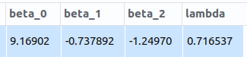

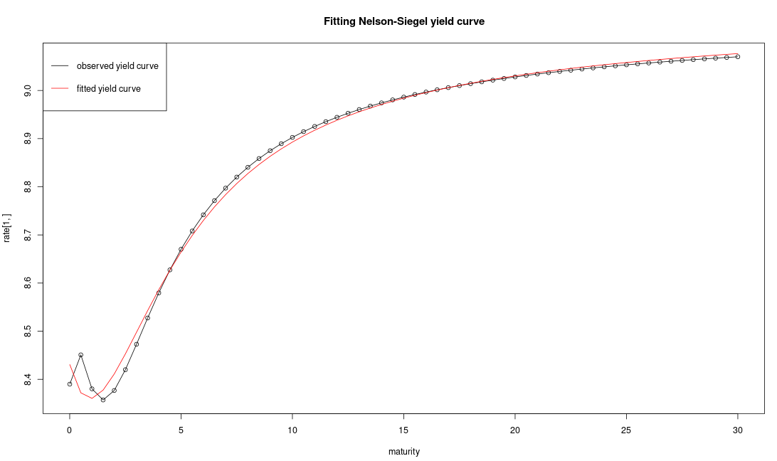

**Nelson Siegel Svensson Model -**

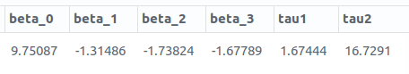

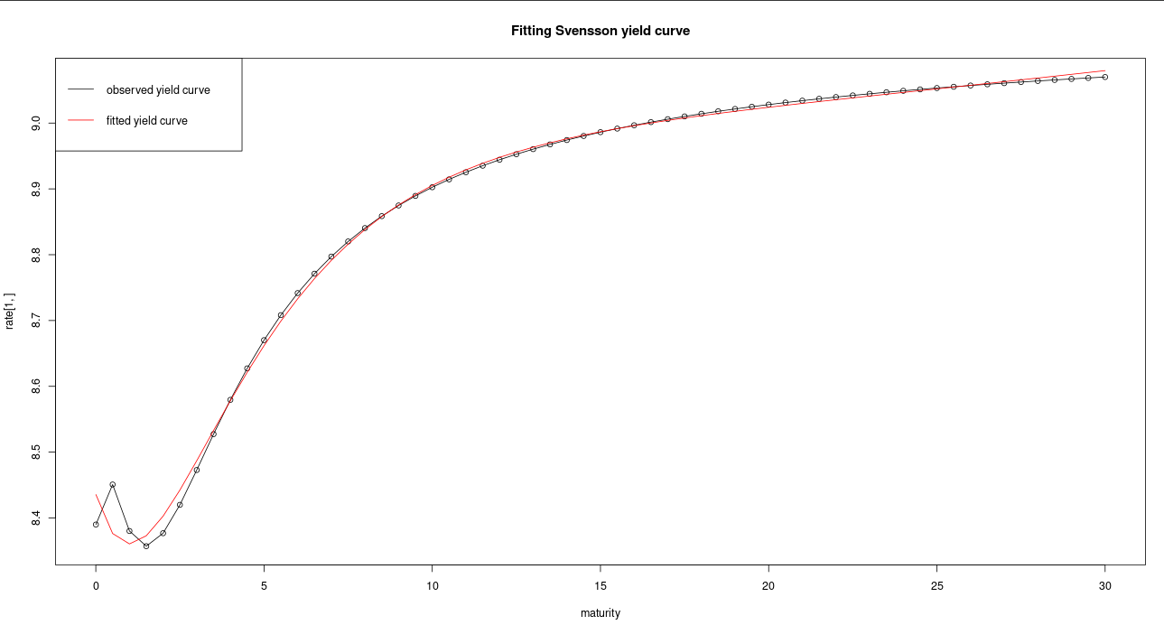

Note – For comparison purpose, I am attaching the estimated parameters as given by CCIL on this particular data. Please refer the same -

|  |  |
| --- | --- |
| Date | 28/03/14 |
| CCIL_Beta.0 | 9.15378401609412 |
| CCIL_Beta.1 | -0.765886002610963 |
| CCIL_Beta.2 | -0.001670369407331 |
| CCIL_Beta.3 | -2.3635603575221 |
| CCIL_Tau.1 | 0.195355485717624 |
| CCIL_Tau.2 | 1 |