**DSC-510_Introduction-to-programming - Course Project**

**Weather-Program**

For this project we will be creating an application to interacts with a webservice to obtain data. Your program will use all of the information you’ve learned in the class in order to create a useful application.  
The program must prompt the user for their city or zip code and request weather forecast data from [OpenWeatherMap](http://openweathermap.org/). This program must display the weather information in a **READABLE** format to the user.

**Requirements:**

* Create a header for your program just as you have in the past.
* Create a Python Application which asks the user for their zip code or city.
* Use the zip code or city name in order to obtain weather forecast data from [OpenWeatherMap](http://openweathermap.org/).
* Display the weather forecast in a readable format to the user.
* Use comments within the application where appropriate to document what the program is doing.
* Use functions including a main function.
* Allow the user to run the program multiple times to allow them to look up weather conditions for multiple locations.
* Validate whether the user entered valid data. If valid data is not presented notify the user.
* Use the **Requests** library to request data from the webservice.
  + Use Try blocks to ensure that your request was successful. If the connection was not successful display a message to the user.
* Use **Python 3**
* Use try blocks when establishing connections to the webservice. You must print a message to the user indicating whether the connection was successful

**Deliverables:**

* Final Program in a .py file (Python file)

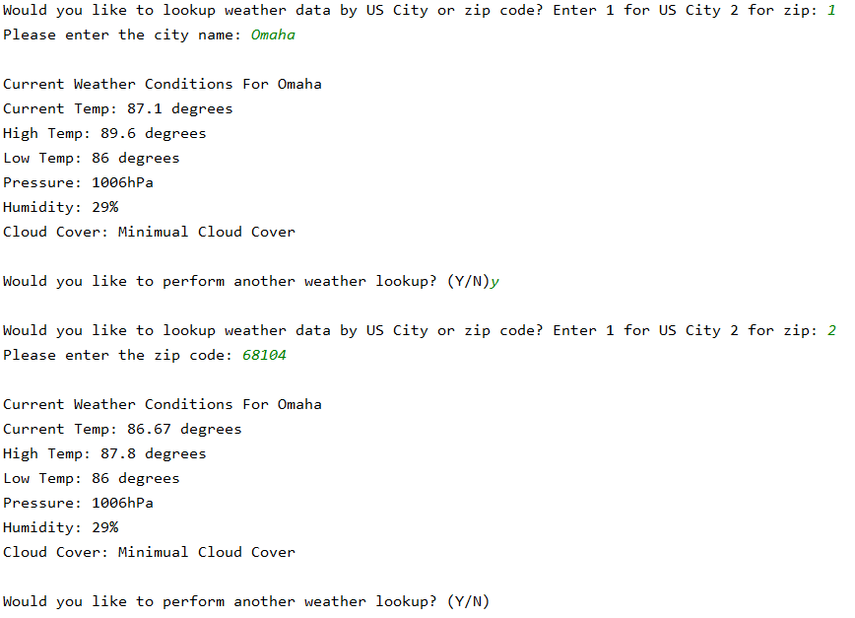

* **Project Notes:**
  + This project is a real-world program. I used it as an opportunity to improve my knowledge.
  + I signed up for [API Key](http://openweathermap.org/appid) by using the above link, which allowed me to get my own API key that I used in the real world program**.**
  + The API key I found is: **c05250b637031a772b7adbfe110350c5**
  + I made a connection to the API using the Requests library.