Final Project Step 4

Soukhna Wade

2/28/2020

SECTION 4

##### Forum: 12.1 Discussion: Final Project Step 4: Final Project Submission

##### Final Project Step 4: Final Project Submission

### LOAD THE LIBRARYneeded for calculation, analysis and plotting the data sets are listed below:

library(boot) library(ggm) library(ggplot2) library(Hmisc) library(polycor) library(rcorr) library(readxl) library(tidyverse) library(tidyr) library(corrplot) library(leaflet) library(lubridate)

library(data.table) library(dplyr) library(VIM) library(DT) library(gridExtra) library(caret) library(Metrics) library(randomForest) library(pROC) library(e1071) library(dtree) library(corrplot) library(DMwR) library(Rcmdr)

##### Functions to examine data set are:

dim(data) #shows the dimensions of the data frame by row and column str(data) # shows the structure of the data frame #summary(data) # provides summary statistics on the columns of the data frame #colnames(data) # shows the name of each column in the data frame #head(data) # shows the first 6 rows of the data frame ## look at the first several rows of the data #tail(data) # shows the last 6 rows of the data frame View(data) # shows a spreadsheet-like display of the entire data frame #rownames(data) #colnames(data) glimpse(data) # Explore the data

attach(data) #attach the data frame to the environment

#### To Perform Exploratory Data Analysis(EDA)

### Import dataset: CSV (WA_Fn-UseC_-HR-Employee-Attrition) form The Original source (link): <https://www.kaggle.com/pavansubhasht/ibm-hr-analytics-attrition-dataset>

library(readxl) data <- read.csv(“~/Data/R Book Examples/WA_Fn-UseC_-HR-Employee-Attrition.csv”)

#View(data) # shows a spreadsheet-like display of the entire data frame

colnames(data) # shows the name of each column in the data frame nrow(data) # Shows the columns(variables) number result: [1] 35 variables  
ncol(data) # shows the rows (observations) number result: [1] 1470 Observations dim(data) # shows the dimensions of the data frame by row and column

str(data) # shows the structure of the data frame #rownames(data) #colnames(data) #head(data) # shows the first 6 rows of the data frame ## look at the first several rows of the data #tail(data) # shows the last 6 rows of the data frame summary(data) # provides summary statistics on the columns of the data frame

library(dplyr) glimpse(data) # Explore the data

### To find the missing values(NA)

missingValues <- sum(is.na(data)) # to directly find out it there are any missing values in out dataframe / result is [1] 0, I found that my data is cleaned missingValues

apply(is.na(data), 2, sum) # There is no missing value

cat(“DataSet has”,dim(data)[1], " Rows and “, dim(data)[2],” Columns" ) # DataSet has 1470 Rows and 35 Columns ### To check for duplicated Record

sum (is.na(duplicated(data))) # result is [1] 0

VIM::aggr(data)

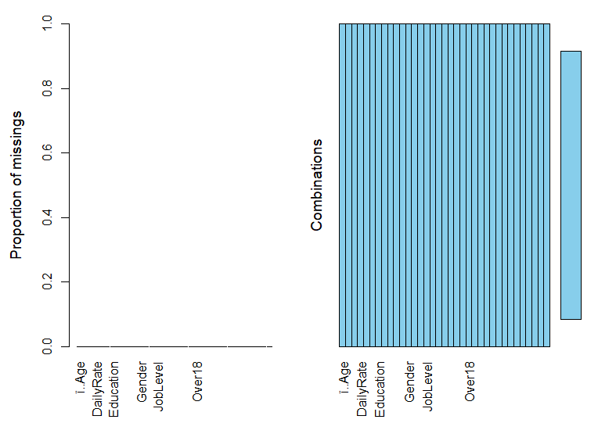

### To Dropping columns irrelevant columns (step need in EDA to drop unused column)

#subset( data, select = -c(BusinessTravel,Department,EducationField, Gender, JobRole, MaritalStatus, Over18))

### To Determine correlation

## data.cor = cor(data $MonthlyIncome,data$ ï..Age, method = c(“pearson”, “kendall”, “spearman”)) # result is [1] 0.4978546

## data.cor = cor(data $MonthlyIncome,data$ ï..Age, method = c(“pearson”)) # result is [1] 0.4978546

## data.cor = cor(data $MonthlyIncome,y=data$ ï..Age, use = “everything”, method = c(“pearson”)) # result is [1] 0.4978546

data.cor = cor(data $MonthlyIncome,data$ ï..Age, use = “complete.obs”) # result is [1] 0.4978546 data.cor = cor(data $MonthlyIncome,y=data$ ï..Age, use = “complete.obs”, method = c(“pearson”, “kendall”, “spearman”)) # [1] 0.4978546 data $MonthlyIncomedata$ ï..Age cor(data[,c(“ï..Age”,“MonthlyIncome”)], use=“complete”)

### To find the Correlation Matrix of Data

library(corrplot) corrplot(cor(sapply(data,as.integer)),method = “pie”)

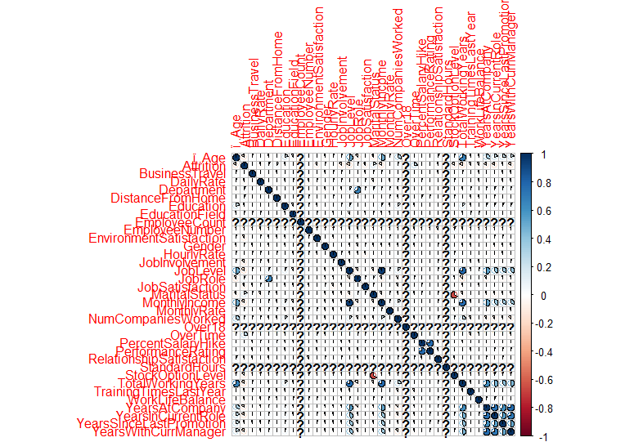

#Some of the variables are highly correlated, such as: JobLevel and MonthlyIncome / Education and YearsEducation. These variables cause a multicollinearity problem in our dataset. Therefore we should remove one of them for any group. then we try again our data set with new attributes using Random Forest

### To calculate the covariance of the two variables monthly income and age

out <- cov(data $MonthlyIncome,data$ ï..Age, use = “complete.obs”) #result is [1] 0.4978546

### To Create Elegant Data Visualisations Using the Grammar of Graphics

library(ggplot2) ggplot2 <- ggplot(data, aes(x=“ï..Age”, y=“JobSatisfaction”)) + geom_point(alpha = 0.6) + stat_smooth(method = “lm”, col = “red”, se = FALSE) ggplot2

## Some attributes are categorical, but in the dataset are integer. We must change them to categorical. Also, we do not need any dummy variable creation, where some machine learning algorithms like RF, Boost, etc. can use categorical variables. For other algorithms like NN, we must change categorical variables more than two-level to dummy variable with two-level (Binary) can be adjusted to number very easy.

data $PerformanceRating<-factor(data$ PerformanceRating) data $RelationshipSatisfaction<-factor(data$ RelationshipSatisfaction) data $StockOptionLevel<-factor(data$ StockOptionLevel) data $WorkLifeBalance<-factor(data$ WorkLifeBalance) data $Education<-factor(data$ Education) data $EnvironmentSatisfaction<-factor(data$ EnvironmentSatisfaction) data $JobInvolvement<-factor(data$ JobInvolvement) data $JobLevel<-factor(data$ JobLevel) data $JobSatisfaction<-factor(data$ JobSatisfaction)

### Visualization of Attrition

data %>% group_by(Attrition) %>% tally() %>% ggplot(aes(x = Attrition, y = n,fill=Attrition)) + geom_bar(stat = “identity”) + theme_minimal()+ labs(x=“Attrition”, y=“Count of Attriation”)+ ggtitle(“Attrition”)+ geom_text(aes(label = n), vjust = -0.7, position = position_dodge(0.11))

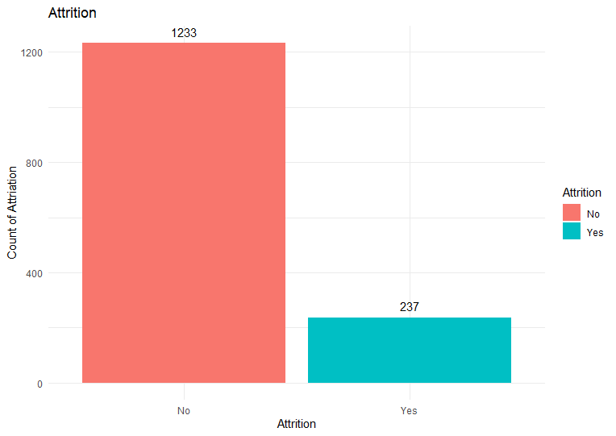

#The above graph shows 237/1470=0.16 % of the dataset label shows the “Yes” in Attrition. This is a problem that should be handled during the process because an unbalanced dataset will bias the prediction model towards the more common class ( ‘NO’). There are different approaches for dealing with biased data in machine learning. It is ideal to use more data( but unfortunately, here is not possible). Resampling, changing the machine performance metric, using various algorithms, etc.

library(ggplot2) ggplot2 <- ggplot(data=data, aes(x=data$Age, y=null)) + geom_histogram(breaks=seq(10, 40, by=2), col=“red”, aes(fill=..count..))+ labs(x=“Age”, y=“Count”)+ scale_fill_gradient(“Count”, low=“green”, high=“red”) ggplot2

### Building the model

## Using Raw data by RF:at the first Stage to use RF for getting some information about the prediction split Data to Train and Test

#install.packages(‘pROC’) #install.packages(‘e1071’) #install.packages(“varImpPlot”) library(randomForest) library(pROC) library(e1071) library(varImpPlot)

## To split Data to Train and Test

rfData <- dataset.seed(123) indexes = sample(1:nrow(rfData), size=0.8*nrow(rfData)) RFtrain.Data <- rfData[indexes,] RFtest.Data <- rfData[-indexes,]

## To build model

rf.model <- randomForest(Attrition~.,RFtrain.Data, importance=TRUE,ntree=600) varImpPlot(rf.model)

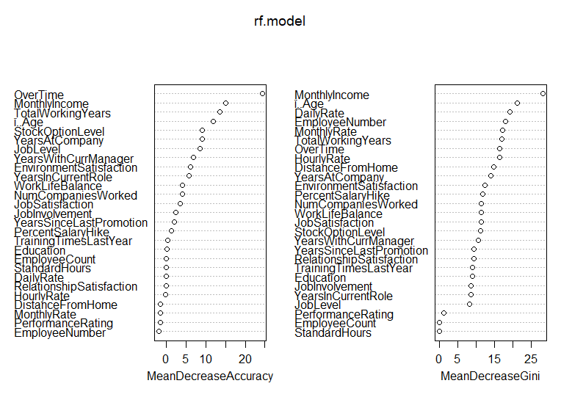

## To build model

#rfData <- data #set.seed(123) #indexes = sample(1:nrow(rfData), size=0.8*nrow(rfData)) #RFRaw.train.data <- rfData[indexes,] #RFRaw.test.data <- rfData[-indexes,] #Raw.rf.model <- randomForest(Attrition~.,RFRaw.train.Data, importance=TRUE,ntree=1000)

#Building the model

rfData <- myData set.seed(123) indexes = sample(1:nrow(rfData), size=0.8*nrow(rfData)) RFRaw.train.Data <- rfData[indexes,] RFRaw.test.Data <- rfData[-indexes,]

Raw.rf.model <- randomForest(Attrition~.,RFRaw.train.Data, importance=TRUE,ntree=800)

varImpPlot(Raw.rf.model)

Raw.rf.prd <- predict(Raw.rf.model, newdata = RFRaw.test.Data) confusionMatrix(RFRaw.test.Data$Attrition, Raw.rf.prd)

##Confusion Matrix and Statistics ## ##Reference ##Prediction No Yes ##No 244 2 ##Yes 40 8 ## ##Accuracy : 0.8571  
##95% CI : (0.8118, 0.8951) ##No Information Rate : 0.966  
##P-Value [Acc > NIR] : 1  
## ##Kappa : 0.2327  
## ##Mcnemar’s Test P-Value : 0.00000001135  
##  
## Sensitivity : 0.8592  
## Specificity : 0.8000  
## Pos Pred Value : 0.9919  
## Neg Pred Value : 0.1667  
## Prevalence : 0.9660  
## Detection Rate : 0.8299  
## Detection Prevalence : 0.8367  
## Balanced Accuracy : 0.8296  
##  
## ‘Positive’ Class : No  
##

### 1. Overall, write a coherent narrative that tells a story with the data as you complete this section.

## This project is about to build a learning model of a fictional data set created by IBM data scientists to analyze the workforce. The main issue is to deals with the employee at the organization. This project is to uncover the factors that lead to employee attrition and to explore the essential questions such as: showing a breakdown of distance from home by job role and attrition comparing average monthly income by education and attrition. It is a fictional data set created by IBM data scientists. The dataset is supplied by Kaggle and contains HR analytics data of employees that stay and leave. The types of data include metrics such as education level, job satisfaction, and commute distance.

### 2. Summarize the problem statement you addressed.

## The data mainly deals with employee details. All of the data is very clean. Added scatter plots, bar charts for the employee details. Box plots for the bivariate analysis like the number of experiences for the number of projects etc. The final goal of the project is to find if an employee resigns next.

### 3. Summarize how you addressed this problem statement (the data used and the methodology employed).

## There are many interesting insights. Mainly I have analyzed it in Univariate and Bivariate analysis. So, I found the details of why if an employee is going to leave or not. Many factors could affect an employee to leave a company, like the number of years they worked in the company if they promoted or not, etc.

### 4. Summarize the interesting insights that your analysis provided.

## The analysis can be used by hour of the company to have a clear idea of how employee behavior is impacting.

### 5. Summarize the implications to the consumer (target audience) of your analysis.

## I can draw more analysis that can affect employee behavior. Implement the Machine Learning Techniques to find which employee will leave next.

### 6. Discuss the limitations of your analysis and how you, or someone else, could improve or build on it.

## Employee Number can be accepted as an indicator for the time of joining the company, which can be used for new feature generation. Still, we do not have any metadata about it; then, we will remove it.

### 7. In addition, submit your completed Project using R Markdown or provide a link to where it can also be downloaded from and/or viewed.

END OF SECTION 4