1. A over B – However this is very hard to make an absolute decision

Pros: Less variance in the probability of meeting the mean productivity level thus, we can say that this employee is more probable to stay in the 75% level. Hiring A is taking less of a risk by hiring A once we are happy with 75%.

Cons: Productivity spectrum of object A is limited compared to object B. And there is higher probability that B exceeds higher productivity level. Candidate A never can have productivity 80% while B has this chance.

2. B

No matter what the true value is for candidate B it is always going to be greater than candidate A. B is more productive in general. By introducing a second predictor into this decision this could be easier to decide which candidate is more appropriate for which type of activities.

3. This forecast is biased

Fixing: reduce the tuning parameters (reduce K, the window)

For (1) and (2) below, you're choosing between two candidates to hire. Discuss the pros and cons of choosing one candidate over the other in the following situations.

1. Both are predicted to have the same productivity score of 75, but have the following probabilistic forecasts.

A over B – However this is very hard to make an absolute decision

Pros: Less variance in the probability of meeting the mean productivity level thus, we can say that this employee is more probable to stay in the 75% level. Hiring A is taking less of a risk by hiring A once we are happy with 75%.

Cons: Productivity spectrum of object A is limited compared to object B. And there is higher probability that B exceeds higher productivity level. Candidate A never can have productivity 80% while B has this chance.

[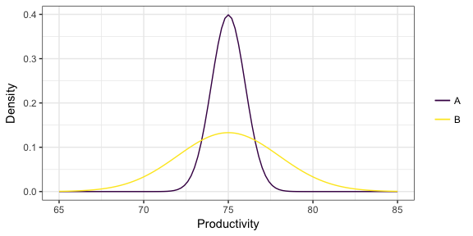](https://github.com/vincenzocoia/BAIT509/blob/master/class_meetings/cm08-beyond_mean_mode_files/figure-html/unnamed-chunk-17-1.png)

1. Two "non-overlapping" forecasts:

No matter what the true value is for candidate B it is always going to be greater than candidate A. B is more productive in general. By introducing a second predictor into this decision this could be easier to decide which candidate is more appropriate for which type of activities.

[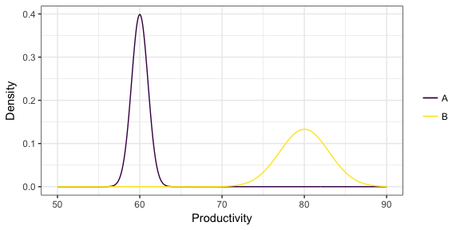](https://github.com/vincenzocoia/BAIT509/blob/master/class_meetings/cm08-beyond_mean_mode_files/figure-html/unnamed-chunk-18-1.png)

1. You've formed a probabilist forecast for a particular value of the predictors, displayed below as a density. You then collect test data for that same value of the predictor, indicated as the points below the density. What is the problem with the probabilistic forecast?

This forecast is biased. Tprobabilistic forecast shows high variance and low biased.

Fixing: reduce the tuning parameters (reduce K, the window)

[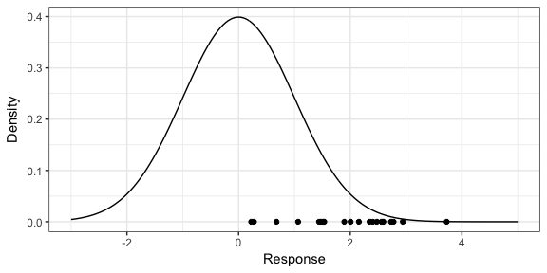](https://github.com/vincenzocoia/BAIT509/blob/master/class_meetings/cm08-beyond_mean_mode_files/figure-html/unnamed-chunk-19-1.png)