Artificial scenarios: some results

Preliminary information:
- fANOVA and RF are using 10000 samples and 300 trees;
- Imputing strategies: random value, middle point (mid), value out of range (out);
- fANOVA is applied on original ranges when using random or middle imputing;
- Basic definitions are using 300 samples.

Scenario 1
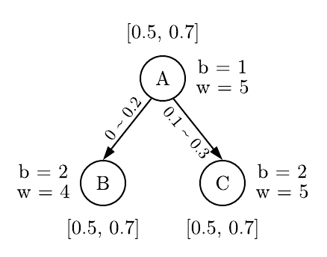 Expected: A, C, B

Basic definitions | fANOVA
Basic definitions | random | 0.5 (mid) | 2.0 (out)
A: 0.8759 | A: 0.6287 | C: 0.3644 | A: 0.3348
C: 0.4444 | C: 0.0467 | A: 0.3171 | C: 0.3211
B: 0.3333 | B: 0.0252 | B: 0.0816 | B: 0.0842

RF measures (raw performance, imputing out of range)
mean-min-depth | no-nodes | mse-increase | node-purity-inc | no-trees | times-root | p-value
A: 0.96 | A: 14034 | A: 4.81 | C: 26487.62 | 300 | C: 105 | A: 1.2e-16
C: 1.17 | C: 12897 | C: 4.33 | A: 23304.94 | 300 | A: 102 | 0.999
B: 1.30 | B: 12846 | B: 3.61 | B: 17591.65 | 300 | B: 93 | 0.999

RF measures (raw performance, imputing random)
mean-min-depth | no-nodes | mse-increase | node-purity-inc | no-trees | times-root | p-value
B: 0.99 | B: 58215 | B: 15.40 | A: 57841.80 | 300 | A: 105 | B: 0.08
A: 1.02 | C: 57839 | C: 7.58 | C: 18016.36 | 300 | B: 104 | C: 0.69
C: 1.13 | A: 57762 | A: 6.02 | B: 12812.64 | 300 | C: 91 | A: 0.82

Scenario 2
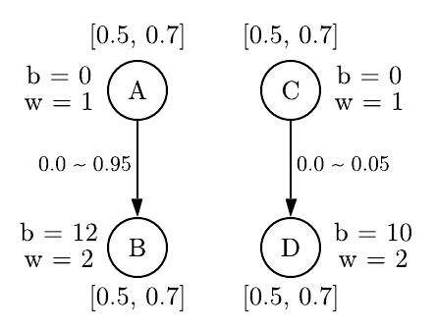 Expected: C, A, B, D

Basic definitions | fANOVA
Basic definitions | random | 0.5 (mid) | 2.0 (out)
C: 0.4462 | B: 0.5179 | B: 0.5300 | B: 0.3721
A: 0.3391 | A: 0.2493 | A: 0.1298 | A: 0.3041
B: 0.2727 | C: 0.1726 | C: 0.1193 | D: 0.1289
D: 0.2273 | D: 0.0009 | D: 0.0882 | C: 0.0394

RF measures (raw performance, imputing out of range)
mean-min-depth | no-nodes | mse-increase | node-purity-inc | no-trees | times-root | p-value
A: 1.35 | A: 10109 | B: 24.81 | B: 123083.28 | 300 | B: 78 | A: 1.1e-7
C: 1.44 | C: 10051 | D: 7.97 | A: 40750.03 | 300 | A: 75 | C: 3.4e-6
D: 1.640 | B: 9754 | A: 7.91 | D: 37075.48 | 300 | C: 75 | B: 1.5e-1
B: 1.643 | D: 8749 | C: 6.56 | C: 34415.31 | 300 | D: 72 | D: 1.00

RF measures (raw performance, imputing random)
mean-min-depth | no-nodes | mse-increase | node-purity-inc | no-trees | times-root | p-value
C: 1.32 | C: 47196 | B: 42.49 | B: 201644.89 | 300 | 82 | C: 0.14
A: 1.33 | B: 47182 | A: 19.88 | A: 103570.21 | 300 | 82 | B: 0.16
B: 1.43 | D: 46882 | C: 12.71 | C: 67519.16 | 300 | B: 73 | D: 0.72
D: 1.44 | A: 46713 | D: 2.62 | D: 11279.92 | 300 | D: 63 | A: 0.93

