Artificial scenarios

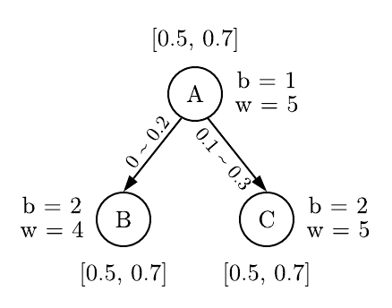
Scenario 1

Parameters: A, B, C
Base contributions (A, B, C): 1, 2, 2
Weights (A, B, C): 5, 4, 5
Target intervals (all parameters): [0.5, 0.7]
Conditions:

Note: not using propagation of weights to parents

Importance

Basic definitions | fANOVA
Basic definitions | Rep 1 | Rep 2 | Rep 3 | Rep 4
A: 0.8506 | C: 0.3385 | A: 0.3775 | C: 0.4576 | C: 0.3171
C: 0.4444 | A: 0.2636 | C: 0.2429 | B: 0.1553 | A: 0.2471
B: 0.3333 | B: 0.1269 | B: 0.0806 | A: 0.1523 | B: 0.1941

Scenario 2
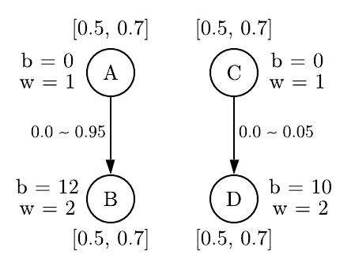
Parameters: A, B, C, D
Base contributions (A, B, C, D): 0, 12, 0, 10
Weights (A, B, C, D): 1, 2, 1, 2
Target intervals (all parameters): [0.5, 0.7]
Conditions:

Note: not using propagation of weights to parents

Importance

Basic definitions | fANOVA
Basic definitions | Rep 1 | Rep 2 | Rep 3 | Rep 4
C: 0.4443 | B: 0.3669 | A: 0.4601 | A: 0.3819 | A: 0.5471
A: 0.3320 | A: 0.2517 | B: 0.2840 | B: 0.2839 | B: 0.2187
B: 0.2727 | D: 0.1510 | D: 0.1580 | D: 0.1580 | C: 0.0647
D: 0.2273 | C: 0.0632 | C: 0.0621 | C: 0.0621 | D: 0.0462

