CNATool - User Manual

Presentation

The **CNATool** tool was developed, using the **MaiaScript** programming language, to allow quick and simplified analysis of complex network graphics from any device connected to the Internet.

Currently the tool allows:

* Display the network graph.
* Define the graph layout algorithm.
* Calculate basic graph properties: average degree, density, average clustering coefficient, average shortest path, diameter and graph efficiency.
* View detailed vertices' properties: degree, clustering coefficient and centralities.
* Save graph in **Pajek** and **JSON** format.
* Export graph in **SVG** format.
* Save a summary of the graph properties in **HTML** format.

Knowing the user interface

The CNATool interface is divided into three parts: **menu bar**, **properties panel** and **graph display panel**.

Menu bar

The menu bar allows access to all application's functionalities. Currently it presents **Maia**, **File**, **View** and **Help** options. Figure 1 presents the options found in the main menu of the program.



Figure 1: Menu bar.

The option **Maia** directs the browser to the **Maia Cloud Lab** site, the virtual lab of the **Maia Research Group**, responsible for the development of this program.

The **File** option allows access to operations related to creating, opening and saving files. It contains three submenus: **New**, **Open** and **Save**. The **New** option allows you to create a graph from some parameters that will be requested. The parameters are **number of vertices**, **number of edges**, **edge probability** and **average degree**. Of these, the only mandatory parameter is the **number of vertices**. The other parameters can be requested or not, depending on the topology of the graph to be created. The types of graphs supported are **complete**, **random**, **scale-free**, **small world** and **hybrid**. Figure 2 presents this menu with all its options expanded.



Figure 2: File, New menu option.

As an example, let us create a **scale-free** graph. To do this, the following actions should be performed:

1. Position the mouse pointer over the **File** menu.
2. Move the mouse pointer to the **New** option.
3. Click on the **Scale-Free Graph** option.
4. Enter 20 in the **Number of vertices** dialog box.
5. Type 2 in the **Average degree** dialog box.
6. Enter 0.3 in the **Edge probability** dialog box.

A graph like the one shown in Figure 3 will be created. This graph was created randomly, and its layout is also random. We can modify this by selecting a **layout algorithm** in the **properties panel**. Figure 4 shows the properties panel and highlights the **Force Atlas 2** option. Click on this option. The algorithm will begin to rearrange the vertices of the graph. When it stabilizes, select **None** from the same menu. Figure 5 shows the graph of Figure 3 rearranged using the **Force Atlas 2** algorithm.

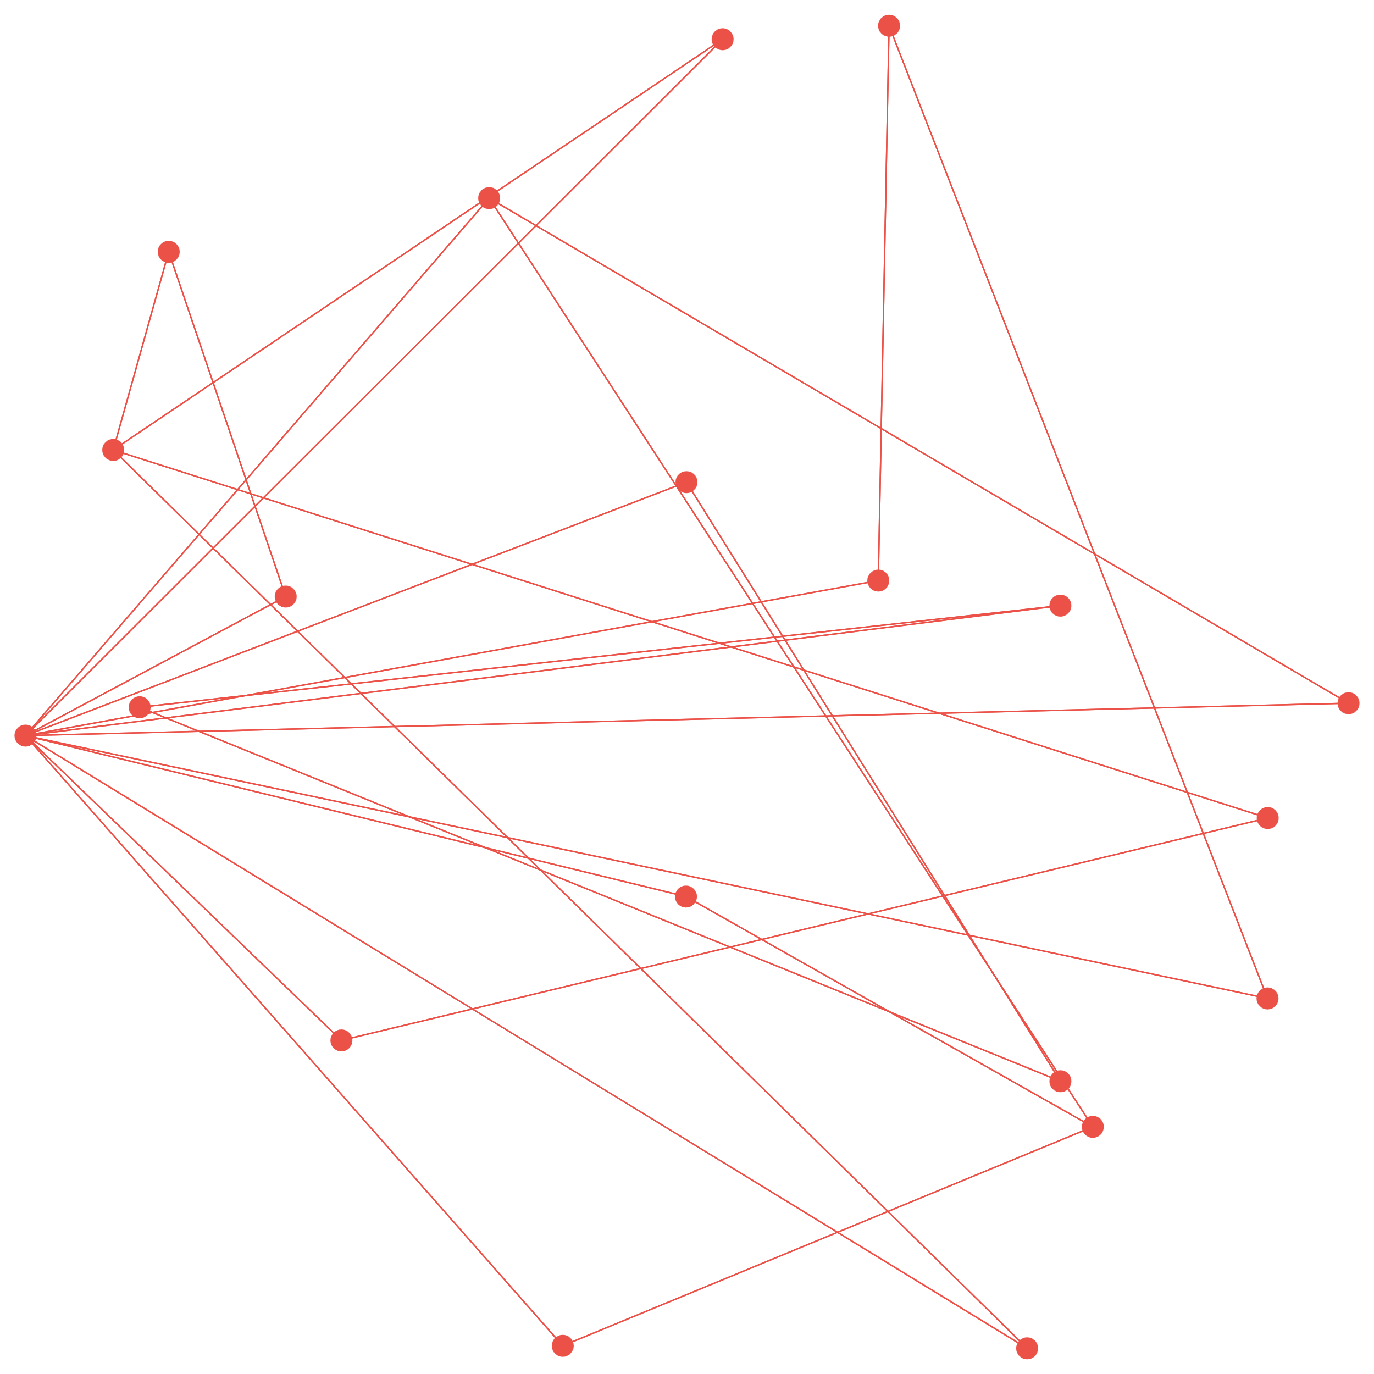

Figure 3: A free scale graph.

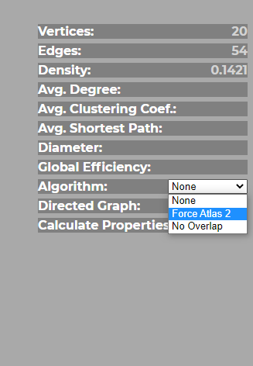

Figure 4: Properties panel highlighting the Force Atlas 2 option.

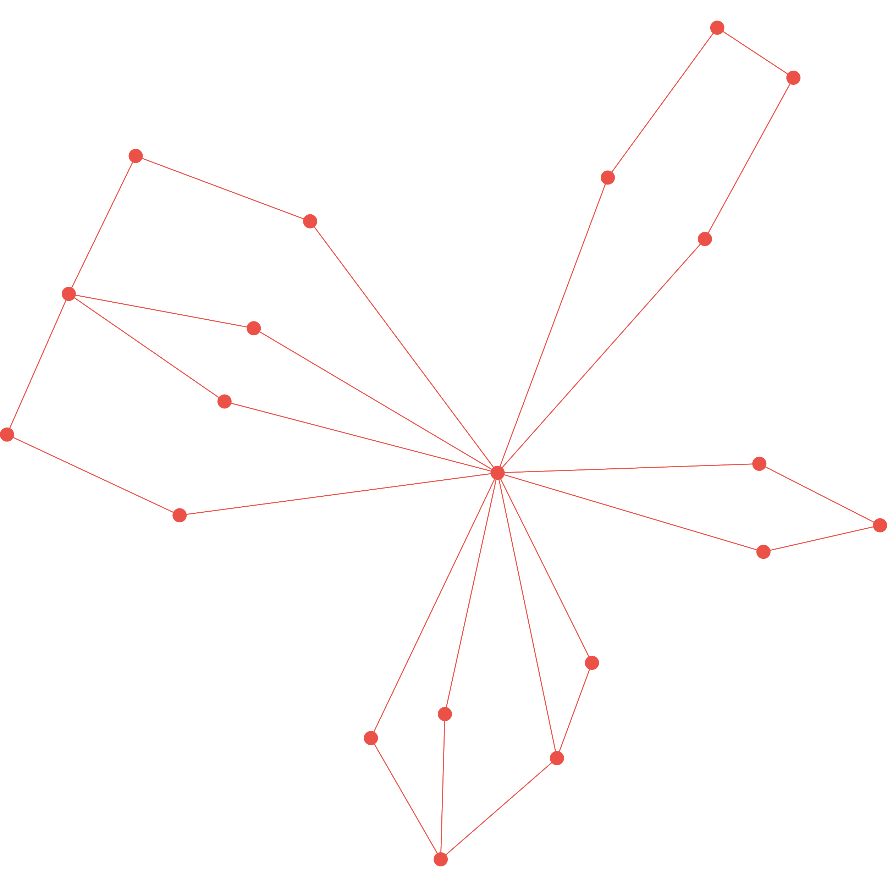

Figure 5: The graph of Figure 3 reorganized using the Force Atlas 2 algorithm.

The **Open** option in the **File** menu allows you to open files in **Pajek** and **JSON** formats. The program automatically identifies the file format based on its file name extension. These extensions are **NET** and **JSON**, respectively.

The menu **Save** allows you to save the graph in the **Pajek**, **JSON** or **SVG** (**Graph File)** file formats. Regardless of the chosen format, the applied layout will be saved in the file.  
  
The **File**, **Save**, **Report file** option allows you to save a report containing the properties displayed in the properties panel. This report also contains the **degree distribution** of the graph. To do so, you must first check the **Calculate Properties** option in the properties panel.  
  
The **View** menu allows you to view the graph properties in detail. This menu presents the options: **Properties Summary**, **Vertices Degrees**, **Vertices Clustering** and **Vertices Centralities**. To use any option in this menu, it is necessary first calculate the properties of the graph. To do so, check the **Calculate Properties** option in the properties panel.

## Command line interface

To run a command line tool, use the command:

cnatool.js [options] file_name.net [--] [args]

Where arguments between [ and ] are advantages.

For example, to calculate the main parameters of network analysis, namely, number and vertices, number of edges, average degree, average clustering efficiency, average shortest path and overall efficiency, we use the following arguments, for a file named “football. net”, one of the sample files distributed with the program:

cnatool.js --all examples/football.net

The file ”football.html“ containing the calculated parameters will be created.

To see the command-line tool options, run the command:

cnatool –help

The following are the other command line options:

|  |  |  |
| --- | --- | --- |
| Option | | Description |
| -h | --help | Displays this help message; |
|  | --all | Include all properties in report; |
|  | --cen | Include vertices centralities in report; |
|  | --clu | Include vertices clustering in report; |
|  | --deg | Include vertices degrees in report; |
|  | --spath | Include only average shortest path in report; |
|  | --gpu | Uses the GPU to speed up calculations; |
|  | --csv | CSV output file name; |
| -j |  | JSON output file name; |
| -l |  | Log output file name; |
| -o | [report.html] | Output report file name; |
| -p | [properties.json] | Properties file name; |
| -r |  | Replace commas by dots in CSV numeric columns; |
| -s |  | CSV column separator; |
|  | --build | Builds a semantic network from a file in DLF format; |
|  | --weighted | The created network must be weighted based on the number of occurrences of the connections between the vertices; |
|  | --if | Calculate the incidence fidelity index |
|  | --create | Creates a network file in Pajek format; |
|  | --directed | Network is a directed graph; |
|  | --export | Exports the network file in Pajek format; |
|  | --json | Save the network file in JSON format; |
|  | --loops | Allow loops; |
|  | --topology | Graph topology (complete, random, scalefree, smallworld or hybrid. For semantic networks it can be: chain, circle or clique); |
|  | --prefix | File name prefix for multiple file creation; |
|  | --vertices | Number of vertices; |
|  | --edges | Number of edges; |
|  | --probability | Edge probability; |
|  | --avgdeg | Average degree; |
|  | --minw | Minimum weight; |
|  | --nfiles | number of files to create; |
|  | --vinc | increment to number of vertices; |
|  | --einc | increment to number of edges; |
|  | --dinc | increment to average degree. |

Legal information

Copyright (C) 2020 Roberto Luiz Souza Monteiro, Renata Souza Barreto, Hernane Borges de Barros Pereira.

This software is distributed under the terms of several open source licenses. Read the LICENSE, COPYING or COPYING.LIB files for more information.