Maia Platform Project Portfolio
Companion document for investor discussion
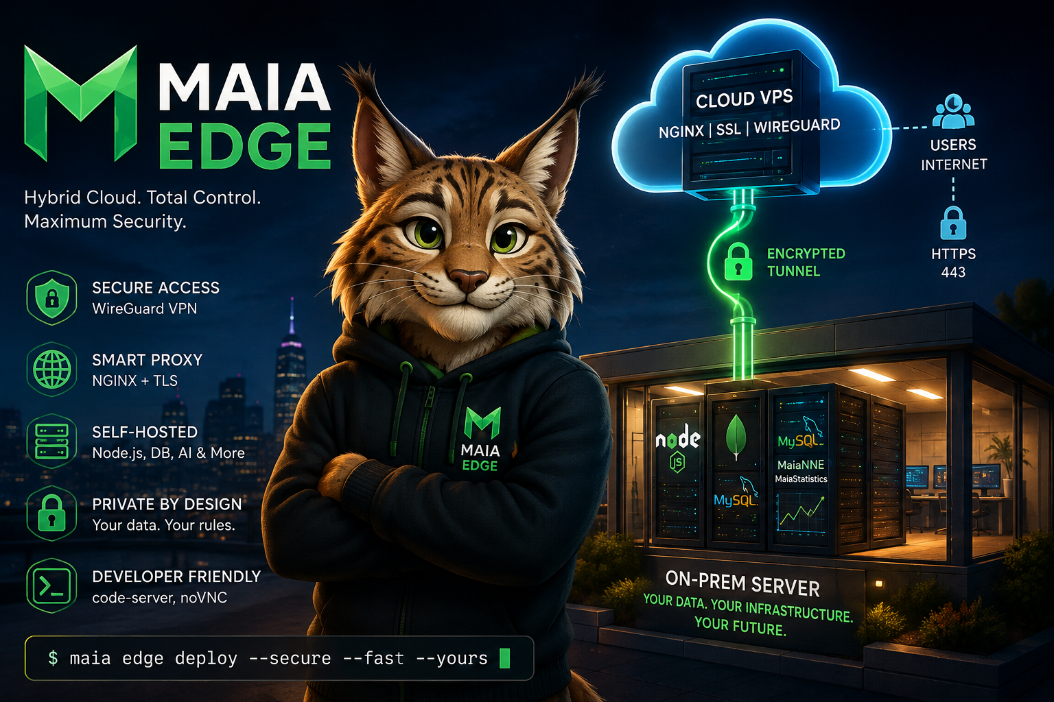
Prepared by Roberto Luiz Souza Monteiro
Maia Platform founder
September 2026
www.maiaplatform.org

Portfolio overview
Maia Platform brings together 49 open source projects spanning infrastructure, artificial intelligence, data science, programming languages and browser applications. Maia Chat and Maia RAG are the current product focus. This companion portfolio presents the other 47 projects that provide technical foundations, reusable components, applied research and routes for future products.
The portfolio matters because the central products do not stand alone. Maia Edge supports controlled deployment. MaiaScript, MaiaCC and MaiaSQL provide language and data capabilities. MaiaNNE and MaiaStatistics support machine learning and scientific analysis. The wider set of applications shows how these foundations can serve education, research, media, accessibility and professional workflows.

Portfolio composition
Project group | Projects
Core foundations | 7
Applied artificial intelligence and data | 6
Languages and developer tools | 14
Media and voice | 11
Applications and experiments | 9

Current product focus
Maia Chat provides a web interface and API for local language models, including streaming responses, document attachments and knowledge retrieval. Maia RAG indexes documents with local embeddings and retrieves relevant sources for Maia Chat and other applications. Both services are online and are covered in the accompanying investor presentation.
Open Maia Chat Visit Maia RAG

Core foundations
Infrastructure, programming languages, data systems, machine learning components and planning tools that support the wider platform.
Maia Edge | Hybrid cloud infrastructure for securely publishing services hosted on local hardware through a lightweight cloud gateway.
MaiaScript | A programming-language ecosystem with compiler, CLI, editor support and learning resources.
MaiaSQL | SQL and database tooling focused on portable, browser-friendly and embedded data workflows.
MaiaCC | Compiler and parser infrastructure for building language tooling and code-processing experiments.
MaiaNNE | Neural-network tooling used in applied machine learning and time-series forecasting projects.
MaiaStatistics | Statistical analysis and scientific-computing components for the Maia data ecosystem.
Loom Planner | A project-planning PWA designed to organize initiatives, tasks, costs and execution.

Applied artificial intelligence and data
Projects that apply machine learning, statistics, forecasting and reproducible datasets to concrete research and analysis problems.
Battery Health Analyzer | Battery telemetry analysis with health metrics, datasets, visualizations and reproducible data formats.
Maia Cryptocurrency | Cryptocurrency analysis and forecasting using MaiaNNE and MaiaStatistics.
Binance API Server | A server-side integration layer for cryptocurrency market data and operations.
Open Mobile Battery Telemetry Dataset | An open dataset supporting battery-health and mobile telemetry research.
MKAffNet | Experimental artificial-intelligence and neural-network research tooling.
Maia Football | Football-oriented analytics and applied prediction experiments.

Languages and developer tools
Compilers, editors, database components, command line tools, educational software and automation utilities used across the ecosystem.
MaiaC | C-oriented language and compiler experimentation in the Maia toolchain.
MaiaCpp | C++ components and tooling for the Maia development ecosystem.
MaiaWASM | WebAssembly experiments and browser runtime integration for Maia projects.
WebSQL SQLite3 | SQLite-backed WebSQL compatibility and browser database experiments.
MKSQL | SQL-focused tooling for parsing, generation and database workflows.
MaiaRegex | Regular-expression tooling and experiments for language-processing projects.
Maia Editor | An editor experience designed around Maia languages and tooling.
Maia Console | Console and terminal utilities for interacting with Maia development tools.
Guash | Shell and command-line experimentation for developer workflows.
Linux on Android | Tools and experiments for bringing Linux development environments to Android.
CNA Tool | Technical utilities for code and systems analysis workflows.
Learning Blockly | Visual programming and educational experiments built around Blockly.
Generate Slides | Utilities for automating and accelerating slide-deck creation.
Translation Tools | Maia Translator and automation utilities for multilingual software workflows.

Media and voice
Browser and native tools for audio, video, recording, transcription, noise suppression, music and voice-enabled applications.
FFmpeg WASM Browser | Browser-based media processing powered by a local WebAssembly build of FFmpeg.
Audio Converter Web App | A browser application for convenient audio conversion workflows.
Camera Recorder Web App | Browser camera capture and recording with a simple web interface.
Screen Recorder Web App | A web application for screen capture and recording directly in the browser.
Browser Video Toolkit | Editors, converters, mixers, extractors, title makers and timeline tools for browser media production.
RNNoise Tools | Native and JavaScript interfaces for real-time neural audio-noise suppression.
Subtitles Generator | A browser-oriented workflow for creating subtitles for audiovisual content.
Maia Recorder | Recording tools and experiments for media capture inside the Maia ecosystem.
Maia Voice | Voice-oriented interfaces and experiments connecting audio with intelligent applications.
MIDI Keyboard Web App | A browser-based MIDI keyboard and music-interaction experiment.
Teleprompter Web App | A lightweight browser teleprompter for recording, teaching and presentations.

Applications and experiments
End-user applications for health, communication, productivity, collaboration, data conversion and integrated development workflows.
Adipometer | A mobile-oriented application supporting body-measurement and fitness assessment workflows.
Fitness Log App | FitLog and WorkoutLog applications for tracking exercise and physical-training routines.
CardDOS | An application experiment combining card-based interaction and software tooling.
Morse Code Web App | A browser application for learning and working with Morse-code communication.
Text Corrector | A writing assistant for reviewing and improving textual content.
XML to SQL | A utility for transforming XML-oriented data into SQL workflows.
Maia Meet | Meeting and communication experiments for browser-based collaboration.
Maia Studio | A studio environment connecting Maia tools, development workflows and applications.
MaiaLexa | Natural language lexer integration experiments within the Maia ecosystem.

Platform context
Maia Platform is an independent open source ecosystem created by Roberto Luiz Souza Monteiro. It connects long-running work in software engineering, computational modeling, artificial intelligence, education and applied research. The platform favors local ownership of data and infrastructure, browser-based applications and reusable technical foundations.

How the projects reinforce each other
Infrastructure Maia Edge provides the hybrid deployment pattern for services that run on local hardware and remain accessible through a secure public gateway.
Intelligence and data MaiaNNE, MaiaStatistics and applied analysis projects supply reusable methods for forecasting, scientific computing and model-driven applications.
Languages and tools MaiaScript, MaiaCC, MaiaSQL and related developer tools reduce dependence on isolated third-party components and support experimentation across the stack.
Product surface Browser applications turn the underlying engineering into tools that people can use for media, education, accessibility, health, communication and productivity.

Links
Maia Platform https://www.maiaplatform.org/
Online applications https://apps.maiaplatform.org/
Maia Chat https://chat.maiaplatform.org/
GitHub profile https://github.com/souzamonteiro
Founder profile https://www.robertomonteiro.net/

