**Title: The first record of the** **Uniform-Finch (*Haplospiza unicolor* Cabanis, 1851) in the Cerrado and Center-West of Brazil**

Yuri Souza1, João Salvador2, Baptiste Wijas1,3

**1.** Department of Biology, University of Miami, Coral Gables, Florida, US

**2.** São Manuel, São Paulo, Brazil

**3.** School of Biological, Earth and Environmental Sciences, University of New South Wales, Sydney, New South Wales, Australia

Corresponding author: Yuri Souza

**Abstract**

The Uniform-Finch *(Haplospiza unicolor* Cabanis, 1851) is typically found in the Atlantic Forest of Brazil, but we have recorded it for the first time in the Brazilian savanna, or Cerrado, at a private property in Alto Paraíso de Goiás, Goiás state. This is a new record at both the biome and state levels. We also accessed all the occurrence information of *H. unicolor* available in databases to explore its overall geographical range. This new sighting indicates this bird was found 679,43km from its original distribution range, thus shedding light either on its potential for dispersal or the prior lack of knowledge on persisting bird populations in the area. The record presented here adds to the understanding of *H. unicolor* distribution and potential for dispersal, indicating the need for further research to explore its population size, stability, and environmental adaptation in the Cerrado.

**Key-words**: Birds, Dispersal, Savanna, Occurrences, GBIF

The Uniform-Finch (*Haplospiza unicolor* Cabanis, 1851) is an endemic bird of the Atlantic Forest, mostly found in the southeastern coastal states of Brazil (da Cunha 2012). Its current conservation status is Least Concern, and it naturally occupies habitats such as subtropical or tropical moist lowland forests and subtropical or tropical moist montane forests (BirdLife International 2016). The Uniform-Finch is commonly seen in areas with bamboo, particularly in forests where the *Chusquea sp.* genus, abundant in the Neotropics, grows in the understory (Young 1991; Fisher et al. 2014). They are considered “bamboo specialists” as bamboo seeds comprise an important part of their diet (Sánchez 2005; da Cunha 2012).

On July 1st, 2024, we spotted the Uniform-Finch (*Haplospiza unicolor* Cabanis, 1851) for the first time in the Brazilian savanna, also known as Cerrado, in the Center-West of the country. The bird was sighted at a privately managed reserve called “Cachoeira da Fazenda Loquinhas” (latitude: -14.1440633, longitude: -47.48816, Figure 1), situated in the city of Alto Paraíso de Goiás in the Goiás state, Brazil. This area has a few tourist trails, which in total cover a loop of 2.2 km and consist mainly of gallery forests (forests formed along rivers and streams) and rupestrian woody fields (a highland woody forest composed of trees, shrubs, and rocks), with elevations ranging from 1200 meters to 1300 meters.

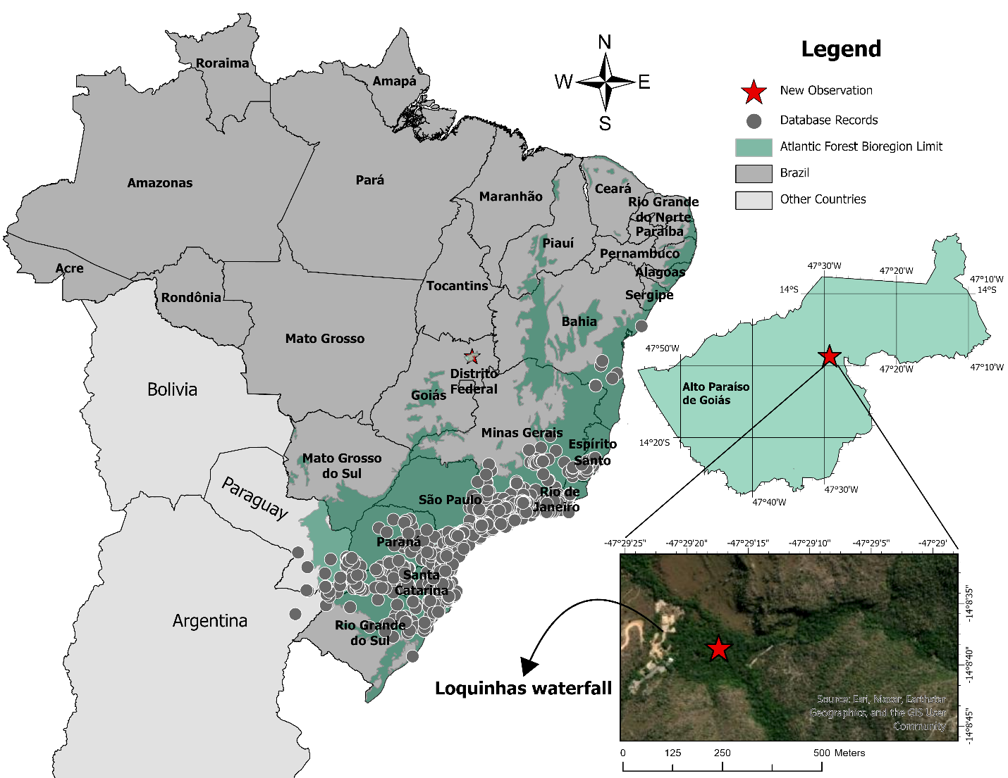

**Fig. 1** All occurrence data of Uniform-Finch (Haplospiza unicolor Cabanis, 1851). Each point is an observation from a museum collection, focal observation, or vocalization record acquired from databases. The reddish star highlights the new location where this bird was recorded, Cachoeira da Fazenda Loquinhas (or “Loquinhas waterfall”), placed in the city of Alto Paraíso de Goiás, Goiás State, Brazil.

The register happened at approximately 7:30 am. The *H. unicolor* individuals were initially identified by their vocalization. We estimated that there were around four to five individuals vocalizing in a gallery forest situated in a valley with a narrow stream. The area is characterized by tall trees and a few bamboos on the slope (latitude: -14.144166, longitude: -47.483497). After identifying the vocalization, we used playback recordings from eBird and Wikiaves (a Brazilian bird database) to lure the birds, which replied and approached after a few minutes. Prior to our record, this species had been recorded only on the coast of the tropical and ombrophile Atlantic Forest. The bird was observed using binoculars, audio recordings, and telephoto cameras (all the images and additional details are available on the GitHub repository: <https://github.com/souzayuri/ornithology_research_haplospiza_unicolor>). The bird was identified with the assistance of the bird guide João Salvador (CRBIO: 113624/01-D). Photos were taken for further identification and are displayed in Figure 2. We also recorded the bird's vocalization and made it available on eBird along with the pictures (<https://ebird.org/checklist/S184727948>).

**Fig. 2** Pictures of an individual of the Uniform-Finch (Haplospiza unicolor Cabanis, 1851) taken from different angles. Picture A was taken using a Nikon D7200, and B to D used a Nikon Z7. Both pictures were taken within the 400-600mm zoom lens range and cropped later using Adobe Photoshop® in order to remove the image noise.

The *H. unicolor* occurrence and records data displayed in Figure 1 comprise the data available on the *Global Biodiversity Information Facility* (gbif – which also includes data from eBird prior to our upload to its database). We downloaded the available occurrence data using the package “*spocc*” in R software (Owens et al. 2024; R Core Team 2024), from which we removed records from museum collections.

To investigate how unusual our record was in relation to others, we calculated the distance of our record in regard to the current bird occurrences available on databases. Using the function *Near* on ArcGIS Pro®, we calculated the average distance among all individual past recorded locations and compared this to the average distance of our new observation with the past recorded locations. On average, each available record (9,482 points) is 0.881 km apart from each other, while the new record is 679,69 km on average apart from the other points (calculated by including the downloaded data from all data sources).

There could be several explanations for why we observed this bird at this location. On one hand, a few individuals could have undertaken an exceptional migration which is not that uncommon for birds in the tropics (da Silva 1995). On the other hand, it could be a case of an isolated *H. unicolor* population that has been residing in this area for decades, if not centuries. The Atlantic Forest has lost 77% of its original cover, and the remnants are mostly composed of isolated and small patches of forest, such as the one in which we recorded *H. unicolor,* spread all across its original biome range (Vancine et al. 2024). As there have been few bird checklists at this location (according to eBird, there have only been 34 checklists since 2015), a sighting of *H. unicolor* could have been previously overlooked. Our new record highlights the need to study these remnant patches of gallery forest more thoroughly, as these could be harboring unexpected biodiversity. Although the Cerrado is Brazil’s second largest biome and comprises many different habitats, it has been historically under-sampled compared to other biomes, such as the Amazon rainforest (Lahsen et al. 2016).

This observation widened the known distribution of *H. unicolor* while highlighting the values of remnant gallery forest patches within the Cerrado. Given the remoteness of its record compared to other observations, we suggest further research in the area to gain a better understanding of its population size and stability as well as its potential to adapt and thrive in different environments, such as the Cerrado.

**Ethical Approval**: No applicable

**Funding**: No funding was received for this work.

**Availability of data and materials**: The dataset used here is available on GitHub (https://github.com/souzayuri/Journal_of_Ornithology_haplospiza_unicolor.git) and eBird (<https://ebird.org/checklist/S184727948>).

**References**

BirdLife International (2016). Haplospiza unicolor. The IUCN Red List of Threatened Species 2016:e.T22723125A94804891.https://dx.doi.org/10.2305/IUCN.UK.2016-3.RLTS.T22723125A94804891.en. Accessed 15 July 2024.

da Cunha FCR, Pinto LCL, de Carvalho Braga CA, Souza H, Specht GVA, Leite L (2012). Widening the distribution range of the Uniform Finch Haplospiza unicolor Cabanis, 1851, in the Brazilian Atlantic Forest. Ornithologia, 5: 34-35.

da Silva JMC (1995). Biogeographic analysis of the South American Cerrado avifauna. Steenstrupia, 21:49-67.

Fisher AE, Clark LG, Kelchner SA (2014). Molecular phylogeny estimation of the bamboo genus Chusquea (Poaceae: Bambusoideae: Bambuseae) and description of two new subgenera. Systematic Botany, 39:829-844. https://doi.org/10.1600/036364414X681554

Lahsen M, Bustamante MM,Dalla-Nora EL (2016). Undervaluing and overexploiting the Brazilian Cerrado at our peril. Environment: science and policy for sustainable development, 58: 4-15. https://doi.org/10.1080/00139157.2016.1229537

Sánchez C (2005). First description of the nest and eggs of the Slaty Finch (Haplospiza rustica) and observations on song and breeding behavior. Ornitología Neotropical, 16:4.

Vancine MH, Muylaert RL, Niebuhr BB et al (2024). The Atlantic Forest of South America: Spatiotemporal dynamics of the vegetation and implications for conservation. Biological Conservation, 291:110499. https://doi.org/10.1016/j.biocon.2024.110499

Vieira LT, Castro AA, Coutinho JM, de Sousa SR, de Farias RR, Castro NM, Martins FR (2019). A biogeographic and evolutionary analysis of the flora of the North-eastern cerrado, Brazil. Plant Ecology & Diversity, 12:475-488. https://doi.org/10.1080/17550874.2019.1649311

Young KR (1991). Natural history of an understory bamboo (Chusquea sp.) in a tropical timberline forest. Biotropica, 542-554. https://doi.org/10.2307/2388392