A MINI PROJECT REPORT
on
MOVIE TICKET BOOKING SYSTEM
Subject: Database Management System (DBMS)
Implemented using MySQL
Submitted By | Sanjana Sovanshi
UID | 25BCD10108
Submitted To | Mrs. Harkamal Kaur
Designation | Assistant Professor
Submission Date | 25 October 2026

Chandigarh University
Gharuan, Mohali, Punjab

Acknowledgement
I would like to express my sincere gratitude to my teacher, Mrs. Harkamal Kaur, Assistant Professor, for her valuable guidance, encouragement and constant support throughout this mini project. Her instructions on how to plan, document and present a database project helped me understand the subject in a practical way.
I am also thankful to Chandigarh University for providing the learning environment and the laboratory facilities needed to complete this work, and to my friends and family for their motivation.
Sanjana Sovanshi
UID: 25BCD10108

Table of Contents
1. Introduction 3
2. Objectives / Problem Statement 4
3. Modules, Tools and Technologies Used 5
4. Database Design (ER Diagram) 6
5. Code with Output 7
5.1 Database and Master Tables 7
5.2 Transaction Tables 8
5.3 Inserting Data 9
5.4 Viewing Table Data 11
5.5 SQL Queries (Joins, Grouping, Aggregates) 12
5.6 View, Transaction and Delete 14
6. Conclusion, Future Scope and References 15

1. Introduction

1.1 Database Management System
A Database Management System (DBMS) is software that allows users to create, store, organise, retrieve and protect data in an efficient and secure way. Instead of keeping information in separate paper registers or scattered files, a DBMS keeps it in structured tables that are linked to each other through keys. This reduces duplication of data, keeps the data consistent, and allows many users to access the same information at the same time. Relational DBMS products such as MySQL, Oracle and PostgreSQL use Structured Query Language (SQL) to define the structure of data and to insert, update, delete and query it.

1.2 About the Project
The Movie Ticket Booking System is a database project that manages the complete flow of booking a cinema ticket: the list of movies, the theatres and screens where they run, the show timings, the customers, the seats they reserve and the payment they make. Today most cinemas sell tickets through websites and mobile applications, and behind every such application there is a well-designed database that decides which seat is free, who has booked it and how much has been paid. This project builds that database layer.
The system is designed with six related tables: movies, theatres, shows, customers, bookings and payments. Primary keys identify every record uniquely, foreign keys connect the tables, and constraints such as NOT NULL, UNIQUE, CHECK and DEFAULT keep the stored data valid. On top of these tables, SQL queries are written to display show schedules, booking details, revenue reports, and a view and transactions are used to cancel a booking safely.

1.3 Why this system is needed
Manual ticket counters cannot show live seat availability, are prone to double booking, and make it difficult to prepare reports. A database-driven system gives accurate seat counts, keeps a permanent record of every booking, supports refunds and cancellations, and gives the management quick answers such as which movie earns the highest revenue or which payment mode is used most.

2. Objectives / Problem Statement

2.1 Problem Statement
Cinemas that handle ticket sales on paper or in spreadsheets face repeated problems: the same seat can be sold twice, the number of available seats is not updated immediately, customer and payment records are difficult to trace, and preparing a revenue report takes a lot of time. The problem is to design and implement a relational database that stores movies, theatres, shows, customers, bookings and payments in a consistent form, and that can answer day-to-day questions of customers and management using SQL.

2.2 Objectives
- To design a normalised relational database for a movie ticket booking system.
- To identify the entities, attributes and relationships and represent them in an ER diagram.
- To create tables in MySQL with primary keys, foreign keys and integrity constraints.
- To insert realistic sample data for movies, theatres, shows, customers, bookings and payments.
- To retrieve information using SELECT queries, JOINs, GROUP BY, HAVING and aggregate functions.
- To create a view that gives a one-line summary of every booking.
- To use transactions (START TRANSACTION, COMMIT) so that cancelling a ticket updates the booking, payment and seat count together.
- To document the project with code and output, and to upload it to GitHub.

2.3 Scope
The project covers the database part of the system: design, creation, population and querying. A front-end (website or mobile app) is not included, but the tables and queries are written so that any front-end can be connected to them later.

3. Modules, Tools and Technologies Used

3.1 Modules
Module | Function | Table(s)
Movie Management | Stores movie title, genre, language, duration, rating and release date. | movies
Theatre Management | Stores theatre name, city and number of screens. | theatres
Show Management | Schedules a movie in a theatre with date, time, ticket price, capacity and available seats. | shows
Customer Management | Stores customer name, unique e-mail and phone number. | customers
Booking Management | Records seats booked by a customer for a show, amount and booking status. | bookings
Payment Management | Records payment mode, amount and payment status for every booking. | payments
Reports | Revenue per movie, repeat customers, booking summary view. | queries, view

3.2 Tools and Technologies
Tool / Technology | Use in this project
MySQL 8.0 (RDBMS) | Database server used to create and manage the database.
MySQL Command Line Client | Used to run the SQL scripts and to capture the output screenshots.
SQL (DDL, DML, DQL, TCL) | CREATE, INSERT, UPDATE, DELETE, SELECT, CREATE VIEW, START TRANSACTION, COMMIT.
ER Modelling | Entity-Relationship diagram to plan tables, keys and relationships.
Git and GitHub | Version control and online submission of the project.
Microsoft Word | Preparation of this project report.
Operating System | Windows 10 / 11 (any OS that supports MySQL).
Hardware | Computer with minimum 4 GB RAM and 1 GB free disk space.

4. Database Design (ER Diagram)
The database movie_booking_db contains six tables. The ER diagram below shows each table with its attributes; PK marks a primary key and FK marks a foreign key. The labels 1, N show the cardinality of each relationship.
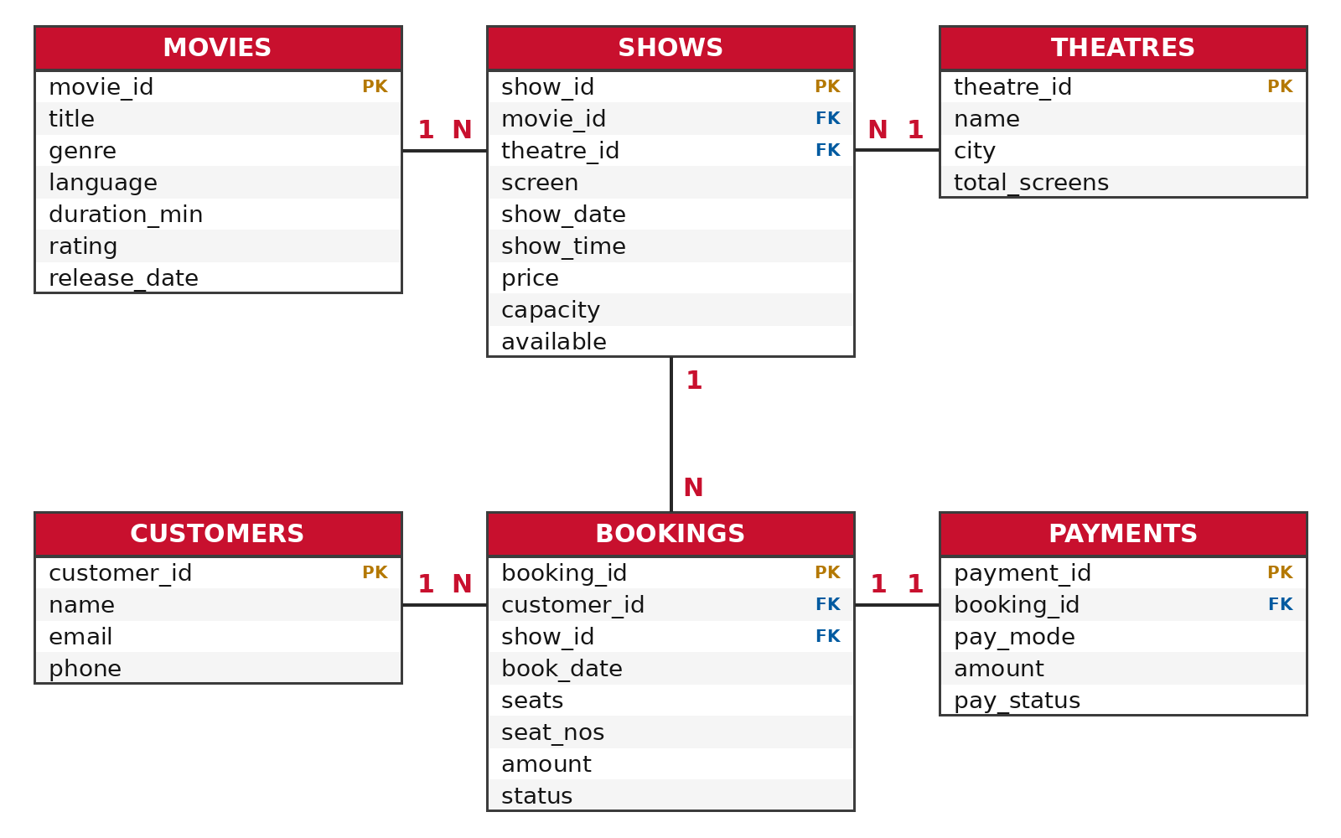
Fig. 4.1: ER diagram of the Movie Ticket Booking System

Relationships
- One movie can be screened in many shows (movies 1 : N shows).
- One theatre can host many shows (theatres 1 : N shows).
- One show can have many bookings (shows 1 : N bookings).
- One customer can make many bookings (customers 1 : N bookings).
- Each booking has one payment record (bookings 1 : 1 payments).

5. Code with Output

5.1 Database and Master Tables
The database is created first, followed by the master tables movies, theatres and customers. Every table has a primary key, and the e-mail of a customer is UNIQUE.
Code: 01_schema_master.sql
CREATE DATABASE movie_booking_db;
USE movie_booking_db;

CREATE TABLE movies (
movie_id INT PRIMARY KEY,
title VARCHAR(100) NOT NULL,
genre VARCHAR(30) NOT NULL,
language VARCHAR(20) NOT NULL,
duration_min INT NOT NULL,
rating DECIMAL(2,1),
release_date DATE
);

CREATE TABLE theatres (
theatre_id INT PRIMARY KEY,
name VARCHAR(60) NOT NULL,
city VARCHAR(30) NOT NULL,
total_screens INT NOT NULL
);

CREATE TABLE customers (
customer_id INT PRIMARY KEY,
name VARCHAR(60) NOT NULL,
email VARCHAR(80) NOT NULL UNIQUE,
phone VARCHAR(15) NOT NULL
);
Output:
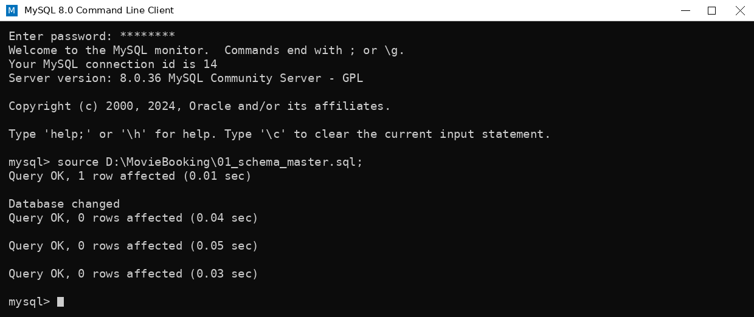
Fig. 5.1: Creating the database and master tables

5.2 Transaction Tables
The tables shows, bookings and payments are linked to the master tables with FOREIGN KEY constraints. CHECK constraints allow only valid seat counts and booking status values.
Code: 02_schema_transaction.sql
CREATE TABLE shows (
show_id INT PRIMARY KEY,
movie_id INT NOT NULL,
theatre_id INT NOT NULL,
screen INT NOT NULL,
show_date DATE NOT NULL,
show_time TIME NOT NULL,
price DECIMAL(8,2) NOT NULL,
capacity INT NOT NULL,
available INT NOT NULL,
FOREIGN KEY (movie_id) REFERENCES movies(movie_id),
FOREIGN KEY (theatre_id) REFERENCES theatres(theatre_id)
);

CREATE TABLE bookings (
booking_id INT PRIMARY KEY,
customer_id INT NOT NULL,
show_id INT NOT NULL,
book_date DATE NOT NULL,
seats INT NOT NULL CHECK (seats > 0),
seat_nos VARCHAR(40) NOT NULL,
amount DECIMAL(8,2) NOT NULL,
status VARCHAR(10) NOT NULL DEFAULT 'Pending'
CHECK (status IN ('Confirmed','Pending','Cancelled')),
FOREIGN KEY (customer_id) REFERENCES customers(customer_id),
FOREIGN KEY (show_id) REFERENCES shows(show_id)
);

CREATE TABLE payments (
payment_id INT PRIMARY KEY,
booking_id INT NOT NULL,
pay_mode VARCHAR(20) NOT NULL,
amount DECIMAL(8,2) NOT NULL,
pay_status VARCHAR(10) NOT NULL,
FOREIGN KEY (booking_id) REFERENCES bookings(booking_id)
);
Output:
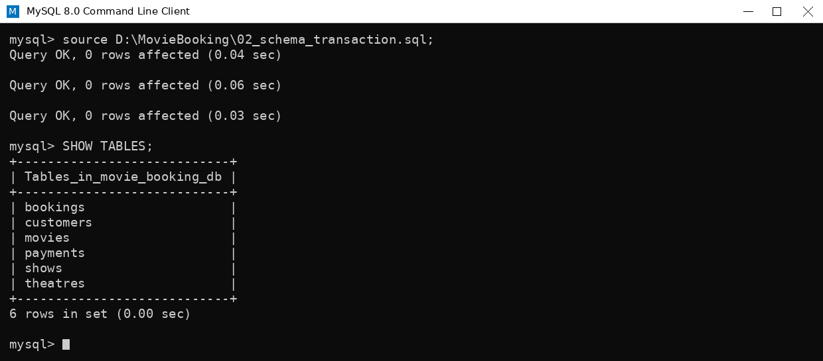
Fig. 5.2: Creating the transaction tables and listing all tables with SHOW TABLES

5.3 Inserting Data
Sample data is inserted first into the master tables (six movies, four theatres and six customers).
Code: 03_insert_master.sql
INSERT INTO movies VALUES
(1, 'Dangal', 'Sports Drama', 'Hindi', 161, 8.3, '2016-12-23'),
(2, '3 Idiots', 'Comedy Drama', 'Hindi', 170, 8.4, '2009-12-25'),
(3, 'Jawan', 'Action', 'Hindi', 169, 7.0, '2023-09-07'),
(4, 'Oppenheimer', 'Biography', 'English', 180, 8.3, '2023-07-21'),
(5, 'Animal', 'Crime Drama', 'Hindi', 201, 6.3, '2023-12-01'),
(6, 'Carry On Jatta 3', 'Comedy', 'Punjabi', 147, 6.6, '2023-06-29');

INSERT INTO theatres VALUES
(1, 'CineMax Plaza', 'Chandigarh', 5),
(2, 'Star Multiplex', 'Mohali', 4),
(3, 'Silver Screen', 'Ludhiana', 3),
(4, 'Galaxy Cinemas', 'Panchkula', 4);

INSERT INTO customers VALUES
(101, 'Aarav Sharma', 'aarav.sharma@example.com', '9876500001'),
(102, 'Simran Kaur', 'simran.kaur@example.com', '9876500002'),
(103, 'Rohan Verma', 'rohan.verma@example.com', '9876500003'),
(104, 'Priya Singh', 'priya.singh@example.com', '9876500004'),
(105, 'Karan Mehta', 'karan.mehta@example.com', '9876500005'),
(106, 'Harpreet Gill', 'harpreet.gill@example.com', '9876500006');
Output:
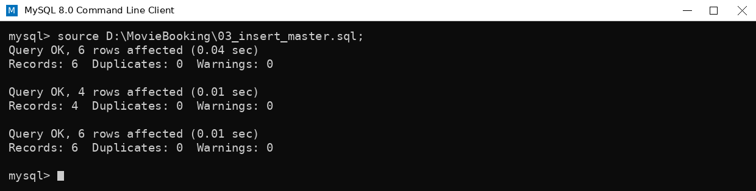
Fig. 5.3: Inserting movies, theatres and customers
Explanation: each INSERT statement adds several rows at once. MySQL reports the number of rows affected and confirms that there were no duplicate keys or warnings.

Inserting Data (continued)
Next, the transaction data is inserted: eight shows, eight bookings and eight payments. The available seats of every show are already reduced by the seats booked.
Code: 04_insert_transaction.sql
INSERT INTO shows VALUES
(1001, 1, 1, 1, '2026-10-22', '10:00:00', 200.00, 120, 118),
(1002, 2, 1, 2, '2026-10-22', '13:30:00', 180.00, 100, 99),
(1003, 3, 2, 1, '2026-10-22', '18:00:00', 250.00, 150, 146),
(1004, 4, 2, 3, '2026-10-23', '19:30:00', 300.00, 90, 87),
(1005, 5, 3, 2, '2026-10-23', '21:00:00', 220.00, 110, 105),
(1006, 6, 4, 1, '2026-10-24', '16:00:00', 160.00, 80, 78),
(1007, 3, 1, 3, '2026-10-24', '20:15:00', 280.00, 140, 138),
(1008, 1, 3, 1, '2026-10-25', '11:00:00', 150.00, 100, 97);

INSERT INTO bookings VALUES
(5001, 101, 1001, '2026-10-18', 2, 'A1,A2', 400.00, 'Confirmed'),
(5002, 102, 1003, '2026-10-18', 4, 'C5,C6,C7,C8', 1000.00, 'Confirmed'),
(5003, 103, 1004, '2026-10-19', 3, 'B3,B4,B5', 900.00, 'Confirmed'),
(5004, 101, 1007, '2026-10-19', 2, 'D9,D10', 560.00, 'Confirmed'),
(5005, 104, 1002, '2026-10-19', 1, 'F12', 180.00, 'Confirmed'),
(5006, 105, 1005, '2026-10-20', 5, 'E1,E2,E3,E4,E5', 1100.00, 'Confirmed'),
(5007, 106, 1006, '2026-10-20', 2, 'G7,G8', 320.00, 'Confirmed'),
(5008, 102, 1008, '2026-10-20', 3, 'H4,H5,H6', 450.00, 'Pending');

INSERT INTO payments VALUES
(9001, 5001, 'UPI', 400.00, 'Success'),
(9002, 5002, 'Credit Card', 1000.00, 'Success'),
(9003, 5003, 'Debit Card', 900.00, 'Success'),
(9004, 5004, 'UPI', 560.00, 'Success'),
(9005, 5005, 'Cash', 180.00, 'Success'),
(9006, 5006, 'Net Banking', 1100.00, 'Success'),
(9007, 5007, 'UPI', 320.00, 'Success'),
(9008, 5008, 'UPI', 450.00, 'Pending');
Output:
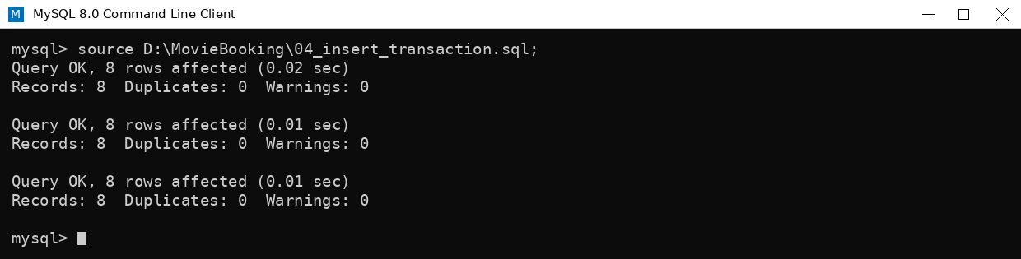
Fig. 5.4: Inserting shows, bookings and payments

5.4 Viewing Table Data
The stored data is displayed with SELECT * statements.
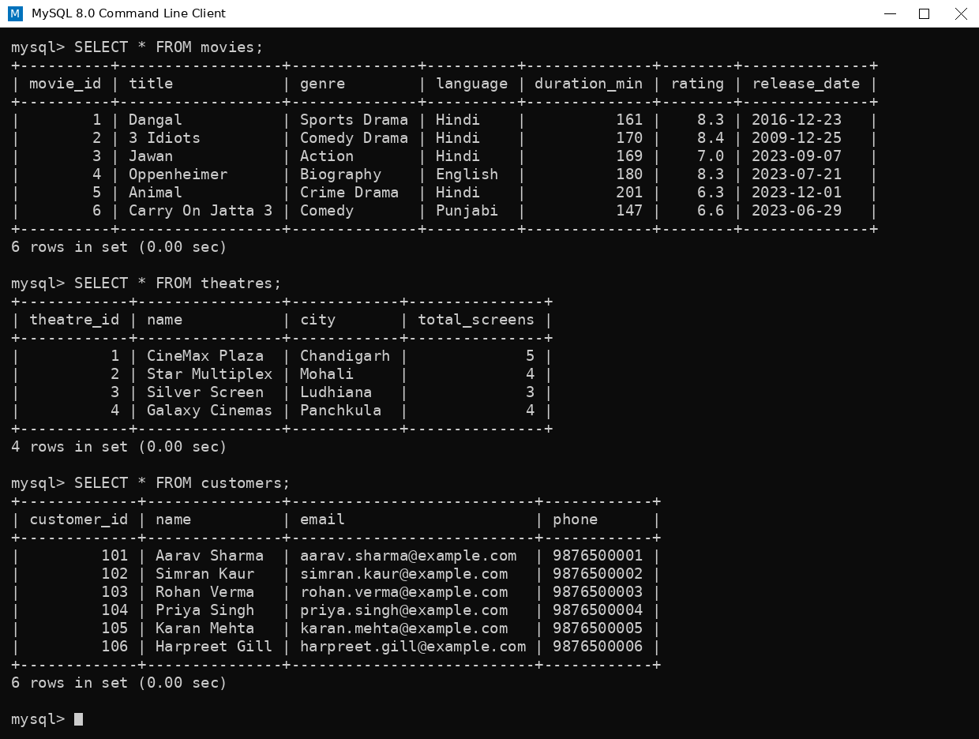
Fig. 5.5: Contents of movies, theatres and customers
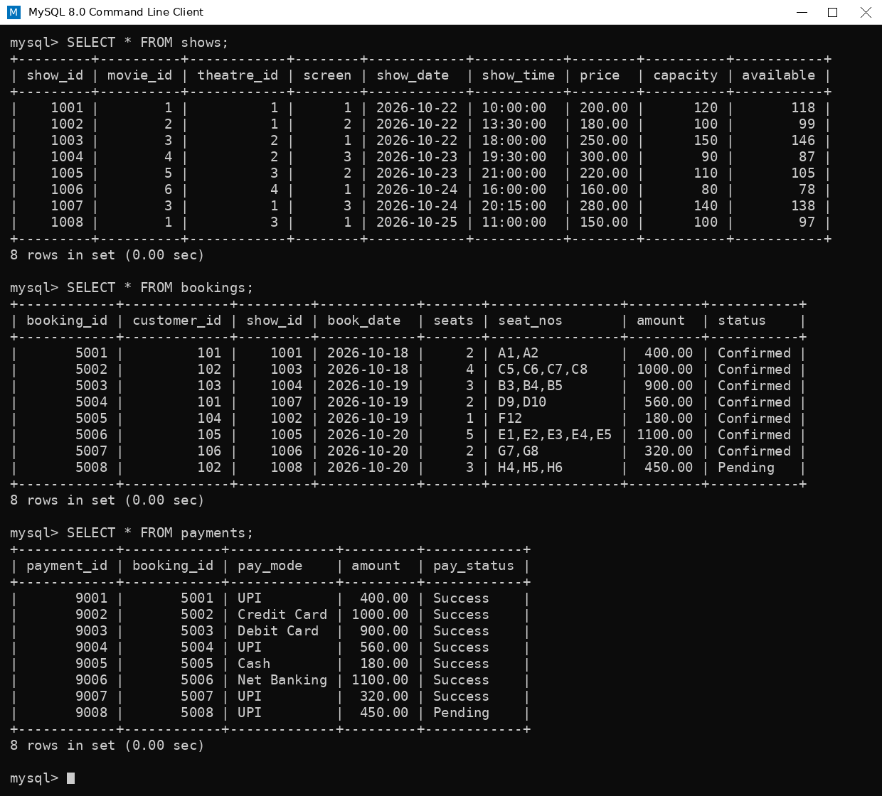
Fig. 5.6: Contents of shows, bookings and payments

5.5 SQL Queries
Query 1: Show schedule with movie and theatre name (JOIN of three tables)
SELECT s.show_id, m.title, t.name AS theatre, s.show_date, s.show_time, s.price
FROM shows s
JOIN movies m ON s.movie_id = m.movie_id
JOIN theatres t ON s.theatre_id = t.theatre_id
ORDER BY s.show_date, s.show_time;
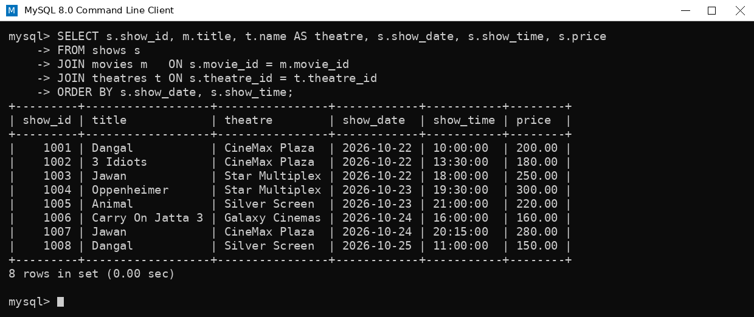
Fig. 5.7: Output of Query 1
Query 2: Booking details with customer name and movie title (JOIN of four tables)
SELECT b.booking_id, c.name AS customer, m.title AS movie, s.show_date,
b.seats, b.amount, b.status
FROM bookings b
JOIN customers c ON b.customer_id = c.customer_id
JOIN shows s ON b.show_id = s.show_id
JOIN movies m ON s.movie_id = m.movie_id
ORDER BY b.booking_id;
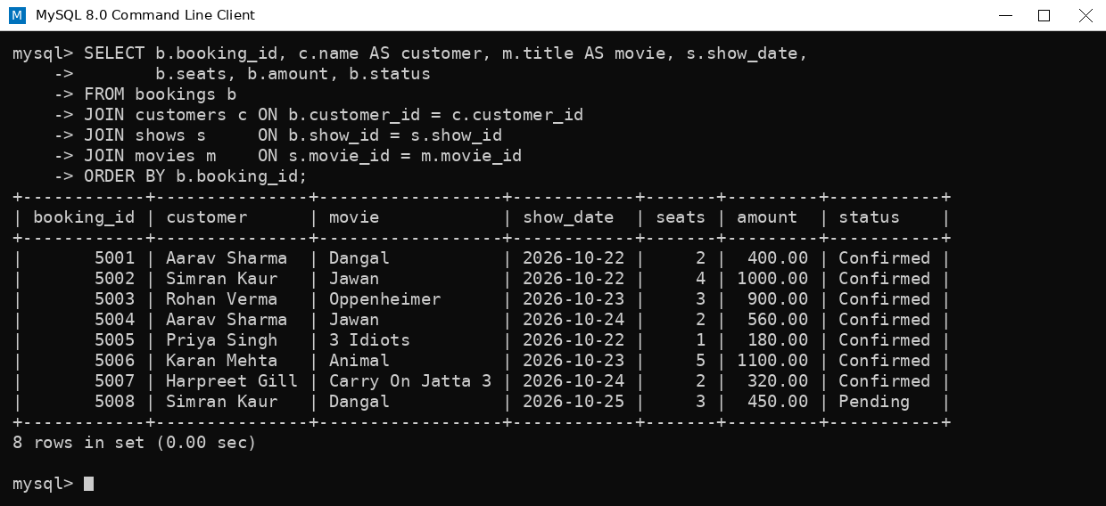
Fig. 5.8: Output of Query 2

SQL Queries (continued)
Query 3: Revenue per movie from confirmed bookings (GROUP BY, SUM, COUNT)
SELECT m.title, COUNT(b.booking_id) AS total_bookings,
SUM(b.seats) AS tickets_sold, SUM(b.amount) AS revenue
FROM movies m
JOIN shows s ON m.movie_id = s.movie_id
JOIN bookings b ON s.show_id = b.show_id
WHERE b.status = 'Confirmed'
GROUP BY m.title
ORDER BY revenue DESC;
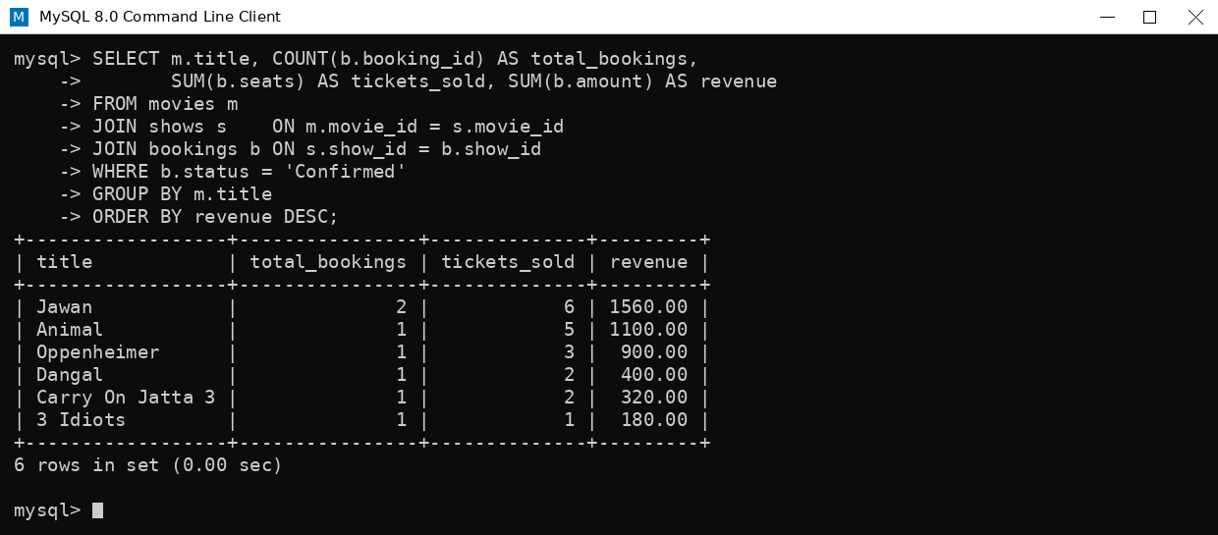
Fig. 5.9: Output of Query 3
Query 4: Customers with more than one booking (HAVING)
SELECT c.name, COUNT(*) AS total_bookings, SUM(b.amount) AS total_spent
FROM customers c
JOIN bookings b ON c.customer_id = b.customer_id
GROUP BY c.customer_id, c.name
HAVING COUNT(*) > 1;
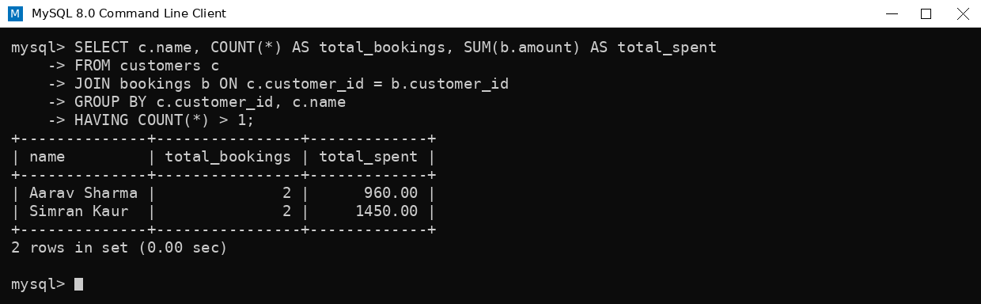
Fig. 5.10: Output of Query 4

5.6 View, Transaction and Delete
A view gives a one-line summary of every booking. A transaction cancels booking 5006: the booking status, the payment status and the seat count are changed together, and COMMIT makes the change permanent. An unpaid pending booking is then deleted.
Code: 06_view_and_transactions.sql
-- View: one-line summary of every booking
CREATE VIEW booking_summary AS
SELECT b.booking_id, c.name AS customer, m.title AS movie,
t.name AS theatre, s.show_date, s.show_time, b.seats, b.status
FROM bookings b
JOIN customers c ON b.customer_id = c.customer_id
JOIN shows s ON b.show_id = s.show_id
JOIN movies m ON s.movie_id = m.movie_id
JOIN theatres t ON s.theatre_id = t.theatre_id;

SELECT * FROM booking_summary WHERE show_date = '2026-10-23';

-- Transaction: cancel booking 5006 and release its seats
START TRANSACTION;
UPDATE bookings SET status = 'Cancelled' WHERE booking_id = 5006;
UPDATE payments SET pay_status = 'Refunded' WHERE booking_id = 5006;
UPDATE shows SET available = available + 5 WHERE show_id = 1005;
COMMIT;

SELECT show_id, capacity, available FROM shows WHERE show_id = 1005;

-- Delete an unpaid (pending) booking and release its seats
DELETE FROM payments WHERE booking_id = 5008;
DELETE FROM bookings WHERE booking_id = 5008;
UPDATE shows SET available = available + 3 WHERE show_id = 1008;
Output:
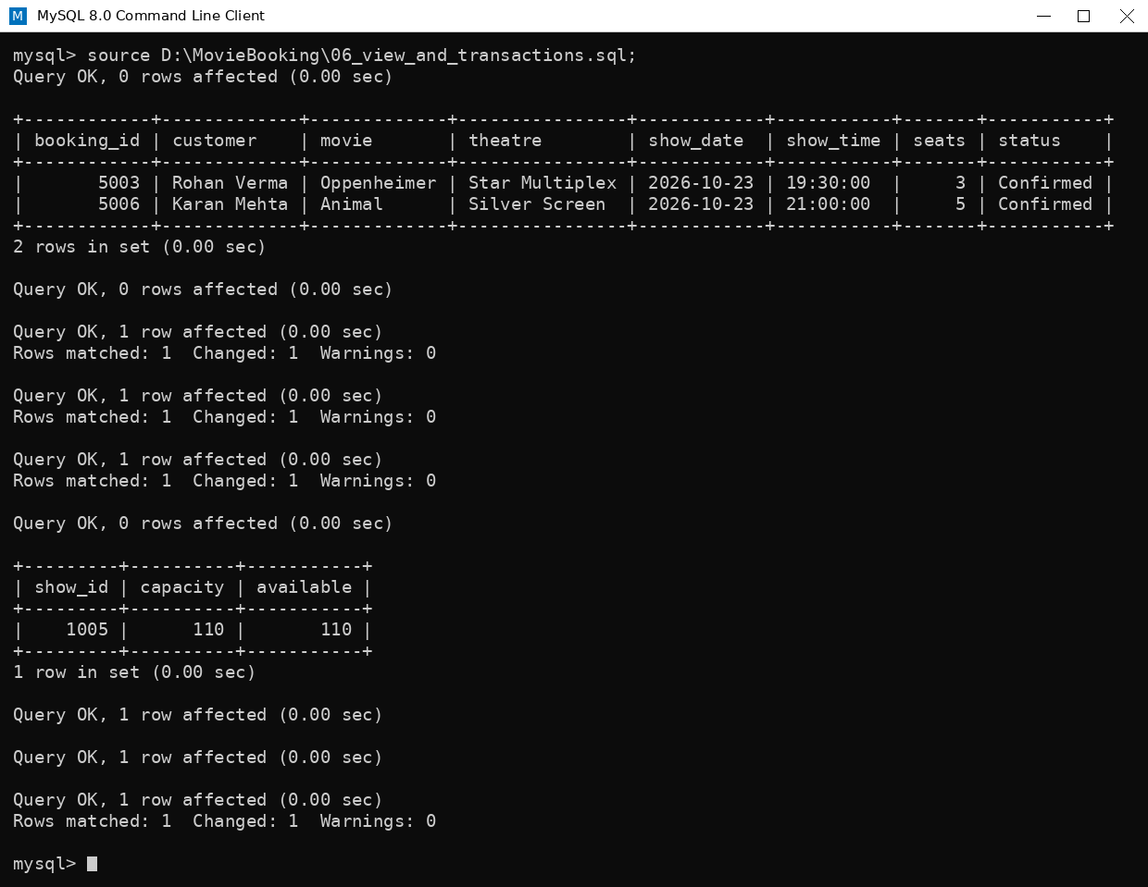
Fig. 5.12: Output of the view, transaction and delete statements

6. Conclusion, Future Scope and References

6.1 Conclusion
The Movie Ticket Booking System shows how a relational database can manage the whole booking process of a cinema. Six tables connected through primary and foreign keys store movies, theatres, shows, customers, bookings and payments without duplication. Constraints protect the data from invalid values, JOIN queries combine information from several tables, aggregate queries give revenue and payment reports, the view simplifies reporting, and the transaction guarantees that a cancellation updates every related table together. Through this project I practised database design, ER modelling and the main groups of SQL commands (DDL, DML, DQL and TCL).

6.2 Future Scope
- Add a seats table so that every seat of every screen is tracked individually and double booking is blocked by the database.
- Add triggers to update the available seats automatically after every booking or cancellation.
- Connect the database to a website or mobile application using Python, Java or PHP.
- Add user login, discount coupons and online payment gateway records.
- Create stored procedures and dashboards for daily and monthly sales reports.

6.3 GitHub Repository
The complete project (SQL scripts, ER diagram and screenshots) is available at: https://github.com/<your-username>/movie-ticket-booking-system

6.4 References
- MySQL 8.0 Reference Manual, Oracle Corporation, https://dev.mysql.com/doc/
- R. Elmasri and S. Navathe, Fundamentals of Database Systems, Pearson.
- A. Silberschatz, H. Korth and S. Sudarshan, Database System Concepts, McGraw-Hill.
- W3Schools SQL Tutorial, https://www.w3schools.com/sql/

