The application was developed as a note creating platform where the users can keep a track of their notes and send them via email. Users can create a new note and view their existing ones.

The backend consists of 4 microservices: user service (user-service) which manages the account creation and login logic, note service (note-service) which manages the note logic: creation, get by id, deletion, update, kafka-logger which is the Kafka consumer, the events being produced in note-service, and notification which manages the email sending logic. Note-service communicates with notification via RabbitMQ. The requests from note-service require authentication. Nginx is used as a load balancer and it distributes the requests between user and note service.

The application uses Docker for creating the images and deploying the containers.

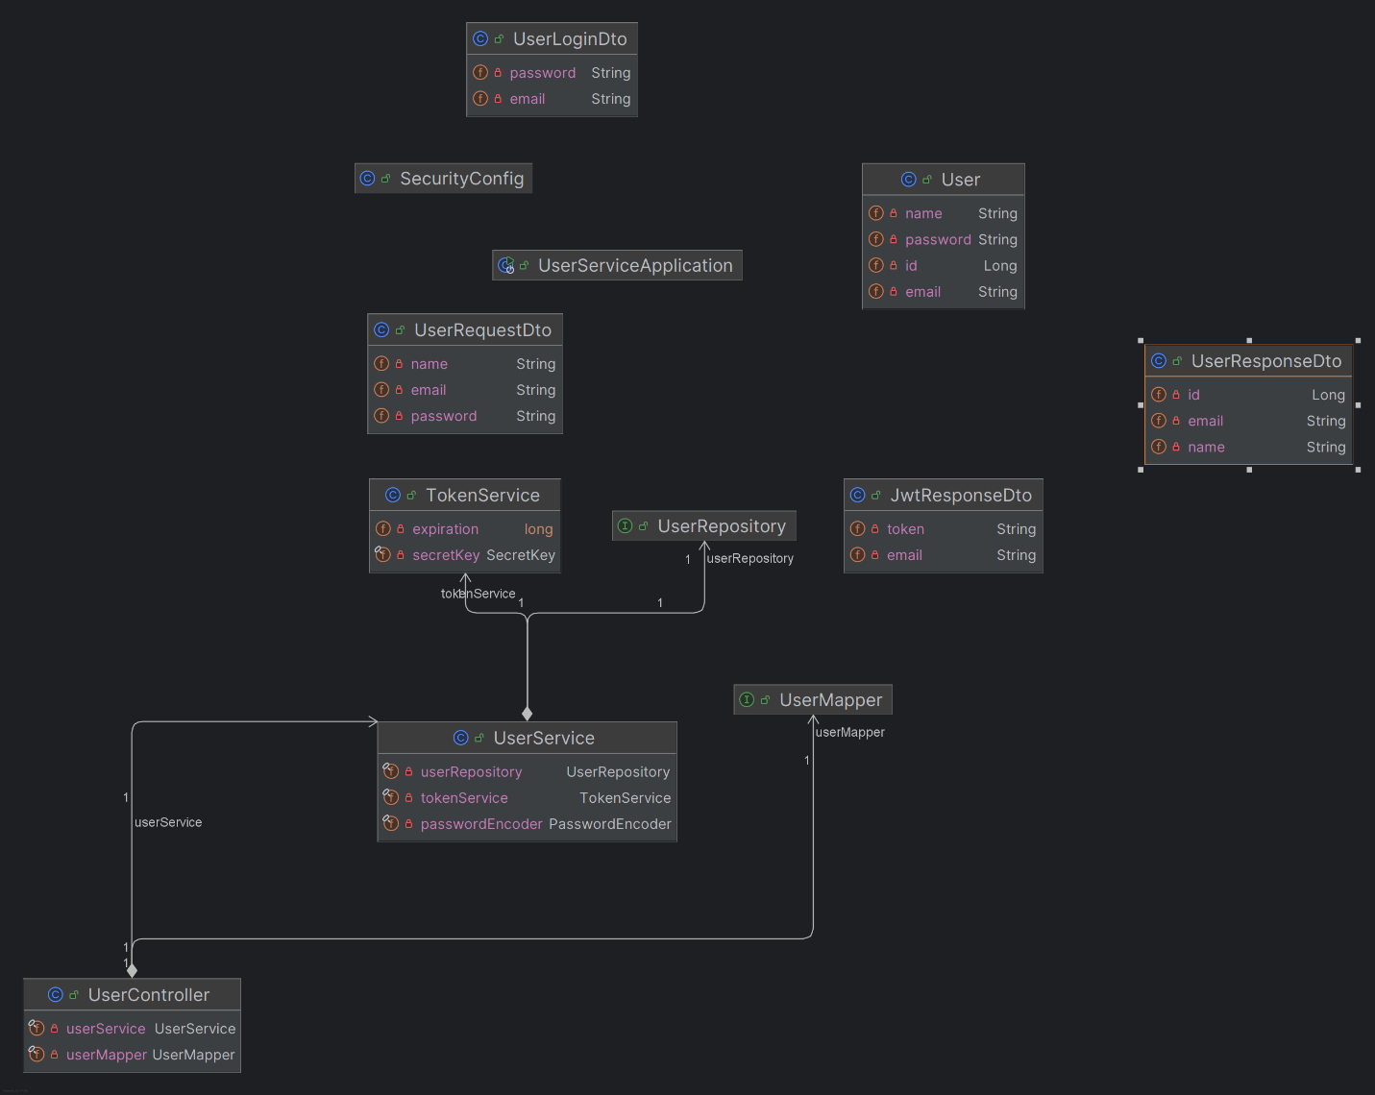UML diagram for user-service

UML diagram for note-service

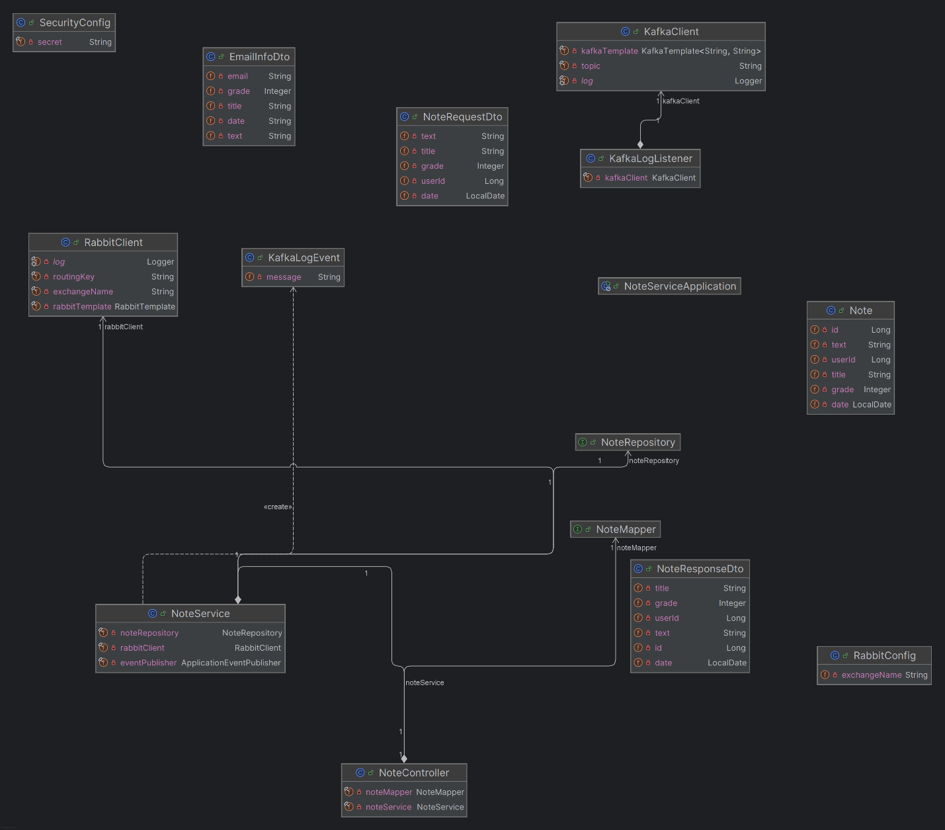

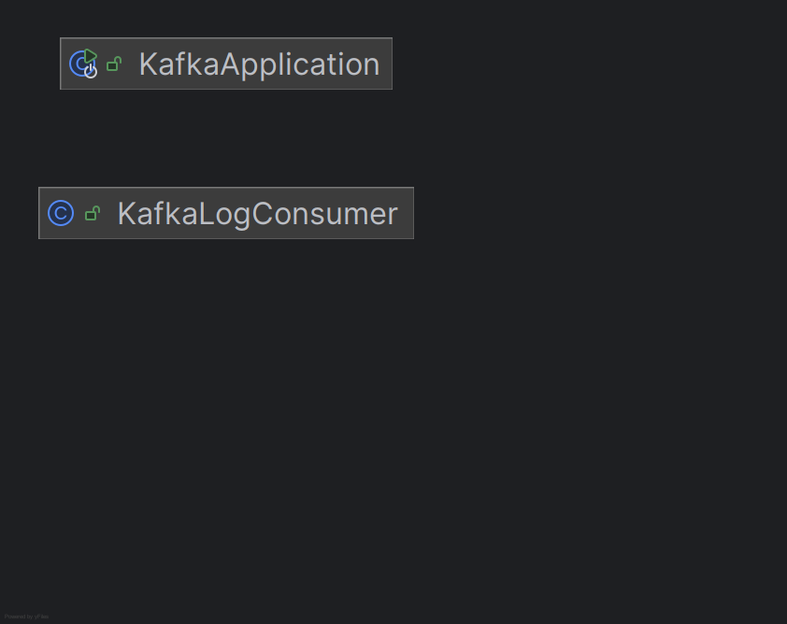UML diagram for kafka-logger

UML diagram for notification

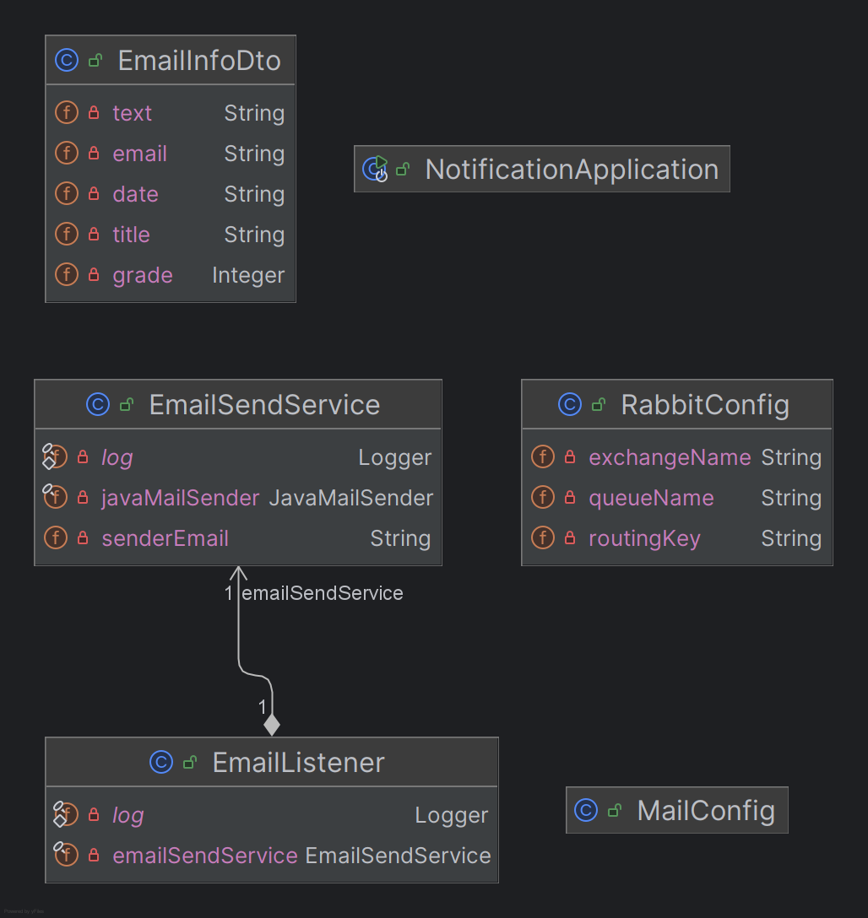

C4 context diagram:

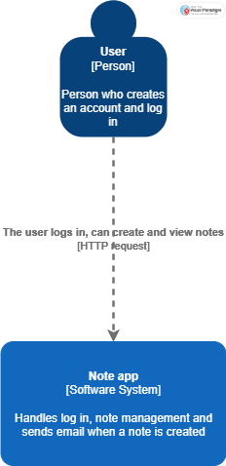

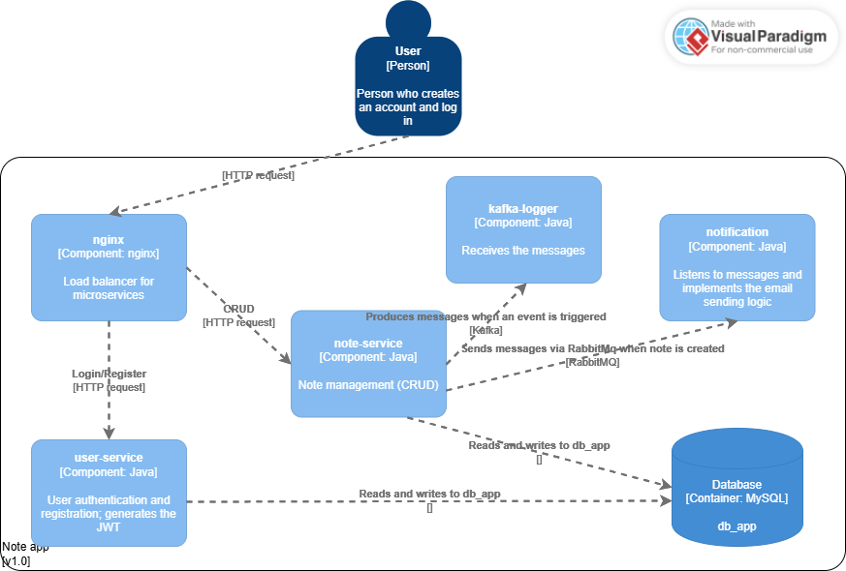C4 Container diagram: