**Curriculum Vitae**

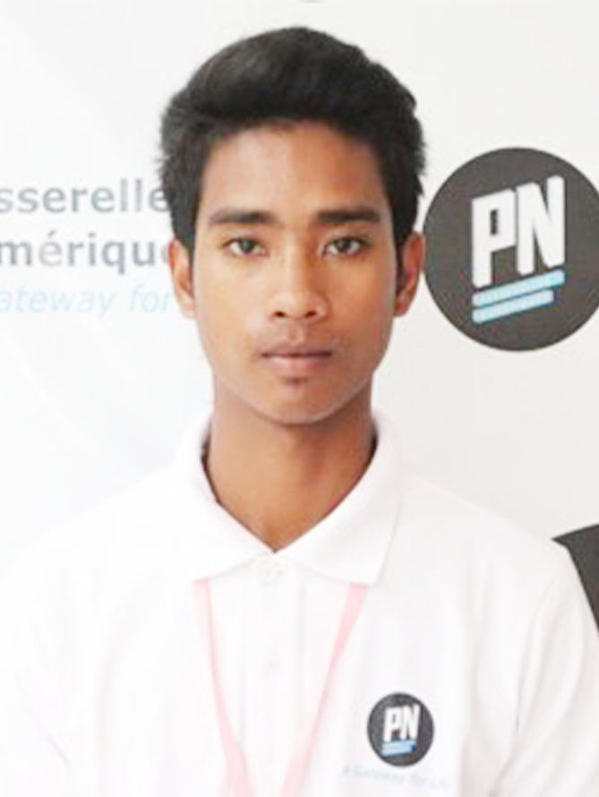

St#371, Tropeang Chhouk village. Sangkat Teck Tlar.

Khan Sen Sok, Phnom Penh, Cambodia.

<Tel:(+885)> 097 61 22513

Email: sovath.koeun@student.passerellesnumeriqus.org

**Apply for : Wep developer**

**Personal Data**

Khan Sen Sok, Phnom Penh, Cambodia.

<Tel:(+885)> 0977299664

Email: [sreyneang.nov@gmail.com](mailto:sreyneang.nov@gmail.com)

Name : Sovath Koeun

Marital status : Single

National : Khmer

Data of birth : July 05, 1999

Sex : Male

Place of birth : Preah Vihear

**Education Background**

**2018 – 2020** : Passerelles numeriques Cambodia

* Associate Degree
* Major Programming (WEB)

**2016 – 2018** : Studied at Chhea Sim High School at Preah Vihear

**Work Experiences**

**First year** : Virtual Company I at Passerelles numeriques Cambodia

* Created website (front-end development)
* Designed Logo, Wireframe, left panel, modal, and Mock up
* Create menus, all link menus (Relational with webpages)

**Second year** : Virtual Company II at Passerelles numeriques Cambodia

* Created website (front-end development)
* Designed Logo, Wireframe, left panel, modal, and Mock up
* Communicate with customer.
* Implementation on front-end development.

**Hard Skill**

: Front-end

* (bootstrap, html.css, responsive web)

: Back-end

- (database, php, oop, java programing, JavaScript)

- Design (Illustrator, Photoshop)

: Mobile Development

* Flutter

**Soft Skill**

* Respect, work hard, responsibility, trust, teamwork, problem-solving, helpful, time management, good communication, leaderships (Class monitor, team leader)

**Language**

**Khmer** :Mother Tongue

**English** :I can Speaking, Listening, Reading, and Writing.

**Training Course**

**2018 – 2019** : Visited related many Companies such as Udaya

Technology, Atech Group, Cambodia post bank and Phsar Tect

: joined some activities with trainers and another school in society.

**Interest**

**Leaning** : Reaching new technologies

**Sport** : Football and volleyball.

**References**

Name: Mr. TengTanghout

Position : Professional Life Trainer

Office : Passerelles Numeriques Cambodia

Tel : 081 811 173

E-mail : [tanghout.teng@passerellesnumeriques.org](mailto:tanghout.teng@passerellesnumeriques.org)

Name: Mr. RadyY

Position : Web Trainer

Office : Passerelles Numeriques Cambodia

Tel : 012 251 803

E-mail : [rady.y@passerellesnumeriques.org](mailto:rady.y@passerellesnumeriques.org)

Name:Ms.LavyHou

Position : English Trainer

Office : Passerelles Numeriques Cambodia

Tel : 012 723 877

E-mail : hou.lavy@passerellesnumeriques.org

Sovath Koeun

St. #371, Phum Tropeang Chhuk (Bores Sorla) Sangtak,

Phnom Penh, Cambodia

Tel: 097 61 22 513

Email: [sovath.koeun@student.passerellesnumeriques.org](mailto:sovath.koeun@student.passerellesnumeriques.org)

**Campany’s name**

1st Floor, #3, St 259, Sang at Teok Laak 1, Khan Toll Kork,

Phnom Penh, Cambodia.

Tel: 023 881 887 / 081 881 887

Email: [info@udaya-tech.com](mailto:info@udaya-tech.com)

07/01/2020

##### Dear Mr. Reasmey Keo,

I am writing to express my interest on position of wep developer posted on bongthom.com as it is very interesting. I want to work in this position because it matches to my skill and my passion that I have learned from school. It is my willingness, and I will improve if I work there and help your company better.

Nowadays, I am second year student at Passerelles numeriques Cambodia (PNC), and I am studying web programing skill; meanwhile, I have learned many hard skills such as back-end (Database, php, MySQL) and front-end (html, java Script, java programing, responsive web, bootstrap, Materialize) and mobile development. More importantly, I have some experience about visiting company (Udaya technologies and Artec group). For virtual company one, I worked on creating home page of website, creating application design interface of website, logo and about Virtual Company II I work on creating application that used many languages. I have joined many workshops such as entrepreneurship, communication presentation, time management, and public speaking.

According my interest and my hard skills, it reflects to my behavior. I am a person who is friendly and have a good communication with other people, and I have learned about professional life such as learning process, business concept, problem solving, and researching skills. I believe my responsibility, trust, solidary, respect, demanding approach of working. Additionally, I always try my best, and I like challenging to learn something new, so I think that makes a perfect fit for your company.

With my experience and educational background, I believe I can make significant contribution to develop your company. I expect I will receive an opportunity for this position with my qualification. To prepare an interview, you can contact me at Gmail regularly that any time by (phone number) and (email). Thank you for your consideration.

Best regard,

##### Sovath Koeun