Master page Home work

# PHP Post vs Get

Make a master page using PHP script to build a dynamic content website as following pictures:

1. **Home page:**

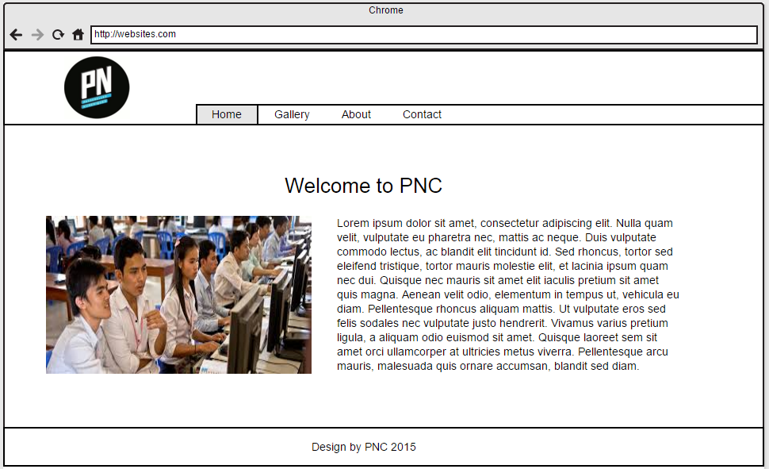

1. **Gallery**

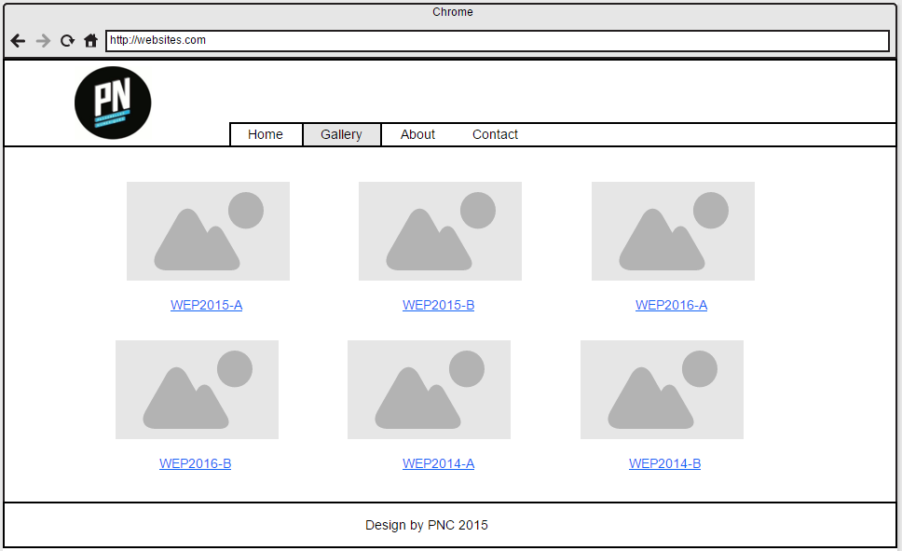

1. **About**

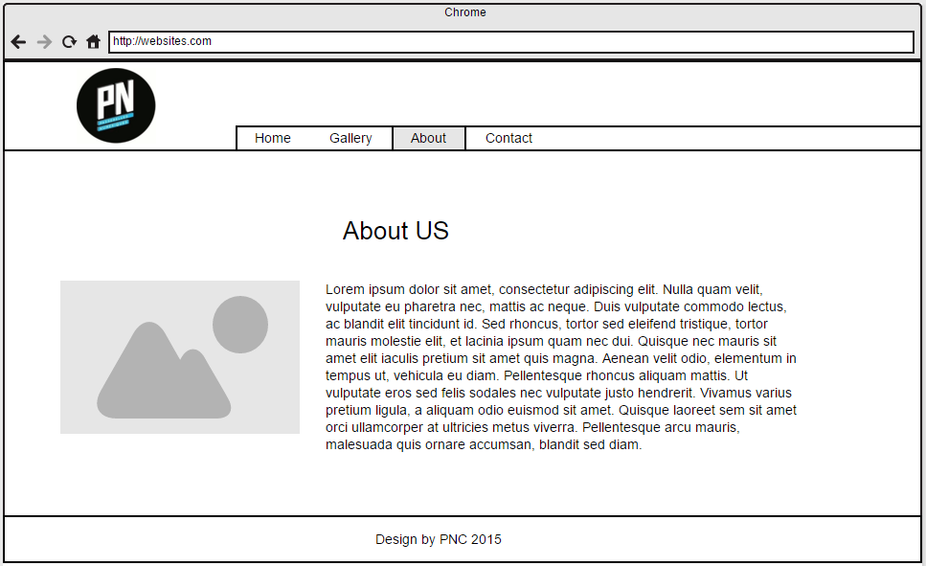

1. **Contact**

