.htaccess

What is .htaccess?

**.htaccess** is a configuration file for use on web servers running on the web apache server software.

Using .htaccess

We use the .htaccess in order to hide folder or file.

Require valid-user

This comment use to hide folder of file (for special folder or file)

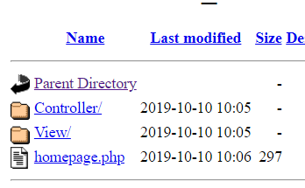For example:

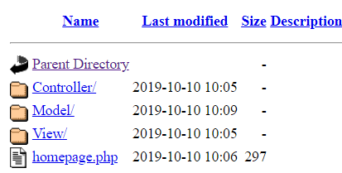

Note: If don’t put Require valid-user in file(.htaccess) We can’t hide folder or file.

Create user and password with .htaccess

Step1:create file(.htpasswe)

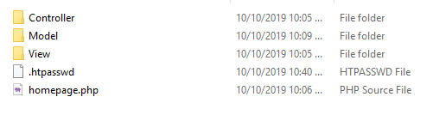

Step2:create user and password in file(.htpasswd)



Step3:Write these comments in file(.htaccess)

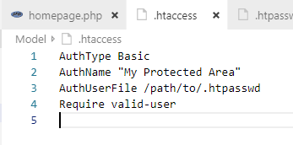

Step4:copy the correct place of file .htpasswd

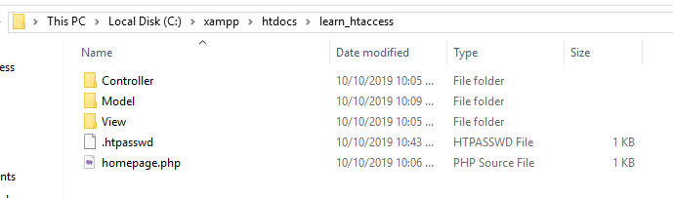

Step4:Past in to AuthUserFile

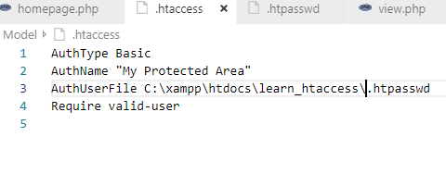

Finally we can input and password with form

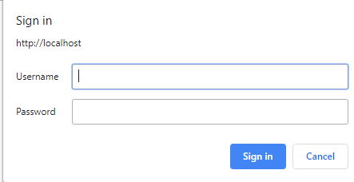

Thank You!