Evolution of agents in a virtual environment using neural networks and genetic algorithm

1st Sovet Sanzhar Nurkenovich
Department of Information Technology
Astana IT University
Astana, Kazakhstan
sansan503451@gmail.com
2nd Nurakhov Edil Sergazievich
Department of Information Technology
Astana IT University
Astana, Kazakhstan
y.nurakhov@astanait.edu.kz
3rd Aitolkyn Kulmuratovna Nurkenovna
Department of Information Technology
Astana IT University
Astana, Kazakhstan
aitosha14@gmail.com

Abstract— This study explores the evolutionary dynamics of intelligent agents in a simulated, decentralized, multi-agent, competitive environment. Agents, controlled by feedforward neural networks, must forage for food and compete for survival, with a genetic algorithm driving the evolution of their neural network weights over 100 generations. The research investigates how environmental pressures, specifically agent population density, influence the emergence of adaptive behaviors. Results indicate that increased agent population correlates with a significant increase in aggressive behavior, driven by heightened competition for scarce resources. This work contributes to the understanding of evolutionary strategies in multi-agent systems and offers insights into the design of robust and adaptive AI in competitive environments.
Keywords—Decentralized Multi-Agent, Evolutionary Reinforcement Learning, Competitive environment, Neural Networks, Genetic Algorithms, Food Forage Task.

Introduction
The study of evolution has traditionally been approached from three perspectives: biological, synthetic, and computational (Lenski et al., 2003). While biological evolution provides empirical data and synthetic evolution enables controlled experimental modifications, computational evolution stands out as the most practical and scalable method for studying adaptive behavior in complex environments (Mitchell, 1998). Computational approaches allow researchers to simulate large populations, track evolutionary changes over numerous generations, and experiment with different parameters in a controlled and repeatable manner. This flexibility makes computational evolution an invaluable tool for exploring the dynamics of complex adaptive systems.
The relevance of this research is driven by the increasing interest in applying artificial intelligence methods to improve autonomous robotics. For instance, evolutionary algorithms can be used to optimize the control strategies of robot swarms, enabling more efficient and adaptive behavior in complex tasks such as search and rescue or environmental monitoring (Floreano et al., 2008). By leveraging artificial neural networks and genetic algorithms, we can investigate how simple agents evolve and adapt to dynamic environments, providing insights into emergent behaviors and optimization strategies. Specifically, this approach can inform the development of more robust and adaptable control systems for robots operating in dynamic and unpredictable environments.
Genetic algorithms (GAs) have demonstrated their effectiveness in solving complex optimization problems across various domains. GAs have been applied to model the spread of infectious diseases, helping researchers understand transmission dynamics and enabling the design of more effective intervention strategies (Eubank et al., 2004; Rahmani & Keshavarz, 2021). In robotics, evolutionary algorithms have optimized robotic locomotion and autonomous decision-making (Lipson & Pollack, 2000; Mouret & Clune, 2015). Genetic algorithms have also been utilized in financial modeling to assist in predicting market trends and optimizing trading strategies (Chen & Kuo, 2020). These diverse applications highlight the versatility and power of GAs in addressing real-world challenges.
The combination of genetic algorithms with different variations of neural networks has demonstrated significant success in the last decade (Abou-Assaleh, 2001). However, limited research has been conducted on combining genetic algorithms with feedforward neural networks in a decentralized, multi-agent, discrete, and competitive environment. This paper closes this gap in knowledge. The goal of this study is to explore the potential of genetic algorithms in optimizing agent behavior in a decentralized, multi-agent, discrete, and competitive environment.
Research Question: How do changes in environmental parameters or genetic algorithm settings influence the evolution of agents in a virtual environment?

Related work
Several studies have explored the intersection of artificial intelligence, genetic algorithms, and multi-agent systems.
The work of Abou-Assaleh (2001) investigated the evolution of recurrent neural networks (RNNs) for controlling autonomous agents in an artificial environment. The study demonstrated that genetic algorithms could effectively optimize the topology and weights of RNNs, leading to adaptive behaviors in agents. However, this approach isolates agents, preventing interactions and competition within a shared environment, which is a key aspect of our study.
Josyula (2022) applied genetic algorithms to simulate evolution in a competitive environment where agents had different attributes such as speed, size, and cloning probability. The research found that varying environmental parameters, such as food availability, significantly influenced the evolutionary success of agents. These results provide valuable insights into how artificial selection pressures shape agent behaviors over multiple generations.
Zemzem & Tagina (2017) explored cooperative multi-agent reinforcement learning in a stationary environment. Their work introduced a method that improves coordination by considering correlated Q-values of neighboring agents, enhancing decision-making in food-foraging tasks.
Kanagawa & Doya (2024) investigated the evolution of reward functions in agents, focusing on how environmental factors shape intrinsic motivation for food collection and motor actions. Their study demonstrated that biologically plausible reward systems emerge through reinforcement learning in a decentralized evolutionary framework.
Yong & Miikkulainen (2001) proposed a cooperative coevolutionary approach where neural networks are evolved separately for each agent but tested together in a common task. Their Multi-Agent ESP (Enforced Subpopulations) method showed that decentralized evolution leads to more effective cooperation compared to centralized control.
Jimenez-Romero et al. (2023) examined the emergence of self-organized communication in agent swarms controlled by spiking neural networks. Their research demonstrated that agents could develop pheromone-based signaling strategies without predefined rules, improving foraging efficiency.
Building on these works, our study combines neural network evolution with genetic algorithms in a decentralized multi-agent competitive environment. Unlike prior studies that focused on either neural network-based control or genetic adaptation separately or single-agent systems, our work integrates all aspects to analyze how changes in environmental conditions and evolutionary parameters influence survival strategies.

Methodology
An evolutionary model was developed to conduct this research, representing a virtual environment populated with multiple agents. A graphical user interface (GUI) was implemented to observe the evolution process in real time. The unit of time within the model is defined as one world iteration.
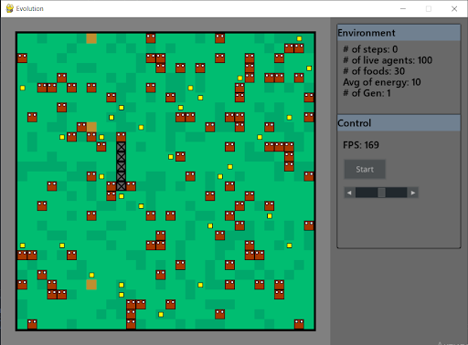
- Picture of environment
The virtual environment is structured as a 2D grid divided into discrete cells, each of which can contain different objects, including agents. Agents are visually represented as red cells with two white dots. Each agent has an internal variable indicating its current energy level. With each world iteration, all agents lose a certain amount of energy. If an agent's energy reaches zero, it dies. The primary objective of agents is to survive in this environment. Energy can be obtained by consuming food, which randomly appears on the map, or by attacking and consuming another agent. This mechanism enforces natural selection pressure by requiring agents to gather energy from their surroundings to sustain themselves.
To navigate and locate food efficiently, each agent is equipped with a feedforward neural network. The neural network receives input regarding the surrounding environment and the agent's internal state, producing an output corresponding to one of the available actions. Each iteration, agents can perform only one action, such as moving in a specific direction. To facilitate agent learning and evolution, a genetic algorithm was applied, where an agent's genome consists of the weight parameters of its neural network.
The environment contains multiple agents that operate independently and are not connected to one another, making it a decentralized multi-agent system. Additionally, agents have limited perception of the environment, meaning they do not have access to complete information about the world, making the system partially observable. Since agents must compete with others to secure resources and survive, the environment is also inherently competitive. Agents’ task is food forage.
  - Virtual environment
The virtual environment is a 2D grid composed of discrete cells. It is stored as a two-dimensional matrix filled with various objects. There are four types of objects in the environment: grass, agents, walls, and food. Some objects can overlap; for example, food may appear on top of grass. The landscape of the environment simulates an open field covered with grass and enclosed by walls. Anything beyond the boundaries of the map is perceived by agents as an infinite wall. Food appears randomly on the map and disappears after 100 iterations. This mechanism prevents excessive food accumulation in areas where agents have not been present for a long time.
Key environmental parameters, such as the food spawn rate, energy value of food, maximum food capacity on the map, and world size, are predefined and remain constant throughout each experiment.
  - Agents
Agents are represented as red cells with two white dots. Each agent has two internal variables: age and energy. Age indicates how many iterations the agent has survived since birth, while energy is the primary resource necessary for survival. If an agent's energy level drops to zero or below, it dies. An agent can also die if it is consumed by another agent.
Each agent is controlled by its own feedforward neural network. At every iteration, the neural network receives input data about the surrounding environment and the agent's internal state. Based on this information, the network outputs one of eight possible actions—moving in one of eight directions on the map. If an agent steps on food, it consumes it and gains a fixed amount of energy. If it steps on another agent, it attacks and consumes it, absorbing 50% of its energy. If the agent attempts to move into a wall, it remains in place.
The neural network architecture consists of an input layer with 27 neurons, three hidden layers with 10 neurons each, and an output layer with 8 neurons. The hidden layers use the ReLU activation function, while the output layer uses Softmax.
The input to the neural network represents an observation of the surrounding environment within a radius of 2 cells around the agent, including the agent's own cell, resulting in a total of 25 cells. Each cell is encoded as follows: food is represented by 2, any agent (including itself) by 1, grass by 0, and walls or world boundaries by -1. Additionally, the agent's two internal variables are included in the input. This encoding enables agents to perceive their environment and adapt to its changes.
  - Evolutionary Process
A genetic algorithm was used to manage the evolutionary process. Genetic algorithms are optimization methods based on the principles of natural selection. They operate on a population of possible solutions, gradually improving them over multiple generations to find optimal or near-optimal solutions. In this model, the genetic algorithm runs for 100 generations, allowing the population to evolve and refine their survival strategies in the environment. The agent's genome is represented as an array of neural network weights and biases, where each connection corresponds to a separate gene.

The key stages of the genetic algorithm include:
- Initialization — the initial population of agents is created, with its size determined by the model parameters. Each agent is assigned a randomly generated genome.
- Evaluation — to assess the adaptability of each agent, the virtual environment is simulated, gradually removing agents over time. The simulation continues until all agents have perished or the maximum of 10,000 iterations is reached. At the end of the simulation, a fitness function is calculated for each agent based on the number of iterations survived. If an agent dies due to external causes, half of its remaining energy at the time of death is added to its fitness function value. This is to consider how much longer the agent could have lived if it hadn't been eaten.
- Selection — the Fitness-Proportional Selection method is used, where an agent's probability of passing its genes to the next generation is proportional to its fitness function. The higher the fitness function value, the greater the chance of reproduction.
- Crossover — new agents are generated using the Uniform Crossover method. Offspring inherit genes randomly from one of their parents, promoting genetic diversity and accelerating the adaptation of the population to environmental conditions.
- Mutation — a certain percentage of genes is altered randomly, depending on the model parameters. Mutations maintain genetic diversity and prevent the population from becoming stuck in local optima.

This evolutionary process enables agents to gradually develop effective survival strategies, adapting to changing environmental conditions.

Experimental setup
To address the research question, the following hypothesis were formulated:

- Hypothesis 1: Increasing the number of agents leads to stronger natural selection pressures and promotes the development of more aggressive behavior.
- Hypothesis 2: Increasing the number of agents leads to stronger natural selection pressures and favors faster adaptation of agents.

To test these hypotheses, five independent runs of the evolutionary model were conducted, each lasting 100 generations. During the experiments, key environmental parameters were varied. The parameters of the control experiment are described in Table 1.

Parameter | Value
Population size | 40 agents
Grid size | 30 × 30 cells
Maximum food on the map | 180 units
Maximum new food per iteration | 10 units
Food energy value | 30 energy points
Initial agent energy | 30 energy points
Mutation probability | 1%

Additional experiments examined the effects of population size variation. To assess the impact of competition on agent survival, two experiments were conducted: one with a small population of 10 agents (low competition) and another with 80 agents (high competition).
A set of key metrics was used to analyze the results: the minimum, median, arithmetic mean, and maximum fitness function values; the average and maximum amount of food consumed by agents; and the percentage of natural and violent deaths. Comparing the data obtained under different experimental conditions will help identify patterns in agent evolution and determine how changes in environmental parameters and genetic algorithm settings affect their behavior.

Results
The results of all runs are shown in the form of two graphs. The first one shows how the adaptability of the agents changed in the simulations, and the second one shows the aggressiveness of the agents.

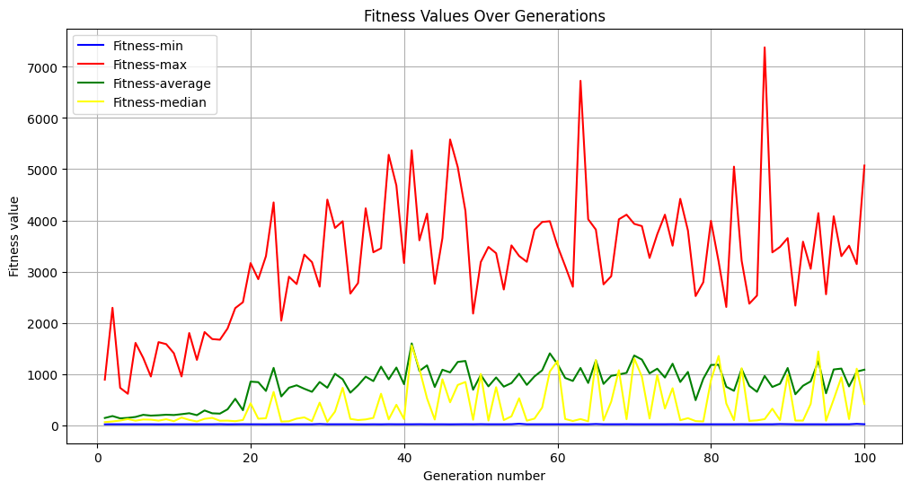
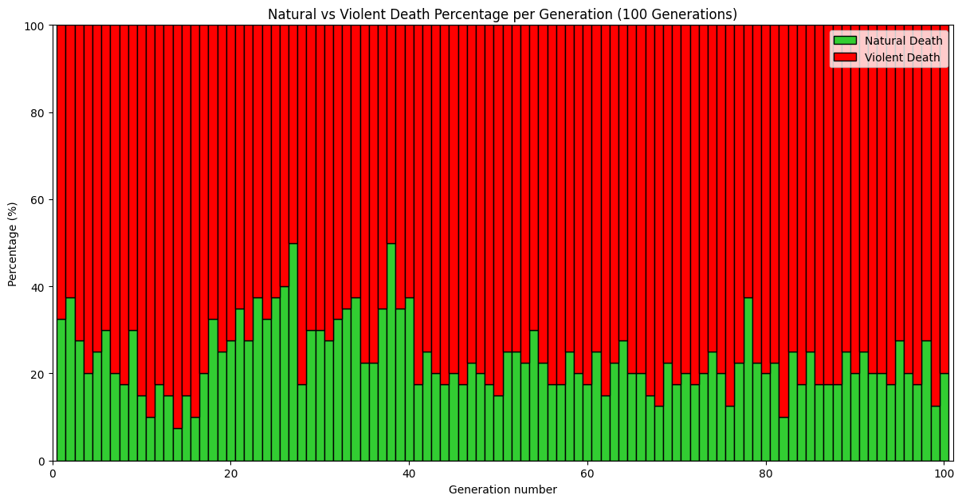
- Results of the control launch
The fitness values graph shows that up to generation 30 there is an increase in adaptability, but after that it stagnates at about the same level. The average fitness value among all generations is 803. The maximum value is 7381. The percentage of violent deaths is 77%.

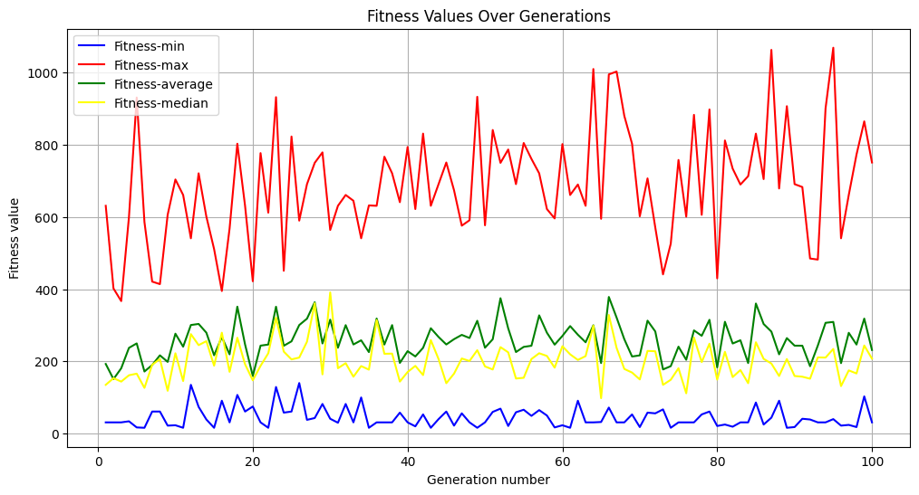
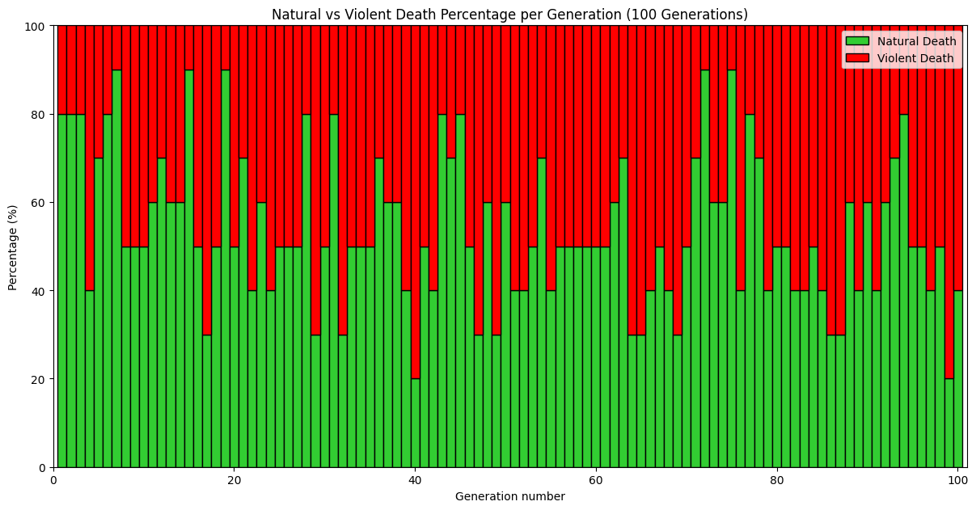
- Results of launch with reduced competition
As the number of agents decreases, the starting fitness values are much higher. This is due to the fact that the lower the competition the easier it is for an agent to survive longer, but then we see very little adaptability gain across generations, precisely because of low competition. The average fitness value among all generations is 259. The maximum value is 1069. The percentage of violent deaths is 46%
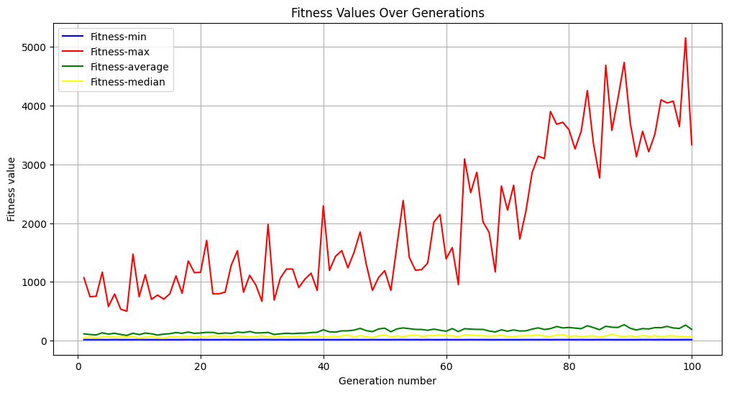
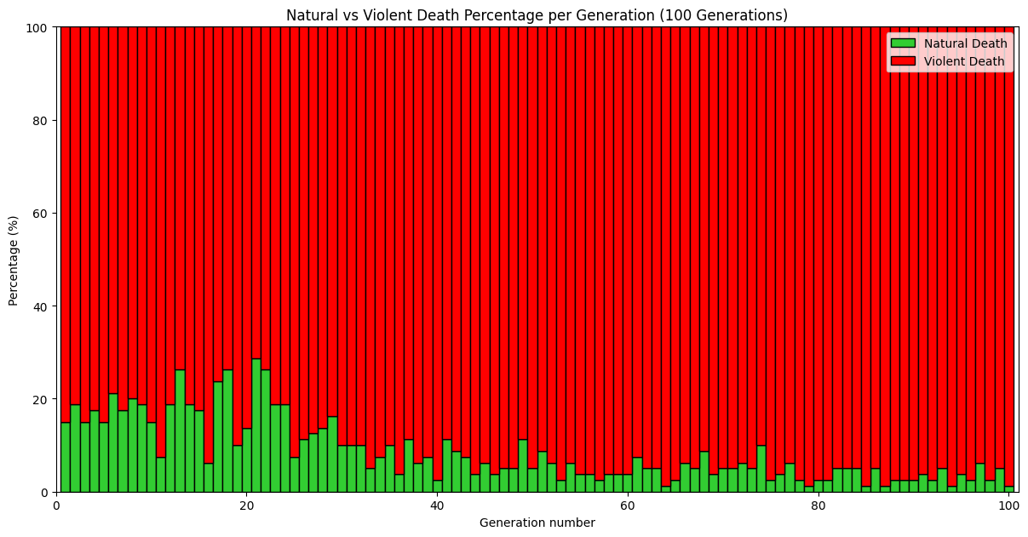
- Results of a launch with increased competition

As the number of agents increased, the starting fitness values did not change much compared to the control run. The average fitness value among all generations is 167. The maximum value is 5155. The percentage of violent deaths is 91%
From the data obtained, there is a clear correlation between the size of the initial populations and the number of violent deaths, which supports hypothesis 1.
Conversely, no significant correlation between population size and agent adaptability was detected. Agents in the medium-sized population (control experiment) exhibited the highest adaptability, as measured by both the mean and maximum fitness function values. The low-competition environment demonstrated a threefold decrease in mean fitness and a sevenfold decrease in maximum fitness, while the high-competition environment resulted in a 4.8-fold decrease in mean fitness and a 1.4-fold decrease in maximum fitness. Given these findings, Hypothesis 2 was not supported, as increased population size did not consistently lead to enhanced adaptation.

Conclusion
In this study, we investigated the evolution of adaptive behaviors in agents within a decentralized multi-agent, competitive, discrete environment, utilizing neural networks and genetic algorithms. The research aimed to answer the question: How do changes in environmental parameters or genetic algorithm settings influence the evolution of agents in a virtual environment?
To answer this question, we formulated and empirically tested two hypotheses. Hypothesis 1: Increasing the number of agents leads to stronger natural selection pressures and promotes the development of more aggressive behavior. This hypothesis was confirmed experimentally, as higher population densities led to increased mortality due to aggression. Based on these results, we conclude that resource scarcity caused by intensified competition fosters the emergence of aggressive evolutionary strategies. Hypothesis 2: Increasing the number of agents leads to stronger natural selection pressures and favors faster adaptation of agents. However, this hypothesis was not supported: adaptability peaked in medium-sized populations, while both low- and high-competition settings resulted in diminished evolutionary performance. These results indicate that, contrary to our expectation, excessive competition may hinder evolutionary progress.
These findings provide insights into how selection pressure and population density shape agent evolution. This has practical relevance in domains where autonomous agents must operate under limited resources and conflicting objectives, such as swarm robotics, decentralized energy systems, and digital ecosystems.
The contribution of this work is a practical and extensible simulation framework for studying adaptive agent behavior under changeable conditions. This framework can serve as a foundation for future research involving heterogeneous agent types, hybrid learning approaches, or the emergence of communication and cooperation in multi-agent systems. Additionally, we provide a detailed quantitative analysis of how varying population densities affect the survival strategies and the evolutionary performance of agents across generations.
Future work should extend this framework to incorporate more complex dynamics, including fluctuating resource availability, alternative neural network architectures, and the potential for emergent cooperation. Experimenting with evolutionary simulations could further enhance our understanding of the mechanisms underlying adaptive behavior in complex environments.

References
- Abou-Assaleh, T. (2001). Evolution of recurrent neural networks to control autonomous life agents.
- Chen, S. H., and Kuo, T. (2020). Evolutionary computation in financial market prediction: A review. IEEE Transactions on Evolutionary Computation, 24(5), 810-830.
- Eubank, S., Guclu, H., Kumar, V. S. A., Marathe, M. V., Srinivasan, A., Toroczkai, Z., and Wang, N. (2004). Modelling disease outbreaks in realistic urban social networks. Nature, 429(6988), 180-184.
- Floreano, D., Husbands, P., and Nolfi, S. (2008). Evolutionary robotics. Springer Handbook of Robotics, 1423-1451.
- Kanagawa, Y., and Doya, K. (2024). Evolution of rewards for food and motor action by simulating birth and death. arXiv preprint arXiv:2406.15016.
- Lenski, R. E., Ofria, C., Pennock, R. T., and Adami, C. (2003). The evolutionary origin of complex features. Nature, 423(6936), 139-144.
- Lipson, H., and Pollack, J. B. (2000). Automatic design and manufacture of robotic lifeforms. Nature, 406(6799), 974-978.
- Mitchell, M. (1998). An introduction to genetic algorithms. MIT Press.
- Mouret, J. B., and Clune, J. (2015). Illuminating search spaces by mapping elites. arXiv preprint arXiv:1504.04909.
- Rahmani, K., and Keshavarz, M. (2021). Genetic algorithm-based optimization for epidemic forecasting models. Computational Intelligence and Neuroscience, 2021, 1-15.
- Stanley, K. O., and Miikkulainen, R. (2002). Evolving neural networks through augmenting topologies. Evolutionary Computation, 10(2), 99-127.
- Yong, C. H., and Miikkulainen, R. (2001). Cooperative coevolution of multi-agent systems. Technical Report AI01-287, University of Texas at Austin.
- Zemzem, M., and Tagina, M. (2017). Cooperative multi-agent reinforcement learning in a large stationary environment. Journal of Artificial Intelligence Research, 58, 231-256.
- Jimenez-Romero, C., Yegenoglu, A., Martin, A. P., Diaz-Pier, S., and Morrison, A. (2023). Emergent communication enhances foraging behaviour in evolved swarms controlled by spiking neural networks. arXiv preprint arXiv:2212.08484.

