COS 10029 - Fundamentals of Programming
Name: Sovithyea Prach
Student ID: 105270743
Task 10.1
int a=1, b=2, *ptr;
...
ptr = &b;
Statement | a (1000) | B (2000) | Ptr
Int a=1, b=2, *ptr; | 1 | 2
Ptr= &b; | 1 | 2 | 2000

int a=1, b=2, *ptr=&b;
...
a = *ptr;
Statement | a (1000) | b (2000) | Ptr
Int a=1, b=2, *ptr=&b; | 1 | 2 | 2000
A=*ptr; | 2 | 2 | 2000

int a=1, b=2, c=5, *ptr=&c;
...
b = *ptr;
*ptr = a;
statement | a (1000) | b (2000) | c (3000) | Ptr
Int a=1, b=2, c=5, *ptr=&c; | 1 | 2 | 5 | 3000
B=*ptr; | 1 | 5 | 5 | 3000
*ptr=a; | 1 | 5 | 1 | 3000

int a=1, b=2, c=5, *ptr;
...
ptr = &c;
c = b;
a = *ptr;
statement | a (1000) | b (2000) | c (3000) | Ptr
Int a=1, b=2, c=5, *ptr; | 1 | 2 | 5
Ptr=&c; | 1 | 2 | 5 | 3000
C=b; | 1 | 2 | 2 | 3000
A=*ptr; | 5 | 2 | 2 | 3000

double x=15.6, y=10.2, *ptr_1=&y, *ptr_2=&x;
...
*ptr_1 = *ptr_2 + x;
statement | X(1000) | Y(2000) | Ptr_1 | Ptr_2
Double x=15.6, y=10.2, *ptr_1=&y, *ptr_2=&x; | 15.6 | 10.2 | 2000 | 1000
*ptr_1=*ptr_2+x; | 15.6 | 31.2 | 2000 | 1000

int w=10, x=2, *ptr_2=&x;
...
*ptr_2 -= w;

statement | w(1000) | x(2000) | Ptr_2
Int w=10, x=2, *ptr_2=&x; | 10 | 2 | 1000
*ptr_2 -= w; | 10 | -8 | 1000

Task 10.2
Code:
#include <iostream>
using namespace std;

void swap_numbers(int *p1, int *p2)
{
int temp;

temp = *p1;
*p1 = *p2;
*p2 = temp;
}

int main()
{
int x = 10;
int y = 20;
// You must figure out how to call the function correctly!
swap_numbers(&x, &y);
// Should print out x: 20, y: 10
cout <<"x: "<< x <<", y: " << y << endl;
}

Output:
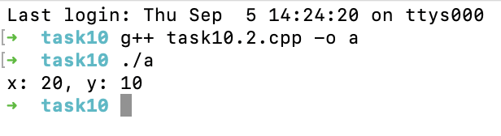
Task 10.3
Code:
#include <iostream>
using namespace std;

void reorder(int *a,int *b,int *c)
{
int temp;

if (*a > *b)
{
temp = *a;
*a = *b;
*b = temp;
}

if (*b > *c)
{
temp = *b;
*b = *c;
*c = temp;
}

if (*a > *b)
{
temp = *a;
*a = *b;
*b = temp;
}
}

int main()
{
int a, b ,c;

cout << "Enter a value for A: ";
cin >> a;
cout << "\nEnter a value for B: ";
cin >> b;
cout << "\nEnter a value for C: ";
cin >> c;

reorder(&a, &b, &c);
cout <<"a: "<<a<<", b: "<<b<<", c: "<<c;
}

Output:
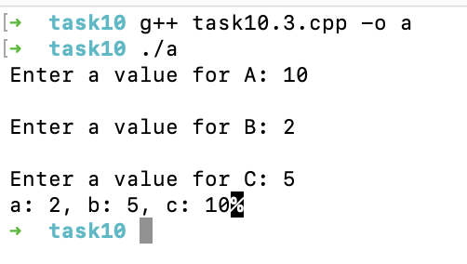
Task 10.4
Code:
#include <iostream>
using namespace std;

int cubeByValue(int n)
{
return n * n * n;
}

void cubeByReference(int *nPtr)
{
*nPtr = *nPtr * *nPtr * *nPtr;
}

int main()
{
int num;

cout << "Enter a value for num: ";
cin >> num;

int result = cubeByValue(num);
cubeByReference(&num);
cout << "cubeByValue answer is: " << result << endl;
cout << "cubeByReference answer is: " << num << endl;
}

Output:
