2026 Semester 1
COS30082: Applied Machine Learning

Lab 01

Name and Student ID:
Sovithyea Prach - 105270743

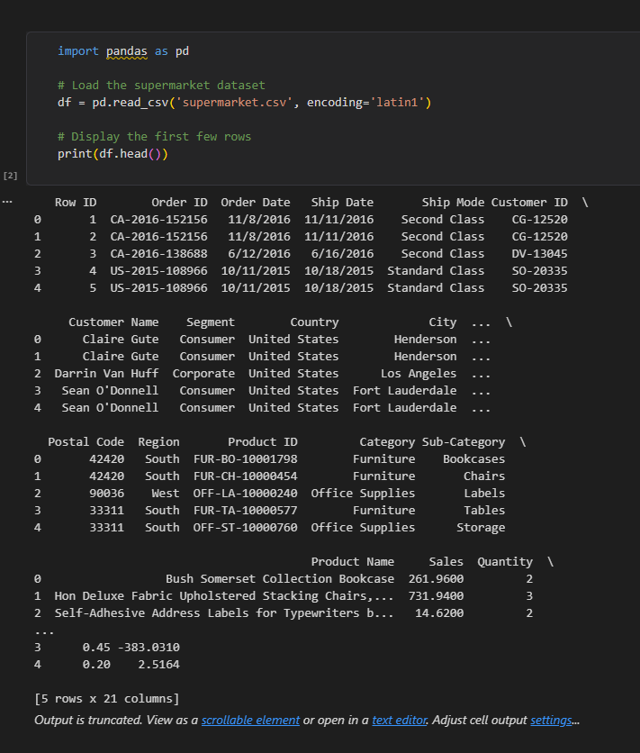
Figure 1: Adding the Dataset into the notebook

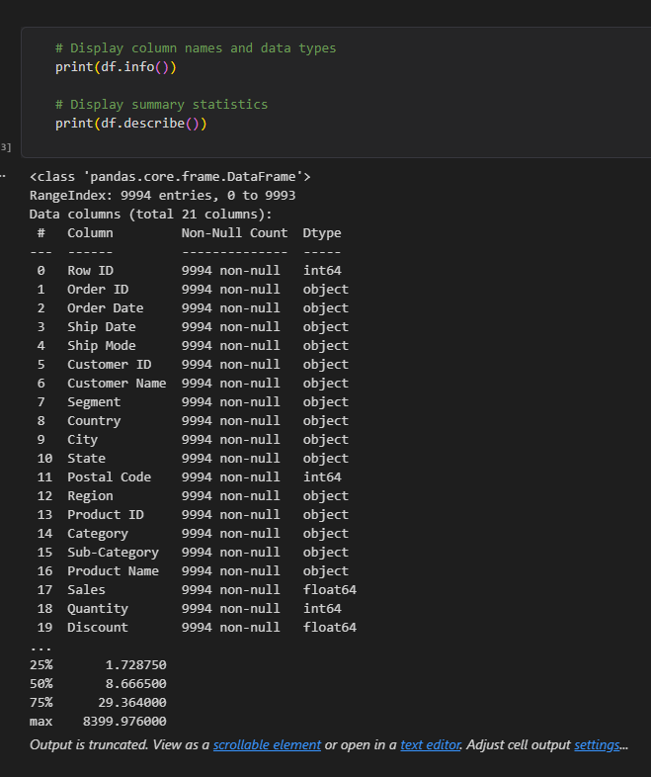
Figure 2: A summary of the Dataset
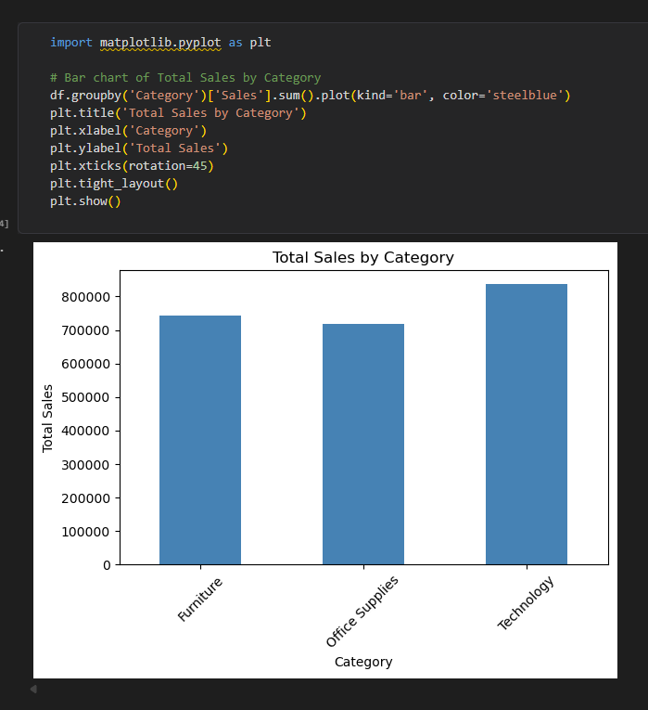
Figure 3: Visualization of sales
This is a dataset from Kaggle which shows data from supermarkets with many categories, such as: Order/Shipping date, Country/City, and Item type. The bottom visualization shows the total number of sales for the most sought-after items. We can see that “Technology” as the most with over 800,000 in total sales with Furniture and Office Supplies coming behind.

