2026 Semester 1
COS30082: Applied Machine Learning

Lab 02

Name and Student ID:
Sovithyea Prach - 105270743

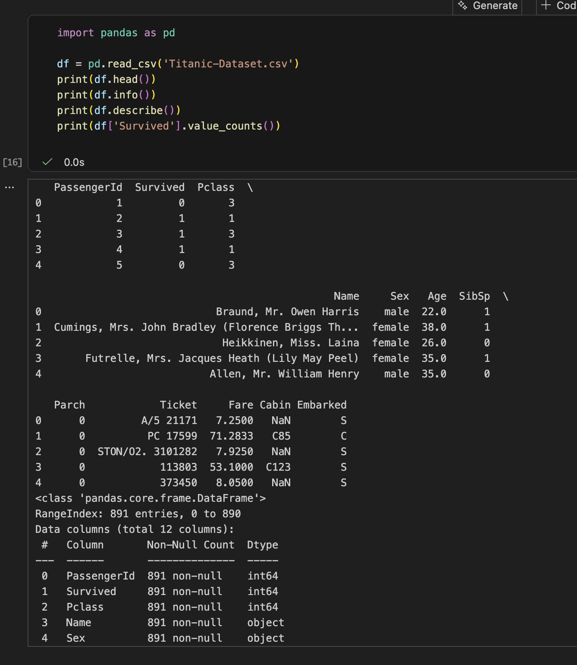
Figure 1: Adding the Dataset into the Notebook
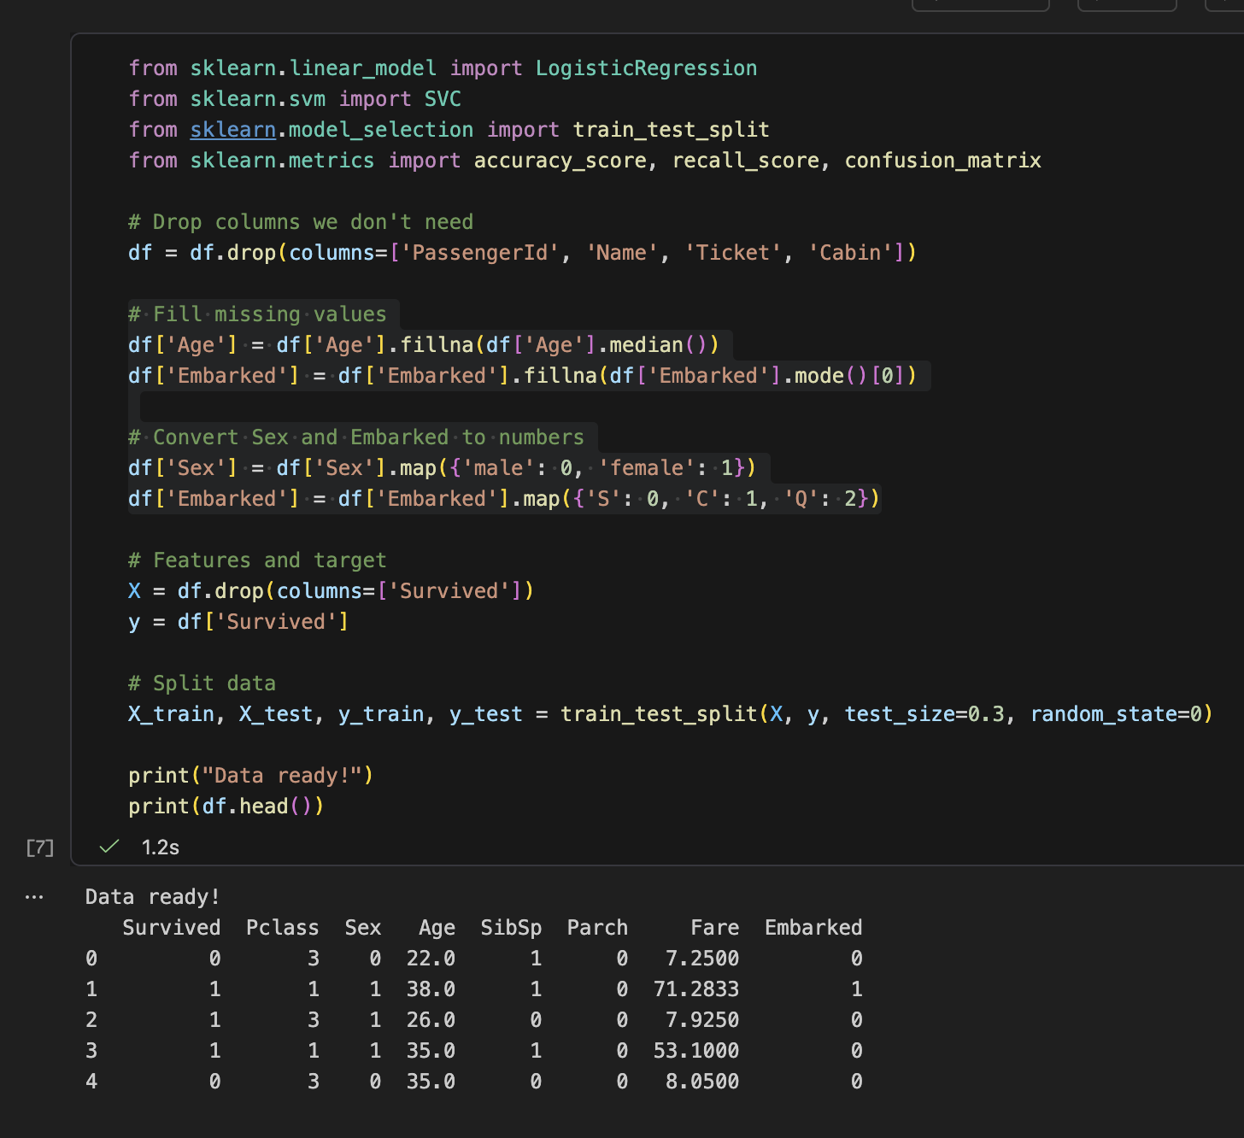
Figure 2: Cleaning Data, Filling missing values with median/mode
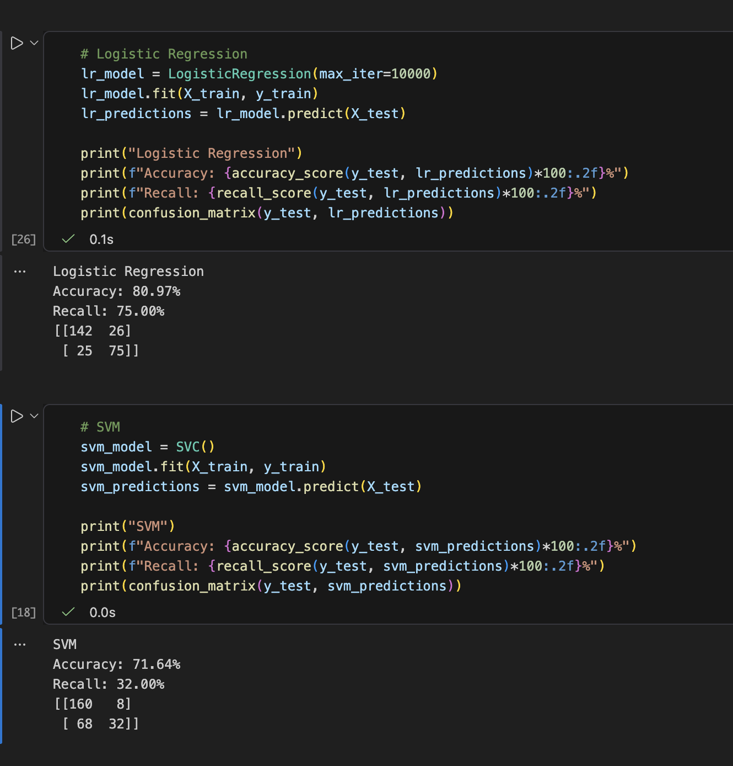
Figure 3: Comparing Logistic Regression/SVM Accuracy and recall score
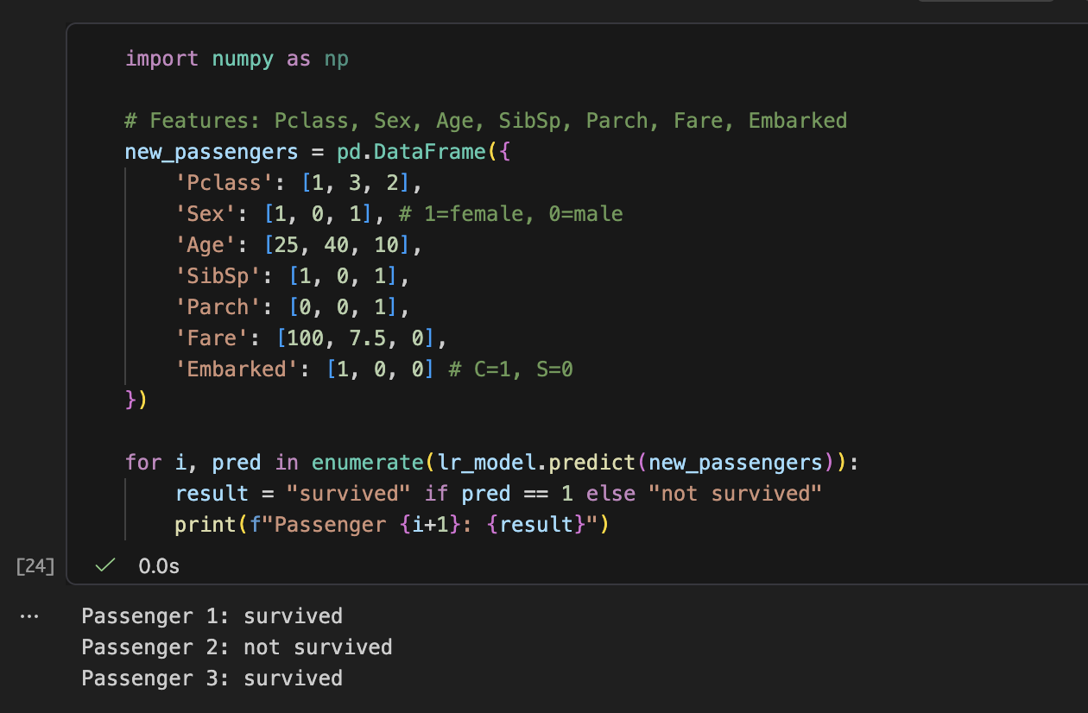
Figure 4: Letting our model predict 3 scenarios

