**Uranium particulates in soil samples from the site of the Israeli bombing of Hassan Nasrallah on Sept 27th 2024. Use of CR39 imaging technology. Novel evidence that micron sized Uranium particles are resuspended by electrostatic effects.**

Christopher Busby PhD, Robert Daly PhD, Jihad Abboud, PhD, Yvonne Anwar Saouiby

Green Audit Report 1/2025; March 25th 2025.

Recent analyses of soil samples from Gaza in 2021 showed the presence of Enriched Uranium (EU) [1]. Previously, EU was found in bomb/missile crater soil and ambulance filter samples in Lebanon in 2006[2,3], in soil and ambulance filter samples in Gaza in 2009 [4, 5] and in hair samples in Fallujah Iraq in 2011 [6].

These and other reports e.g. [e.g. 7,8] have led to a belief that a new Uranium cold fusion weapon has been deployed by Israel and the USA in the past 20 years. Added to this are observations of unusual explosions in Gaza and the Lebanon, together with unexplained injuries and health effects in those affected by the explosions in the recent conflicts.

Here, we report on some preliminary analyses of some soil and air filter samples collected from the site of the Israeli bombing on 27th September 2024 of the underground bunker in Beirut which resulted in the death of Hassan Nasrallah. Our method involved imaging alpha activity tracks from the samples with CR39 plastic. Because Uranium-238 and Uranium-235 have low specific activity, an exposure time of 30 days was employed.

**The samples**

On 19th December Dr Jihad Abboud, President of the Lebanese Chemists Syndicate and Dr Robert Daly, Chair of the American Peace Information Council, and representative of Green Audit, and Lebanese journalist Yvonne Anwar Saouiby visited the impact site of the bomb that killed Hezbollah General Secretary Hassan Nasrallah in Beirut. They took a Geiger Counter and found that the site was significantly more radioactive than the normal background for the area. Dr Daly reported that 100m from the impact site the normal background radiation level was between 0.07 and 0.1 μSv/h. As they approached the Nasrallah bombing site the reading steadily increased to 0.27 to 0.32 μSv/h at the site itself. This was 84 days after the explosion [10]. In 2006, a similar finding of radiation at a bomb crater in Khiam was reported by the late Dr Ali Al Khobeisi, and the samples taken there were analysed by two separate techniques in the UK (alpha spectrometry and Inductively Coupled Plasma Mass Spectrometry ICPMS) [2,3]. Enriched Uranium (EU) was detected. One explanation is that the new weapon has a neutron-producing warhead and the short-lived radiation (12 weeks) is due to activation products which physically decay over a period of some months. This explanation, originally due to the late Dr Emilio Del Guidice, also predicts the excess EU which has been found [8]. Dr Jihad Abboud had obtained a fairly fresh sample from a worker shortly after the bombing and sent it for analysis to France. The French laboratory told him that it contained significant levels of Uranium but refused to provide details of enrichment or a report, presumably for political reasons. Nevertheless, Dr Abboud released a short report about the issue of Uranium contamination [9]. Three soil samples were collected from the impact site some 12 weeks after the explosion. The samples were obtained from the ground surfaces using a small portable vacuum cleaner. Samples e and b were from close to the impact site of the weapon. Sample c was taken from Deeb neighbourhood, 100m from the impact site, but which had also been bombed. A vehicle engine air filter was also obtained. The samples were sent to the Green Audit lab in England and screened for activity using various detectors. Here, some results are presented for 30-day exposure of CR39 plastic to measure alpha activity and look for Uranium hot particles.

**Procedure**

10g of each sample was spread out in a 90mm plastic Petri dish, the depth was approximately 2mm. A piece of CR39 plastic 75 x 25 x 1mm (microscope slide size) was placed on the sample, the Petri dish was covered with a plastic lid and the samples transferred to a closed glass vacuum desiccator. A control piece of CR39 was also placed in the desiccator. The samples were left for 30 days and then the slides removed and developed in 5N Potassium hydroxide for 4 hours at 80 degrees. They were washed and dried and examined using a Vickers metallurgical microscope with a silver reflector. The total number of tracks was counted for three separate passes at 100X. The entire slide was then examined for the occurrence of multiple track events due to point source emissions from hot particles. The slides were reversed and the same process was carried out. It was accidentally discovered that multiple track events could be seen on the side facing away from the sample, showing that hot particles had become resuspended from the soil sample and precipitated on the reverse surface of the CR39 slide. The field of view of the counting window was obtained from a calibrated eyepiece graticule and the transit field pass length was 50mm.

Samples were placed in contact with CR39 at 6pm GMT on Feb 5th 2025 and removed on March 7th at 3.55pm. The exposure was assumed to be 30 days (2592000 s).

**Results.**

The alpha track activity on the soil sample facing side of the slides is given in Table 1.

Some images of the particle tracks are shown in Figs. 1a,b, c, d and e.

**Table 1** Alpha track counts in three passes at 100X. Microscope field is 0.0136cm2. Total calculated area of swept field for 3 passes is 0.204cm2. Hot particles are highlighted.

|  |  |  |  |  |  |
| --- | --- | --- | --- | --- | --- |
| **Sample**  **f:facing**  **a:away** | **Tracks per three passes** | **2**  **cluster**  **Full surface** | **3**  **cluster**  **Full surface** | **4**  **cluster**  **Full surface** | **>5**  **cluster**  **Full surface** |
| e (f) | 1213 | 102 | 9 | 2 | 0 |
| e (a) | 1038 | 2 | 1 | 3 | 6 |
| b (f) | 870 | 83 | 4 | 1 | 1 |
| b (a) | 1143 | 24 | 6 | 0 | 2 |
| c (f) | 631 | 3 | 4 | 0 | 0 |
| c (a) | 504 | 3 | 0 | 0 | 0 |
| Cont. (f) | 5 | 0 | 0 | 0 | 0 |
| Cont. (a) | 4 | 0 | 0 | 0 | 0 |

**Fig 1a** Photomicrograph of CR39 tracks with no hot particles. 30d exposure. Normal distribution. Radon alpha tracks; microscope X100.

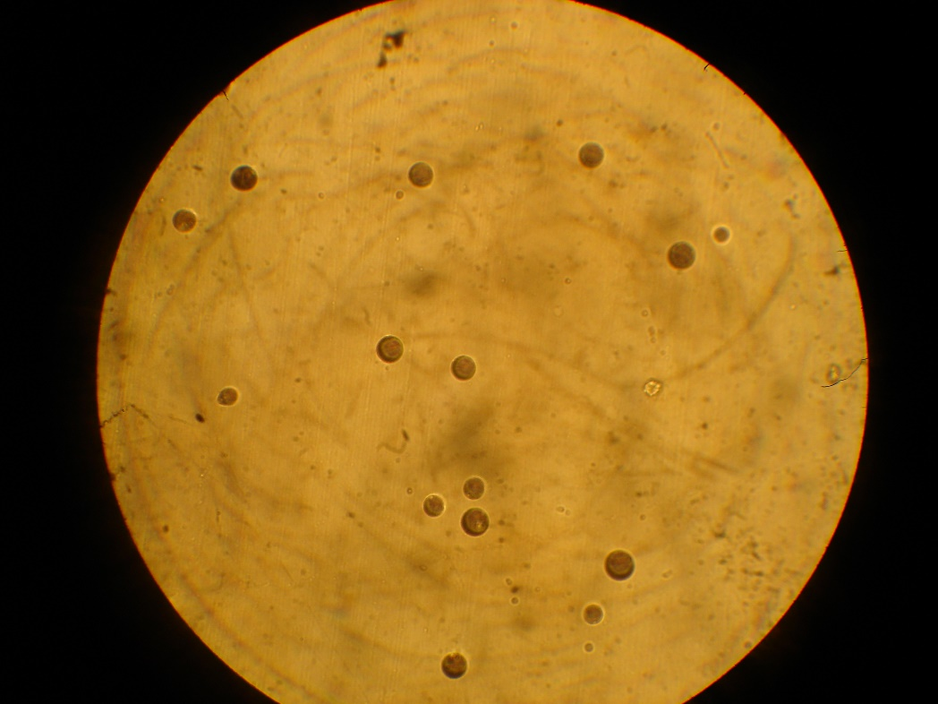

**Fig 1b** Hot particle cluster. microscope X400; 10 tracks into the field of view. 30d exposure. Sample e (reverse, resuspended and re-deposited particle).

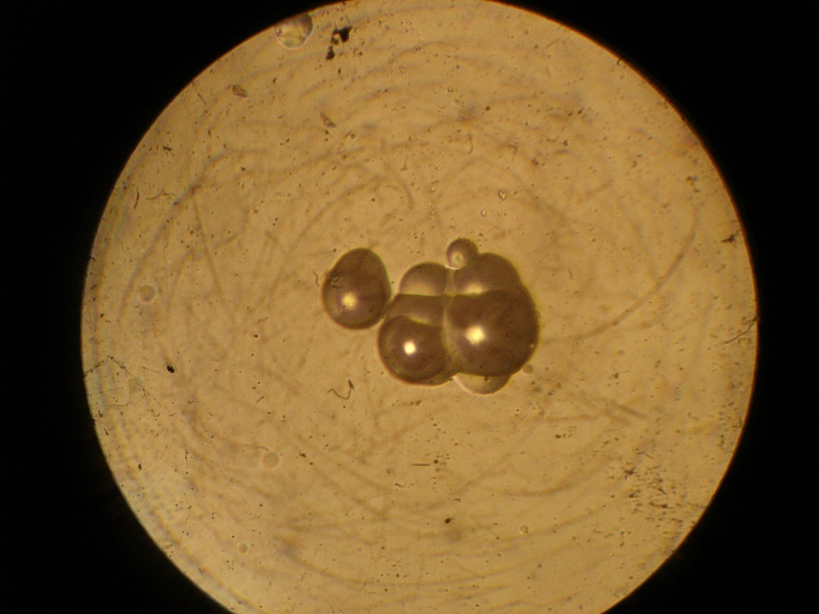

**Fig 1c** Hot particle cluster microscope x100. Sample b. Redeposited on reverse of slide facing away from soil.

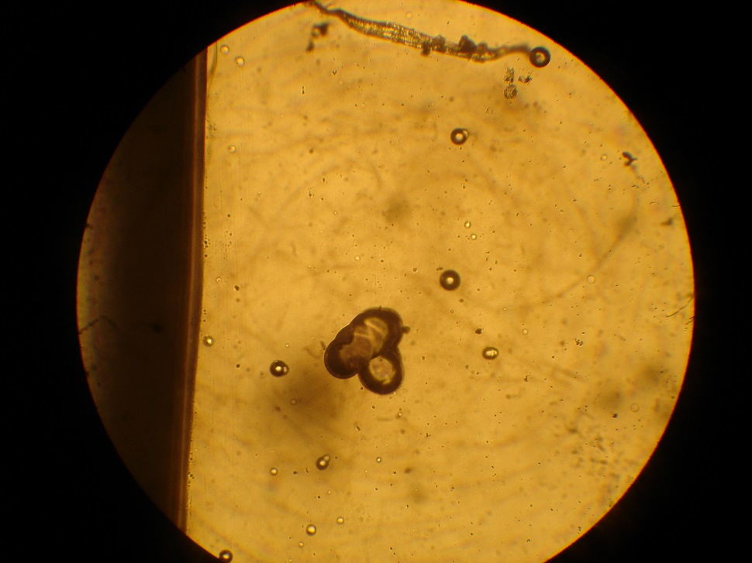

**Fig 1d** As for Fig 1c but X400. Sample b. Redeposited on reverse of slide facing away from soil.

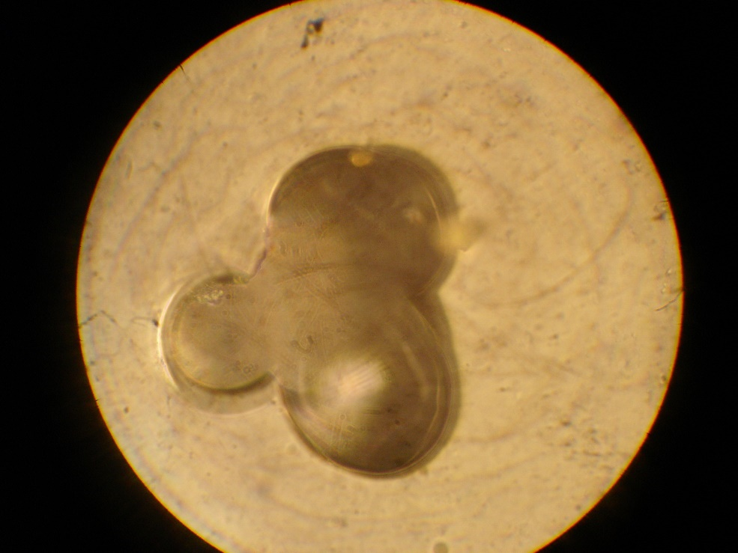

**Fig 1e.** 9 track particle. Sample e. Facing soil. X400.

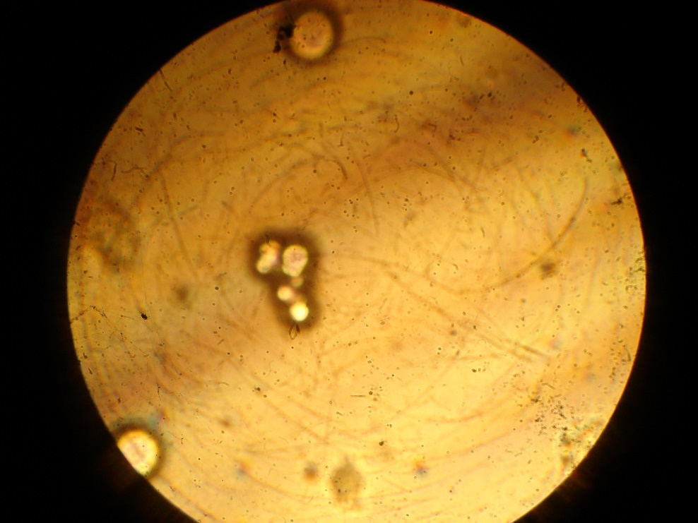

**Discussion**

The method employed is extremely sensitive for obtaining relative alpha activity and looking for hot particles of Uranium, or indeed any other alpha emitting contaminant. The samples were also examined using a 4-inch thin film scintillation counter with alpha discrimination circuitry and with a 2-inch thin window Geiger counter, but these latter did not distinguish between the samples even with several hours counting. The beta/gamma activity of the samples was not significantly higher than lab background and so no gamma emitting fission-products (e.g. Caesium-137) were present. There was insufficient material so carry out gamma spectroscopy.

**Assumptions**

In order to analyse the track data a number of assumptions were necessary. These were based on relevant directional track geometry, Poisson probability predictions for clustering, decay data for alpha emitters in the environment and shielding (self-absorption) by the sample matrix and other arguments. These will be discussed in a further report which will have spectroscopic results for these and other samples, including the vehicle engine filters.

Briefly, the tracks were counted over the whole field and it was assumed:

1. 1/6th of the total 2p Steradian emission from a concise particle.
2. That the self-absorption by the soil sample of depth 2mm could be ignored. This is almost certainly a false assumption, but gives results which are conservative regarding the activity of the particle.
3. That clustering was not a Poisson-related issue and that all multiple cluster observations were not probabilistic.
4. That the clusters were not due to exotic alpha emitters released from nuclear reactors or fission bombs.
5. That the identity of the emitters could be analysed on the basis of known alpha decay schemes from the Natural Radioactive Series Uranium-238, Thorium-232 and Uranium-235.
6. That particles consisted of pure Actinide Oxides in terms of density.
7. That the particles were spherical unless noted otherwise.

The possible natural alpha emitting series are shown in Table 2 where possible double hit sequences are highlighted. Sequences involving double hits are begun with Radon, Thoron and Rn-219 gases since it is assumed that the gases will be displaced relative the parent nuclide.

**Table 2** Natural background alpha emitters series with double hit sequences are highlighted. T1/2 is the limiting half-life of the parent sequences (intermediate b emitters only considered in terms of limiting half-lives).

|  |  |  |
| --- | --- | --- |
| **Uranium-238 (T1/2)** | **Thorium-232 (T1/2)** | **Uranium-235 ( usually low concentrations) (T(1/2)** |
| U-238 (4.46 x 109y) | Th-232 (1.4 x 1010y) | U235 (7 x 108y) |
| Several decays to gas | Several decays to gas | Several decays to gas |
| Rn-222 Radon (3.1m) | Rn-220 Thoron (55s) | Rn-219 (1.78 x 10-3s) |
| Po-218, a ------ , b----- | Po-216, a (0.145s) | Po-215, a (36m) |
| Pb-214, a------ (26m) | Pb-212 (10.64h), b | Pb-211, a(0.51s) |
| Or | Bi-212, a (60m) | Pb-207 stable |
| Bi-214, a------, (19m) | Or |  |
| Pb-210/ Po-210 (20y), a | Po-212, a (2.99 x 10-7s) |  |
| Pb-208 stable | Pb-208 stable |  |

The overall conclusions were as follows:

1. There were clusters of tracks with greater than 4 impacts in the CR39 which support the existence of Uranium active particles in samples **e** and **b**. There were few or no such particles in sample **c**, which was also significantly less active.
2. These particles were resuspended inside the covered Petri Dish and re-precipitated on the reverse surface facing away from the soil. This is a novel discovery. This surface also showed alpha activity from the radon released from the sample in the 30-day counting period.
3. The track density for the hot particles (generally 7-9 tracks into the plane of the slide) support the origin being Uranium 238/234 oxide particles of between 5 and 6 microns diameter. The presence of U-235 in these particles (or more active alpha emitters) would reduce the particle diameter to between 1 and 3 microns.
4. The background alpha activity from Radon in the desiccator was very low, as shown by the control, and so the results were not an artifact.
5. There was one cluster of highly active material of significant size on the reverse of sample b slide near one edge. This is shown in Fig 2 below. The size of the particle is 0.12 x 0.016mm (120 x 16u). Modelled as a cylinder and employing the specific activity of Uranium (U-238 and U234) we can expect about 8000 decays in this volume if this is pure Uranium oxide. If we divide by 6 for the spatial dispersion of tracks there should be about 1000 tracks in this particle in Fig 2. This seems more than we see, but of course the particle might contain a smaller percentage of Uranium. Whatever the explanation, such a particle would cause a very high local dose.

**Activity of the imaged particles, biological effects.**

On the basis of the tracks found in 30 days exposure, and assuming U238/U234 dioxide particle of specific activity 24MBq/kg the activity of the imaged particles supported a particle diameter of between 5 and 6 microns AMAD if the particles are Uranium-238. If the particles have significant U-235 in them (EU) then the particle diameter would be in the 1 to 3 micron range. The specific activity of the possible components of the particles are given in Table 3. The activities for pure U-238 oxide particles are given in Table 4. Employing the geometric dispersion assumption (that is, that only one sixth of the decay tracks impacted the plastic, other tracks were away from the plastic) a 9-track impact would have originated in a particle that emitted 54 tracks. Since each track has a path length in the plastic of 30microns and in tissue of 40 microns, the relevant absorbed dose to local tissue cells (diameter 10 microns, 4 cells in path) would be in the cancer -producing/ cell death range. The calculated Absorbed Dose in Joules per kg (Grays) to the cell community in range of the 40 micron tracks from the 54 track particle imaged by the CR39 is 190mGy or an Equivalent Dose in Sieverts of 3.87Sv, well in the range of cancer initiation, cell mutation and cell death.

It must be emphasised that what is seen in the track photographs is what would occur also in human tissue. The dose to the relevant tissue is thus very much greater than would occur naturally.

**Table 3** Specific activity (kBq/g) for U-238/U-234, U-235 and Th-232.

|  |  |  |
| --- | --- | --- |
| U-238/U234 (stochastic equilibrium | U-235 | Th-232 |
| 24.6kBq/g | 80kBq/g | 4.1kBq/g |

**Table 4** Expected decay number in 30 days from particles of different diameter of U-238/U234 and U-235 in 30 days. Note that particles were detected with from 24 to 72 decays into Steradian volume. The resolution of the microscope and the overall track cluster size eliminates Th-232 as a possibility except in the case of the large particle shown in Fig 2.

|  |  |  |  |
| --- | --- | --- | --- |
| Particle diameter microns | **U-238/U-234** | **U-235** | **Th-232** |
| 1 | 0.58 | 0.174 | 3.39 |
| 2 | 4.66 | 1.39 | 27.2 |
| 3 | 15.7 | 4.71 | 91.8 |
| 4 | 37.44 | 11.2 | 219 |
| 5 | 72.86 | 21.8 | 426 |
| 6 | 125 | 37.5 | 648 |

**Fig 2** Highly active large particles on reverse of slide of sample b. Microscope X1000.

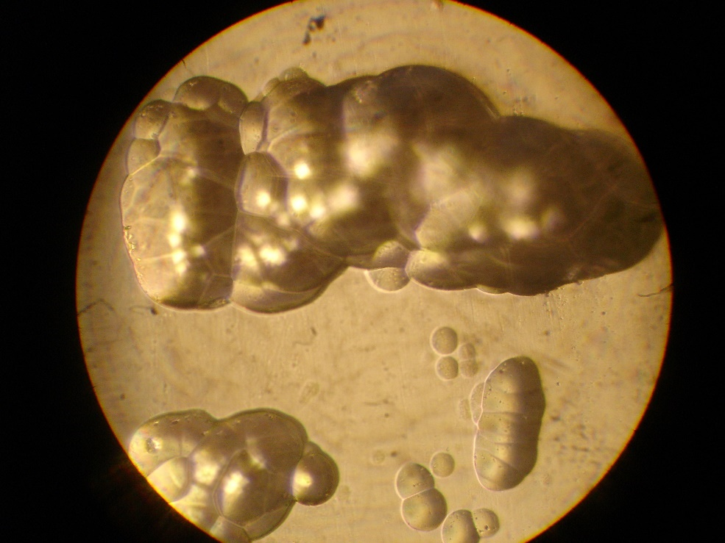

**Resuspension of hot particles**

One of the most unexpected and accidental discoveries here, which also has important Public Health implications is the confirmation of previous work carried out in Kosovo that Uranium particles become resuspended from surfaces. In Kosovo, it was found that DU particles collected and concentrated in snow puddles, showing that they had become systematically resuspended and re-precipitated. This was reported to the Royal Society by the author, but was denied on the basis of calculations.

In the investigation reported here, hot particles were found to have left the surface of the soil sample and re-precipitated on the opposite surface of the CR39 slide, remote from the sample. In fact, these particles were clearly isolated and provided a far better signal of clustering tracks than those in the matric pressed against the slide.

**Summary, Conclusions and recommendations**

This report provides evidence confirming the presence of alpha emitting Uranium hot particles in soil samples from the Israeli bombing of Hassan Nasrallah in Beirut on Sept 27th 2024. This also supports earlier work by Green Audit and others that point to the use of a novel weapon which employs Uranium and may produce or incorporate Enriched Uranium. The decays from the particles imaged which are in the respirable range (<10 micron), and become resuspended, would cause energy deposition to the cells within range of the 4-micron alpha tracks of about 200mGy or 2.4 Sieverts. Such doses are able to kill cells, cause genetic mutations and cancer.

The results show for the first time that such radioactive alpha emitting particles become airborne through resuspension in the absence of any wind, and re-precipitate on clean surfaces.

The nature of the weapon is unknown without further work on the isotopic ratios and the presence of other elements in the soil samples from the site. What can be concluded is that the weapon employed Uranium and left Uranium particle residues. Further work on these samples and those obtained from Gaza will be reported.

The CR39 method is shown to provide a simple, inexpensive and highly sensitive way of analysing soil samples for hot particles. This means that reliance on expensive tests (ICPMS, alpha spectrometry, gamma spectrometry) is not necessary to prove that such weapons have been deployed. Green Audit has increasingly found that pressure is brought to bear on independent laboratories to provide misleading or biased results. In many cases, the laboratories refuse to provide such results (as was the case with Dr Abboud and the French CRIIRAD laboratory). Furthermore, the cost of laboratory tests (in the region of 300$ per sample) is currently beyond the means of Green Audit or those who are interested in examining samples from war zones.

It is recommended that independent analysis is carried out of samples from the site, and other sites in Lebanon and Gaza where Israel has deployed novel warheads and that the public in these areas are warned of the health consequences resulting from inhalation of resuspended particles. Epidemiological studies in Iraq have already found significant excess genetic effects in local populations from the use of Uranium weapons. Particularly worrying is the evidence that a novel warhead which employs or produces EU has been deployed for some 20 years.

**References**

1. Abd Elkader MA, Shinonaga T, Sherif MM (2021) Radiological hazard assessments of radionuclides in building materials, soils and sands from the Gaza strip and the north of the Sinai peninsula. Nature Scientific Reports (2021) 11:23251.

2. Busby C and Williams D (2006) Evidence of Enriched Uranium in guided weapons deployed by the Israeli military in Lebanon in July 2006. Green Audit Research Note 6/2006, Oct 20 2006. Aberystwyth: Green Audit. <https://www.researchgate.net/publication/265064420_Evidence_of_Enriched_Uranium_in_guided_weapons_employed_by_the_Israeli_Military_in_Lebanon_in_July_2006_Preliminary_Note>

3. Busby C, Williams D (2006) Further evidence of enriched Uranium in guided weapons employed by the Israeli Military in Lebanon in July 2006. Ambulance air filter analysis. Green Audit Research Note 7/2006, November 3 2006 Aberystwyth : Green Audit

<https://www.researchgate.net/publication/228485893_Further_Evidence_of_Enriched_Uranium_in_guided_weapons_employed_by_the_Israeli_Military_in_Lebanon_in_July_2006_Ambulance_Air_Filter_Analysis>

4. Busby Christopher (2024) Anomalous Enriched Uranium in environmental samples from Gaza. DOI 10.13140/RG.2.2.30937.08808

<https://www.researchgate.net/publication/378175255_Anomalous_Enriched_Uranium_in_environmental_samples_from_Gaza>

5. Busby Christopher (2024) Evidence for the use by Israel of a neutron Uranium warhead in Palestine and Lebanon. <https://www.researchgate.net/publication/376445659_Evidence_for_the_use_by_Israel_of_a_neutron_uranium_warhead_in_Palestine_and_Lebanon#fullTextFileContent>

6. Alaani Samira Tafash Muhammed, Busby Christopher, Hamdan, Malak and Blaurock-Busch Eleonore (2011) Uranium and other contaminants in hair from the parents of children with congenital anomalies in Fallujah, Iraq *Conflict Health*  5, 1-15

7. Robert Fisk, *The Independent.* The mystery of Israel’s secret Uranium bomb

<https://www.independent.co.uk/voices/commentators/fisk/robert-fisk-mystery-of-israel-s-secret-uranium-bomb-6230359.html>

8. Emilio Del Guidice, (Theoretical Physicist 1940-2014.) Maurizio Torrealta. *The Secret of the Three Bullets.* See https://en.wikipedia.org>wiki>Emilio_del_Guidice

9. Abboud J (2024) see: <https://en.kataeb.org/articles/conflicting-reports-emerge-as-lebanon-faces-concerns-of-depleted-uranium-exposure>

10. Abboud J, Daly R (2025), Technical Report, Feb 9 2025.