Directorist Shopping Centres
Easy User Guide for InStoreOnly Admins
Short summary
This extension displays shopping centre image tiles. Selecting a tile opens real Directorist deals for that centre, and selecting a deal opens the normal Directorist single listing page.

What This Extension Does
- Adds a Shopping Centres taxonomy to Directorist listings.
- Adds an image upload field for every shopping centre.
- Displays shopping centre tiles through an Elementor widget.
- Displays real Directorist listings and deals on each centre page.
- Opens the existing Directorist single listing page when a visitor selects a deal.
Item | Meaning
Shopping Centre | Example: Westfield Bondi Junction
Deal Listing | Example: JB Hi-Fi - bonus gift card today only
Centre Image | Image uploaded or selected from the WordPress Media Library
Frontend Tile | Homepage image, centre name, and deal count
Centre Page | Automatic URL: /shopping-centre/westfield-bondi-junction/

Step 1: Find The Plugin Pages
1. Open WordPress Admin
Open /wp-admin in your browser and sign in.
2. Open Listings > All Shopping Centres
In the left sidebar, open Listings, then select All Shopping Centres.
3. Open The Extension Tools Page
Open Listings > Shopping Centre Tools to access archive settings, import and sync tools, shortcode information, and the frontend archive link.
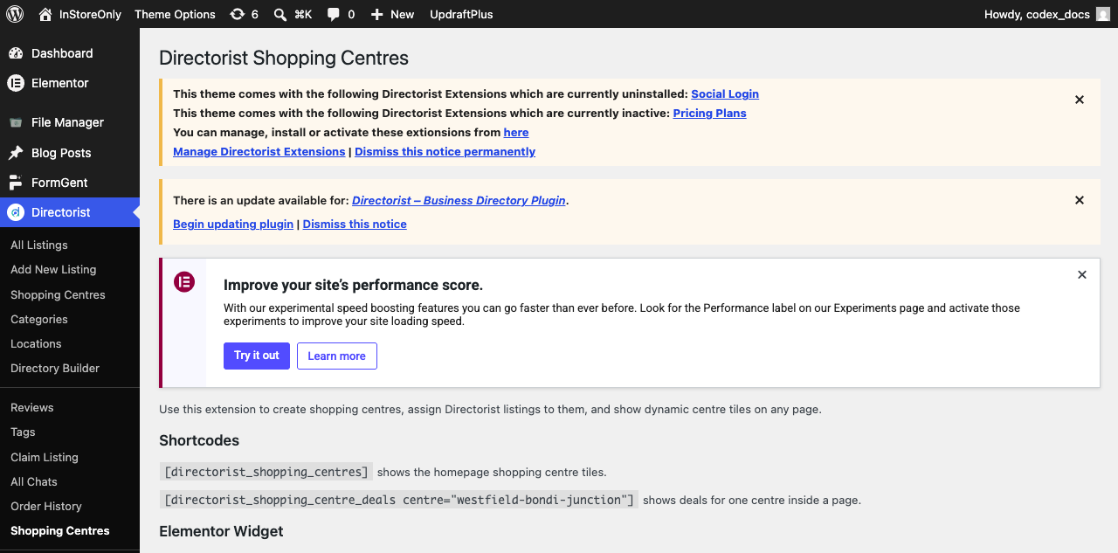
Plugin guide page: shortcodes, Elementor widget note, and sync button area.

Step 2: Add Or Edit A Shopping Centre
1. Open Listings > All Shopping Centres
This page lists all managed shopping centres. To update an existing centre, hover over its name and select Edit.
2. Enter The Centre Name
Example: Westfield Bondi Junction. You can leave the slug empty and let WordPress create it automatically.
3. Add An Optional Description
The description can appear on the centre page. Leave it empty if no description is required.
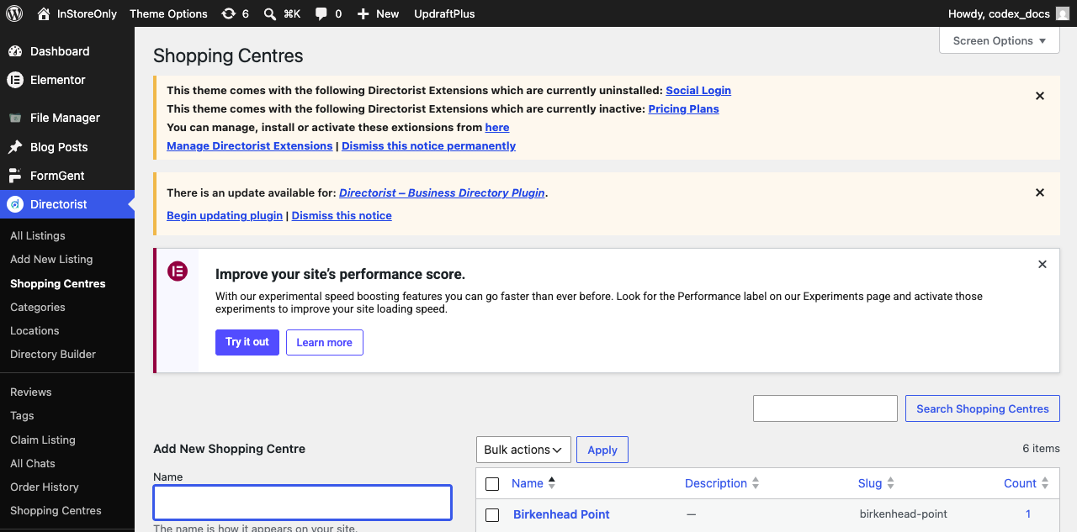
Shopping Centres admin list.

Step 3: Upload A Shopping Centre Image
1. Open The Shopping Centre Edit Page
Scroll down to the Shopping Centre Image field.
2. Select An Image
Click Select Image, then choose an existing image from the WordPress Media Library or upload a new one.
3. Update The Centre
Click Update. The saved image will be used on frontend tiles and the centre page.
Image tip
Use a clear, wide landscape image of the centre or building. The recommended minimum width is 1200 pixels.

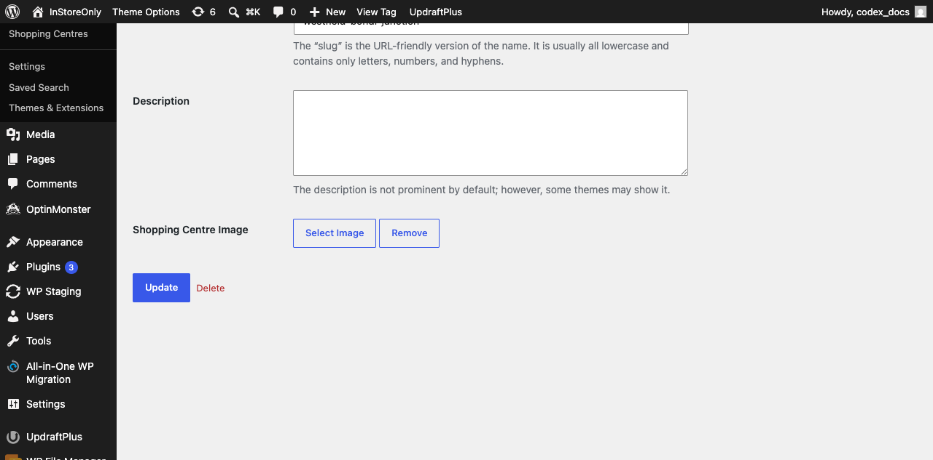
Shopping Centre Image field with Select Image and Remove buttons.

Step 4: Assign A Deal Listing To A Centre
1. Open Listings > All Listings
Edit the deal listing that should appear on the shopping centre page.
2. Find The Shopping Centres Panel
Select the correct centre. If it is missing, enter the centre name in the field and select Add.
3. Update The Listing
After the listing is saved, the deal will appear on the selected shopping centre page.
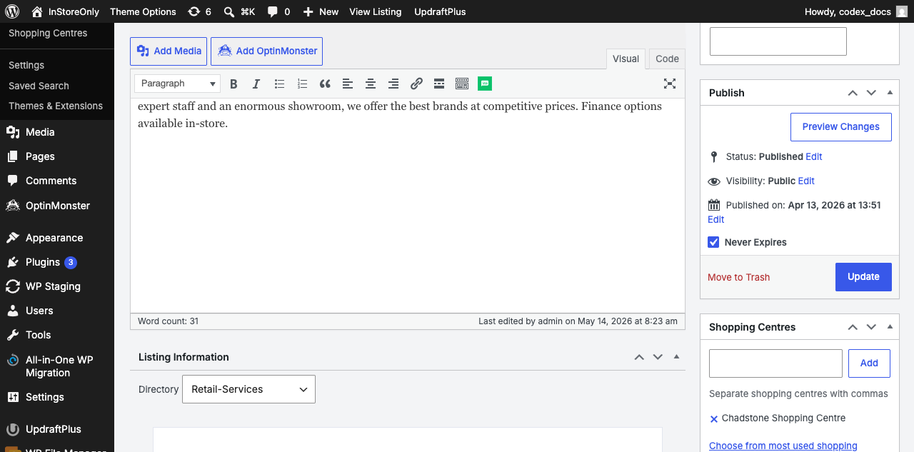
Listing edit screen: Shopping Centres assignment box on the right.

Step 5: Add The Elementor Widget To The Homepage
1. Edit The Homepage With Elementor
Open the homepage from Pages, then select Edit with Elementor.
2. Find The Widget
Enter Shopping Centres in the Elementor widget search field.
3. Add The Widget
Drag the widget into the section where the centre tiles should appear.
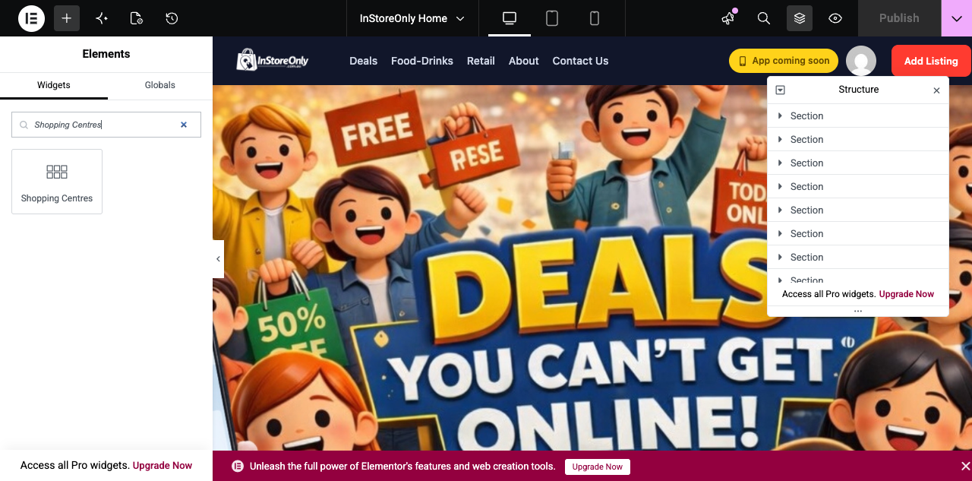
Elementor widget search showing the Shopping Centres widget.

Step 6: Style The Widget In Elementor
No coding needed
You do not need to edit CSS. Select the Elementor widget and use its Content and Style tabs.

Item | Meaning
Content > Title | Change the section heading text
Content > Columns | Set desktop, tablet, and mobile column counts
Content > Hide Empty Centres | Show or hide centres with no current deals
Style > Heading | Title color, typography, alignment
Style > Grid | Spacing between cards
Style > Card | Background, border, radius, shadow, height, padding
Style > Image | Image height, radius, fallback background
Style > Centre Name | Name font and color
Style > Deal Count | Deal count font, color, spacing

Step 7: Configure The Complete Shopping Centres Archive
1. Open Listings > Shopping Centre Tools
Use Archive display settings to control the complete /shopping-centres/ page.
2. Choose Whether To Show Empty Centres
When enabled, publicly visible centres with zero current deals remain in the archive. When disabled, only centres with current deals appear.
3. Configure Archive Options
Choose 6, 12, 24, or all centres per page; enable or disable search; sort by Name, Deal Count, or Recently Added; and show or hide deal counts.
4. Save Archive Settings
The archive updates immediately. The homepage Elementor widget's Hide Empty Centres and Limit settings remain unchanged.
Important: a centre remains hidden if Show this Shopping Centre publicly is not selected, even when the archive is configured to show empty centres.

Step 8: Check The Frontend Result
1. Open A Centre Tile
Selecting a homepage tile opens the corresponding shopping centre page.
2. Check The Deal List
The page should display only participating-store deals assigned to that centre.
3. Open A Deal
Selecting a deal opens the normal Directorist single listing page.
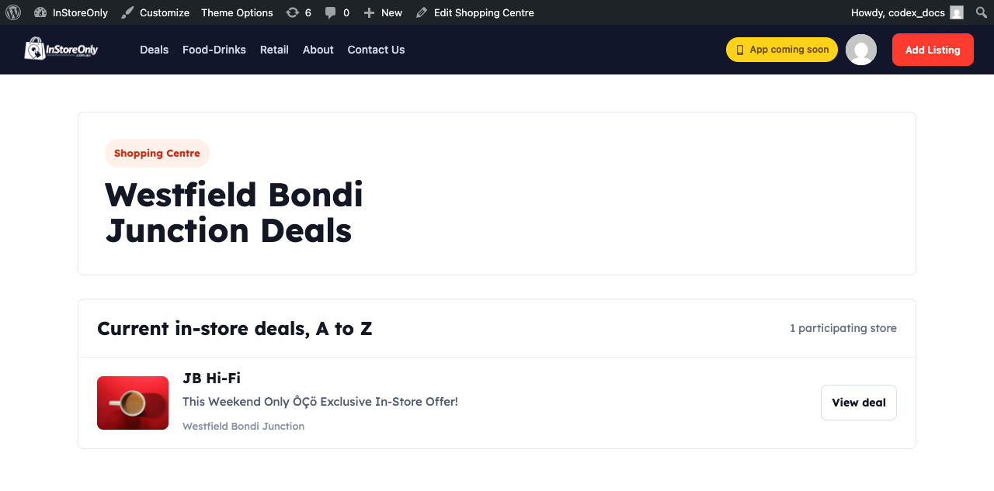
Frontend centre page with real Directorist deal listing.

Shortcode Option
[directorist_shopping_centres hide_empty="1"]
If Elementor is not used, paste this shortcode into a Shortcode widget or the page content.
Item | Meaning
hide_empty="1" | Hide centres with no current deals
hide_empty="0" | Show all publicly visible centres
columns="3" | 3-column tile layout
number="6" | Display a maximum of six centres

Troubleshooting
Item | Meaning
Centre tile is not visible | Confirm that the centre exists and that the widget's hide_empty setting is correct.
Deal is not visible | Edit the listing and assign the centre in the Shopping Centres panel.
Image is not visible | Edit the centre, select an image, and click Update.
Centre page 404 | Open Settings > Permalinks and click Save Changes.
Incorrect centre name | Rename or delete the incorrect centre from Directorist > Shopping Centres.

Admin Checklist
- The extension is active.
- The shopping centre has been created.
- A shopping centre image has been uploaded.
- Deal listings are assigned to the correct centre.
- The Elementor widget has been added to the homepage.
- The frontend centre tile and centre page have been checked.
- The Directorist listing page has been checked from a deal link.
- Archive display settings have been saved according to the site requirements.

Developer Reference
Item | Meaning
Main plugin | directorist-shopping-centres.php
Elementor widget | includes/class-elementor-shopping-centres-widget.php
Frontend template | templates/taxonomy-shopping-centre.php
Frontend CSS | assets/css/frontend.css
Admin image picker | assets/js/admin.js
Taxonomy | at_biz_dir-shopping-centre
Image meta key | _dsc_image_id

