Question 1:
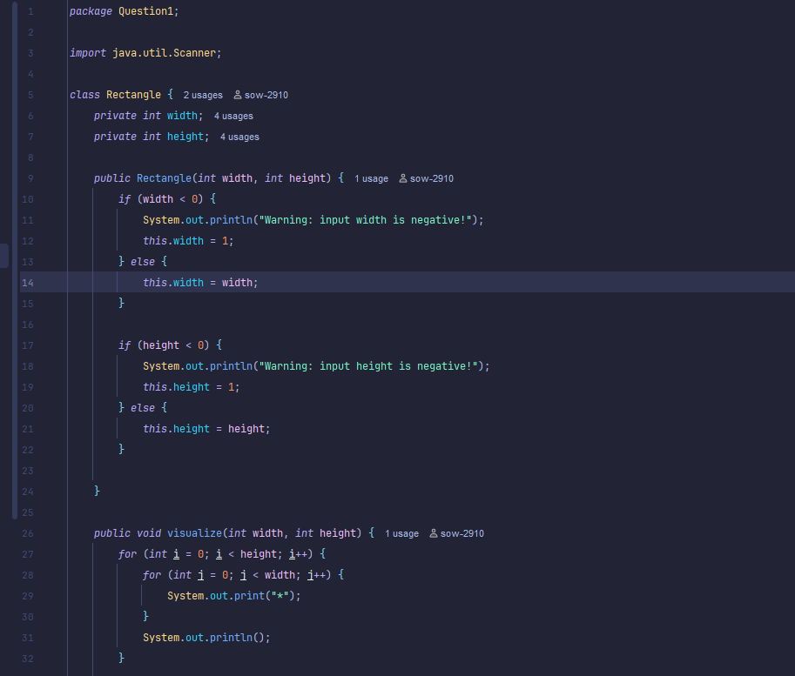

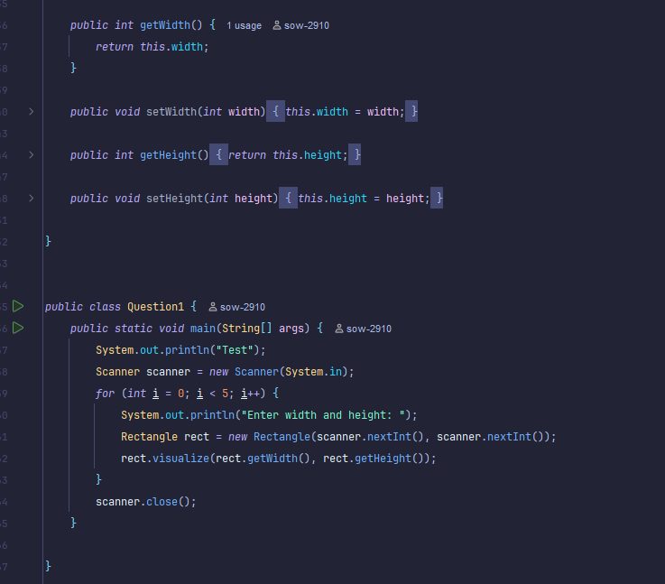

How this code works:
This program defines a class called Rectangle that models a rectangle with a given width and height. In the constructor, if the user inputs a negative value for width or height, the program prints a warning and automatically sets that value to 1. The visualize() method prints the rectangle using asterisks (*), displaying it according to the given width and height. In the main() method, the program asks the user to enter width and height values five times using a Scanner. For each pair of inputs, a new Rectangle object is created and immediately visualized on the console.

Question 2:
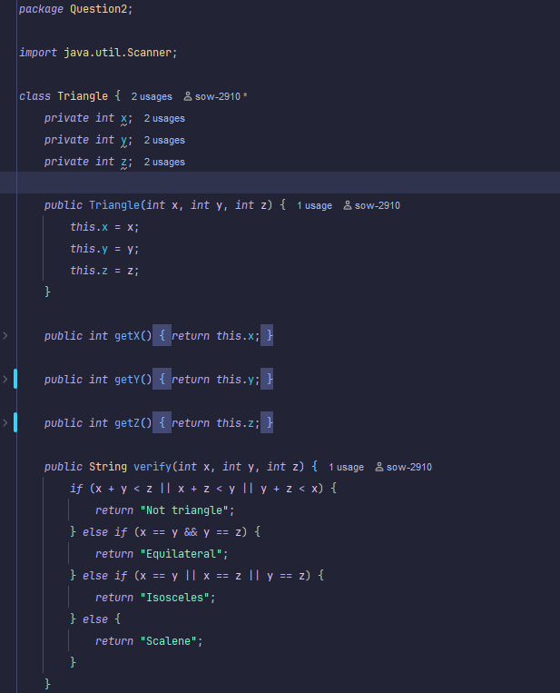

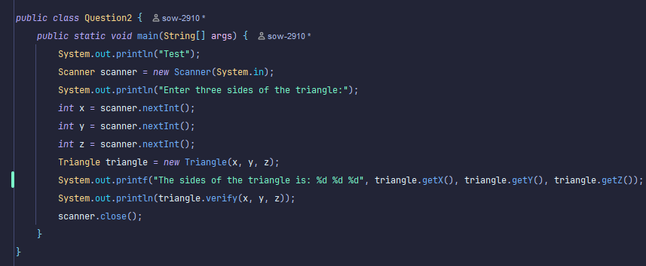
How this code works:
This Java program determines the type of triangle based on its three sides. First, it asks the user to input three integers representing the sides of the triangle. These values are then passed to the Triangle class, which stores them as private attributes x, y, and z. The verify method checks if the given sides can form a valid triangle using the triangle inequality rule. If the sides are valid, it further classifies the triangle as Equilateral, Isosceles, or Scalene depending on the equality of the sides. Finally, the program prints out the sides using the verify() method entered and the corresponding type of triangle.

Question 3:
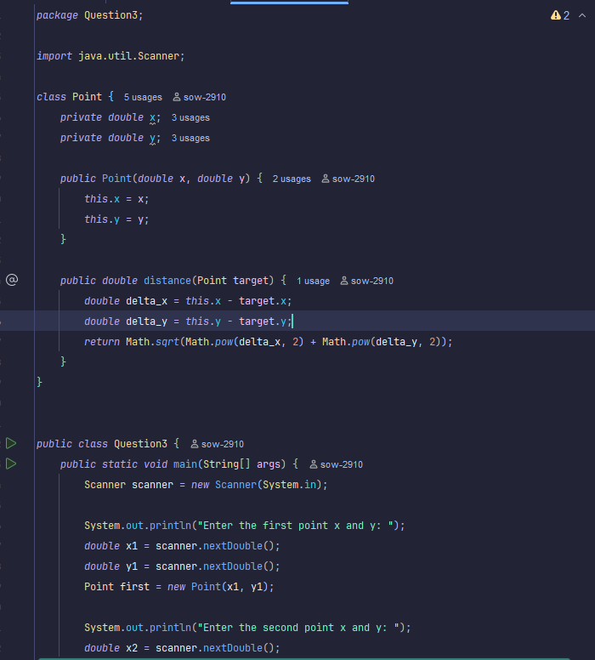
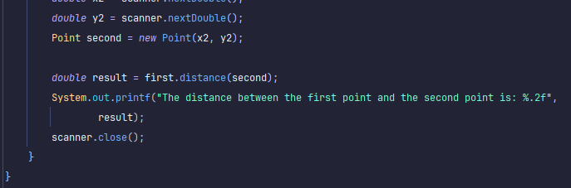
How this code works:
This program defines a class named Point that represents a point in a 2D coordinate system with x and y values. The constructor initializes these coordinates when a new Point object is created. The distance() method calculates the Euclidean distance between the current point and another point using the distance formula. In the main() method, the user is asked to input the coordinates of two points through the console. After both points are created, the program calls the distance() method to compute the distance between them.
Finally, it prints the result formatted to two decimal places, showing the distance between the two entered points.

Question 4:
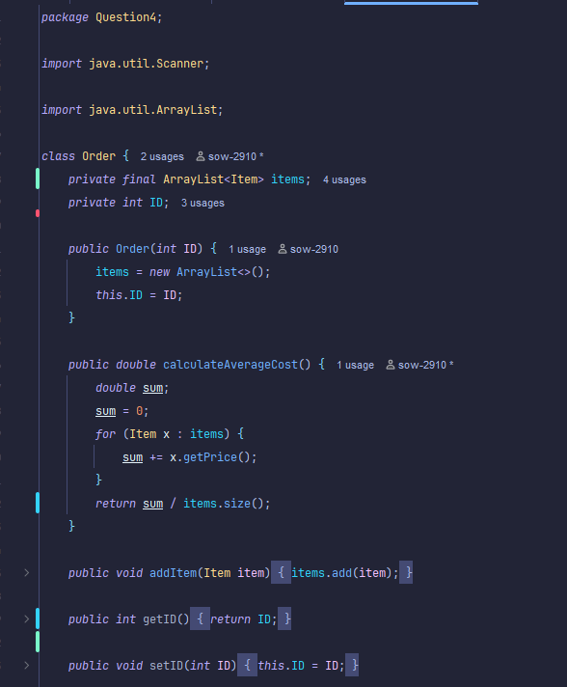
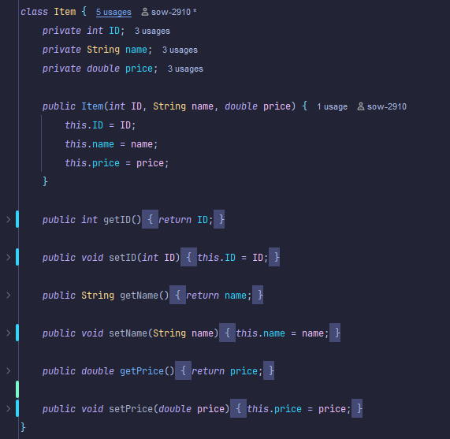

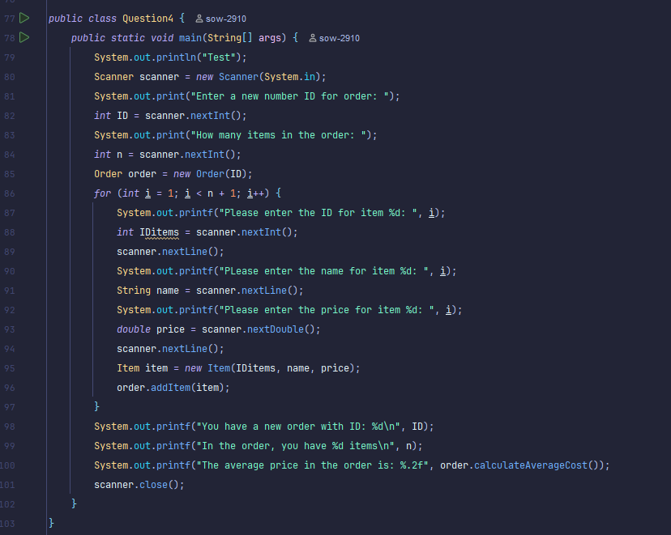
How this code works:
This program manages an order that contains multiple items. It defines two classes: Order and Item, where Order stores a list of Item objects using an Array List. Each Item has an ID, name, and price, while Order has methods to add items and calculate the average cost. In the main method, the program asks the user to input the order ID and the number of items. Then, it repeatedly takes the information of each item and adds it to the order. Finally, it prints out the order details and the average price of all items entered by the user.
Question 5:
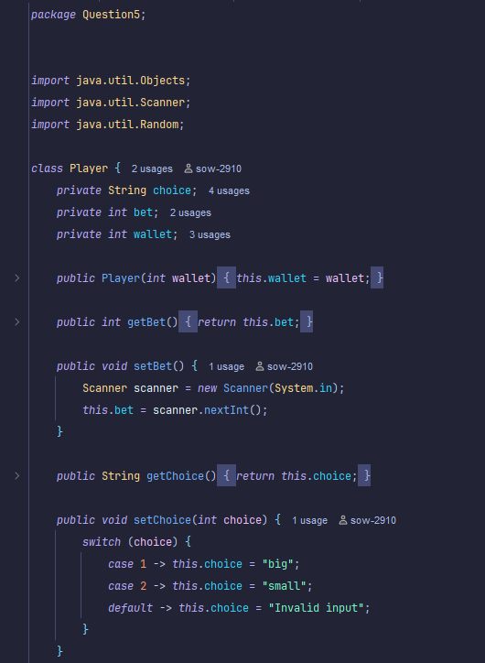
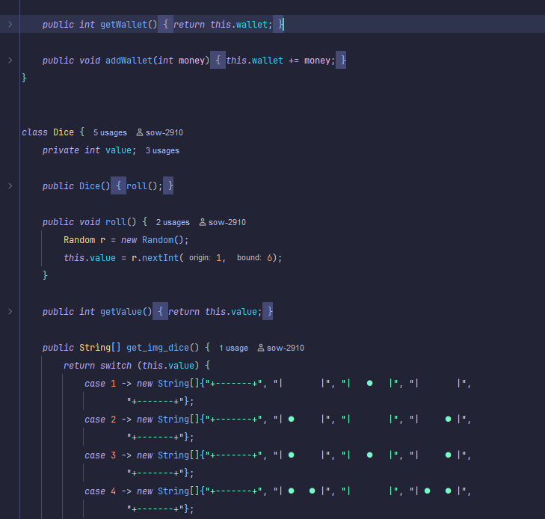
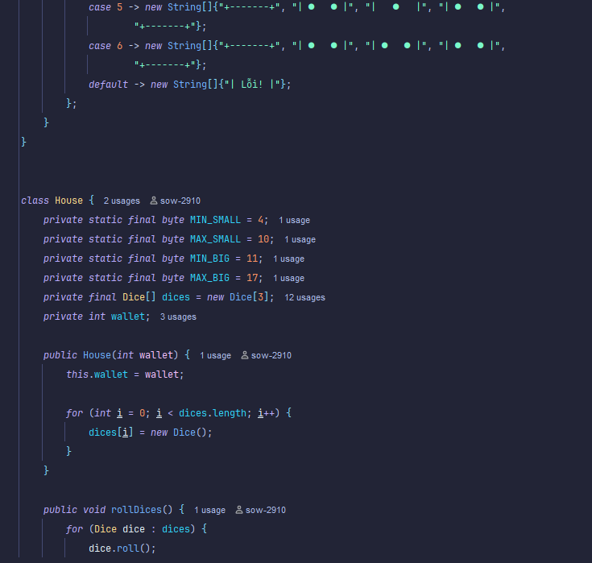
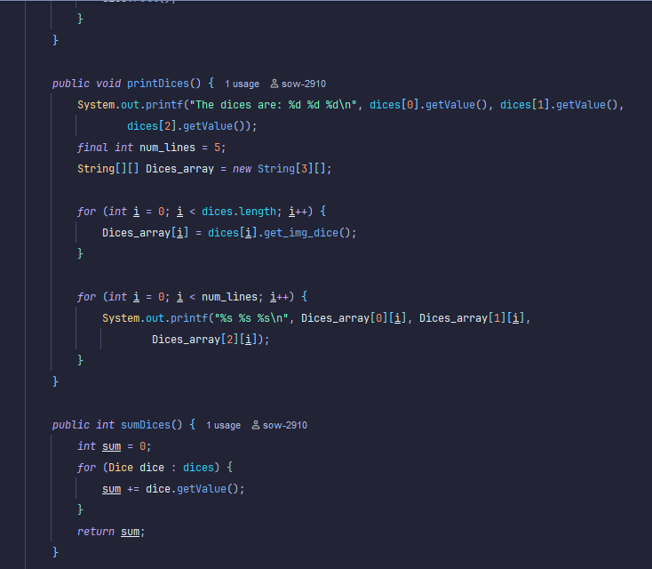
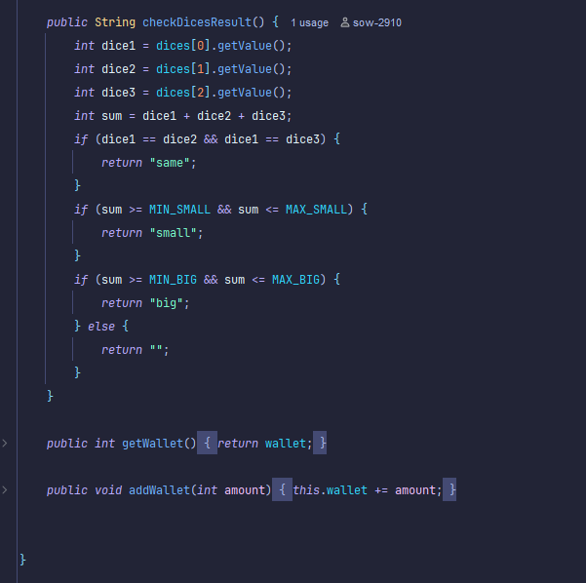
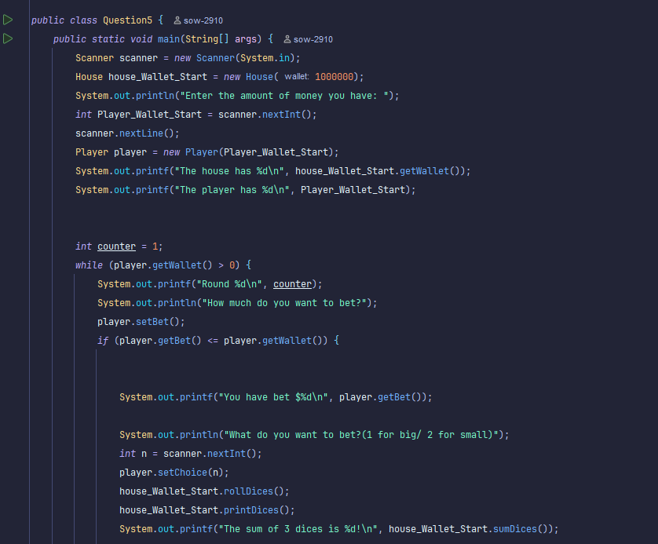
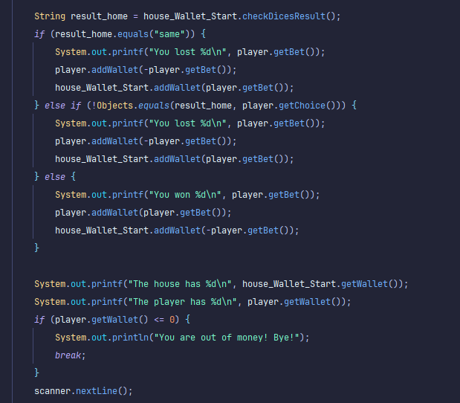
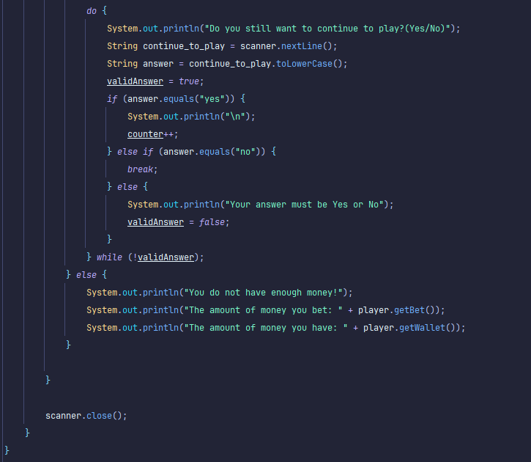
How this code works:
The Player class stores the player's wallet, bet amount, and choice (big or small) and allows the user to set these values through input. The Dice class represents a single dice that can roll a random value from 1 to 6 and display its ASCII image. The House class manages three dices, rolls them, prints their results, and checks whether the total sum is “big,” “small,” or “same. “ In the main method, the program lets the user input their money, place bets, and decide whether to continue playing each round.

