MODULE: PROG209 EVENT DRIVEN PROGRAMMING

ASSIGNMENT TITLE: BASIC INTERACTIVE GUI

1. Introduction
Java Swing is a platform-independent, lightweight Graphical User Interface (GUI) development library built on top of Java’s Abstract Window Toolkit (AWT). It empowers software developers to build interactive, event-driven desktop applications. The primary top-level window container in Swing is the JFrame, which manages OS-level frame operations, system icons, and title decorations. Within this main window, an intermediate container called JPanel is organized to hold user controls such as display labels (JLabel) and interactive command buttons (JButton). Layout control is established dynamically through FlowLayout managers, which position components based on screen dimensions.
The architecture of this application strictly follows Object-Oriented Programming (OOP) paradigms through single inheritance by extending JFrame and directly implementing the ActionListener interface. Instead of relying on anonymous inner classes, the primary SowGUI class serves as its own centralized event handler. When a user interacts with a button component, an ActionEvent object is generated and routed to the actionPerformed method. Depending on the event source (evt.getSource()), the application dynamically modifies component states at runtime—such as altering display text on the JLabel or updating the background color of the main container to yellow (Color (250, 220, 0)) without needing full-window repaints.

2. Figma Wireframe Design

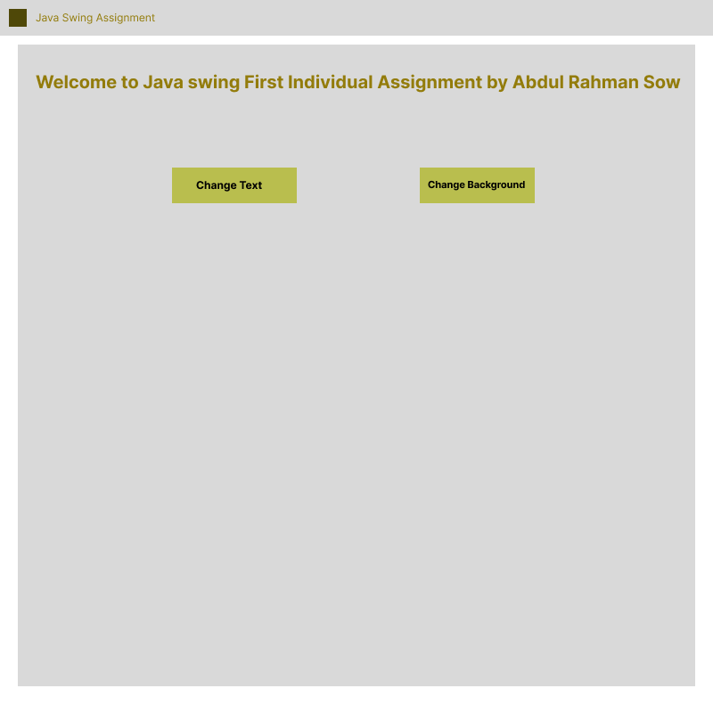

3. Complete Source Code (SowGUI.java)
Java
import java.awt.Color;
import java.awt.Dimension;
import java.awt.FlowLayout;
import java.awt.Font;
import java.awt.event.ActionEvent;
import java.awt.event.ActionListener;
import javax.swing.ImageIcon;
import javax.swing.JButton;
import javax.swing.JFrame;
import javax.swing.JLabel;
import javax.swing.JPanel;
import javax.swing.SwingUtilities;

public class SowGUI extends JFrame implements ActionListener {

// Member components
private final JLabel headerLabel;
private final JButton btnModifyText;
private final JButton btnModifyBg;
private final JPanel mainContainer;

public SowGUI() {
// Window Configuration
super("Java Swing Assignment");
this.setSize(new Dimension(800, 800));
this.setDefaultCloseOperation(JFrame.EXIT_ON_CLOSE);
this.setLocationRelativeTo(null);

// Load Window Icon
loadWindowIcon("asset/Download Tan Leather C...");

// Main Panel Setup
mainContainer = new JPanel();
mainContainer.setLayout(new FlowLayout(FlowLayout.CENTER, 25, 25));
mainContainer.setBackground(new Color(240, 240, 240));

// Primary Header Label
headerLabel = new JLabel("Welcome to Java Swing First Individual Assignment by Sow GUI");
headerLabel.setFont(new Font("Segoe UI", Font.BOLD, 17));
headerLabel.setForeground(new Color(30, 30, 30));

// Control Buttons
btnModifyText = new JButton("Change Text");
btnModifyBg = new JButton("Change Background");

btnModifyText.setFocusable(false);
btnModifyBg.setFocusable(false);

// Register Action Listeners
btnModifyText.addActionListener(this);
btnModifyBg.addActionListener(this);

// Secondary Panel to keep buttons grouped on a lower row
JPanel controlPanel = new JPanel(new FlowLayout(FlowLayout.CENTER, 15, 0));
controlPanel.setOpaque(false);
controlPanel.add(btnModifyText);
controlPanel.add(btnModifyBg);

// Assemble Layout
mainContainer.add(headerLabel);
mainContainer.add(controlPanel);
this.add(mainContainer);
}

// Helper method for icon handling
private void loadWindowIcon(String path) {
try {
ImageIcon windowIcon = new ImageIcon(path);
this.setIconImage(windowIcon.getImage());
} catch (Exception ex) {
System.err.println("Could not load icon file: " + ex.getMessage());
}
}

// Single Event Handler for both buttons
@Override
public void actionPerformed(ActionEvent evt) {
Object source = evt.getSource();

if (source == btnModifyText) {
headerLabel.setText("Text updated! Event Driven Programming in Java Swing.");
} else if (source == btnModifyBg) {
mainContainer.setBackground(new Color(250, 220, 0)); // Yellow
}
}

// Execution Entry Point
public static void main(String[] args) {
SwingUtilities.invokeLater(() -> {
SowGUI application = new SowGUI();
application.setVisible(true);
});
}
}

4. Program Screenshots

Screenshot 1: Application Launch State
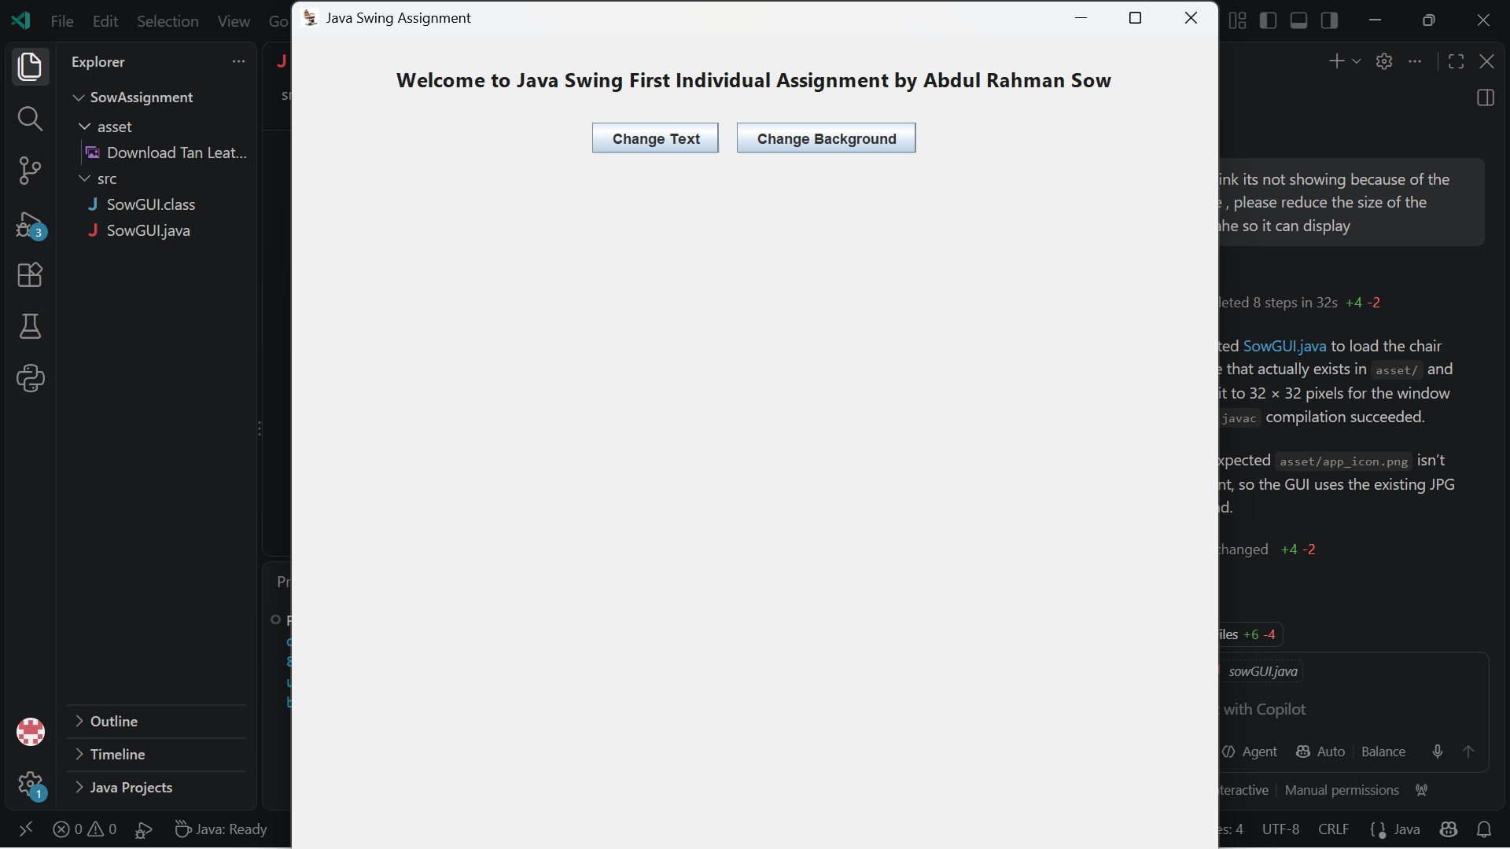

Screenshot 2: Text Modification State
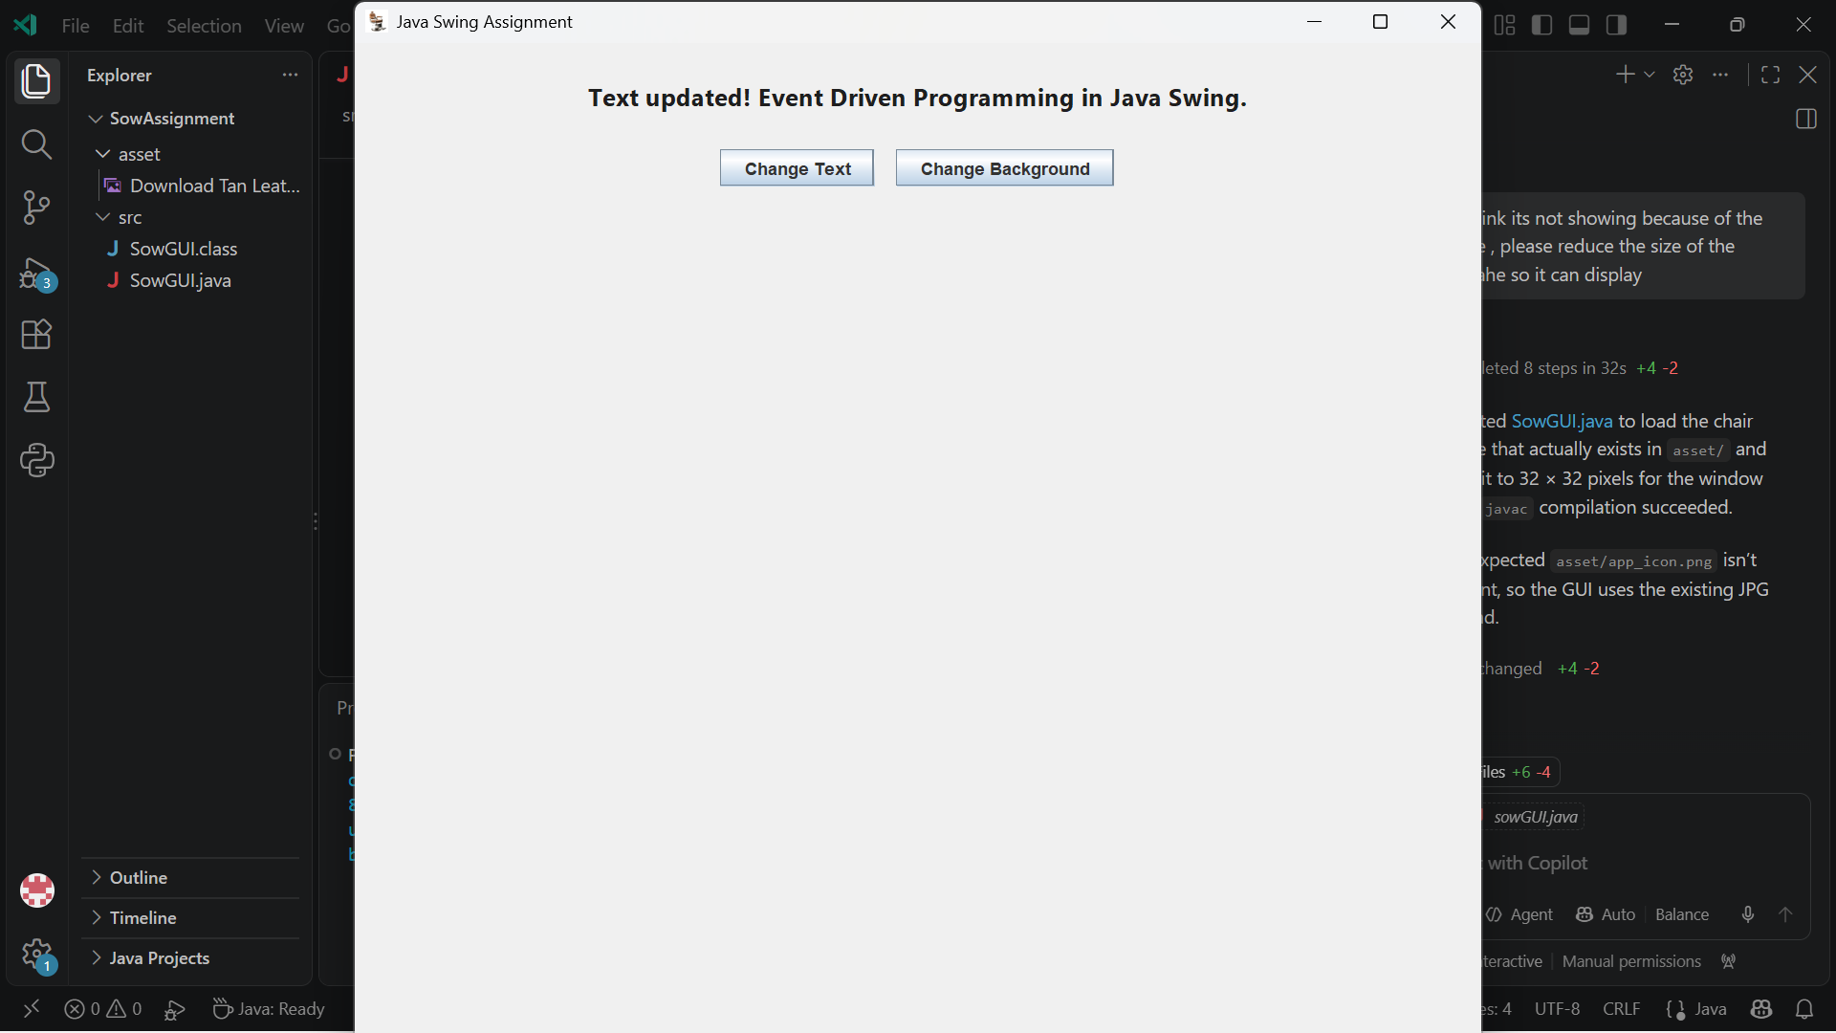

Screenshot 3: Background Color Modification State
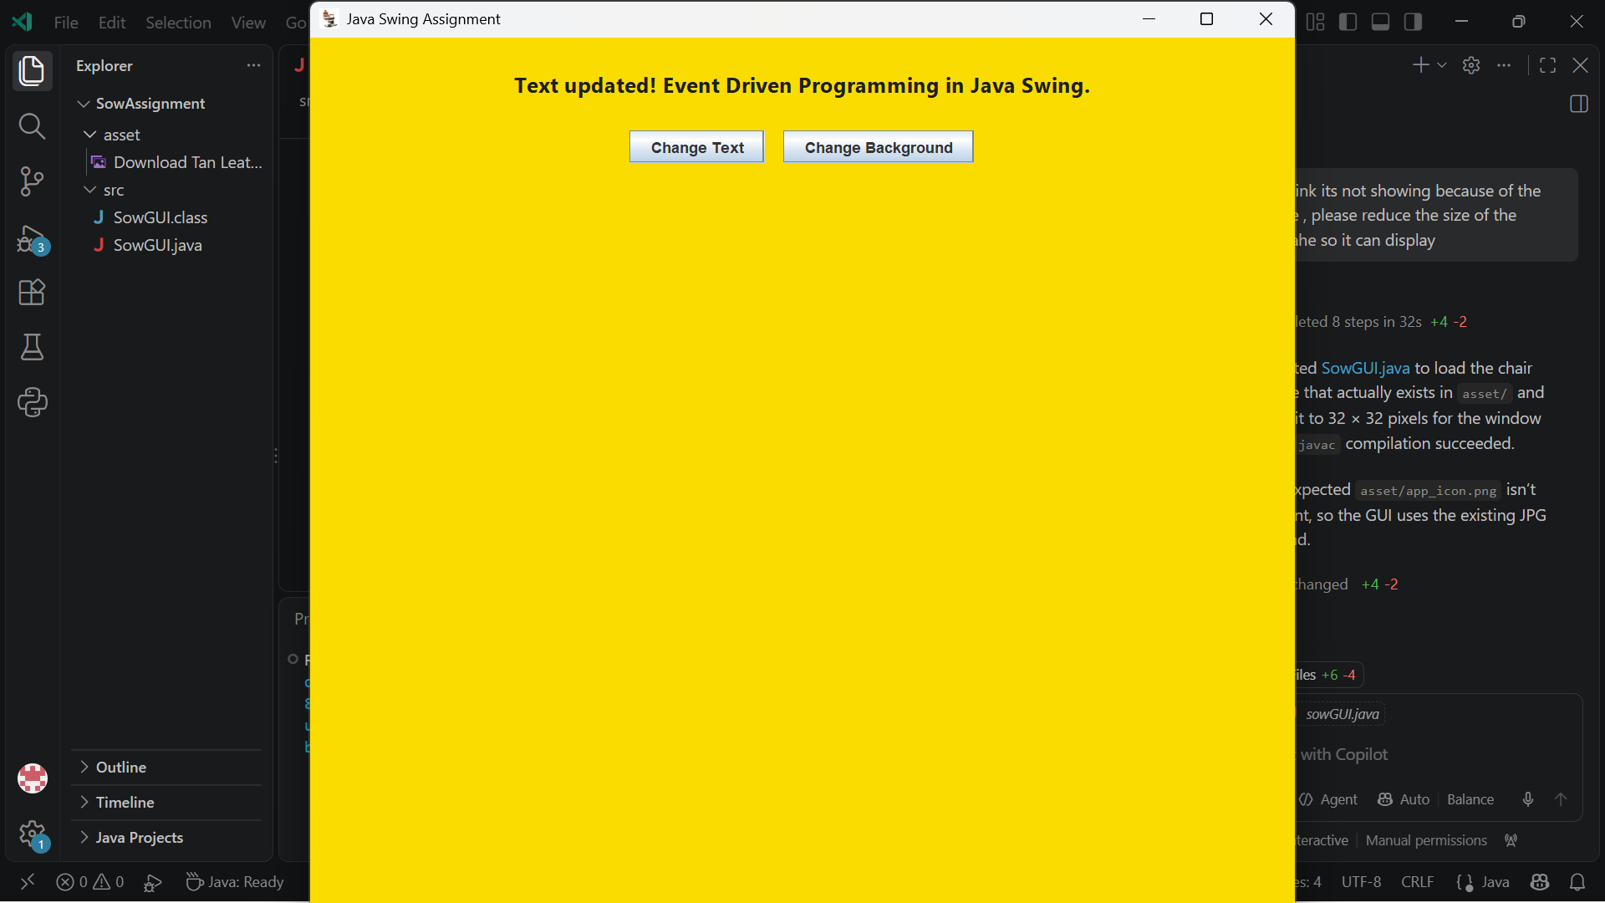

5. GitHub Repository Verification
- GitHub Repository URL: [https://github.com/](https://github.com/)[Your-GitHub-Username]/SowAssignment
PNG
- Collaborator Added: amandus.bcoker@limkokwing.edu.sl
PNG

Collaborator Invitation Screenshot
(Insert a screenshot from your GitHub Repository settings -> Collaborators showing amandus.bcoker@limkokwing.edu.sl added)
PNG
Plaintext
[ PASTE GITHUB COLLABORATOR SCREENSHOT HERE ]

