1. **Dataset create and visualize: Dogs**

**Dataset can be found here:** [dataset_task02](https://drive.google.com/drive/folders/1Mn-4wtsXXTqTjSsf87pAtwIIuJZ2TsZd?usp=drive_link)

**Code for visualization:**

plt.figure(figsize=(15, 6))

for i in range(min(10, len(dog_images))):

img = dog_images[i]

img_rgb = cv2.cvtColor(img, cv2.COLOR_BGR2RGB)

plt.subplot(2, 5, i + 1)

plt.imshow(img_rgb)

plt.axis('off')

plt.title(f'Image {i + 1}')

plt.tight_layout()

plt.show()

**OUTPUT:**

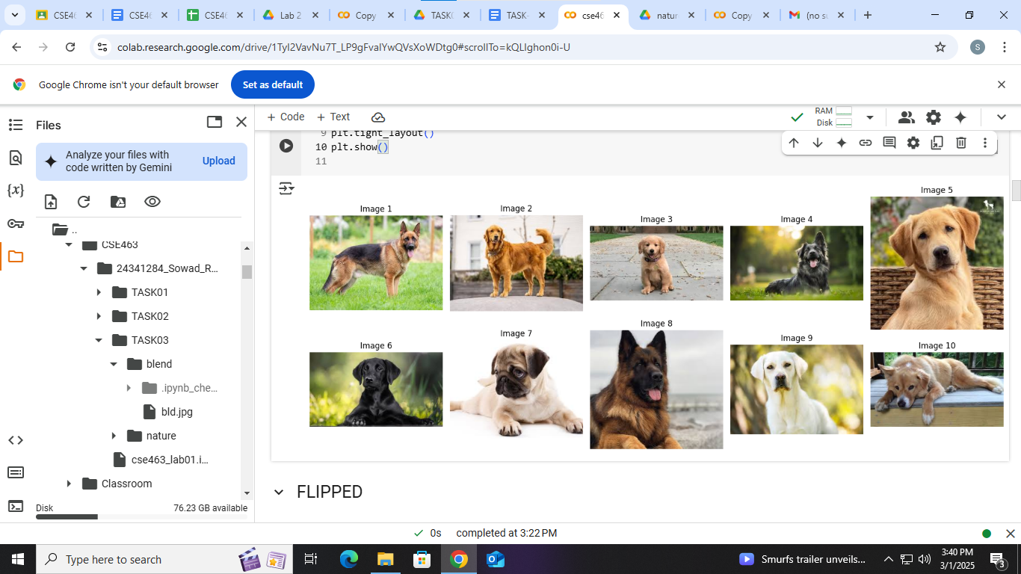

1. Performed 5 different transformations:
2. **Flipped:**

**I applied a flip augmentation technique to increase the dataset size. When models will be trained on this dataset the model generalization will increase as in real world a dog might be in vertical or horizontal position.**

**Flipped Image can be found here:**[**flip**](https://drive.google.com/drive/folders/1-aXflerfasyxGg98TdvfvnPEggCUtjzk?usp=drive_link)

**Code:**

import cv2

import os

from google.colab.patches import cv2_imshow

image_folder = '/content/drive/MyDrive/CSE463/24341284_Sowad_Rahman_LAB01/TASK02/dataset_task02'

flip_folder = '/content/drive/MyDrive/CSE463/24341284_Sowad_Rahman_LAB01/TASK02/flip'

os.makedirs(flip_folder, exist_ok=True)

images = os.listdir(image_folder)

flipped_images = []

for file in images:

if file.endswith(('.jpg')):

img_path = os.path.join(image_folder, file)

img = cv2.imread(img_path)

flipped_image = cv2.flip(img, 0)

flipped_images.append(flipped_image)

flipped_save_path = os.path.join(flip_folder, f"flipped_{file}")

cv2.imwrite(flipped_save_path, flipped_image)

plt.figure(figsize=(15, 6))

for i in range(min(10, len(flipped_images))):

plt.subplot(2, 5, i + 1)

plt.imshow(cv2.cvtColor(flipped_images[i], cv2.COLOR_BGR2RGB))

plt.axis('off')

plt.title(f'Image {i + 1}')

plt.tight_layout()

plt.show()

**OUTPUT:**

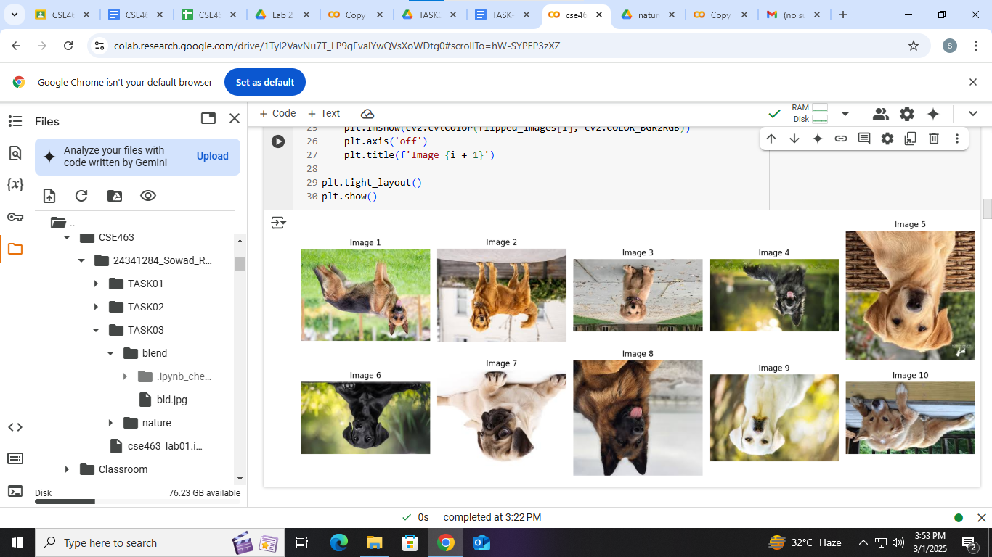

1. **Cropped:**

**I applied a crop augmentation technique to increase the dataset variability. This augmentation technique helps a model to understand the object localization. Suppose only the face of the dog is given.**

**Cropped Image can be found here:**[**crop**](https://drive.google.com/drive/folders/10DAZ3eHX8mdKWo9vEELYSwjb3F4Opexg?usp=drive_link)

**Code:**

import cv2

import os

import matplotlib.pyplot as plt

image_folder = '/content/drive/MyDrive/CSE463/24341284_Sowad_Rahman_LAB01/TASK02/dataset_task02'

crop_folder = '/content/drive/MyDrive/CSE463/24341284_Sowad_Rahman_LAB01/TASK02/crop'

os.makedirs(crop_folder, exist_ok=True)

images = os.listdir(image_folder)

cropped_images = []

for image_file in images:

if image_file.endswith(('.jpg')):

img_path = os.path.join(image_folder, image_file)

img = cv2.imread(img_path)

height, width = img.shape[:2]

print(height,width)

cropped_image = img[50:height-10, 50:width-10]

cropped_images.append(cropped_image)

cropped_save_path = os.path.join(crop_folder, f"cropped_{image_file}")

cv2.imwrite(cropped_save_path, cropped_image)

plt.figure(figsize=(15, 6))

for i in range(min(10, len(cropped_images))):

plt.subplot(2, 5, i + 1)

plt.imshow(cv2.cvtColor(cropped_images[i], cv2.COLOR_BGR2RGB))

plt.axis('off')

plt.title(f'Image {i + 1}')

plt.tight_layout()

plt.show()

**OUTPUT:**



1. **Rotated:**

**I applied a rotation augmentation technique so that the model can generalize. In real life a dog can appear in many angles so I applied rotation techniques so that the model can recognize a dog coming from different angles.**

**Rotated Image can be found here:**[**rotated**](https://drive.google.com/drive/folders/10hr2T5eUHK7O5XBPd7vO1lcEWFuiXCfq?usp=drive_link)

**CODE:**

import cv2

import os

import matplotlib.pyplot as plt

image_folder = '/content/drive/MyDrive/CSE463/24341284_Sowad_Rahman_LAB01/TASK02/dataset_task02'

crop_folder = '/content/drive/MyDrive/CSE463/24341284_Sowad_Rahman_LAB01/TASK02/rotated'

os.makedirs(crop_folder, exist_ok=True)

images = os.listdir(image_folder)

rotated_images_save=[]

for image_file in images:

if image_file.endswith(('.jpg')):

img_path = os.path.join(image_folder, image_file)

img = cv2.imread(img_path)

print(f'Original image shape: {img.shape}')

rows, cols = img.shape[:2]

M = cv2.getRotationMatrix2D((cols / 2, rows / 2), -90, 0.5)

rotated_image = cv2.warpAffine(img, M, (cols, rows))

rotated_images_save.append(rotated_image)

rotated_save_path = os.path.join(crop_folder, f"rotated_{image_file}")

cv2.imwrite(rotated_save_path, rotated_image)

plt.figure(figsize=(15, 6))

for i in range(min(10, len(rotated_images_save))):

plt.subplot(2, 5, i + 1)

plt.imshow(cv2.cvtColor(rotated_images_save[i], cv2.COLOR_BGR2RGB))

plt.axis('off')

plt.title(f'Image {i + 1}')

plt.tight_layout()

plt.show()

**OUTPUT:**

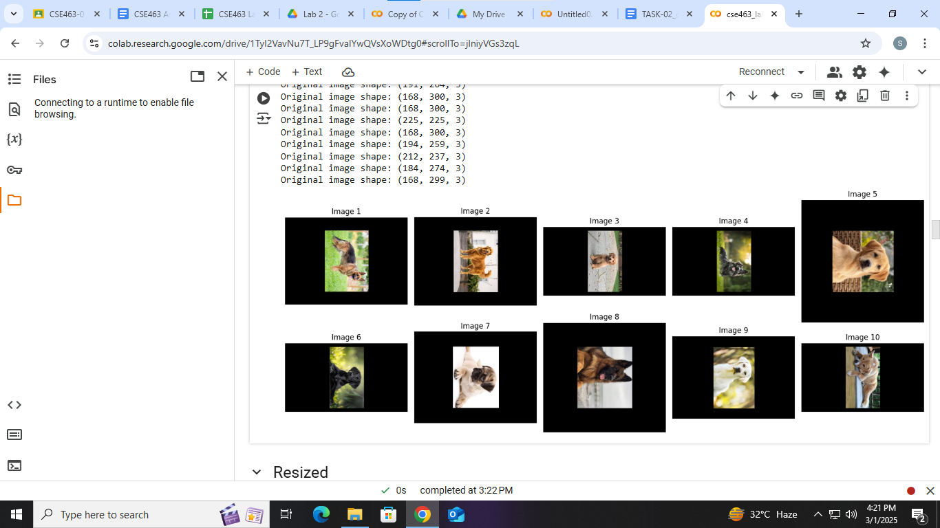

1. **Resized:**

**Because datasize size will increase and variety. The model can generalize more.**

**Resized images can be found here:**[**resized**](https://drive.google.com/drive/folders/11J7qAg3bkrohkoQFjflJj9U-c_p7Z26y?usp=drive_link)

**CODE:** import cv2

import os

import matplotlib.pyplot as plt

image_folder = '/content/drive/MyDrive/CSE463/24341284_Sowad_Rahman_LAB01/TASK02/dataset_task02'

resize_folder = '/content/drive/MyDrive/CSE463/24341284_Sowad_Rahman_LAB01/TASK02/resized'

os.makedirs(resize_folder, exist_ok=True)

images = os.listdir(image_folder)

resized_images = []

for image_file in images:

if image_file.endswith(('.jpg')):

img_path = os.path.join(image_folder, image_file)

img = cv2.imread(img_path)

width = int(img.shape[1] * 0.5)

height = int(img.shape[0] * 0.5)

dim = (width, height)

resized_image = cv2.resize(img, dim, interpolation=cv2.INTER_CUBIC)

resized_images.append(resized_image)

resized_save_path = os.path.join(resize_folder, f"resized_{image_file}")

cv2.imwrite(resized_save_path, resized_image)

plt.figure(figsize=(15, 6))

for i, resized_image in enumerate(resized_images):

plt.subplot(2, 5, i + 1)

plt.imshow(cv2.cvtColor(resized_image, cv2.COLOR_BGR2RGB))

plt.title(f"Resized {i + 1}")

plt.axis('off')

plt.tight_layout()

plt.show()

**OUTPUT:**

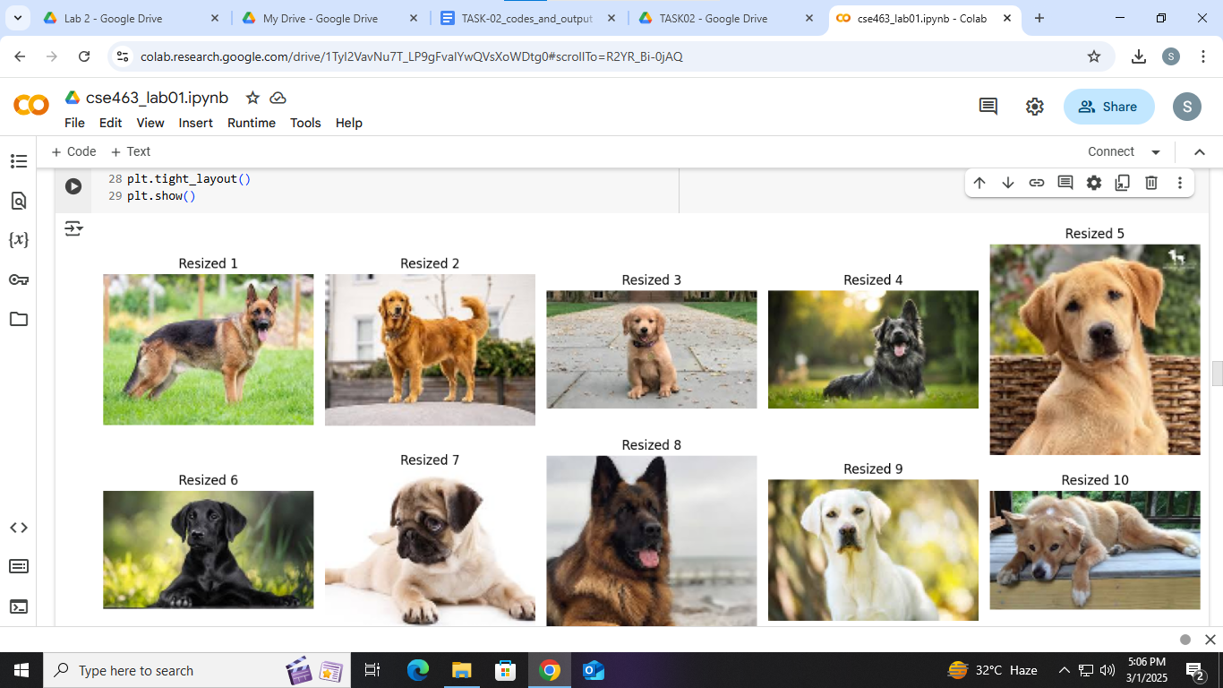

1. **Sheared:**

**I applied sheared augmentation technique so that dataset size and variation can be increased as in real life a dog might be seen from different angles.**

**Sheared images can be found here:**[**sheared**](https://drive.google.com/drive/folders/11oIkU_ekTbb3JIKXw0M1OSKzbTlC33v-?usp=drive_link)

**CODE:**

import cv2

import os

import numpy as np

import matplotlib.pyplot as plt

image_folder = '/content/drive/MyDrive/CSE463/24341284_Sowad_Rahman_LAB01/TASK02/dataset_task02'

sheared_folder = '/content/drive/MyDrive/CSE463/24341284_Sowad_Rahman_LAB01/TASK02/sheared'

os.makedirs(sheared_folder, exist_ok=True)

images = os.listdir(image_folder)

sheared_images = []

for image_file in images:

if image_file.endswith(('.jpg')):

img_path = os.path.join(image_folder, image_file)

img = cv2.imread(img_path)

height, width = img.shape[:2]

shear_x = 0.5

shear_y = 0.0

shear_matrix = np.float32([

[1, shear_x, 0],

[shear_y, 1, 0]

])

sheared_image = cv2.warpAffine(img, shear_matrix, (width + int(shear_x * height), height))

sheared_images.append(sheared_image)

sheared_save_path = os.path.join(sheared_folder, f"sheared_{image_file}")

cv2.imwrite(sheared_save_path, sheared_image)

plt.figure(figsize=(15, 6))

for i, sheared_image in enumerate(sheared_images):

plt.subplot(2, 5, i + 1)

plt.imshow(cv2.cvtColor(sheared_image, cv2.COLOR_BGR2RGB))

plt.title(f"Sheared {i + 1}")

plt.axis('off')

plt.tight_layout()

plt.show()

**OUTPUT:  
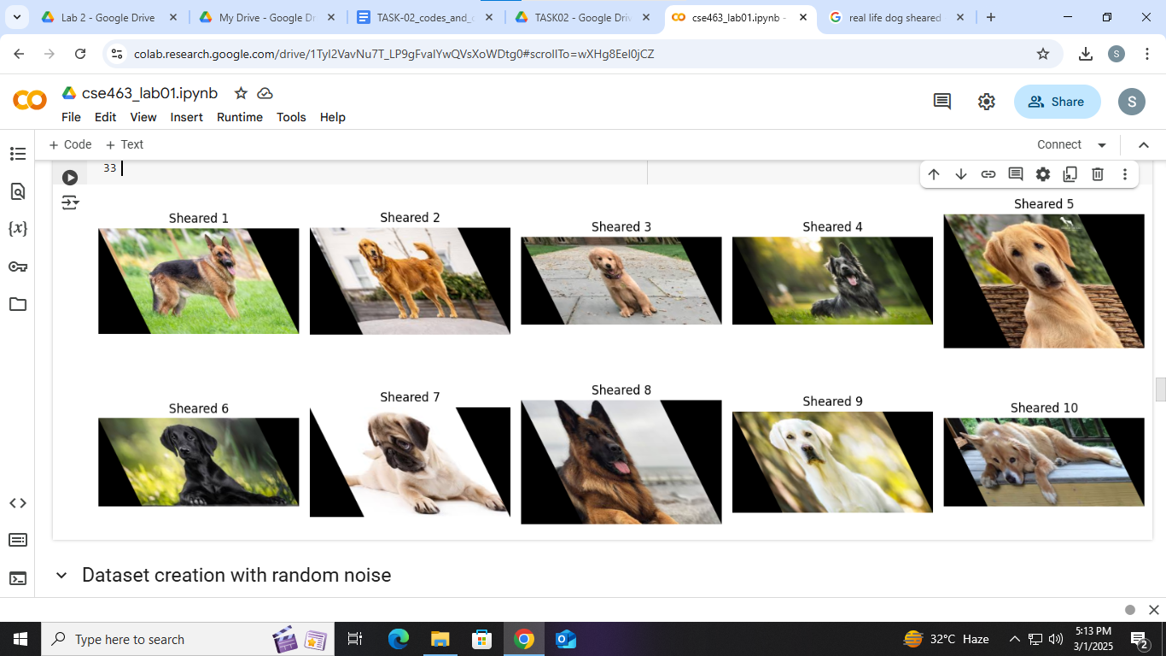**

**3. Dataset creation with random noise:  
Original dataset(before) can be found here:**[**dataset_task02**](https://drive.google.com/drive/folders/1Mn-4wtsXXTqTjSsf87pAtwIIuJZ2TsZd?usp=drive_link)

**After Applying Random Noise dataset can be found here:**[**noisy_images_dataset**](https://drive.google.com/drive/folders/12hBhAnmRwWodQmLKwdYVWJd226mX23rR?usp=drive_link)

**CODE:**

import cv2

import os

import numpy as np

import matplotlib.pyplot as plt

image_folder = '/content/drive/MyDrive/CSE463/24341284_Sowad_Rahman_LAB01/TASK02/dataset_task02'

noisy_folder = '/content/drive/MyDrive/CSE463/24341284_Sowad_Rahman_LAB01/TASK02/noisy_images_dataset'

os.makedirs(noisy_folder, exist_ok=True)

images = os.listdir(image_folder)

prob = 0.10

for image_file in images:

if image_file.endswith(('.jpg')):

img_path = os.path.join(image_folder, image_file)

img = cv2.imread(img_path)

row, col, ch = img.shape

noisy_image = np.copy(img)

num_salt = np.ceil(prob * img.size * 0.5).astype(int)

num_pepper = np.ceil(prob * img.size * 0.5).astype(int)

salt_coords = [np.random.randint(0, i - 1, num_salt) for i in img.shape]

noisy_image[salt_coords[0], salt_coords[1]] = 255

pepper_coords = [np.random.randint(0, i - 1, num_pepper) for i in img.shape]

noisy_image[pepper_coords[0], pepper_coords[1]] = 0

noisy_save_path = os.path.join(noisy_folder, f"noisy_{image_file}")

cv2.imwrite(noisy_save_path, noisy_image)

plt.figure(figsize=(10, 5))

plt.subplot(1, 2, 1)

plt.title("Original Image")

plt.imshow(cv2.cvtColor(img, cv2.COLOR_BGR2RGB))

plt.subplot(1, 2, 2)

plt.title("Image with Salt-and-Pepper Noise")

plt.imshow(cv2.cvtColor(noisy_image, cv2.COLOR_BGR2RGB))

plt.show()

**OUTPUT:**

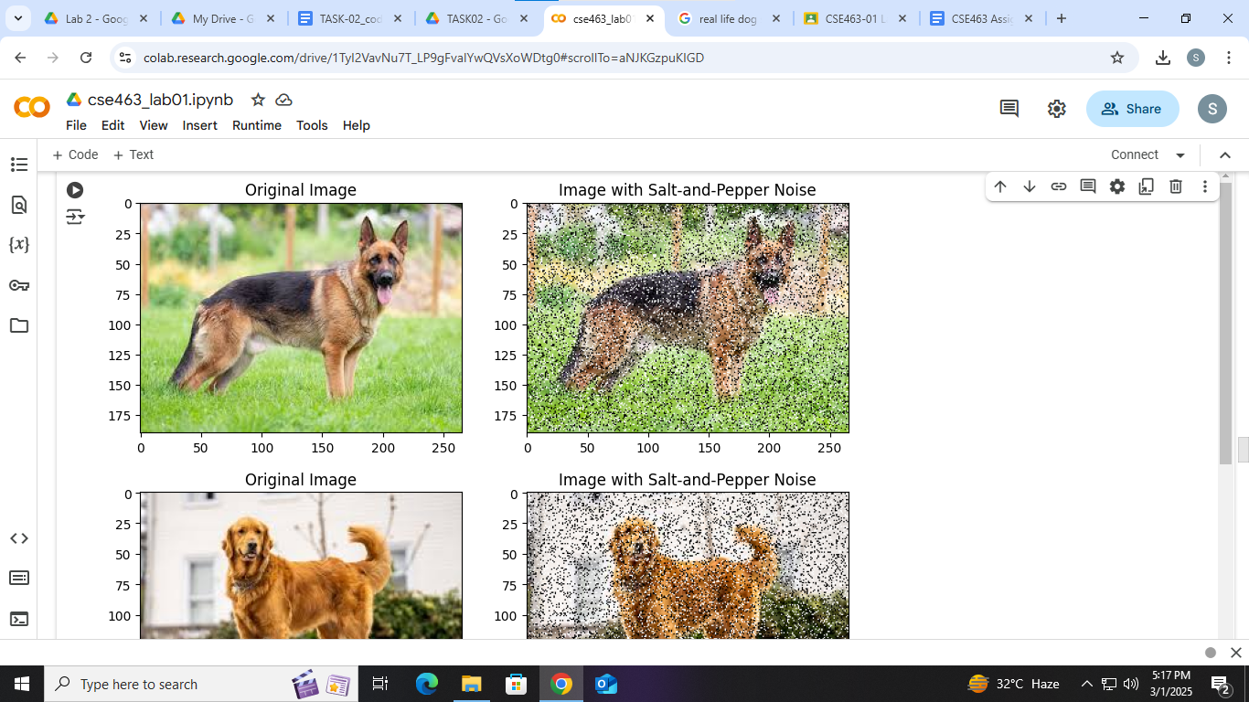

**4. Histogram**

**Plotted Histogram Images can be found here:**[**histograms**](https://drive.google.com/drive/folders/13rcspRLBxPTq0_Hgs0l8e-cSyRvVR0Bv?usp=drive_link)

**CODE:**import cv2

import os

import numpy as np

import matplotlib.pyplot as plt

noisy_folder = '/content/drive/MyDrive/CSE463/24341284_Sowad_Rahman_LAB01/TASK02/noisy_images_dataset'

histogram_folder = '/content/drive/MyDrive/CSE463/24341284_Sowad_Rahman_LAB01/TASK02/histograms/'

os.makedirs(histogram_folder, exist_ok=True)

noisy_images = os.listdir(noisy_folder)

for noisy_image_file in noisy_images:

if noisy_image_file.endswith(('.jpg')):

noisy_image_path = os.path.join(noisy_folder, noisy_image_file)

noisy_image = cv2.imread(noisy_image_path, cv2.IMREAD_COLOR)

flattened_noise = noisy_image.flatten()

plt.figure(figsize=(10, 5))

plt.hist(flattened_noise, bins=256, color='green', alpha=0.7)

plt.title(f"Histogram of Noisy Image: {noisy_image_file}")

plt.xlabel("Pixel Intensity")

plt.ylabel("Frequency")

histogram_save_path = os.path.join(histogram_folder, f"histogram_{noisy_image_file}.png")

plt.savefig(histogram_save_path)

plt.show()

plt.close()

print(f"Histogram saved for {noisy_image_file}")

**OUTPUT:**

