1. **Created a dataset of 5 different images:**

**Dataset of Nature can be found here:**[**nature**](https://drive.google.com/drive/folders/18hpc6f34mvW76kjxum2DUQ9uHdXOfHtX?usp=drive_link)

**Dataset image Visualization:**

**Code:**

import matplotlib.pyplot as plt

import cv2

import os

from google.colab import drive

drive_path = '/content/drive/MyDrive/CSE463/24341284_Sowad_Rahman_LAB01/TASK03/nature'

images = os.listdir(drive_path)

nature_images = []

for image_file in images:

if image_file.endswith(('.jpg')):

img_path = os.path.join(drive_path, image_file)

nature_images.append(cv2.imread(img_path))

plt.figure(figsize=(15, 6))

for i in range(5):

img_rgb = cv2.cvtColor(nature_images[i], cv2.COLOR_BGR2RGB)

plt.subplot(2, 5, i+1)

plt.imshow(img_rgb)

plt.axis('off')

plt.title(f'Image {i+1}')

plt.tight_layout()

plt.show()

**OUTPUT**:

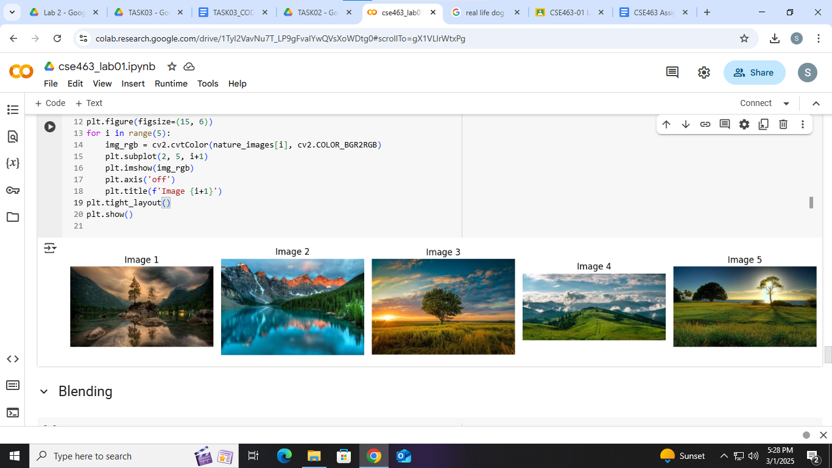

1. **Blending the images:**

**Blended image can be found here:**[**blend**](https://drive.google.com/drive/folders/12tGECpp3KhpZ_Q6eIKIdq7aluPt2DCn5?usp=drive_link)

**CODE:** import numpy as np

import cv2

import os

import matplotlib.pyplot as plt

from google.colab import drive

drive.mount('/content/drive')

img_fol = "/content/drive/MyDrive/CSE463/24341284_Sowad_Rahman_LAB01/TASK03/nature"

out_fol = "/content/drive/MyDrive/CSE463/24341284_Sowad_Rahman_LAB01/TASK03/blend"

os.makedirs(out_fol, exist_ok=True)

img_lst = os.listdir(img_fol)

img_fls = []

for fl in img_lst:

if fl.endswith('.jpg'):

img_fls.append(fl)

img_fls.sort()

w, h = 225, 225

dim = (w, h)

bld_img = None

idx = 0

for fl in img_fls:

img_pth = os.path.join(img_fol, fl)

img = cv2.imread(img_pth, cv2.IMREAD_COLOR)

img = cv2.resize(img, dim, interpolation=cv2.INTER_AREA)

img = img.astype(np.float32)

if bld_img is None:

bld_img = np.zeros_like(img, dtype=np.float32)

idx += 1

alp = 1.0 / idx

bld_img = bld_img * (1 - alp) + img * alp

bld_img = bld_img.astype(np.uint8)

bld_pth = os.path.join(out_fol, "bld.jpg")

cv2.imwrite(bld_pth, bld_img)

bld_img = cv2.cvtColor(bld_img, cv2.COLOR_BGR2RGB)

plt.imshow(bld_img)

plt.axis("off")

plt.show()

**OUTPUT:  
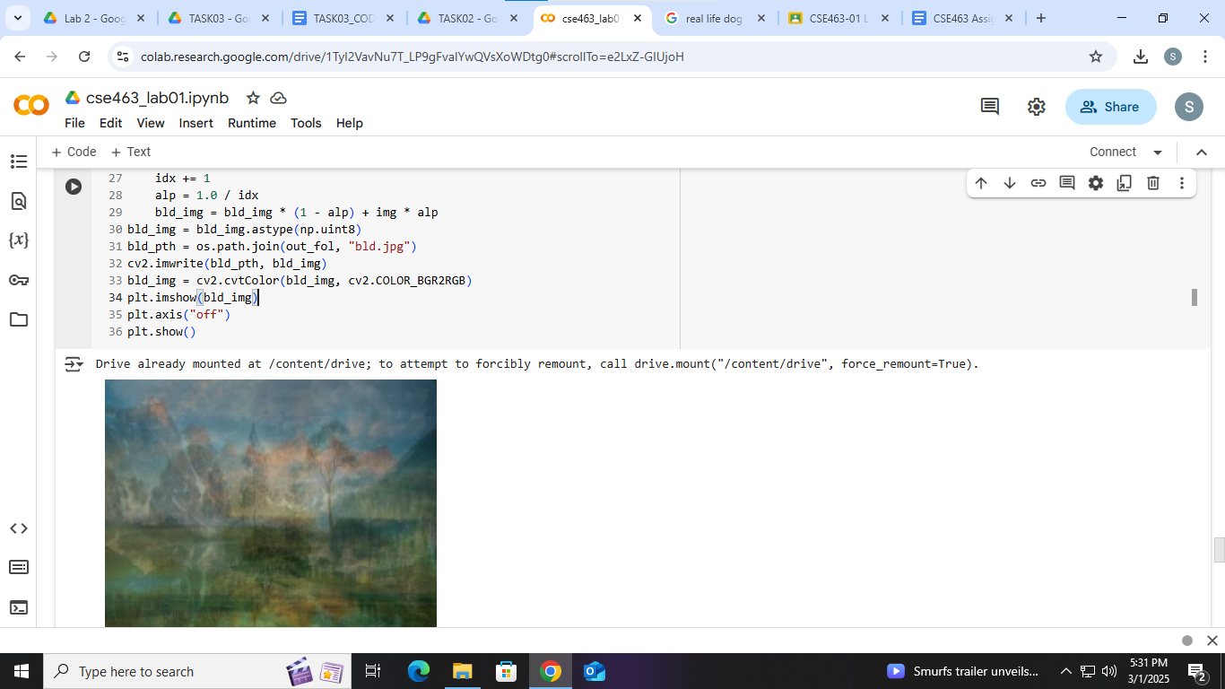**

**3 Gaussian Noise added where mean=0 and std=25**

**Code:**

mean = 0

std = 25

bld_img= cv2.imread("/content/drive/MyDrive/CSE463/24341284_Sowad_Rahman_LAB01/TASK03/blend/bld.jpg")

noise = np.random.normal(mean, std, bld_img.shape).astype(np.float32)

noisy_img = bld_img.astype(np.float32) + noise

noisy_img = np.clip(noisy_img, 0, 255).astype(np.uint8)

plt.figure(figsize=(10, 5))

plt.subplot(1, 2, 1)

plt.imshow(bld_img)

plt.axis("off")

plt.title("Original Blended Image")

plt.subplot(1, 2, 2)

plt.imshow(noisy_img)

plt.axis("off")

plt.title("Noisy Image")

plt.show()

**OUTPUT:  
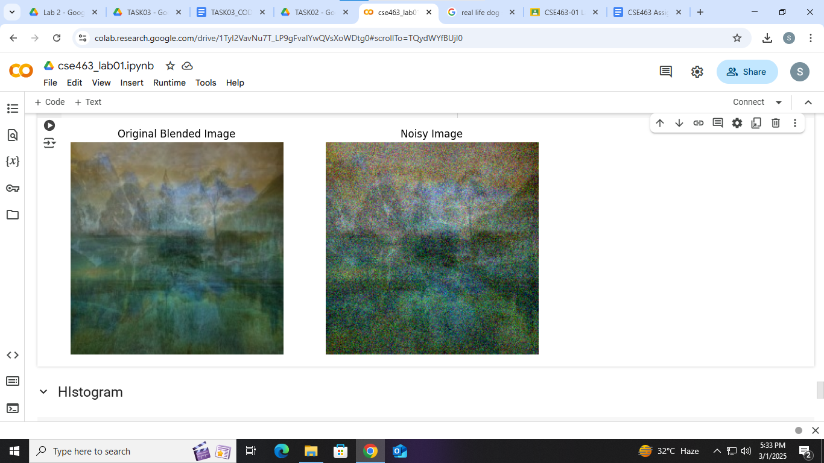**

**4. Histogram of the Noisy blended image:**

**CODE:**plt.figure(figsize=(10, 5))

plt.hist(noisy_img.ravel(), bins=256, range=[0, 256], color='g')

plt.xlabel("Pixel Value")

plt.ylabel("Frequency")

plt.title("Histogram of Noisy Image")

plt.show()

**OUTPUT:**

