GROUNDED & FRUITFUL

Product Flow, UI Experience
and Backend Delivery Contract
  - A production baseline for replacing generic pages with authorized, data-backed journeys

Fundamental principle
Reward consistent participation in the process of growth—not perfection, ratings, correctness, grades, writing quality, spiritual performance, or comparative child ranking.

Status: Proposed authoritative product/engineering baseline
Owners: Product, Design, Frontend, Backend, Privacy/Safeguarding, Operations

1. Purpose and authority
This document converts the supplied functional overview into a testable product journey and a shared contract between the Angular frontend and the Node/Express/Firebase backend. It defines what each role should see, what data must come from the server, which actions are permitted, how states transition, and when a feature must remain unavailable.
Authority rule
The diagram is a vision artifact. This document becomes authoritative only after product, privacy/safeguarding, and engineering approval. Existing executable code and published OpenAPI remain the operational truth until rollout is completed.

1.1 What “working” means
- A route is not complete merely because it renders. It must have a dedicated experience, a validated API contract, relationship-aware authorization, honest loading/empty/error states, and automated tests.
- A backend feature is not complete merely because a collection, type, schema, or repository method exists. The route, service policy, persistence boundary, indexes, audit, OpenAPI, tests, staging evidence, and rollback path must exist.
- Generic “feature unavailable” pages are acceptable only for deliberately disabled, unpublished contracts. They must never replace an implemented workflow or conceal integration failures.
- No production page may show fabricated people, totals, points, progress, statuses, activities, or successful controls.

1.2 Current experience gap
Observed symptom | Likely cause | Required correction
Pages show generic unavailable content | Route points to a shared placeholder or frontend contract is disabled | Give each approved journey a dedicated lazy component and connect it only after its backend contract is published.
Signed-in role sees 403 responses | Session roles, memberships, participant mapping, or tenant context disagree | Resolve canonical roles and active memberships server-side; provision required organization, membership, relationship, and participant records.
UI renders but contains no real flow | Vision boxes were treated as labels instead of stateful workflows | Implement explicit step/state models, drafts, completion commands, retry behavior, and return navigation.
Data exists but is not visible | Payload fields, envelope, URL, cursor, or status enums differ | Generate and validate contracts from OpenAPI; add drift tests between mounted routes and documentation.

2. Product principles
Principle | Non-negotiable behavior
Participation, not performance | Points depend only on eligible completion/participation. A character rating of 0 and 10 earns the same completion award.
Private by default | Feelings, check-in notes, gratitude text, assessments, grades, private reflections, and incident content never appear in team or leaderboard views.
Server authority | The backend owns roles, tenant scope, relationships, lifecycle state, point rules, totals, recognition eligibility, and calculation timestamps.
Honest UI | Loading, empty, unavailable, forbidden, conflict, throttled, dependency failure, and stale states are visibly distinct.
No child ranking | Leaderboards show composite team totals only. No child rank, child point comparison, or private contribution breakdown is exposed to other children.
Historical integrity | Finalized submissions and ledger entries are retained. Corrections append versioned updates or reversals; they do not rewrite history.
Least privilege | Every request repeats token, role, active membership, organization, relationship, status, and resource checks.

3. Roles and access boundaries
Role | Primary experience | Permitted scope | Explicit exclusions
Child | Own growth journey | Own check-in, gratitude, character, Bible, reading, project, points history, awards, composite team progress | Other children’s private data; point rules; approvals; assignments; grades-based rewards
Parent / guardian | Linked-child support | Linked children, approved summaries, observations, family activities, support requests, reports, consent | Unlinked children; private answers unless explicitly approved; point awarding; observation approval
Mentor | Assigned-team guidance | Assigned teams, participation summaries, project guidance, encouragement, approved notes | Private emotions/notes; unrelated teams; role assignment; child impersonation
Authorized adult / observer | Positive observations | Approved participant scope and observation submission only | Dashboards or records beyond grant; moderation; point award; private responses
Admin | Program operations | Scoped users, teams, quarters, content, point-rule configuration, surveys, reports | Cross-tenant access; silent history edits; unrestricted incident content
Super admin | Tenant administration | Organization-level membership, configuration, lifecycle and operational controls | Platform-global access unless separately designed; child impersonation; unaudited overrides

Terminology decision required
The diagram says “authorized adult,” while the current application uses “observer.” Approve whether these are the same role, separate roles, or a grant attached to a membership. Do not silently rename production claims.

4. End-to-end product journey
Stage | Actor | Frontend outcome | Backend responsibility | Exit condition
1. Organization setup | Super admin | Create/configure organization and initial admins | Create tenant, scoped membership, audit event and settings | Active organization with at least one administrator
2. Parent onboarding | Parent / admin | Account, membership, consent and family setup | Verify identity, membership, consent version and status | Active parent membership and accepted required consent
3. Child enrollment | Parent / admin | Create/link child and issue safe login details | Create participant, link, child membership, Firebase identity and Argon2 PIN credential | Active participant and relationship; one-time credential delivery
4. Team assignment | Admin | Assign 3–5 participants to growth team | Validate tenant, capacity, active dates and assignment invariants | One active team assignment per program policy
5. Quarter setup | Admin | Select dates, timezone, five qualities, goals and content | Validate lifecycle and prevent overlapping active quarters | Quarter transitions to open
6. Daily child flow | Child | Complete heart/mind, gratitude, character and Bible steps | Private drafts, atomic completion commands and server-calculated participation awards | Daily completion state and refreshed dashboard
7. Extended growth | Child/parent/mentor | Reading, project, family, support and approved activities | Eligibility, source records, relationship scope and idempotent award transactions | Source lifecycle reaches eligible completion
8. Observation | Parent / observer | Submit constructive positive observation | Moderation queue, audit, optional approved bonus award | Approved/rejected with author-visible status
9. Quarter close | Admin/system | Final totals, reports and recognition | Lock submissions, reconcile ledger, snapshot results and issue awards | Verified closed quarter and recognition cycle

5. Navigation and page ownership
Every enabled navigation item must map to a dedicated experience. A menu item must be hidden or visibly disabled when its contract is not enabled; it must not navigate to a generic page that resembles a finished feature.
Area | Route / page | Primary information | Primary actions | Required server source
Child | /child/today | Quarter/week, completion steps, own contribution, composite team progress, calculatedAt | Resume or complete today’s flow | GET /child/today
Child | /child/character | Five active cycle qualities and draft/final status | Save draft; submit all responses once | GET /child/character; PUT draft; POST complete
Child | /child/bible | Assigned activity, content/media and response status | Save/submit supported response type | GET /child/bible; POST response
Child | /child/reading | Quarter book, weekly assignment and response history | Submit weekly reflection/progress | GET /child/reading; POST response
Child | /child/project | Own projects, state, milestones, guidance and updates | Create, edit, transition, add milestone/update | /child/projects...
Child | /child/team | Composite team goal and progress | View only; encouragement if approved | GET /child/team
Parent | /parent/children | Linked-child summaries and honest empty state | Search/filter; open authorized child | GET /parent/children
Parent | /parent/observations | Own submissions and moderation status | Submit positive observation | GET/POST /parent/observations
Mentor | /mentor/teams | Assigned teams and participation needs | Open team; add approved guidance | GET /mentor/teams
Observer | /observer/observations | Permitted observation subjects and own submissions | Submit observation only | Observer observation contract
Admin | /admin/* | Scoped operational resources | Validated lifecycle commands | Versioned admin contracts

6. Core daily child check-in
Privacy boundary
Heart & mind, gratitude, character ratings/reflections, and Bible responses are private source records. Team and leaderboard APIs may expose only approved aggregate/composite progress.

6.1 Step model
Step | UI requirement | Persistence | Completion rule | Points rule
Heart & mind | Accessible feeling selection plus optional bounded note; unanswered is distinct from lowest value | Private dailyCheckins draft | Required fields pass validation | Completion only; content never affects amount
Gratitude | Private response with save/retry and history | Private gratitudeEntries record | Non-empty bounded response where required | Completion only
Character | Five server-selected qualities; typed controls; rating 0 remains a valid answer | One character assessment command with five responses | All required qualities answered exactly once | Same amount for rating 0 or 10
Daily Bible | Content/media plus reflection, memory verse, true/false or multiple choice | Activity response linked to assigned activity | Supported response validates and is submitted | Correctness never affects participation award

6.2 Frontend state machine
- initializing → loading: restore Firebase auth, refresh token if required, then request the server session and daily summary.
- loading → ready: render server data and completion state. Never populate defaults that look like answers.
- ready → saving-draft: disable only the affected action; preserve entered data; announce progress accessibly.
- saving-draft → saved or recoverable-error: retain the draft locally in form state, not persistent browser storage containing child private text.
- ready/saved → submitting: attach one idempotency key to the logical command and reuse it only for exact retries.
- submitting → completed: replace local state with the server response and refresh server-owned totals.
- submitting → conflict: reload the authoritative record and explain whether it was already finalized or changed elsewhere.
- any authenticated request → unauthorized/session-error: distinguish missing role/membership from an unreachable session service.

6.3 Daily completion transaction
A source completion and its participation award must commit atomically. The transaction validates ownership, active membership, organization, quarter, assignment, source eligibility, point rule, idempotency ownership, and current lifecycle state before creating the completion and immutable ledger entry and incrementing aggregates.

7. Extended journeys
Journey | Minimum complete experience | Privacy / integrity rule
Character observations | Subject selector limited by active grant; constructive description; date; moderation status; author history | Submission never directly awards points. Approval may trigger one auditable bonus transaction.
Family connection | Active activity, instructions, linked child, deterministic completion and history | Family responses remain family-scoped; participation award is server-selected.
Reading | Quarter book, media, weekly assignment, text/audio/video response where approved, history | Progress/completion can award participation; reading correctness and quality cannot.
Personal project | Idea → goal → plan → action → progress → reflection → completion; milestones and mentor guidance | Transitions are validated; evidence visibility is explicit; awards attach only to eligible milestones/completion.
Academic support | Request category, safe description, status and authorized follow-up | Grades/test outcomes do not affect points; no incident content in ordinary requests.
Special activities | Admin-defined eligibility, dates, audience, completion evidence and optional approval | No generic endpoint may accept arbitrary source IDs or point amounts.
Surveys | Targeted pre/program/post surveys with privacy notices and completion status | Responses are private; reporting uses approved aggregation thresholds.
Recognition | Backend-owned award criteria, issuance history and quarter ceremony state | Awards are deterministic and auditable; no manual silent edits.

8. Dashboard contracts
Dashboard | Must show | Must not show
Child | Own points/history, daily status, reading/project/family status, recognition, own contribution, composite team goal progress, calculatedAt | Other children’s contributions, ratings, private responses or rank
Parent | Linked children, participation overview, selected qualities, submitted observations, family/support status, reports/notifications | Unlinked children, private team members, unauthorized child answers
Mentor | Assigned teams, composite progress, participation status, approved reading/project summary, encouragement needs | Private emotions, gratitude, ratings, grades, unrelated teams
Admin | Scoped users/memberships, teams, quarters, content, point rules, surveys, reports, awards and audit summaries | Cross-tenant records, secrets, child PIN hashes, unrestricted incident content

8.1 Dashboard response rules
- Every calculated response includes `calculatedAt` in ISO 8601 UTC and the source quarter/week identifiers.
- Empty collections return empty arrays and zero-valued aggregates only when zero is mathematically established; missing configuration is not converted into zero.
- The backend owns totals, progress percentages, recognition status, team composites and date boundaries using the organization IANA timezone.
- Frontend cards map to named response fields. Unknown/missing required fields are treated as contract errors—not replaced with generic copy.
- Dashboard endpoints are summaries, not authorization shortcuts. Detail endpoints repeat all scope checks.

9. API contract baseline
All routes are relative to `/api/v1`, use Firebase bearer authentication unless explicitly public, and preserve the existing `{ data: ... }` / `{ error: ... }` envelope. Exact payload schemas belong in OpenAPI and generated frontend types.
Domain | Representative endpoints | Command safeguards
Session | GET/POST /auth/session; POST /auth/child-login | Revocation-aware token verification; canonical membership resolution; no-store; generic child-login failures
Onboarding | Organizations, memberships, participants, parent links, teams, consent | Least privilege; tenant checks; optimistic concurrency; immutable audit
Child daily | GET /child/today; daily draft/complete; gratitude history | Private records; local-date uniqueness; atomic eligible completion/award
Character/Bible | GET active content; draft/complete response commands | Server-selected content; exact required set; correctness/rating excluded from points
Reading/project | Assignments/responses; projects/milestones/updates | Ownership; lifecycle transitions; idempotency; bounded media metadata
Parent | Dashboard, children, observations, family, support, reports | Active parentChildLink and organization match on every child-specific request
Mentor/observer | Assigned teams, guidance, observation grants | Active dated assignment/grant; minimum data; revocation takes immediate effect
Admin | Scoped CRUD and lifecycle commands | Admin vs super-admin boundary; version checks; audit; final-admin protection
Points/reports | History, aggregates, awards, reconciliation, exports | Immutable ledger; snapshots; asynchronous exports; expiry and download audit

9.1 Error contract
Status | Code family | Frontend behavior
401 | UNAUTHENTICATED / TOKEN_REVOKED | Clear session safely and return to login with application-local returnUrl.
403 | FORBIDDEN / RELATIONSHIP_REQUIRED | Show access denial; do not retry or redirect to role-required unless session truly lacks canonical role.
404 | NOT_FOUND | Show scoped not-found state without revealing whether an unrelated record exists.
409 | CONFLICT / VERSION_CONFLICT / IDEMPOTENCY_CONFLICT | Reload authoritative state; exact retries remain safe.
422 | VALIDATION_FAILED / DOMAIN_STATE_INVALID | Bind field/domain errors without discarding entered form state.
429 | RATE_LIMITED | Show retry guidance and honor Retry-After.
5xx | INTERNAL / DEPENDENCY_UNAVAILABLE | Show recoverable service state with requestId; never present as feature unavailable.

10. Firestore ownership model
Record family | Authoritative owner | Key invariants
organizations / memberships | Server/admin services | Active tenant and canonical scoped roles; no public membership writes
participants / parentChildLinks / teamMembers | Server onboarding/assignment services | Organization consistency, active dates/status, one approved identity mapping
quarters / content libraries | Scoped admin lifecycle services | No overlapping active quarter; five cycle qualities; immutable finalized configuration snapshot
private child responses | Child workflow services | Owner/tenant/local date/source uniqueness; private by default; finalization retained
observations / support | Relationship-aware services | Server-set author/subject/status; moderation/lifecycle audit
pointLedger / aggregates | Point engine only | Append-only ledger; rule snapshot; idempotency; organization/quarter/team/participant scope
consents / auditLogs | Dedicated restricted services | Versioned acceptance/withdrawal and immutable redacted audit evidence
childCredentials | Child login service only | HMAC lookup ID, Argon2id PIN hash, lockout state; never browser-readable

11. Points engine contract
Immutable invariant
Clients never submit a point amount. They submit an eligible source completion. The server selects a currently effective rule and snapshots the rule identity, version, amount and evaluation facts into an append-only ledger entry.

11.1 Eligible participation sources
- Daily check-in completion
- Gratitude completion
- Character assessment completion
- Bible activity completion
- Family activity completion
- Reading participation
- Project milestone/completion
- Academic session participation
- Approved observation bonus
- Explicit administrator adjustment/reversal with reason and original-entry linkage

11.2 Prohibited point inputs
- Mood or emotion
- Character rating value
- Quiz correctness
- Grade or test result
- Reading level or speed
- Writing/reflection quality
- Spiritual performance
- Child rank
- Client-provided point amount or approval status

11.3 Reconciliation
Rebuild tooling scans immutable ledger entries into a new aggregate generation, verifies participant/team/quarter totals, and atomically activates the new generation. It supports dry-run, bounded checkpoints, variance reports, repair audit events and rollback. It never mutates ledger history.

12. Quarter lifecycle
State | Allowed operations | Locking rule
draft | Configure dates, timezone, qualities, content and goals | Not visible to children
scheduled | Preview and validate readiness | Material changes require version bump and audit
open | Normal participation and source completion | Configuration fields affecting awards are snapshotted/versioned
checkpoint | Continue participation; run progress review | No silent rule changes
closed | Stop new ordinary completion; reconcile totals | Submissions locked except explicit correction workflow
recognition | Issue deterministic awards and publish approved results | Totals must reference verified reconciliation generation
archived | Read-only historical access under retention policy | No mutation; exports remain scoped and audited

Diagram mismatch to resolve
The image describes a 12-week quarter and a five-quality 8-week cycle. Product must define whether qualities remain active through weeks 9–12, whether a second cycle starts, and which date governs final assessment. Code must not guess.

13. Security, privacy and safeguarding
Control | Production requirement
Authentication | Firebase token verification with revocation checks; child custom tokens issued only after secure credential verification.
Authorization | Role, active membership, tenant, relationship/grant, resource and status checks at service boundary.
Consent | Versioned guardian consent, withdrawal behavior, age policy and participation blocking defined before launch.
Data minimization | Return only fields necessary for the role and page. Free text is exempted from indexing where appropriate.
Safeguarding | Incident content uses a separately reviewed restricted boundary, access audit and escalation policy—not ordinary observations.
Audit | Privileged/lifecycle actions create immutable, redacted audit events with actor, target, organization, requestId and server time.
Retention/deletion | Approved schedules, legal holds, export, deletion evidence and recovery procedure precede automated deletion.
Rate limits/App Check | Shared limiter before horizontal scale; App Check staged in monitor mode before enforcement.

14. Frontend implementation standard
- Angular standalone lazy components with OnPush change detection and typed reactive forms where data entry is required.
- Signals for local view state; RxJS for cancellation, debouncing, request composition and streams. Do not create unions of incompatible observable response types.
- Central API client unwraps envelopes, preserves request IDs, attaches Firebase bearer tokens, and maps known errors without hiding unknown failures.
- No deployed hostname in components. All API addresses come from validated environment configuration.
- Every page defines skeleton/loading, ready, empty, validation, conflict, forbidden, throttled, dependency error and retry states as applicable.
- Responsive shell includes keyboard-accessible hamburger/drawer, focus management, escape-to-close, backdrop, horizontal toolbar, profile menu and logout.
- Do not persist private child response text in localStorage/sessionStorage. Preserve unsent form state in memory and warn before destructive navigation when appropriate.
- Accessibility target: WCAG 2.2 AA, logical headings, labels/instructions, announced errors/status, visible focus, touch targets and non-color status cues.

15. Backend implementation standard
- Route → controller → service/domain policy → repository boundaries. Controllers do not contain authorization or Firestore business logic.
- Zod validates HTTP inputs and Firestore records at runtime; no unchecked casts at persistence boundaries.
- Queries are tenant-scoped, bounded, deterministically ordered and cursor-paginated. Required indexes are committed and tested.
- Dependent writes use Firestore transactions. Commands are idempotent where client retry is expected.
- Structured logs are redacted and include requestId, actor ID, route, status and safe code; no tokens, credentials, secrets or private response bodies.
- OpenAPI documents every mounted route and fails CI on drift. Existing envelopes remain compatible.
- Unit, API, emulator, rules, cross-tenant, concurrency and rollback tests run in CI without `--passWithNoTests`.
- Migrations are additive, dry-runnable, checkpointed, bounded, verifiable and reversible through compatibility flags.

16. Delivery plan
Increment | Scope | Enablement gate
0. Contract and identity | Current route inventory, OpenAPI, canonical session/membership resolution, deterministic emulator identities | No role-required loops; 401/403 semantics verified; contract drift tests pass
1. Onboarding foundation | Organizations, memberships, parent/child links, participant provisioning, teams, consent shell | Cross-tenant denial and rollback tested; admin bootstrap documented
2. Quarter and content | Timezone, quarter lifecycle, five-quality cycle, Bible/reading/activity assignment | No overlapping active quarter; content versioning and preview approved
3. Core child day | Today summary, heart/mind, gratitude, character, Bible, atomic award | Private data tests pass; idempotency/concurrency verified
4. Parent experience | Children, observations, family, support, reports | Active-link enforcement and field-level privacy reviewed
5. Reading/project/mentor | Reading, project milestones, guidance, assigned-team dashboard | Assignment/grant expiry and private-data exclusions tested
6. Admin and operations | Scoped lifecycle UI/API, point rules, reconciliation, audit, reports | Final-admin protection; dry-run migration/reconciliation; alerts/runbooks
7. Recognition and reporting | Awards, surveys, safe team leaderboard, exports | Privacy thresholds, export expiry/download audit, no child ranking
8. Safeguarding/retention | Separately approved restricted incident and retention infrastructure | Legal/safeguarding sign-off; access-audit and recovery exercises

17. Definition of done
- Product behavior, roles, tenant boundaries, privacy/retention and failure behavior are approved.
- Dedicated frontend route/component and complete loading/empty/error/conflict/success behavior exist.
- Validated HTTP contract, mounted route, service policy and tenant-scoped repository are implemented.
- No identity, role, tenant, ownership, approval, point amount or history field is trusted from the client.
- Indexes/rules and additive migrations have a safe deployment order, verification and rollback plan.
- Unit, API, emulator, rules, cross-tenant, idempotency and concurrency tests pass in CI as applicable.
- OpenAPI and generated frontend types match executable behavior.
- Structured audit, redacted logs, metrics/alerts and operational recovery/reconciliation exist.
- The workflow has been exercised in staging using production-like configuration and real empty/error cases.
- No generic placeholder, mock fallback, hardcoded production data or misleading control remains on the enabled route.

18. Release acceptance checklist
Check | Evidence required | Owner
Route inventory complete | Mounted-router test and published matrix | Backend
Frontend contract aligned | Generated types/build and contract tests | Frontend
Authorization verified | Role, relationship and cross-tenant allow/deny tests | Security/backend
Private fields excluded | Response snapshots and privacy review | Product/privacy
Points invariant verified | Domain, transaction and reconciliation tests | Backend/product
UI journey complete | Responsive, keyboard, screen-reader and Playwright evidence | Frontend/QA
Operational readiness | Metrics, alerts, secrets, index/migration and rollback runbook | Operations
Production smoke | Health, session and representative role flows | Release owner

19. Decisions required before full launch
- Is “authorized adult” a canonical role, an observer alias, or a dated participant-specific grant?
- What guardian consent text/version, age thresholds, withdrawal effects and retention periods apply?
- What information may parents see from child character, Bible, gratitude and check-in records?
- What is the exact quarter/character-cycle relationship and organization timezone policy?
- Who may approve observation bonuses and what prevents duplicate or biased awards?
- What team leaderboard privacy threshold applies to small teams or organizations?
- What defines project milestone eligibility and completion evidence?
- What are the academic-support lifecycle roles and closure authority?
- What safeguarding reporting channel and escalation policy must exist before incident content is stored?
- What notification and asynchronous export providers, expiry periods and retry policies will be used?

Appendix A. Source functional overview
The supplied diagram is retained below as the product vision reference. Where it conflicts with approved privacy, authorization, lifecycle, or data-integrity policy, the approved policy and executable contract take precedence.
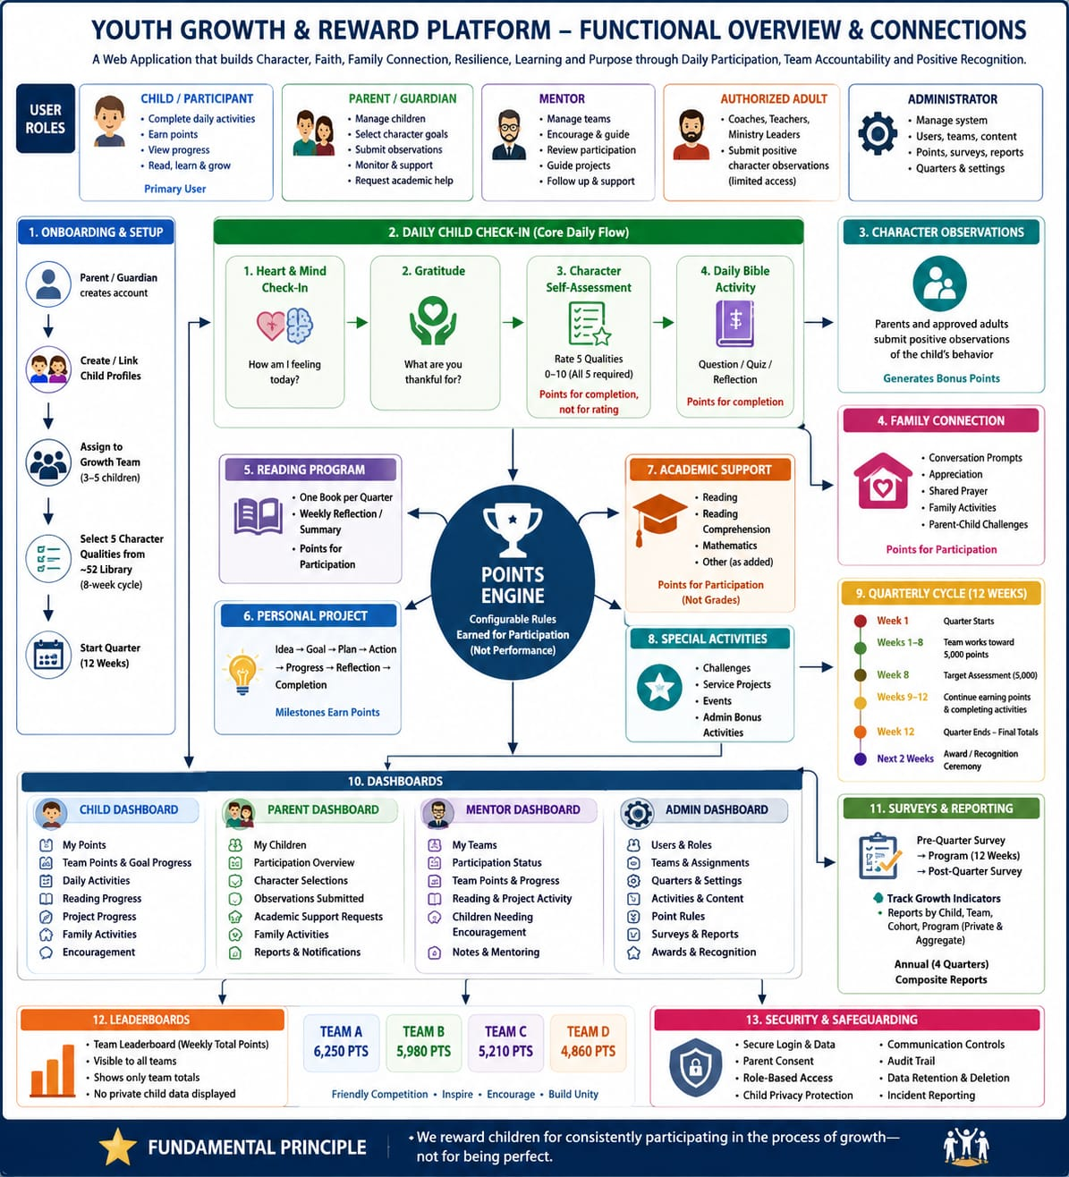
Figure A1. Youth Growth & Reward Platform — Functional Overview & Connections

Appendix B. Status vocabulary
Marker | Meaning
[x] Verified | Implemented in executable code/configuration and supported by applicable automated tests.
[~] Partial | Some executable behavior exists, but contract, authorization, testing, operations or UX remains incomplete.
[ ] Absent | No executable implementation is present.
[!] Blocked | Requires an explicit product, privacy, legal, safeguarding, tenancy or infrastructure decision.

