# **Install Apache Kafka on Mac**

# **Kafka Introduction:**

Apache Kafka is a distributed publish-subscribe messaging system as well as streaming platform

It has a robust queue that can accept large amounts of message data.

With Kafka, applications can write and read data to topics. A topic acts as a category for labeling data.

Next, an application can consume messages from one or multiple categories.

# **Follow the below steps to do the Kafka setup in your Mac**

Prerequisite: Install JAVA 8 SDK

Make sure you installed JAVA 8 SDK on your system by using this command --> java -version

This above command to know the java version installed on the system.

**STEP 1: Go to Apache Kafka official download page**:

(https://kafka.apache.org/downloads) and download the binaries.

We will use “Apache Kafka binaries” for installing Apache Kafka.

Download and Install Apache Kafka Binaries. Below is the direct link for download Kafka 2.8

<https://archive.apache.org/dist/kafka/2.8.0/kafka_2.12-2.8.0.tgz>

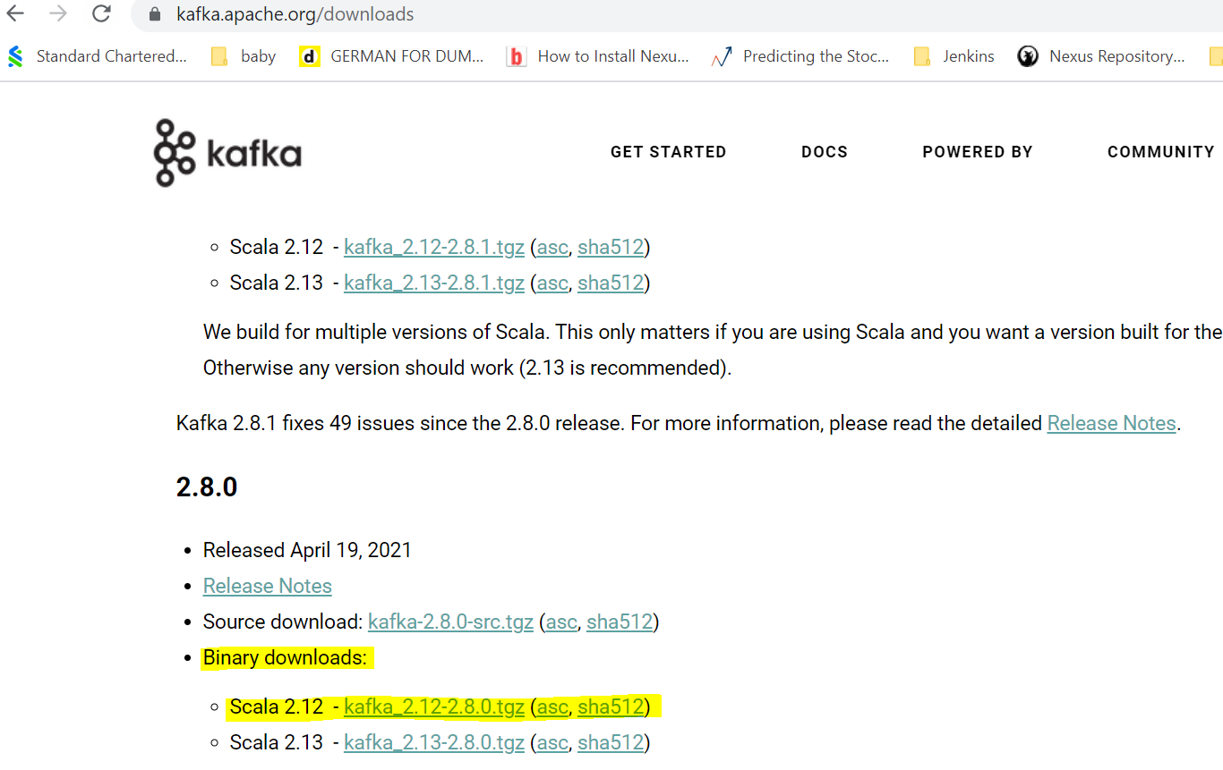

**STEP 2: Extract the contents:**

A Kafka 'tar' file will be downloaded. Move to the downloaded Kafka directory. Untar or uncompress the directory by using the command: 'tar -xvf '.

**STEP 3: Use the 'ls' command to**

view the untar file. Now, move into the .

To test, use **'bin/kafka-topics.sh'**.

If you see the instructions for using the command printed, it means that the setup is working.

**STEP 4:** If the required java version is not installed or java is not yet installed, then use the brew command as: **'brew tap caskroom/versions'**, then use **'brew cask install java8'** and java8 will start installing. It will ask: 'brew cask install java8', press enter.

**STEP 5**: java8 will be installed on the system. Use 'java-version' to check again.

Navigate to root of Apache Kafka folder and open a Terminal. Or Open a Terminal and navigate to the root directory of Apache Kafka.

**apples-MacBook-Pro:kafka_2.12-1.0.0 Adam$ ls**

**bin config libs LICENSE logs NOTICE site-docs**

### **Start Zookeeper**

Apache Kafka depends on Zookeeper for cluster management. Hence, prior to starting Kafka, Zookeeper has to be started. There is no need to explicitly install Zookeeper, as it comes included with Apache Kafka.

**Step1:** Create a new directory '**data**' under the kafka_directory. Use the command 'mkdir data' to do so.

**Step2:** Within the data directory, make two new directories: '**zookeeper**' and '**kafka**'.

**Step3:** Open the 'config' directory placed within the kafka_directory using the command 'nano config/zookeeper.properties'.

**Step4:** Edit the value of 'datadir' by placing the address of the newly created zookeeper directory. Save the file and exit.

**Step5:** Type 'ls data/zookeeper' on the window. A new directory 'version-2' will appear in the list. It means the zookeeper is started successfully.

**Step6:** Now, open 'server.properties' file to begin the Kafka server. Use the command: 'nano config/server.properties' to open the file.

**Step7:** Edit the value of **log.dirs** by placing the address of the newly created kafka folder from the forepath. Save the file and exit.

From the root of Apache Kafka, run the following command to start Zookeeper :

**~$ bin/zookeeper-server-start.sh config/zookeeper.properties**

The zookeeper should be started with a similar following trace in the output.

**apples-MacBook-Pro:kafka_2.12-1.0.0 Adam$ bin/zookeeper-server-start.sh config/zookeeper.properties**

**[2021-22-09 15:18:36,556] INFO Reading configuration from: config/zookeeper.properties (org.apache.zookeeper.server.quorum.QuorumPeerConfig)**

**[2021-22-09 15:18:36,650] INFO Server environment:zookeeper.version=3.4.10-39d3a4f269333c922ed3db283be479f9deacaa0f, built on 03/23.6.07 10:13 GMT (org.apache.zookeeper.server.ZooKeeperServer)**

**[2021-22-09 15:18:36,650] INFO Server environment:host.name=192.168.0.104 (org.apache.zookeeper.server.ZooKeeperServer)**

Based on the above command, If the port value=**2181** is achieved without any error like above, it means the zookeeper is successfully started. Otherwise, if some other application is bound to 2181, 'address in use' error will be thrown.

### **Start Apache Kafka Server**

The zookeeper window should not be closed to work with Kafka.

Open another Terminal and run the following command from the root of Apache Kafka to start Apache Kafka.

|  |
| --- |
| **~$ bin/kafka-server-start.sh config/server.properties** |

Following should be the end of trace stating that Kafka server is started.

|  |
| --- |
| [2017-12-31 15:52:20,291] INFO Initiating client connection, connectString=localhost:2181 sessionTimeout=6000 watcher=org.I0Itec.zkclient.ZkClient@4690b489 (org.apache.zookeeper.ZooKeeper)  [2017-12-31 15:52:20,307] INFO Waiting for keeper state SyncConnected (org.I0Itec.zkclient.ZkClient)  INFO Result of znode creation is: OK (kafka.utils.ZKCheckedEphemeral)  [2017-12-31 15:52:21,897] INFO Registered broker 0 at path /brokers/ids/0 with addresses: EndPoint(192.168.0.104,9092,ListenerName(PLAINTEXT),PLAINTEXT) (kafka.utils.ZkUtils)  [2017-12-31 15:52:21,900] WARN No meta.properties file under dir /tmp/kafka-logs/meta.properties (kafka.server.BrokerMetadataCheckpoint)  [2017-12-31 15:52:21,920] INFO Kafka version : 1.0.0 (org.apache.kafka.common.utils.AppInfoParser)  [2017-12-31 15:52:21,920] INFO Kafka commitId : aaa7af6d4a11b29d (org.apache.kafka.common.utils.AppInfoParser)  [2017-12-31 15:52:21,922] INFO [KafkaServer id=0] started (kafka.server.KafkaServer) |
| If the output displays 'kafka server started',  **Then d**o 'ls data/kafka', and the newly created files will be visible,  which indicates the Kafka server is successfully installed on the system.  Note:If you want to use Brew for the setup, Please refer the  Kafka_Mac_Brew text file.  If you want to understand the basic setup in Windows, Please refer  Kafka_windows_setup document |

**Run below commands and ensure that you are able to create the Kafka topic**

Command for creating Kafka topic:

**~$ bin/kafka-topics.sh** --create --zookeeper localhost:2181 --replication-factor 1 --partitions 1 --topic demo-topic

Command for listing our created Kafka topics:

**~$ bin/kafka-topics.sh** --list --zookeeper localhost:2181

### **Conclusion**

we have successfully learnt to install Apache Kafka on Mac and start Kafka along with Zookeeper. Time to understand real use cases of the Apache Kafka in our demo session on 4th Oct, 2021.