# **Install Apache Kafka on Windows**

# **Kafka Introduction:**

Apache Kafka is a distributed publish-subscribe messaging system as well as streaming platform

It has a robust queue that can accept large amounts of message data.

With Kafka, applications can write and read data to topics. A topic acts as a category for labeling data.

Next, an application can consume messages from one or multiple categories.

# **Follow the below steps to do the Kafka setup in your Windows machine:**

Prerequisite: Install JAVA 8 SDK

Make sure you installed JAVA 8 SDK on your system by using this command --> **java -version**

This above command to know the java version installed on the system.

### **STEP 1: Go to Apache Kafka official download page:**

(https://kafka.apache.org/downloads) and download the binaries.

We will use “Apache Kafka binaries” for installing Apache Kafka.

Or

Below is the direct link for download Kafka 2.8

<https://archive.apache.org/dist/kafka/2.8.0/kafka_2.12-2.8.0.tgz>

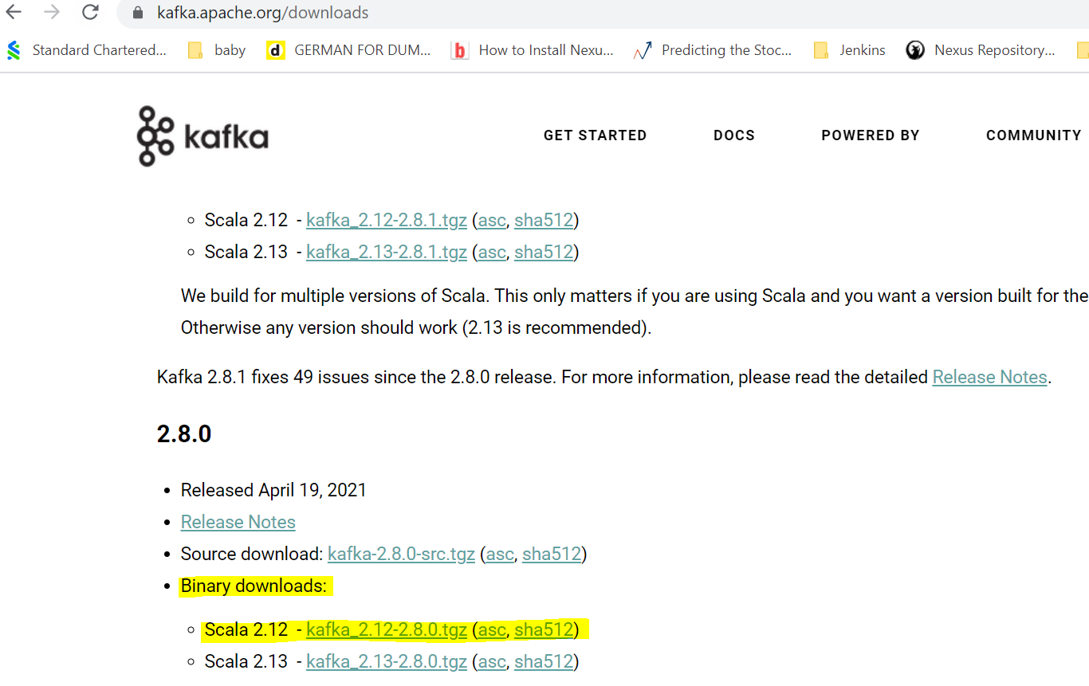

### **STEP 2: Create Data folder for Zookeeper and Apache Kafka:**

Create “data” folder and Kafka / Zookeeper directories inside data folder

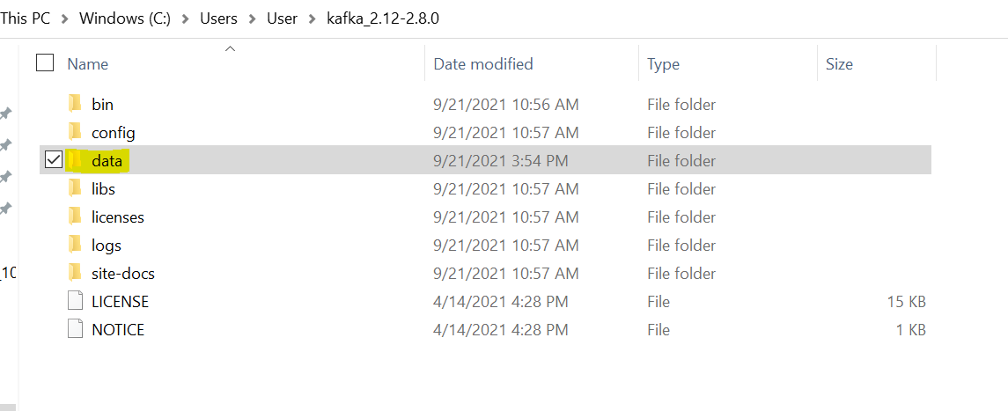

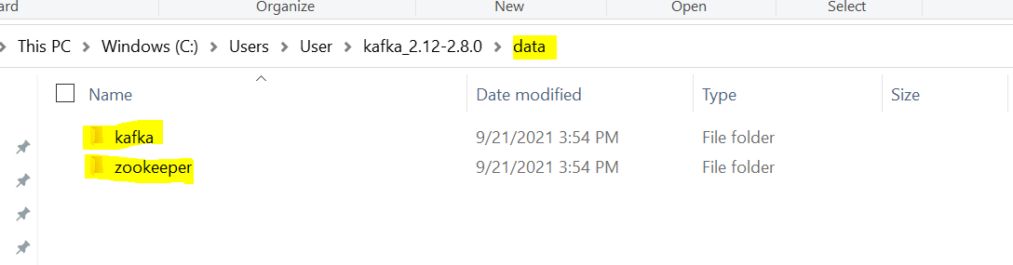

### **STEP 3: Change the default configuration value**

Update zookeeper data directory path in “config/zookeeper.Properties” configuration file.

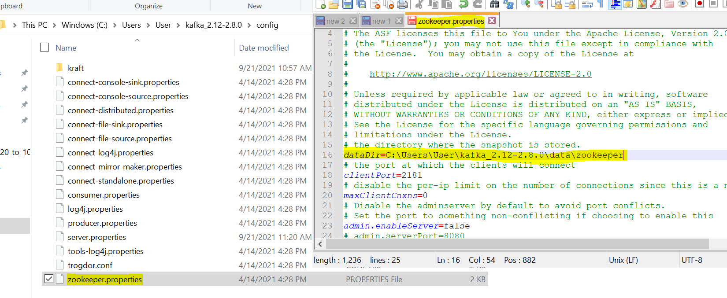

Update Apache Kafka log file path in “config/server.properties” configuration file.

e.g, Go to config folder in Apache Kafka and edit “server.properties” using any text editor.

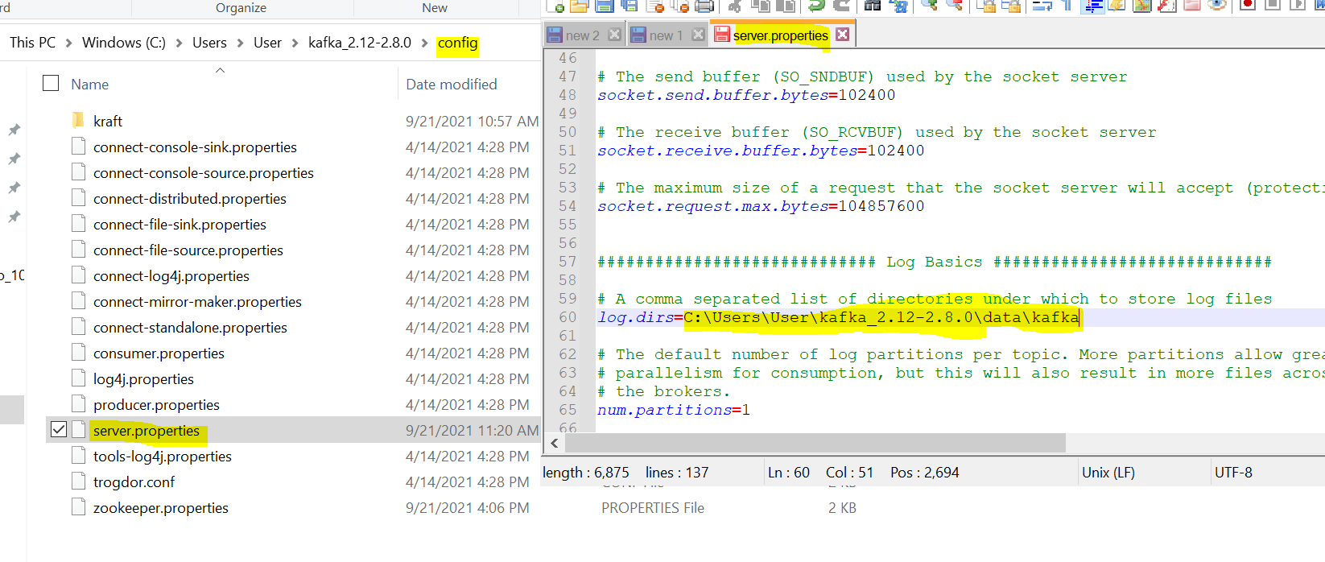

### STEP 4:  Start Zookeeper

Now time to start zookeeper from command prompt. Change your directory to your Kafka binary path and execute **zookeeper-server-start.bat** command with config/zookeeper.Properties configuration file.



**Commands:**

C:\Users\User\kafka_2.12-2.8.0>**.\bin\windows\zookeeper-server-start.bat .\config\zookeeper.properties**

Based on the above command, If the port value=2181 is achieved without any error like above, it means the zookeeper is successfully started. Otherwise, if some other application is bound to 2181, 'address in use' error will be thrown.

And make sure zookeeper started successfully like below

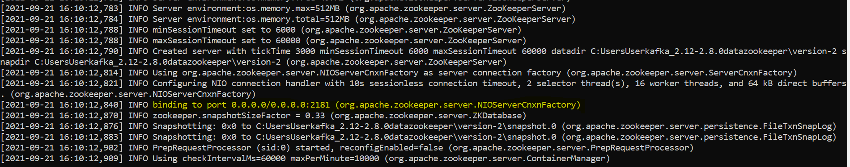

### **STEP 5:  Start Apache Kafka**

The zookeeper window should not be closed to work with Kafka. Open another window for running below command to start Kafka server

Finally, time to start Apache Kafka from command prompt. Run **kafka-server-start.bat**command with kafka config/server.properties configuration file.

This will start our Apache Kafka successfully.



**commands**:

C:\Users\User\kafka_2.12-2.8.0>**.\bin\windows\kafka-server-start.bat .\config\server.properties**

And make sure Kafka server started successfully like below

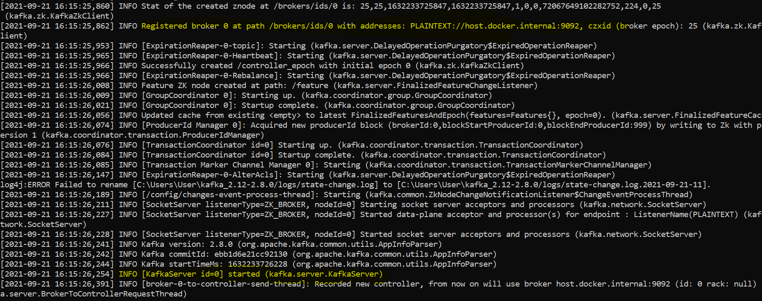

**Run below commands and ensure that you are able to create the Kafka topic**

Command for creating Kafka topic:

**.\bin\windows\kafka-topics.bat --create --zookeeper localhost:2181 --replication-factor 1 --partitions 1 --topic demo-topic**

Command for listing our created Kafka topics:

**.\bin\windows\kafka-topics.bat --list --zookeeper localhost:2181**

Conclusion

That is all for installing Apache Kafka on windows. Time to understand real use cases of the Apache Kafka in our demo session on 4th Oct, 2021.