## **Install Apache Spark on Mac OS**

**Introduction**

Apache Spark is an open-source framework that processes large volumes of stream data from multiple sources. Spark is used in distributed computing with machine learning applications, data analytics, and graph-parallel processing. The main feature of Spark is its in-memory cluster computing that increases the processing speed of an application.

This guide will show you **how to install Apache Spark on Windows**and test the installation**.**

**Please follow that Mac Prerequisite** document if you don’t have JAVA, Homebrew or xcode-select in your machine

### **STEP 1: Install Scala**

To install Scala through command line, enter and run the following command in the Terminal:

|  |
| --- |
| $ **brew install scala**  Below is the outcome after executing above command |
| apples-MBP:~ Adam$ brew install scala  Updating Homebrew...  ==> Auto-updated Homebrew!  Updated 1 tap (homebrew/core).  ==> Updated Formulae  grafana                    idris                      passenger    ==> Using the sandbox  ==> Downloading <https://downloads.lightbend.com/scala/2.12.3/scala-2.12.3.tgz>  ######################################################################## 100.0%  ==> Downloading <https://raw.githubusercontent.com/scala/scala-tool-support/0a217>  ######################################################################## 100.0%  ==> Caveats  To use with IntelliJ, set the Scala home to:    /usr/local/opt/scala/idea    Bash completion has been installed to:    /usr/local/etc/bash_completion.d  ==> Summary  ? /usr/local/Cellar/scala/2.12.3: 44 files, 20.1MB, built in 1 minute 1 second | |

### **STEP 2: Install Spark**

To install Apache Spark through command line, enter and run the following command in the Terminal:

|  |
| --- |
| $ **brew install apache-spark**  Below is the outcome after executing above command |
| apples-MBP:~ Adam$ brew install apache-spark  ==> Using the sandbox  ==> Downloading <https://www.apache.org/dyn/closer.lua?path=spark/spark-2.2.0/spa>  ==> Best Mirror <http://www-eu.apache.org/dist/spark/spark-2.2.0/spark-2.2.0-bin->  ######################################################################## 100.0%  ? /usr/local/Cellar/apache-spark/3.1.2: 1,318 files, 221.5MB, built in 12 minutes 8 seconds | |

### **STEP 3: Verifying installation**

To verify if the installation is successful, run the spark using the following command in Terminal:

|  |
| --- |
| $ **spark-shell** |
| apples-MBP:~ Adam$ spark-shell  Using Spark's default log4j profile: org/apache/spark/log4j-defaults.properties  Setting default log level to "WARN".  To adjust logging level use sc.setLogLevel(newLevel). For SparkR, use setLogLevel(newLevel).  21/09/24 21:52:51 WARN NativeCodeLoader: Unable to load native-hadoop library for your platform... using builtin-java classes where applicable  21/09/24 21:52:58 WARN ObjectStore: Version information not found in metastore. hive.metastore.schema.verification is not enabled so recording the schema version 1.2.0  21/09/24 21:52:58 WARN ObjectStore: Failed to get database default, returning NoSuchObjectException  21/09/24 21:52:59 WARN ObjectStore: Failed to get database global_temp, returning NoSuchObjectException  Spark context Web UI available at [http://192.168.1.101:4040](http://192.168.1.101:4040/)  Spark context available as 'sc' (master = local[*], app id = local-1501604572582).  Spark session available as 'spark'.  Welcome to        __              __       / _/_  _ __/ /_      \ \/ _ \/ _ `/ _/  '_/     /_/ ._/\,// //\\   version 2.2.0        /_/    Using Scala version 2.12.8 (Java HotSpot(TM) 64-Bit Server VM, Java 1.8.0_144)  Type in expressions to have them evaluated.  Type :help for more information.    scala> | |

We have successfully installed Apache Spark on Mac OS.

Finally, the Spark logo appears, and the prompt displays the **Scala shell**.

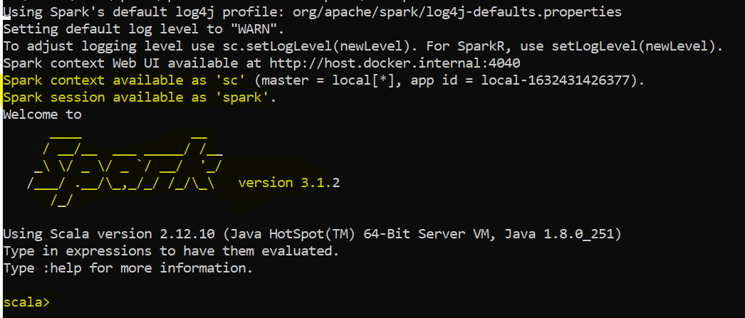

Run below command to check the execution which will return the string “Hello World”

val s = "hello world"

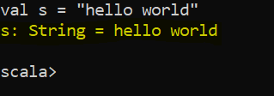

Just try it in your browser

1. Open a web browser and navigate to **http://localhost:4040/**.

2. You can replace **localhost**with the name of your system.

3. You should see an Apache Spark shell Web UI. The example below shows the Executors page.

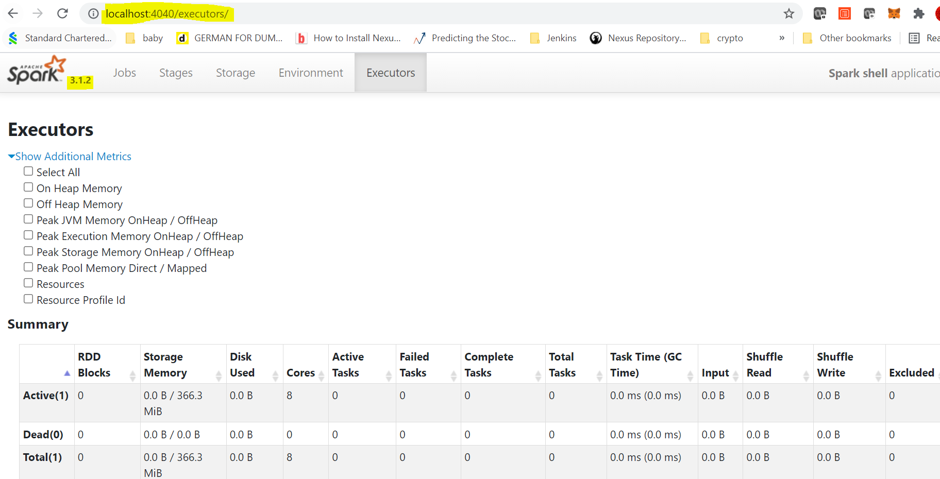

You can download Apache Spark from official website manually like Kafka setup and follow those instructions instead of Homebrew commands.

Conclusion

That is all for installing Apache Spark on Mac. We will see the real use cases of the Apache Spark in our demo session on 4th Oct, 2021.