Kayla McDanel  
08/24/2022  
Assignment 3  
Normalization

NodeSecurity ORD

NodeSecurity NoSQL Data Structure

NodeBookCo 2NF ORD

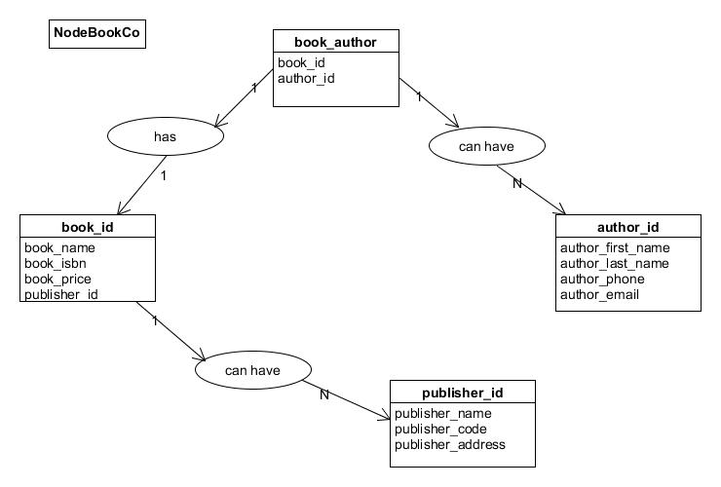

NodeBookCo NoSQL Data Structure

